**1NF**

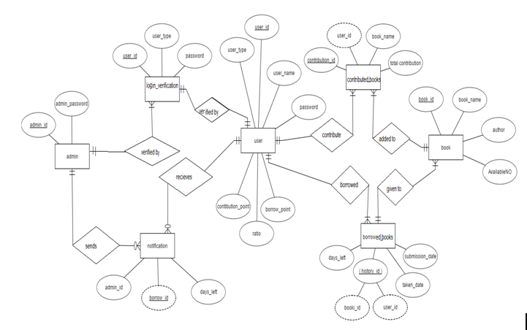

**Done by:**  
Shifat Ara Rafiq(08)  
Tasnim Tabassum Shimi(18)

**2NF and 3NF**

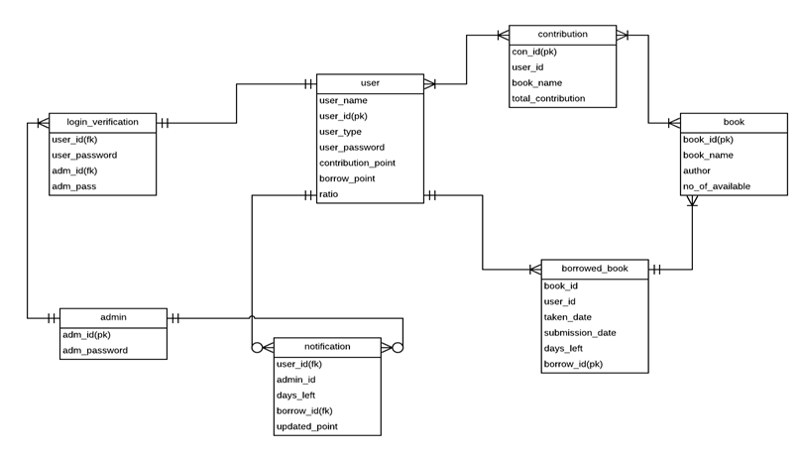

**Done by:**  
Nabilah Hossain Sarkar(21)  
Md.Habibur Rahman(40)