PART D: DATA WAREHOUSE DESIGN - STAR SCHEMA

EG Retail Sales Case Study

1. WHY STAR SCHEMA?
PROBLEMS SOLVED BY STAR SCHEMA
Problem 1: Data Redundancy

BEFORE (Excel - Messy):
OrderID | CustomerName | Phone | Product | Price
ORD-001 | Ahmed Ali | +201234567890 | Laptop | 15000
ORD-002 | Ahmed Ali | +201234567890 | Mouse | 500
ORD-003 | Ahmed Ali | +201234567890 | Keyboard | 800

Issues:
- ❌ "Ahmed Ali" written 3 times (repeated 10x if he makes 10 orders!)
- ❌ Phone number written 3 times
- ❌ Wastes storage space, difficult to update

AFTER (Star Schema - Clean):
Fact_Sales Table: | SaleID | CustomerKey | ProductKey | Price | |--------|-------------|------------|-------| | 1 | C001 | P001 | 15000 | | 2 | C001 | P002 | 500 | | 3 | C001 | P003 | 800 |
Dim_Customer Table (stored ONCE): | CustomerKey | Name | Phone | |-------------|-----------|---------------| | C001 | Ahmed Ali | +201234567890 |

Solution:
- ✅ Ahmed's information stored ONCE only
- ✅ Update phone in ONE place - no errors
- ✅ Saves significant storage space

Problem 2: Inconsistent Data
BEFORE (Excel):
- Same customer entered 4 different ways:
  - "Ahmed Ali"
  - "ahmed ali"
  - "Ahmed Ali" (extra space)
  - "أحمد علي" (Arabic)

AFTER (Star Schema with ETL):
- During data loading (ETL), we standardize to "ahmed ali"
- Create ONE customer record only
- All sales correctly linked to same customer

Problem 3: Slow Queries
BEFORE (Excel):
- Excel must scan ALL 150 rows for every query
- Searches through repeated data
- Gets slower as data grows
AFTER (Star Schema):
- Database uses indexes for fast lookup
- Queries run 10-100x faster
- Performance stays good even with millions of rows

Summary: Problems Solved
Problem | Excel (Before) | Star Schema (After) | Benefit Gained
Redundancy | Ahmed's name 10 times | Stored once | 90% space saving
Inconsistency | 4 different spellings | Standardized | Accurate reports
Performance | Slow queries | Fast queries | 10x faster
Analysis | Complex formulas | Simple SQL | Easy to query
Updates | Change 10 rows | Change 1 row | No errors

4. STAR SCHEMA DESIGN OVERVIEW
Schema Details
- Schema Type: Star Schema
- Total Tables: 10 tables
  - 1 Fact Table: Fact_Sales (transactions)
  - 9 Dimension Tables: Customer, Product, Date, Location, Payment Method, Payment Status, Shipper, Channel, Status
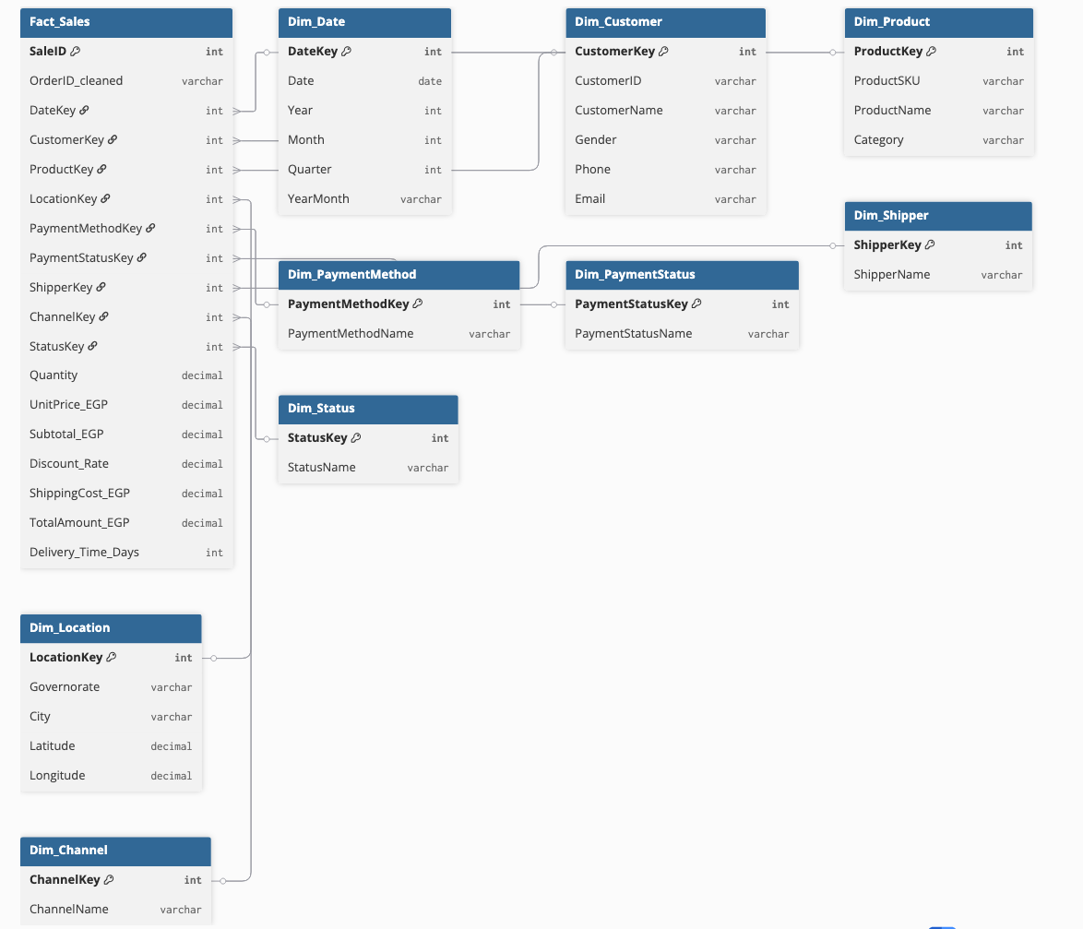

5. FACT AND DIMENSION TABLES
Fact_Sales (Main Transaction Table)
Purpose: Store all sales transactions with measurable values
Contains:
- Keys: Links to all 9 dimension tables
- Measures:
  - Quantity (items sold)
  - UnitPrice (price per item)
  - Subtotal (quantity × price)
  - Discount (discount applied)
  - ShippingCost (shipping charge)
  - TotalAmount (final amount)
  - Delivery_Time_Days (delivery time)
- Flags:
  - Delivery_Delayed (Yes/No)
  - Return indicators
  - Data quality flags
Dimension Tables (9 Total)
- Dim_Date - Calendar information (Year, Month, Quarter, Day)
- Dim_Customer - Customer details (Name, Phone, Email, Gender)
- Dim_Product - Product catalog (SKU, Name, Category)
- Dim_Location - Geographic data (Governorate, City, Coordinates)
- Dim_PaymentMethod - Payment types (Cash, Visa, Fawry)
- Dim_PaymentStatus - Payment state (Paid, Unpaid, Pending)
- Dim_Shipper - Delivery companies (Aramex, Egypt Post)
- Dim_Channel - Order source (E-com, Store, WhatsApp, Tel-Sales)
- Dim_Status - Order status (Pending, Shipped, Delivered, Cancelled)

6. BUSINESS QUESTIONS ANSWERED
With this star schema, we can easily and quickly answer important business questions:
Question 1: "What are total sales by month?"
Query Approach:
- Join Fact_Sales with Dim_Date
- Group by Month
- Sum TotalAmount
Business Value: Track revenue trends over time

Question 2: "Who are my top 10 customers?"
Query Approach:
- Join Fact_Sales with Dim_Customer
- Group by Customer
- Sum TotalAmount and order by total (descending)
Business Value: Identify high-value customers for retention programs

Question 3: "Which products sell best in Cairo?"
Query Approach:
- Join Fact_Sales with Dim_Product and Dim_Location
- Filter: Governorate = 'Cairo'
- Group by Product
- Sum Quantity
Business Value: Regional product performance analysis

Question 4: "What's the average delivery time by shipper?"
Query Approach:
- Join Fact_Sales with Dim_Shipper
- Group by Shipper
- Calculate average Delivery_Time_Days
Business Value: Evaluate shipper performance, optimize logistics

Question 5: "Revenue at risk from unpaid orders?"
Query Approach:
- Join Fact_Sales with Dim_PaymentStatus
- Filter: Status = 'Unpaid'
- Sum TotalAmount
Business Value: Identify financial risk, prioritize collection efforts

7. BENEFITS SUMMARY
Business Benefits
✅ Fast Decision Making - Queries return results in seconds
✅ Accurate Reports - Standardized, clean data
✅ Easy Analysis - Business users can query without IT help
✅ Scalable - Handles growth from 150 to millions of rows
✅ Historical Tracking - Keep full history of all transactions
Technical Benefits
✅ Simple Structure - Easy to understand and maintain
✅ Query Performance - Optimized for analytical queries
✅ Data Quality - Single source of truth
✅ Flexibility - Easy to add new dimensions or measures
✅ BI Tool Compatible - Works seamlessly with Power BI, Tableau

CONCLUSION
The Star Schema design transforms our messy Excel file into a clean, efficient, and fast data warehouse that enables powerful business intelligence and reporting capabilities.
Key Takeaway: By organizing data into one central fact table surrounded by dimension tables, we eliminate redundancy, improve performance, ensure consistency, and enable fast, accurate business analysis.

