Smart Restaurant Order System
Issue #2 — High-Level System Architecture
Architecture Design Documentation

Objective
This document covers the architectural decisions made for the Smart Restaurant Order System. The goal is to answer three core questions:
- What deployment architecture fits the system's scale and requirements?
- Which communication pattern synchronous or asynchronous should be used where?
- Where does each piece of state live, and why?

Each decision is backed by analysis of trade-offs, not assumptions. The principle guiding every choice is: there is no universally best architecture only the most suitable one for a given project.

Part 1: Deployment Architecture

Architecture Options Considered
Three architectural patterns were evaluated before arriving at a decision. Understanding each one and its strengths and its costs is essential context for justifying the final choice.

Option A — Traditional Monolith

Overview
In a traditional monolithic architecture, the entire application is built and deployed as a single unit. All components authentication, business logic, background processing, and data access run within the same process and share a single database.

Advantages
- Simplicity of Development and Deployment The system is developed, tested, and deployed as one unit. This reduces infrastructure complexity and accelerates early-stage development.
- Strong Consistency by Default Since all modules share the same database and runtime, transactions across domains (e.g., Orders + Stock updates) are straightforward and reliable.
- Lower Operational Overhead No need for service discovery, distributed tracing, inter-service authentication, or container orchestration.
- Faster In-Process Communication Function calls between components are local and do not incur network latency.

Disadvantages
- Tight Coupling Risk Without strict boundaries, domains become highly interconnected, making refactoring difficult and risky.
- Limited Independent Scalability The entire system must be scaled as a whole, even if only one part (e.g., order processing) requires more resources.
- Slower Team Parallelization As the system grows, multiple developers modifying the same codebase cause conflicts and coordination overhead.
- Maintainability Degradation Over Time Without modular discipline, the system evolves into a "big ball of mud." هنا معناه ان مع مرور الوقت تعقيد الكود هيبقى اكتر و ده لأن الموضوع متشابك و كل حاجه داخلة في تفاصيل الحاجات التانية ف لو جيت تغير حاجة ممكن تكسر حاجات تانية كانت معتمده عليها لأنها هنا مش بتتعامل معاها بشكل abstract or in high level so if you make change things will still as it is ف علشان كده ده عيب من عيوبه

Option B — Modular Monolith

Overview
A modular monolith maintains a single deployment unit and shared database but enforces strict internal boundaries between domains. Each module encapsulates its own logic and interacts with other modules through well-defined interfaces not by directly accessing internal data structures, modules communicate with each other in high level abstract way without entering in each other details which making the changing more easy.

Advantages
- Clear Domain Separation Each module (Auth, Orders, Menu, Payments) owns its internal logic and exposes only defined interfaces to the outside.
- High Cohesion, Reduced Coupling Modules cannot directly access each other's internals, dramatically improving long-term maintainability.
- Strong Transactional Consistency Since all modules share the same database, complex operations (e.g., atomic stock reservation + order creation) remain simple and reliable.
- Easier Future Migration to Microservices If scaling requirements increase, modules can be extracted into independent services with minimal refactoring.
- Operational Simplicity Still deployed as a single application with no distributed infrastructure complexity.

Disadvantages
- Monolithic Deployment Constraint All modules must be deployed together, even if only one changes.
- Requires Architectural Discipline Without consistent enforcement of boundaries, modules can degrade back into a traditional monolith.
- Shared Resource Contention Heavy load in one module can still impact overall system performance.

Option C — Microservices

Overview
Microservices decompose the application into independently deployable services. Each service owns its logic, runtime, and database. Services communicate over the network via REST, gRPC, or asynchronous messaging.

Advantages
- Independent Scalability Each service can scale based on its own resource requirements.
- Fault Isolation Failure in one service does not necessarily bring down the entire system.
- Technological Flexibility Different services can use different programming languages or data storage technologies.
- Team Autonomy Multiple teams can work independently on separate services without coordination bottlenecks.

Disadvantages
- Increased Infrastructure Complexity Requires container orchestration (e.g., Kubernetes), service discovery, monitoring, logging aggregation, and distributed tracing.
- Distributed System Challenges Network latency, partial failures, and retry logic must be handled explicitly in application code.
- Complex Data Consistency Cross-service transactions require advanced patterns such as Saga or eventual consistency mechanisms.
- Higher Operational Cost More environments, more deployment pipelines, more monitoring systems disproportionate for a single-branch system.

Architecture Comparison Summary
Criterion | Traditional Monolith | Modular Monolith | Microservices
Deployment Complexity | Low | Low | High
Domain Isolation | None / Weak | Strong | Very Strong
Transactional Consistency | Easy | Easy | Complex (Saga)
Independent Scalability | No | No | Yes
Operational Overhead | Low | Low | High
Team Parallelism | Low | Medium | High
Suitable for Solo / MVP | Yes | Yes (preferred) | No
Future Microservice Migration | Hard | Straightforward | N/A

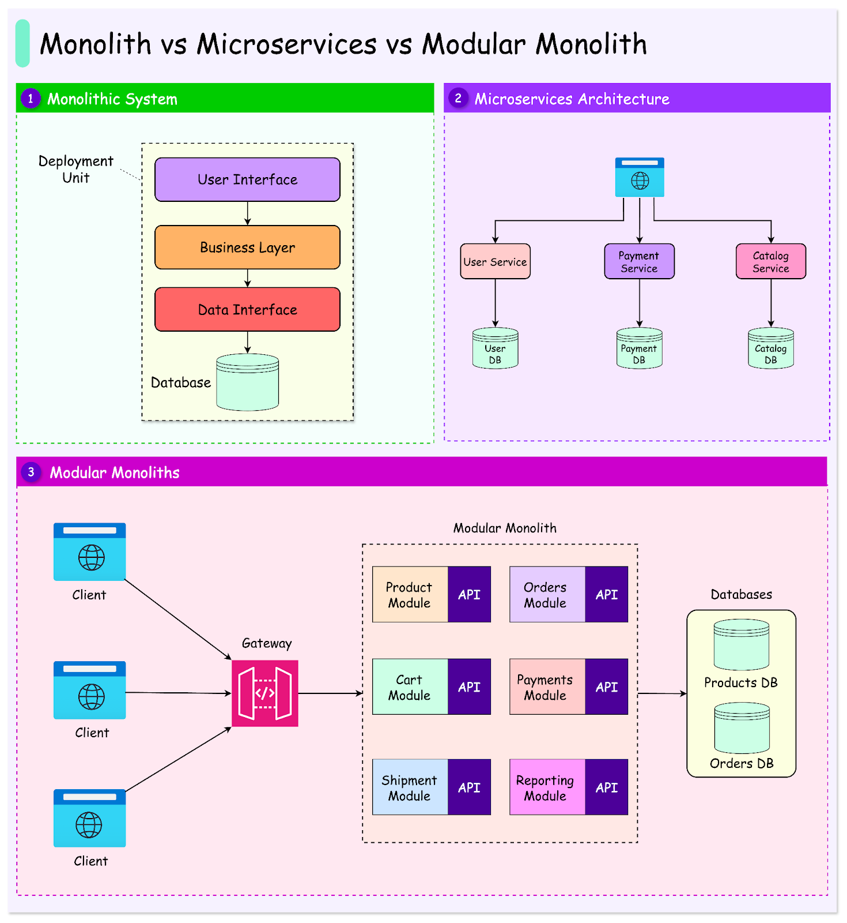
Figure 1: Visual comparison of Monolith, Microservices, and Modular Monolith architectures

Decision: Modular Monolith
Selected Architecture: Modular Monolith

The Smart Restaurant Order System is a single-branch, single-tenant application developed by a solo engineer within a constrained timeline (11-day MVP target). The system requires:
- Strong transactional consistency during checkout
- Atomic stock reservation under concurrent access
- Real-time status updates via WebSocket
- Clear domain separation: Auth, Menu, Cart, Orders, Payments, Admin

Given these constraints, the Modular Monolith architecture provides the optimal balance between structural clarity and operational simplicity. An additional benefit is that if the system later needs to scale into microservices, the clean module boundaries make that migration significantly easier.

Why Not a Traditional Monolith?
While a traditional monolith would simplify initial implementation, the project includes multiple distinct domains (orders, payments, inventory, reviews). Without enforced modular boundaries, the system risks tight coupling and long-term maintainability issues. A modular structure ensures separation of responsibilities from day one, avoiding technical debt accumulation.

Why Not Microservices?
Adopting microservices at this stage would introduce unnecessary complexity due to:
- Distributed transaction management across services
- Network-based inter-service communication with latency and failure handling
- Increased DevOps requirements beyond the project's scope
- Infrastructure overhead disproportionate to a single-branch, moderate-load system
The current scale assumptions (single branch, shared database, moderate load) do not justify the operational cost of a distributed architecture.

Strategic Justification
The modular monolith approach enables:
- Strong consistency guarantees at checkout via database-level transactions
- Simpler concurrency handling no distributed locks or Saga patterns needed
- Clean domain boundaries that map directly to the system's business domains
- Future extensibility if the system evolves into a multi-branch or multi-tenant platform

Conclusion: This architecture aligns with the system's scale, constraints, and long-term growth potential while avoiding premature optimization and overengineering.

Part 2: Sync vs Async Communication

Understanding the Difference

Synchronous Communication
In synchronous communication, the caller sends a request and waits for a response before continuing. The caller is blocked until it receives a reply. This is the standard request-response model used in REST APIs.
- Immediate feedback the caller knows success or failure instantly
- Simple to reason about and debug
- Tightly coupled in time both sides must be available simultaneously

Asynchronous Communication
In asynchronous communication, the caller does not wait for the result. It sends a message or triggers an event and immediately continues its work. The result arrives later through a callback, event listener, or push mechanism (e.g., WebSocket).
- Non-blocking the caller is free to do other work
- Better for long-running operations and real-time updates
- More complex to implement and trace

Pros & Cons
Dimension | Synchronous | Asynchronous
Response Model | Wait for result | Continue immediately; result arrives later
Latency | Direct result returned in same call | Indirect update pushed when ready
Coupling | Tight (both sides must be active) | Loose (sender and receiver independent)
Complexity | Low easy to follow and debug | Higher requires event handling
Best For | CRUD, checkout, authentication | Real-time updates, kitchen display, notifications
Error Handling | Inline errors returned immediately | Requires reconnect and retry logic

Decision: How Communication is Used in This System
Pattern: Synchronous for all CRUD and business operations. Asynchronous via WebSocket for real-time kitchen and customer updates.

Synchronous communication (standard HTTP REST) is used for:
- Authentication and session management
- Menu browsing and cart operations
- Checkout and payment confirmation
- Admin operations (inventory management, reporting)
- All standard database read/write operations

Asynchronous communication via WebSocket is used for:
- Real-time order status propagation to customers (e.g., "Your order is being prepared")
- Kitchen display system updates orders appear instantly on the kitchen screen without polling

This split keeps the architecture simple: REST for reliability and predictability, WebSocket for the real-time experience where it genuinely adds value.

Part 3: Where State Lives

Design Considerations
Deciding where each type of state lives requires answering two questions:
- Does this data need to be retrieved very quickly? If so, consider cache or in-memory.
- Does this data need to persist permanently? If so, it must live in the database.

The general principle: the more frequently read and the less frequently written a piece of data is, the better a candidate it is for caching. Data that must survive system restarts, power failures, or deployments belongs in persistent storage.

State Location Table
State / Data | Where It Lives | Justification
Menu Items | Cache (Redis) | Menu data changes rarely but is read on every page load by every user. Caching reduces database load and speeds up page rendering significantly.
Historical Orders | Database (PostgreSQL) | Completed orders must be stored permanently for business records, data analysis, and customer history. Durability and auditability are non-negotiable.
Current / Active Orders | Cache (Redis) | Kitchen staff and customers need real-time access to in-progress orders with minimal latency. Cache ensures fast reads under concurrent access.
Stock / Inventory | Database (PostgreSQL) | Stock levels are safety-critical. Incorrect stock data can lead to overselling or operational failures. Persistence and atomic updates are required.
User Sessions / Auth Tokens | Cache (Redis) | Session data needs fast lookup per request. Redis provides sub-millisecond reads with built-in TTL support for automatic expiry.
Payment Records | Database (PostgreSQL) | Financial records require full persistence, audit trails, and consistency guarantees. They must never live only in volatile memory.

Summary
State is distributed across two stores:
- PostgreSQL (Database) for anything that must survive indefinitely: historical orders, inventory, payments, and user accounts. Consistency and durability are the priority.
- Redis (Cache) for anything that must be accessed at high speed and can be reconstructed if lost: active orders, menu data, and user sessions. Speed and low latency are the priority.

Key Principle: If the data is permanent or financial, it lives in the database. If it is temporary, frequently read, or speed-critical, it lives in cache.

Architecture Diagram
The system follows a Modular Monolith architecture. The high-level diagram below describes the top-level components and their interactions.

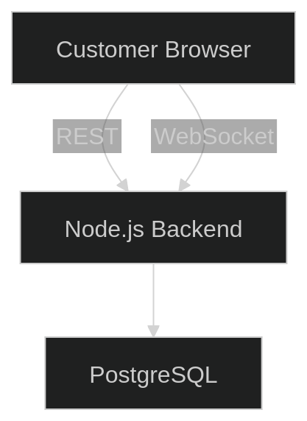
Figure 2: High-level system architecture — Customer Browser ↔ Node.js Backend ↔ PostgreSQL

Layer | Component | Role
Client | Web Browser / Mobile | User-facing interface for customers and admin
Frontend | Simple front end | Renders menu, cart, checkout, and order tracking UI
Backend | Node.js (Modular Monolith) | Hosts all domain modules: Auth, Menu, Cart, Orders, Payments, Admin
Real-Time | WebSocket Server | Pushes live order status to customers and kitchen display
Cache | Redis | Stores menu data, active orders, and sessions
Database | PostgreSQL | Persists all permanent data: users, orders, stock, payments

Inside the Node.js backend layer, each domain is implemented as a fully isolated module with its own service layer, repository, and defined public interface. The detailed module-level diagram (showing intra-module communication) will be produced later.

