Design Relational Model First Draft
Issue #4 Smart Restaurant Order System
ERD v1 · Initial Schema · Normalization Analysis

Objective
This document covers the initial database design for the Smart Restaurant Order System. It answers three questions defined in Issue #4:
- What should be normalized? identify redundancy that should be eliminated
- What can be denormalized? identify intentional redundancy kept for performance or correctness
- Where do relationships belong? define foreign keys and relationship ownership

Note: This is a first draft. Database design is iterative Issue #5 will revisit this schema for indexing strategy and performance optimization. The schema may evolve as implementation reveals new requirements.

Entity Relationship Diagram v1
The diagram below uses Chen notation: rectangles = entities, ovals = attributes, diamonds = relationships. Cardinality labels (1, M) appear on all relationship lines.

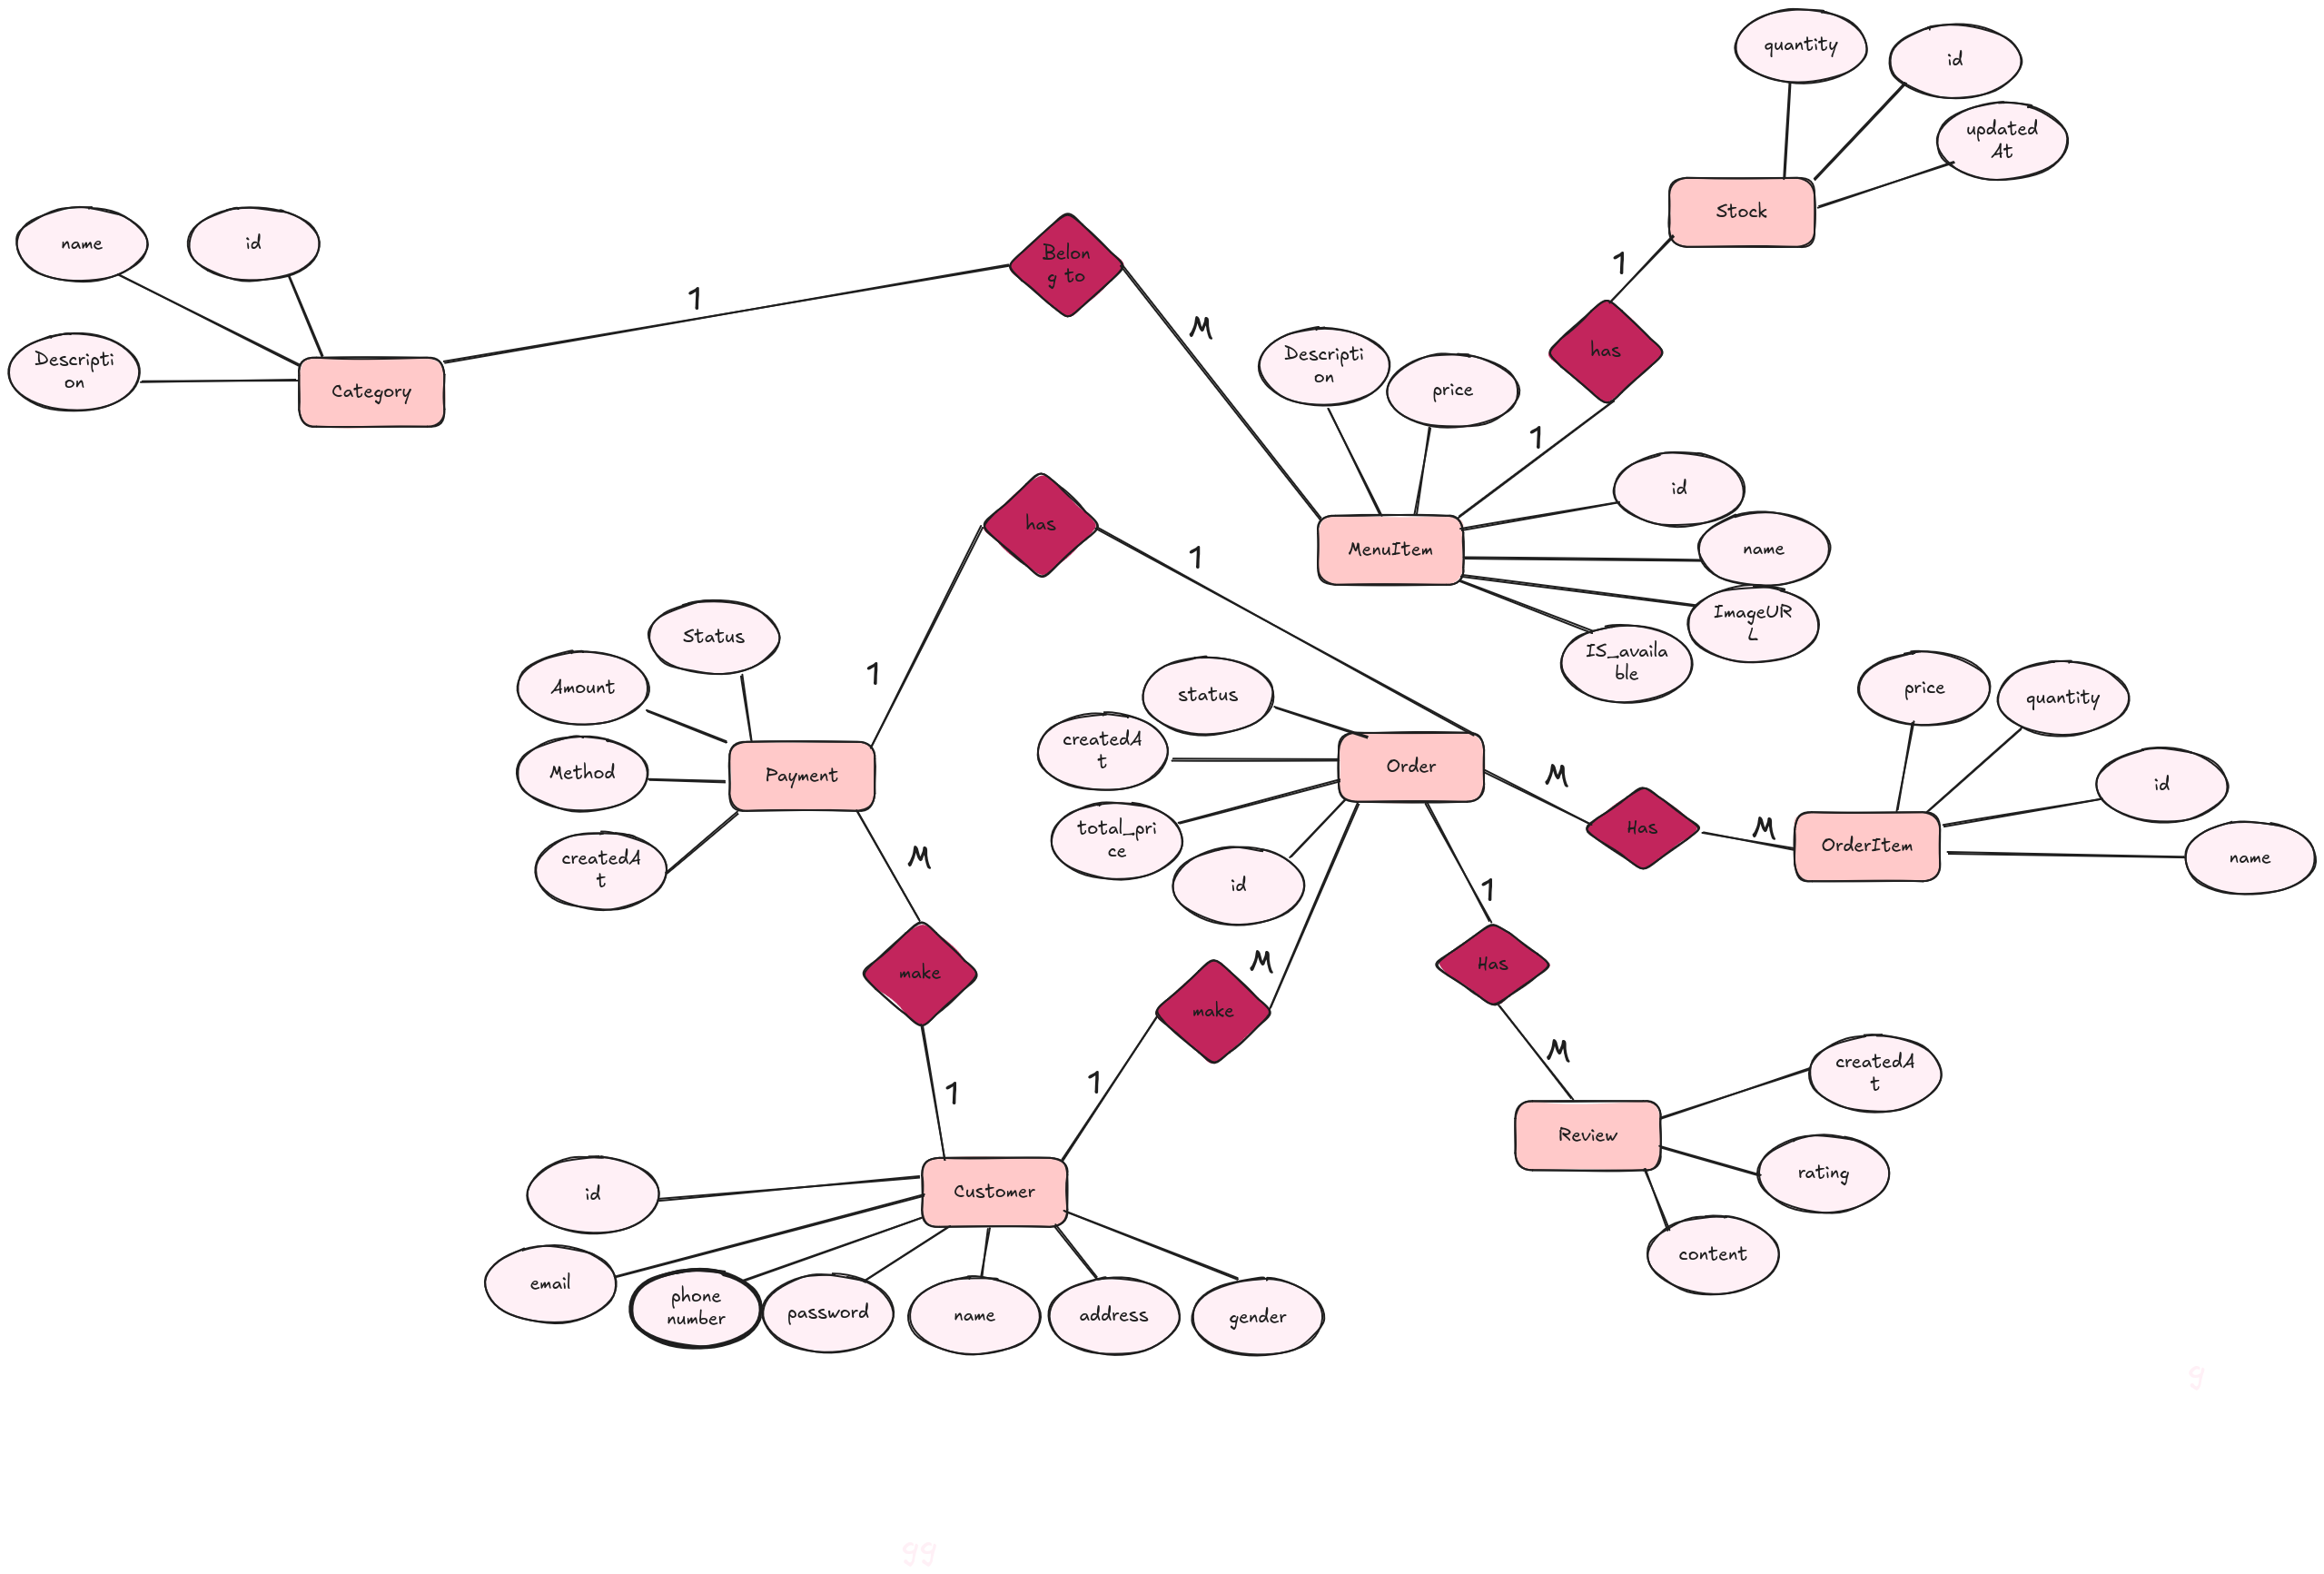
Figure 1: Final ERD v1 Smart Restaurant Order System

Relationship Map
Every relationship stated in plain language with its cardinality and how it translates into the schema.

Relationship | Cardinality | How it maps to schema
Category → MenuItem | 1 : M | category_id FK on menu_items table
MenuItem → Stock | 1 : 1 | menu_item_id FK (UNIQUE) on stock table
Customer → Order | 1 : M | customer_id FK on orders table
Order → OrderItem | 1 : M | order_id FK on order_items table
Order → Payment | 1 : 1 | order_id FK (UNIQUE) on payments table
Customer → Payment | 1 : M | customer_id FK on payments table
Order → Review | 1 : 1 | order_id FK (UNIQUE) on reviews table one review per order

Initial Schema
A faithful translation of the ERD into PostgreSQL CREATE TABLE statements. No performance optimizations yet indexes and query tuning are covered in Issue #5. All tables follow a consistent convention: snake_case names, SERIAL primary keys, explicit NOT NULL constraints, and created_at timestamps where applicable.

Convention: All primary keys use SERIAL (auto-increment integer) for v1 simplicity. UNIQUE constraints on FK columns enforce 1:1 relationships at the database level, not just in application code and to make things consistent like the 1:1 relation between payment and order the fk must be unique here and that cause there Is will not existed more than one payment for specific order.

categories
CREATE TABLE categories (
id SERIAL PRIMARY KEY,
name VARCHAR(100) NOT NULL,
description TEXT,
created_at TIMESTAMP NOT NULL DEFAULT NOW()
);

menu_items
CREATE TABLE menu_items (
id SERIAL PRIMARY KEY,
category_id INT NOT NULL REFERENCES categories(id),
name VARCHAR(150) NOT NULL,
description TEXT,
price NUMERIC(10,2) NOT NULL,
image_url TEXT,
is_available BOOLEAN NOT NULL DEFAULT TRUE,
created_at TIMESTAMP NOT NULL DEFAULT NOW()
);

Note: is_available is an admin toggle hides a dish from customers without deleting it. Stock quantity lives in the stock table, not here.

stock
CREATE TABLE stock (
id SERIAL PRIMARY KEY,
menu_item_id INT NOT NULL UNIQUE REFERENCES menu_items(id),
quantity INT NOT NULL DEFAULT 0,
updated_at TIMESTAMP NOT NULL DEFAULT NOW()
);
-- UNIQUE on menu_item_id enforces 1:1 with menu_items

Concurrency: Stock quantity updates during checkout must use atomic transactions (SELECT FOR UPDATE or UPDATE ... WHERE quantity > 0) to prevent overselling under concurrent access. This is a key requirement identified in Issues #2 and #3.

customers
CREATE TABLE customers (
id SERIAL PRIMARY KEY,
name VARCHAR(150) NOT NULL,
email VARCHAR(255) NOT NULL UNIQUE,
password_hash VARCHAR(255) NOT NULL,
phone_number VARCHAR(20),
address TEXT,
gender VARCHAR(20),
created_at TIMESTAMP NOT NULL DEFAULT NOW()
);

staff
CREATE TABLE staff (
id SERIAL PRIMARY KEY,
name VARCHAR(150) NOT NULL,
email VARCHAR(255) NOT NULL UNIQUE,
password_hash VARCHAR(255) NOT NULL,
role VARCHAR(50) NOT NULL DEFAULT 'kitchen',
created_at TIMESTAMP NOT NULL DEFAULT NOW()
);
-- role values: 'admin' | 'kitchen'
-- admin : full access (menu, orders, stock, reports)
-- kitchen : view orders + update order status only

Note: Staff and Customer are completely separate tables with separate authentication flows. They must never be merged into a single users table their permissions, data models, and lifecycles are fundamentally different (defined in Issue #3).

orders
CREATE TABLE orders (
id SERIAL PRIMARY KEY,
customer_id INT NOT NULL REFERENCES customers(id),
status VARCHAR(50) NOT NULL DEFAULT 'pending',
total_price NUMERIC(10,2) NOT NULL,
created_at TIMESTAMP NOT NULL DEFAULT NOW()
);
-- status values: 'pending' | 'preparing' | 'ready' | 'delivered' | 'cancelled'

order_items
CREATE TABLE order_items (
id SERIAL PRIMARY KEY,
order_id INT NOT NULL REFERENCES orders(id),
name VARCHAR(150) NOT NULL,
price NUMERIC(10,2) NOT NULL,
quantity INT NOT NULL
);

Intentional denormalization: name and price are copied from menu_items at checkout time. If the admin later changes a dish price, historical orders must still reflect what the customer actually paid. These fields are written once and never updated.

payments
CREATE TABLE payments (
id SERIAL PRIMARY KEY,
order_id INT NOT NULL UNIQUE REFERENCES orders(id),
customer_id INT NOT NULL REFERENCES customers(id),
amount NUMERIC(10,2) NOT NULL,
method VARCHAR(50) NOT NULL,
status VARCHAR(50) NOT NULL DEFAULT 'pending',
created_at TIMESTAMP NOT NULL DEFAULT NOW()
);
-- method values : 'cash' | 'card' | 'online'
-- status values : 'pending' | 'completed' | 'failed' | 'refunded'
-- UNIQUE on order_id enforces 1:1 one payment per order

reviews
CREATE TABLE reviews (
id SERIAL PRIMARY KEY,
order_id INT NOT NULL UNIQUE REFERENCES orders(id),
customer_id INT NOT NULL REFERENCES customers(id),
rating SMALLINT NOT NULL CHECK (rating BETWEEN 1 AND 5),
content TEXT,
created_at TIMESTAMP NOT NULL DEFAULT NOW()
);
-- UNIQUE on order_id enforces 1:1 one review per order
-- Customer can only review after placing an order (enforced via order_id FK)

Normalization Analysis
Normalization is the process of structuring a database to reduce redundancy and ensure data integrity. The target is Third Normal Form (3NF). Each normal form is verified below.

First Normal Form (1NF)
Rule: Every column holds a single atomic value. No repeating groups. Every row is uniquely identifiable by its primary key.

✅ All tables comply with 1NF:
- Every column stores one atomic value no comma-separated lists or arrays
- Every table has a single SERIAL primary key
- No repeating groups OrderItems are a separate table, not repeated columns on Orders

Second Normal Form (2NF)
Rule: Must be in 1NF. Every non-key attribute must depend on the whole primary key. Partial dependencies are only possible with composite primary keys.

✅ All tables comply with 2NF:
- No table uses a composite primary key all use a single SERIAL id
- With no composite keys, partial dependencies are impossible by definition

Third Normal Form (3NF)
Rule: Must be in 2NF. No transitive dependencies every non-key column must depend directly on the primary key, not on another non-key column.

✅ The schema reaches 3NF with two intentional, justified exceptions:

Exception 1 total_price on orders
total_price is derivable by summing order_items.price * quantity. Storing it on orders is technically a transitive dependency via the order_items rows.

Justification: Recalculating total_price on every order read requires a JOIN and aggregation across order_items. For high-frequency reads like order history and the kitchen dashboard, having total_price directly on the order row eliminates this cost. The value is computed once at checkout and never changes — zero risk of inconsistency.

Decision: Keep total_price on orders. Compute once at checkout from the sum of OrderItems. Never recalculate from order_items after the fact.

Exception 2 name and price on order_items
order_items stores name and price copied from menu_items. These could be retrieved via the menu_item_id FK, making them a transitive dependency.

Justification: This is a deliberate correctness decision, not a performance shortcut. If a MenuItem price changes or the item is deleted, historical order records must still show exactly what the customer was charged. Without the snapshot, order history becomes unreliable the moment any menu update occurs.

Decision: Keep name and price on order_items as immutable snapshots. Written once when the order is placed. Must never be updated afterwards.

Denormalization Summary
All intentional denormalization decisions in this schema:

Table | Denormalized field(s) | Reason kept | Risk if removed
orders | total_price | Avoids JOIN + SUM aggregation on every order read. Written once at checkout. | Slow order history queries; aggregation needed on every page load
order_items | name, price | Price snapshot preserves what the customer actually paid, even if the menu changes later. | Historical orders show wrong prices after any menu price update

Where Do Relationships Belong?
In a relational database, a relationship is implemented by placing a foreign key on the table that represents the 'many' or 'dependent' side. The rule: the FK goes on the table that answers 'I belong to whom?'

Relationship | FK lives on | Constraint | Reasoning
Category → MenuItem | menu_items.category_id | NOT NULL | A MenuItem must belong to exactly one Category.
Customer → Order | orders.customer_id | NOT NULL | An Order must belong to exactly one Customer.
Order → OrderItem | order_items.order_id | NOT NULL | An OrderItem must belong to exactly one Order.
MenuItem → OrderItem | order_items.menu_item_id | NOT NULL | An OrderItem must reference its source MenuItem.
Order → Payment | payments.order_id | NOT NULL UNIQUE | 1:1 — one payment per order. UNIQUE enforced at DB level.
Customer → Payment | payments.customer_id | NOT NULL | Enables querying all payments by a customer directly.
Order → Review | reviews.order_id | NOT NULL UNIQUE | 1:1 — one review per order. Prevents duplicate reviews.
Customer → Review | reviews.customer_id | NOT NULL | Enables querying all reviews by a customer directly.
MenuItem → Stock | stock.menu_item_id | NOT NULL UNIQUE | 1:1 — one stock record per MenuItem.

Cart Why It Is Not in This Schema
Cart does not appear as a CREATE TABLE statement. This is intentional.
As decided in the state management analysis (Issue #2), Cart is an ephemeral entity. It exists only while a customer is building their order. Once checkout happens, the Cart is converted into an Order and destroyed. It does not need to survive database restarts or be queried historically.
Cart will be implemented as a Redis data structure a JSON object keyed by customer session. Its exact structure will be defined when the Cart module is built.
Planned Redis structure: Key: cart:{customer_id} Value: JSON { items: [{ menu_item_id, name, price, quantity }], updated_at }

