

CMPS310 – Group project report -Phase Two
Group 1
Class section: L51

• QUID: 202308043 STUDENT NAME: Habiba Mohamed • QUID: 202304384 STUDENT NAME: Ashley Danoy • QUID: 202307776 STUDENT NAME: Amaa Aoun

DECLARATION: We hereby certify that no part of this project or product has been copied from any other student’s work or from any other sources except where due acknowledgement is made in the project. No part of this project/product has been written/produced for us by any other persons.

# Reserve item

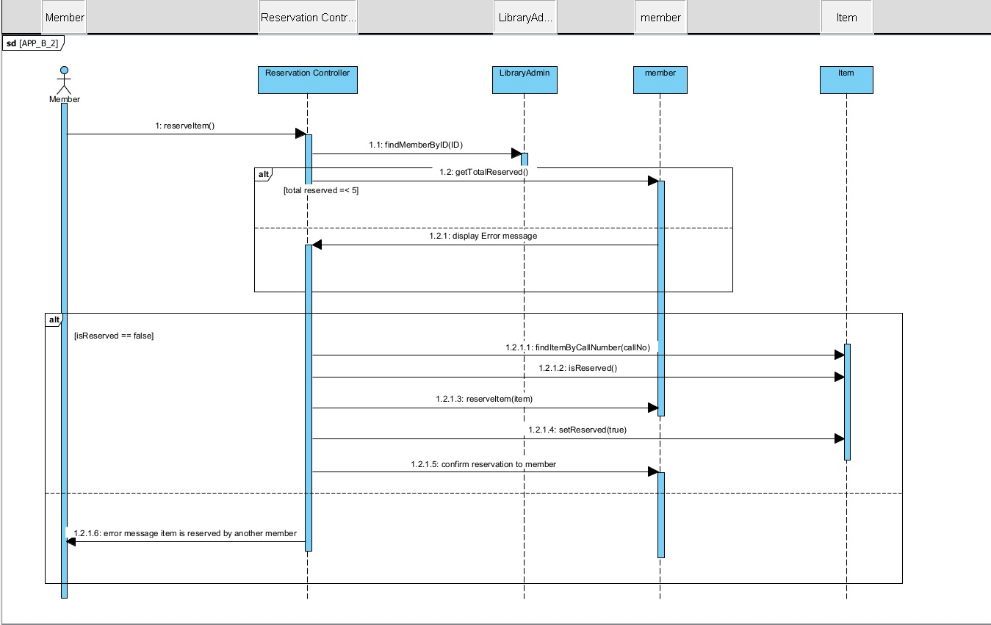

# Register new member

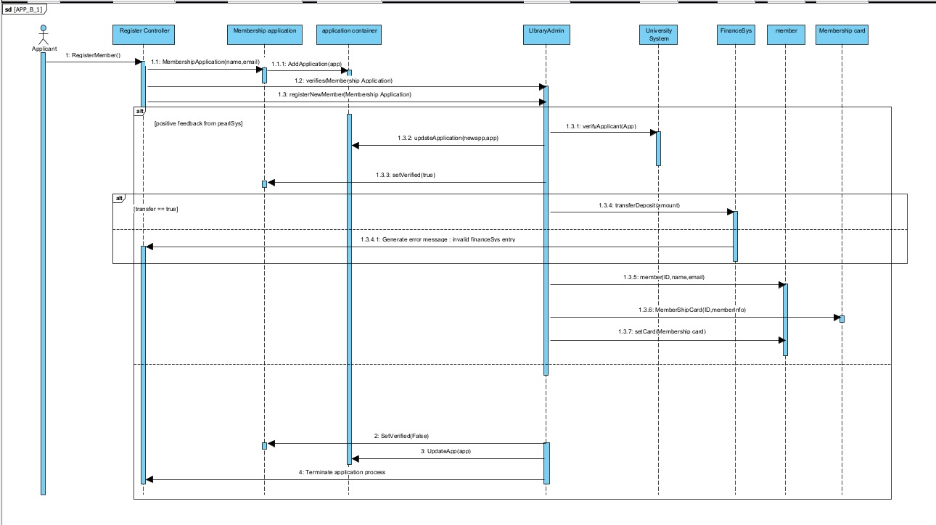

Constraints + Quality Requirements (NFRs)

2.1 Constraints

A. Technical Constraints
- The system must run as a plug-in for the Registration System, which uses Google Firebase
- The system must run on multiple OS: Linux, Windows, macOS, iOS, Unix
- FinanceSys and PearlSys already exist → the library system must integrate with both using existing interfaces .
- Components must be loosely coupled with minimal dependencies /
- Only one new server can be purchased .

B. Security Constraints
- Member payment information must be stored encrypted .
- Financial data must be kept in the backend only, isolated from the UI .
- Only authorized staff can access membership and financial records.

C. Organizational Constraints
- Only three new technical staff can be hired.
- Only staff or students with valid PearlSys accounts may apply for membership (page 3).

D. Operational Constraints
- The system must support up to 400 concurrent borrowing requests now, scaling to 1000 members in 2 years .
- Daily automated lost-item checks must occur exactly at 8 a.m. .

E. Business Constraints
- Membership deposit fixed at QR 1500 .
- Only items marked as loan-eligible can be borrowed.

2.2 Quality Requirements (Non-Functional Requirements)
A. Performance
Requirement | Specification
Scalability | The system must support more than 50,000 cumulative library operations over the next 3 years.
Response Time | Membership verification with PearlSys must complete within 3 seconds under normal load.
Batch Processing | The overdue-item batch job must complete within 5 minutes after the 8 a.m. trigger.
B. Security
Requirement | Specification
Data Encryption | All financial and membership-related data must be encrypted using AES-256 before storage or transmission.
Access Control | Only authenticated staff accounts may access sensitive operations (loan history, reservation logs, financial transfers).
C. Usability
Requirement | Specification
User Efficiency | A user should be able to complete a borrowing, returning, or reservation request in fewer than 5 clicks.
Error Feedback | Error messages for invalid input must appear within 1 second.

D. Reliability & Availability
Requirement | Specification
Uptime | System uptime must be at least 99%, excluding scheduled maintenance.
Backup & Recovery | The system must maintain three independent backup modules to ensure high availability.

E. Maintainability
Requirement | Specification
Low Coupling | Modifying a core module (Item, Loan, Member) must require changes to no more than one additional module.
Feature Integration | New features should be integratable and deployable within two weeks.

F. Portability
Requirement | Specification
Cross-Platform Support | The system must run on Windows, Linux, macOS, Unix, and iOS without requiring changes to core source code.

Task 3:

We did not fully implement the UniversitySystem (PearlSys) or FinanceSys because we do not know their real behavior or internal logic.
So for this milestone, we assumed that both systems always return true when we call them.
This allowed us to continue building and testing our Register Member use case without needing the actual external systems. We only needed them to behave in a predictable way so we can focus on our system and the Adapter Pattern.

Task 5: Testing Two Quality Requirements (NFRs)

Non-functional Requirements:

We are required to test at least 2 quality requirements identified in Task 2 so we have selected the following 3 NFRs:

Requirement | Specification
Scalability | The system must support more than 50,000 cumulative library operations over the next 3 years.
Response Time | Membership verification with PearlSys must complete within 3 seconds under normal load.
Error Feedback | Error messages for invalid input must appear within 1 second.

How we tested the requirements:

We created three Java Sampler classes:
- RegistrationLoadTest.java – test the system’s ability to handle multiple registration requests
- RegistrationResponseTimeTest.java – measure response time for membership verification with PearlSys
- BorrowErrorFeedbackTest.java – check if invalid borrow inputs generates proper error messages quickly

The Eclipse java project is exported into a jar file (Phase2NFR.jar) with the following java files included:
- Adapter package
- Model package
- Testing package - RegistrationLoadTest.java, RegistrationResponseTest.java, BorrowErrorFeedbackTest.java

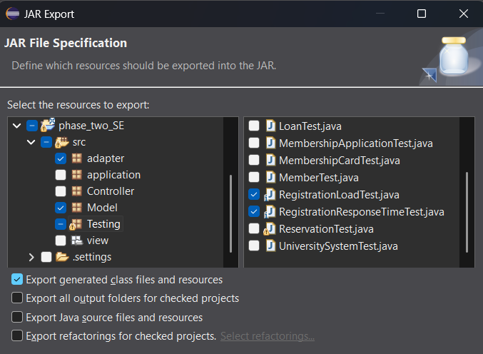

The exported jar file is added to the following folder to be properly used in JMeter:
- "C:\apache-jmeter-5.6.3\lib\ext"

JMeter Test Plan
After launching JMeter, we created a test plan for the three quality requirements:
- A separate thread group is created for each of the 3 NFRs along with the Java Request listeners

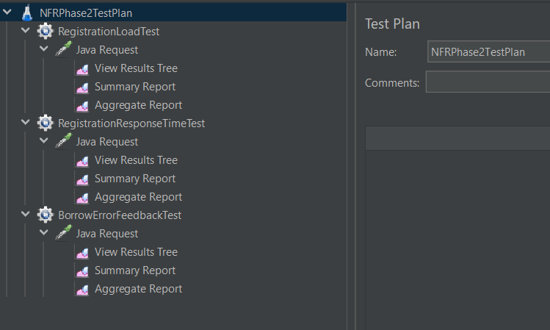

Thread Group Values:

Test | Number of Threads (users) | Ramp-up Period (seconds) | Loop Count
RegistrationLoadTest | 200 | 20 | 20
RegistrationResponseTimeTest | 30 | 15 | 3
BorrowErrorFeedbackTest | 50 | 10 | 5

Thread Group 1 – Registration Load Test

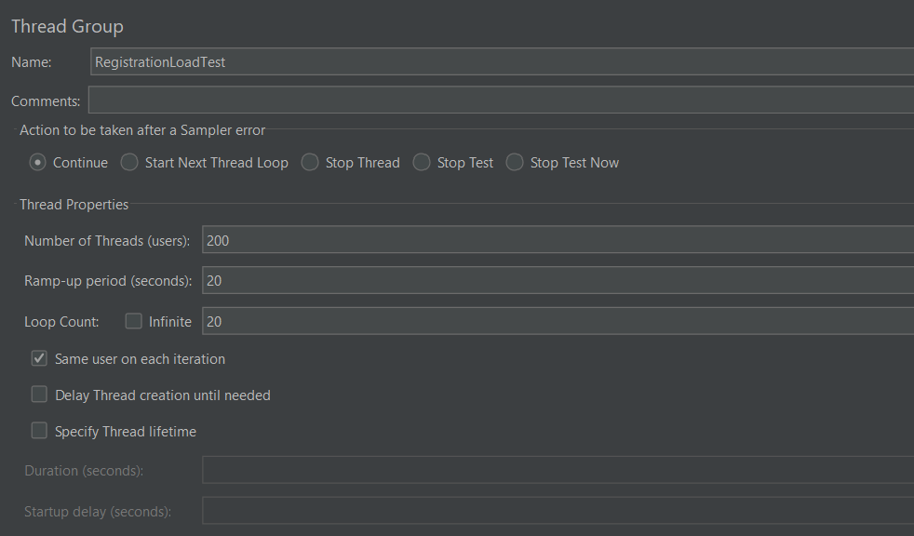

View Results Tree

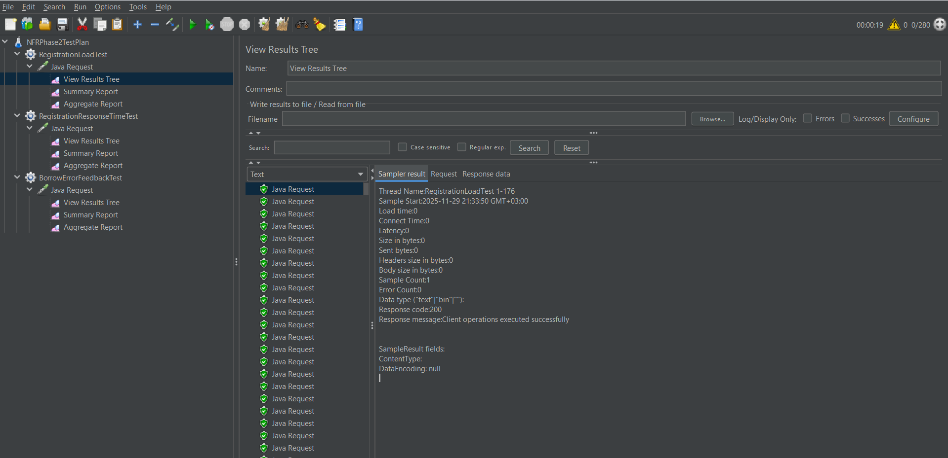

Summary Report

Aggregate Report

Thread Group 2 – Registration Response Time Test

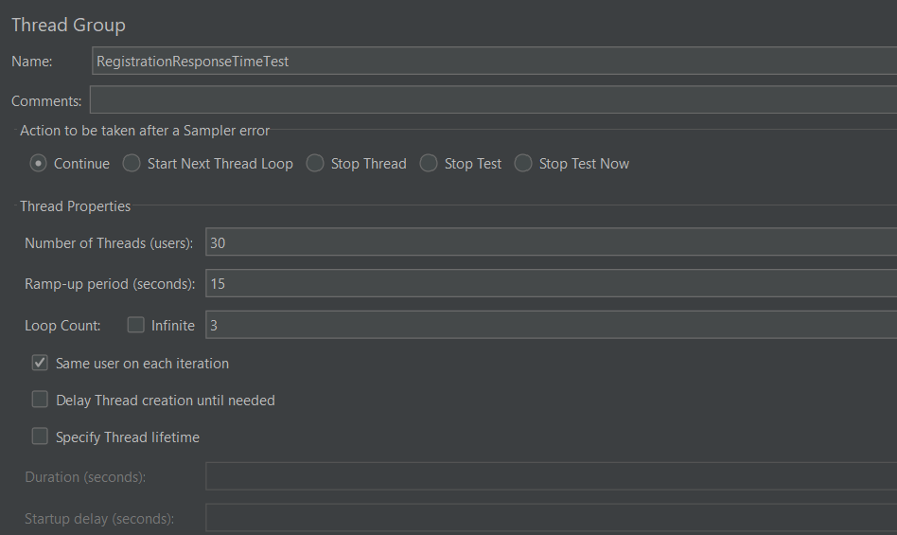

View Results Tree

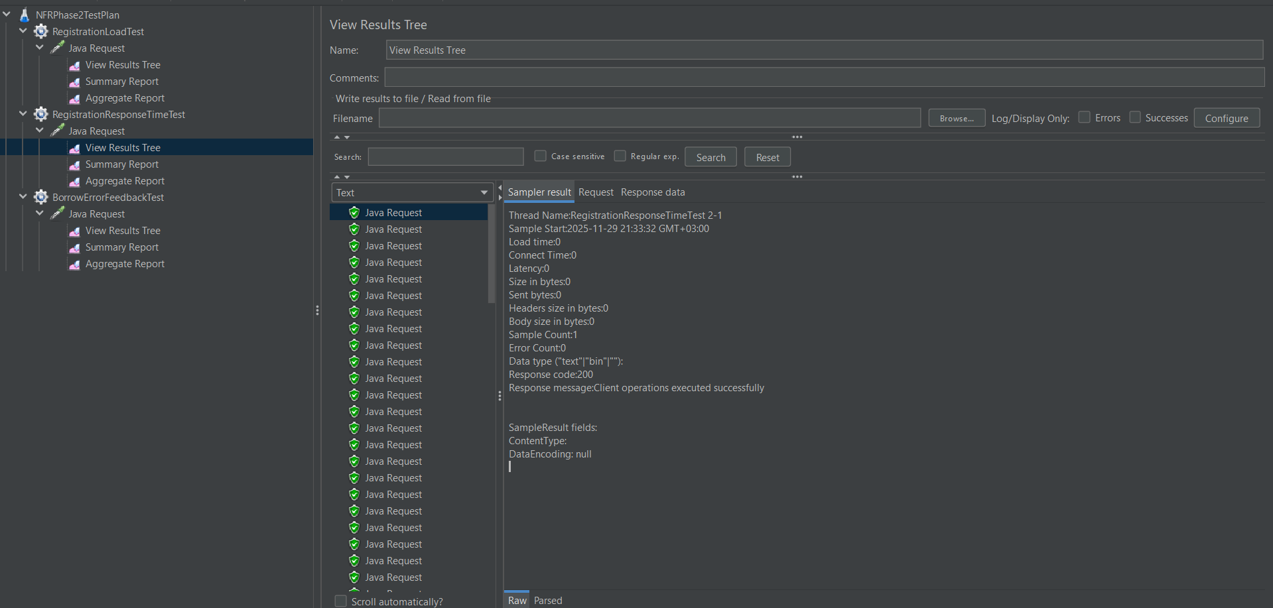

Summary Report

Aggregate Report

Thread Group 3 – Borrow Error Feedback Test

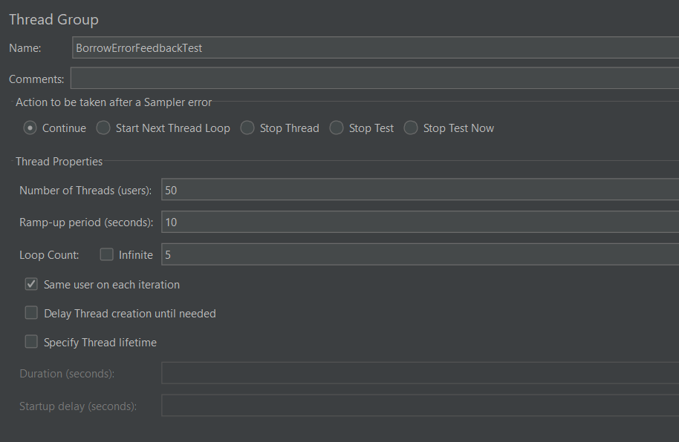

View Results Tree

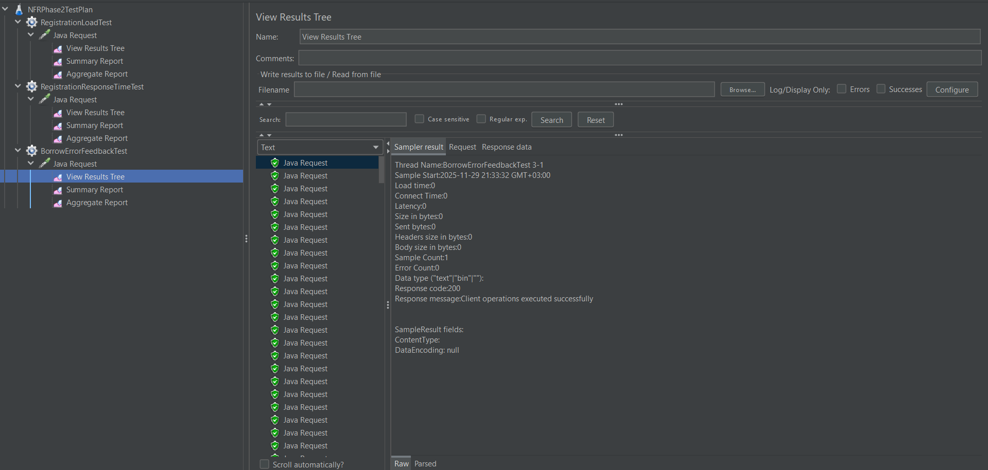

Summary Report

Aggregate Report

Results

Registration Load Test – Summary Report
Label | #Samples | Average | Min | Max | Std. Dev. | Error % | Throughput | Received KB/sec | Sent KB/sec | Avg. Bytes
Java Request | 4000 | 0 | 0 | 1 | 0.04 | 0.00% | 201.0454 | 0 | 0 | 0
TOTAL | 4000 | 0 | 0 | 1 | 0.04 | 0.00% | 201.0454 | 0 | 0 | 0

Registration Load Test – Aggregate Report
Label | #Samples | Average | Median | 90% Line | 95% Line | 99% Line | Min | Max | Error % | Throughput | Received KB/sec | Sent KB/sec
Java Request | 4000 | 0 | 0 | 0 | 0 | 0 | 0 | 1 | 0.00% | 201.0454 | 0 | 0
TOTAL | 4000 | 0 | 0 | 0 | 0 | 0 | 0 | 1 | 0.00% | 201.0454 | 0 | 0

- 200 users, 20s ramp-up, 20 loops → 4000 requests
- Error % = 0% → all registration requests succeeded
- Average response time = 0 ms → requests processed quickly
- Throughput = 201 → system can handle 201 requests/sec

The system successfully handled 4,000 registration requests with 0% errors and a throughput of 201 requests/sec, demonstrating it can scale efficiently. This indicates the system can support the required 50,000 cumulative library operations over the next 3 years.

Registration Response Time Test – Summary Report
Label | #Samples | Average | Min | Max | Std. Dev. | Error % | Throughput | Received KB/sec | Sent KB/sec | Avg. Bytes
Java Request | 90 | 0 | 0 | 0 | 0 | 0.00% | 6.20561 | 0 | 0 | 0
TOTAL | 90 | 0 | 0 | 0 | 0 | 0.00% | 6.20561 | 0 | 0 | 0

Registration Response Time Test – Aggregate Report
Label | #Samples | Average | Median | 90% Line | 95% Line | 99% Line | Min | Max | Error % | Throughput | Received KB/sec | Sent KB/sec
Java Request | 90 | 0 | 0 | 0 | 0 | 0 | 0 | 0 | 0.00% | 6.20561 | 0 | 0
TOTAL | 90 | 0 | 0 | 0 | 0 | 0 | 0 | 0 | 0.00% | 6.20561 | 0 | 0

- 30 users, 15s ramp-up, 3 loops → 90 requests
- Error % = 0% → all verification requests succeeded
- Average response time = 0 ms → requests processed quickly
- Throughput = 6.2 → system can handle 6 requests/sec

All 90 membership verification requests were processed rapidly with 0 errors, confirming that the system meets the requirement of completing verification within 3 seconds under normal load.

Borrow Error Feedback Test - Summary Report
Label | #Samples | Average | Min | Max | Std. Dev. | Error % | Throughput | Received KB/sec | Sent KB/sec | Avg. Bytes
Java Request | 250 | 0 | 0 | 0 | 0 | 0.00% | 25.47641 | 0 | 0 | 0
TOTAL | 250 | 0 | 0 | 0 | 0 | 0.00% | 25.47641 | 0 | 0 | 0

Borrow Error Feedback Test - Aggregate Report
Label | #Samples | Average | Median | 90% Line | 95% Line | 99% Line | Min | Max | Error % | Throughput | Received KB/sec | Sent KB/sec
Java Request | 250 | 0 | 0 | 0 | 0 | 0 | 0 | 0 | 0.00% | 25.47641 | 0 | 0
TOTAL | 250 | 0 | 0 | 0 | 0 | 0 | 0 | 0 | 0.00% | 25.47641 | 0 | 0

- 50 users, 10s ramp-up, 5 loops → 250 requests
- Error % = 0% → all requests succeeded
- Average response time = 0 ms → fast execution
- Throughput = 25.47 → system can handle 25 requests/sec

Invalid borrow inputs were immediately rejected with fast execution and 0 errors, ensuring that error messages are displayed within the required 1-second timeframe, meeting the system’s usability requirement.

Conclusion
All the three NFRs were tested: Scalability, Response Time, and Error Feedback and were satisfied according to the JMeter test results. The system demonstrates good performance, fast response, and effective error handling under the simulated load conditions.

Applying Two Design Patterns
In this milestone, we were required to apply two different design patterns—each from a different category—in our library management system. We selected:
- Factory Pattern (Creational Pattern)
- Adapter Pattern (Structural Pattern)
These patterns were chosen because they directly solve architectural problems present in the system and align with the requirements in the project specification. Both patterns are fully implemented and applied within real use-case logic (“Reserve Item” and “Register New Member”).

Factory Pattern (Creational Pattern)

Reason for Selection
The system manages several types of library items. For Milestone-2, we introduced three item categories consistent with actual library systems:
- Book
- DigitalMedia
- Magazine
Before applying the pattern, all items were manually created using:
new Item(callNumber, title);
This approach causes:
- Duplication of creation logic
- Difficulty adding new item types in the future
- Tight coupling between controllers and item construction
To solve this, the Factory Pattern centralizes object creation and ensures flexibility, extensibility, and clean separation between the controller and object initialization.

Implementation

Class Hierarchy
+------------------+
| Item |
+------------------+
| callNumber |
| title |
| year |
| isAvailable |
+------------------+
/ | \
/ | \
/ | \
+--------+ +-------------+ +-----------+
| Book | | DigitalMedia| | Magazine |
+--------+ +-------------+ +-----------+
^
|
+----------------+
| ItemFactory |
+----------------+
| +createItem() |
+----------------+

Use of Factory Pattern in the Actual System
The Factory is integrated directly into the Reserve Item use case (ReservationController):
Item item1 = ItemFactory.createItem("book", 101, "Java Programming", 2021);
Item item2 = ItemFactory.createItem("book", 102, "Data Structures", 2020);
Item item3 = ItemFactory.createItem("digital", 103, "Algorithms (Digital Media)", 2023);
Item item4 = ItemFactory.createItem("magazine", 104, "Database Monthly Magazine", 2024);
Item item5 = ItemFactory.createItem("book", 105, "Software Engineering", 2022);
This replaces manual construction and demonstrates the Factory pattern in a real workflow.

Adapter Pattern (Structural Pattern)

Reason for Selection
The library system interacts with two external university systems:
- UniversitySystem (PearlSys) → verifies membership eligibility
- FinanceSys → processes deposits for new members
Before applying the pattern, LibraryAdmin directly called:
uni.verifyApplicant(app);
finance.transferDeposit(1000f);
This created:
- Tight coupling between the library subsystem and university subsystems
- No flexibility to replace or modify the external systems
- Violation of the requirement for loose coupling and interoperability (Appendix A, page 5)
Using the Adapter Pattern decouples the library logic from these external APIs and allows both systems to be used through stable abstraction layers.

Implementation

UML Diagram for Adapter Pattern
+----------------------------------+
| UniversitySystemAdapter |
+----------------------------------+
| +verifyApplicant(app): boolean |
+------------------^---------------+
|
+---------------------+
| PearlSysAdapter |
+---------------------+
| -uniSystem |
+---------------------+

+----------------------------------+
| FinanceSystemAdapter |
+----------------------------------+
| +transferDeposit(amount):boolean |
+------------------^---------------+
|
+---------------------+
| FinanceSysAdapter |
+---------------------+
| -finance |
+---------------------+

Use of Adapter Pattern in the Actual Register Use Case
Inside LibraryAdmin.registerNewMember():
// ADAPTER for University verification
UniversitySystemAdapter uniAdapter = new PearlSysAdapter();
boolean verified = uniAdapter.verifyApplicant(app);

if (!verified) {
System.out.println("University verification failed");
return null;
}

// ADAPTER for FinanceSys transfer
FinanceSystemAdapter financeAdapter = new FinanceSysAdapter();
boolean transfer = financeAdapter.transferDeposit(1000f);

if (!transfer) {
System.out.println("Financial transfer failed");
return null;
}

