OPEN-ENDED LAB

Multi-Threaded Online Order Processing System

Objective: To design and implement a Java-based application that demonstrates core SCD concepts by effectively using inheritance, multithreading, synchronization and exception handling to build a reliable and concurrent system.

Task Description: This system utilizes inheritance, multithreading, and synchronization to concurrently process customer orders while managing user roles. It incorporates custom exception handling to gracefully manage invalid inputs and ensure thread-safe execution during order processing.
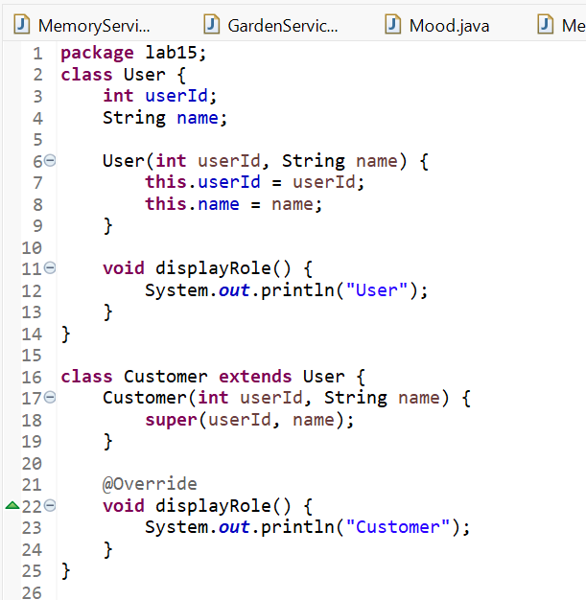

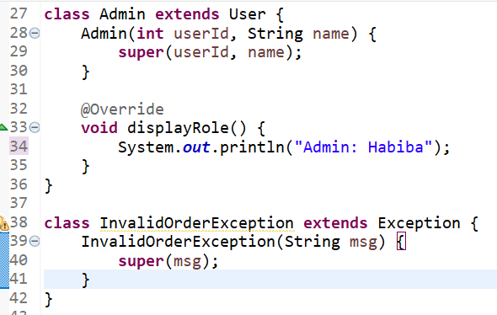

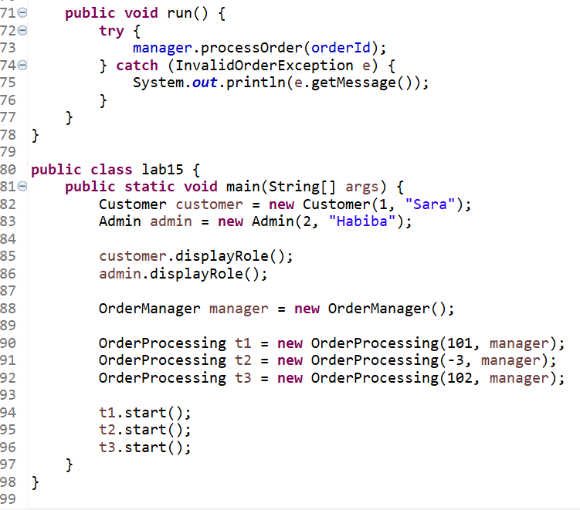
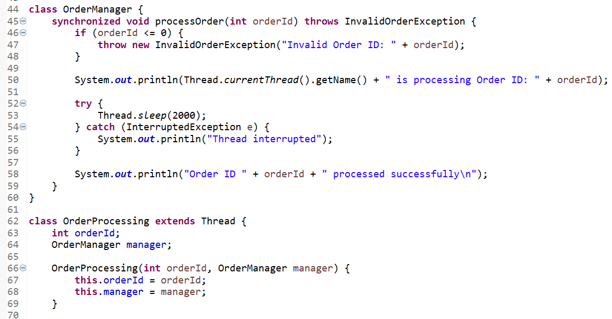

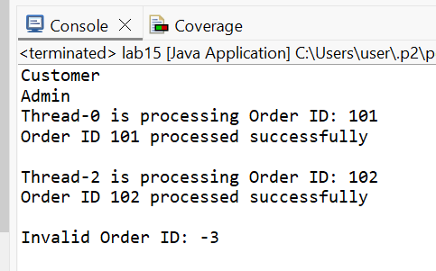

OUTPUT:

