**LAB # 1**

**Introduction to Eclipse IDE**

**OBJECTIVE**

Introduction to Eclipse IDE, creating projects, its classes and mapping UML class diagram in to java code.

**Lab Task:**

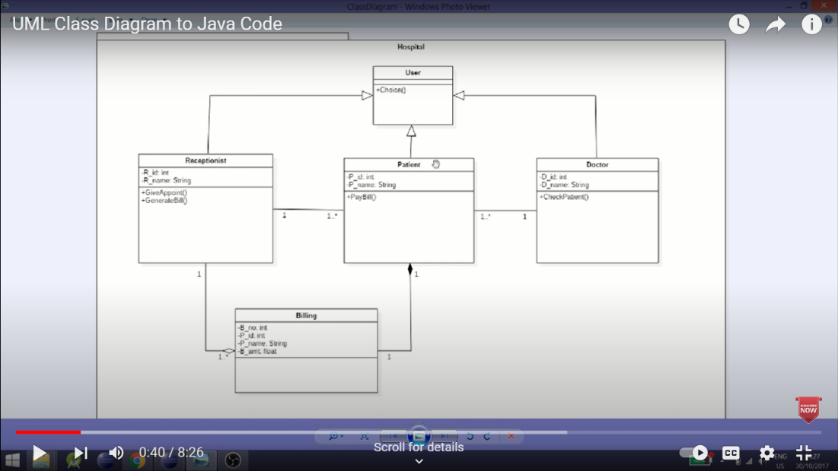Write the java code with the help of the given class diagram of Hospital Management System.

**CODE:**

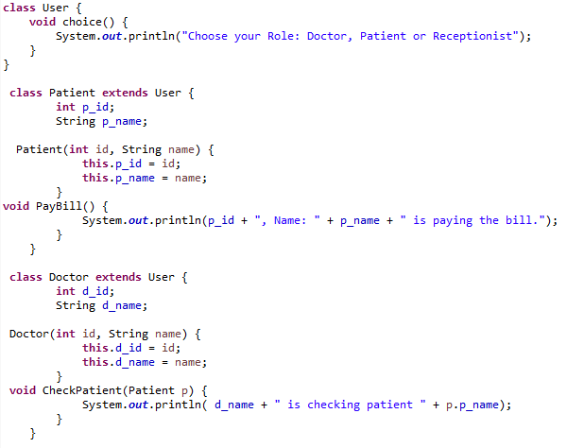

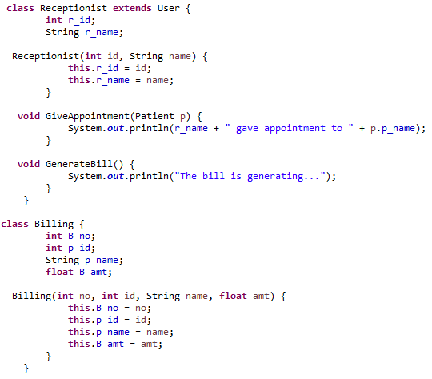

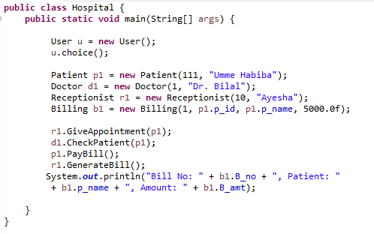

**OUTPUT:**

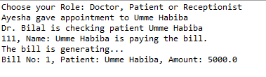

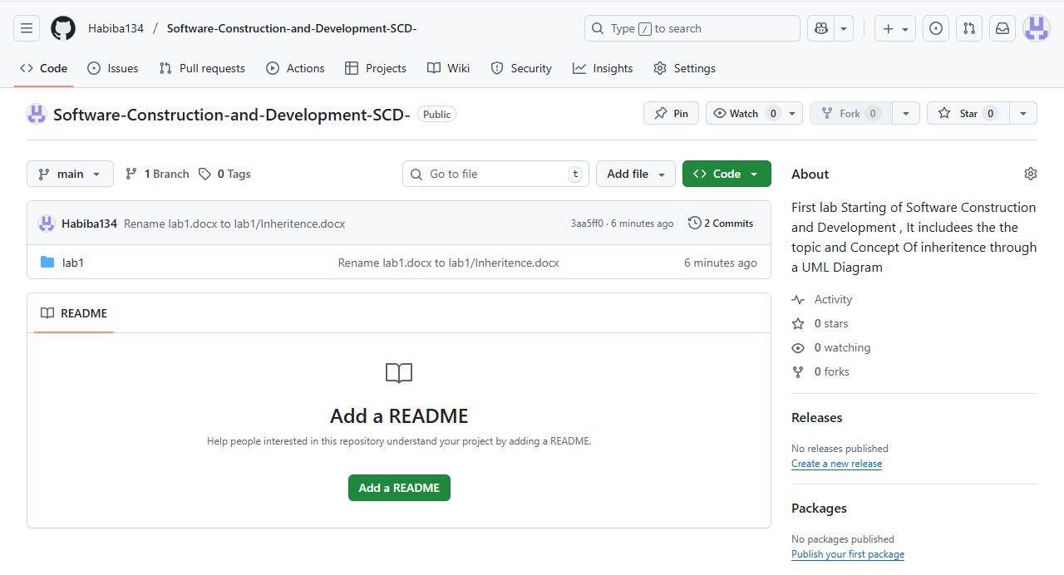**Git Hub ScreenShot:**