**MySQL Labs**

**MySQL (Day1):**

|  |  |
| --- | --- |
| **1** | **Create a database called grades** |
|  | create database grades.;  use grades. |
| **2** | **Create the following tables in the grades database:**  ***courses***  ***course_id*** *int pk*  *course_name varchar(100) not null*  *credit_hour int*  ***students_courses***  ***course_id*** *int*  ***student_id*** *int*  *grade int*  *reg_date date*  ***students***  ***student_id*** *int pk*  *student_name varchar (100) not null*  *email varchar (50)*  *tel varchar (20)* |
|  | create table students  -> (students_id int primary key,  -> student_name varchar(100) Not null,  -> email varchar(50),  -> tel varchar(20))  -> ;  create table courses  -> (course_id int primary key,  -> course_name varchar(100) Not null,  -> credit_hour int)  -> ;  create table students_courses  -> (course_id int,  -> students_id int,  -> grade int,  -> reg_date date,  -> primary key (course_id, students_id),  -> foreign key (course_id) references courses(course_id),  -> foreign key (students_id) references students(students_id))  -> ; |
| **3** | **Modify the students table to allow for longer Student names (150 char)**  **Confirm your modification.** |
|  | alter table students modify column student_name varchar(150) Not null;  describe students; |
| **4** | **Add constraint to force unique email for each student** |
|  | alter table students ADD constraint unique_email unique(email); |
| **5** | **Get Time, Date, Current user, MySQL Version using prompt?** |
|  | select current_time();  select current_date();  select current_user();  select version(); |
| **6** | **Add gender column for the students table. It holds two value (male or female)** |
|  | alter table students ADD column gender ENUM('male','female'); |
| **7** | **Add birth_date column for the students table.** |
|  | alter table students ADD column birth_datee Date; |
| **8** | **Drop the student_name column and replace it with first name and last name.** |
|  | alter table students drop column student_name,  -> add column first_name varchar(50),  -> add column last_name varchar(50); |

**Part II**

**Populate your tables with the following records:**

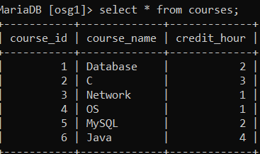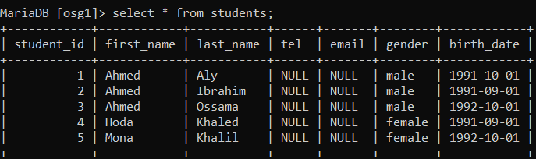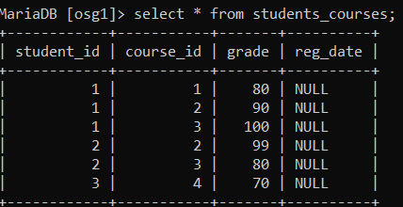

|  |  |
| --- | --- |
| **1** | **Display all students’ information.** |
|  | SELECT * FROM students; |
| **2** | **Display male students only.** |
|  | SELECT * FROM students WHERE gender='male'; |
| **3** | **Display the number of female students.** |
|  | SELECT COUNT(*) FROM students WHERE gender='female'; |
| **4** | **Display the students’ data for the students who are born before 1992-10-01.** |
|  | SELECT * FROM students WHERE birth_datee >'1991-10-01'; |
| **5** | **Display the students’ data for the students who are born after 1991-10-01.** |
|  | SELECT * FROM students WHERE birth_datee >'1991-10-01'; |