<https://www.carbonindependent.org/index.html>

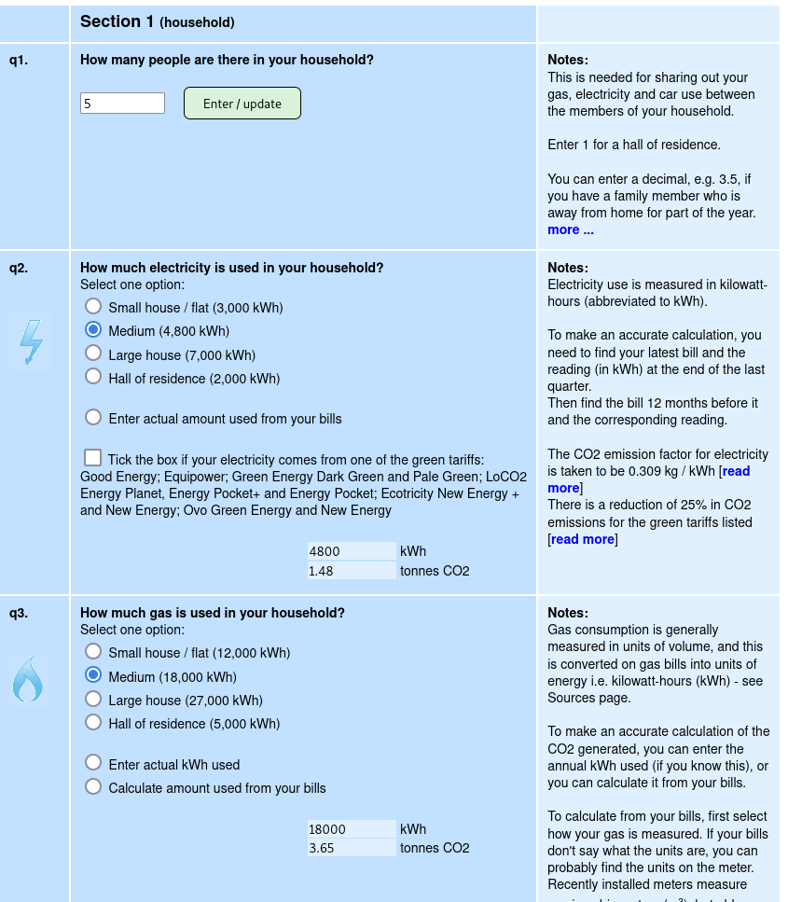

Figure The input to <https://www.carbonindependent.org/index.html> current system.

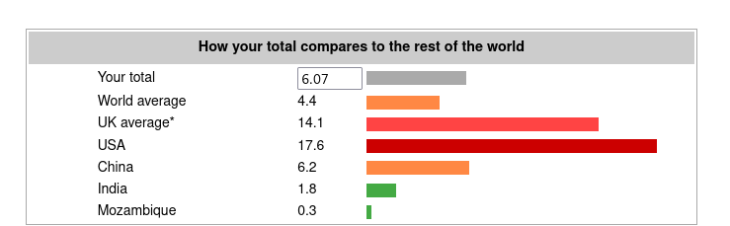Figure The results from the <https://www.carbonindependent.org/index.html>

The carbon calculator includes information for each section of the calculation and specifies how much co2 emission is produced from it.

The benefit of the calculator is that the questions are simple and understandable and there are helpful notes alongside the questions to help guide users to the appropriate choice. Even though the questions are simple to understand, the answer choices are not specific, for example one of the choices were “small house/ flat (12,000 kWh)”, this information is a bit confusing as some people will not know how much kWh their house produces to know if it is considered a small house. The results show a graph of the user's carbon footprint compared to other countries, however, not all countries are included so the user's country may not be included. The layout of the carbon calculator looks overcrowded with the helpful text on the side, which might overwhelm users and result in user disengagement.

The best parts of this calculator are that the questions are split into 2 sections of house and personal so the user knows what type of questions may be asked. There is basic multiple-choice questions so the use won’t feel overwhelmed with having to know information, but it also allows users to input figures to have a more tailored result rather than an estimate.

[CoolClimate Calculator (berkeley.edu)](https://coolclimate.berkeley.edu/calculator)

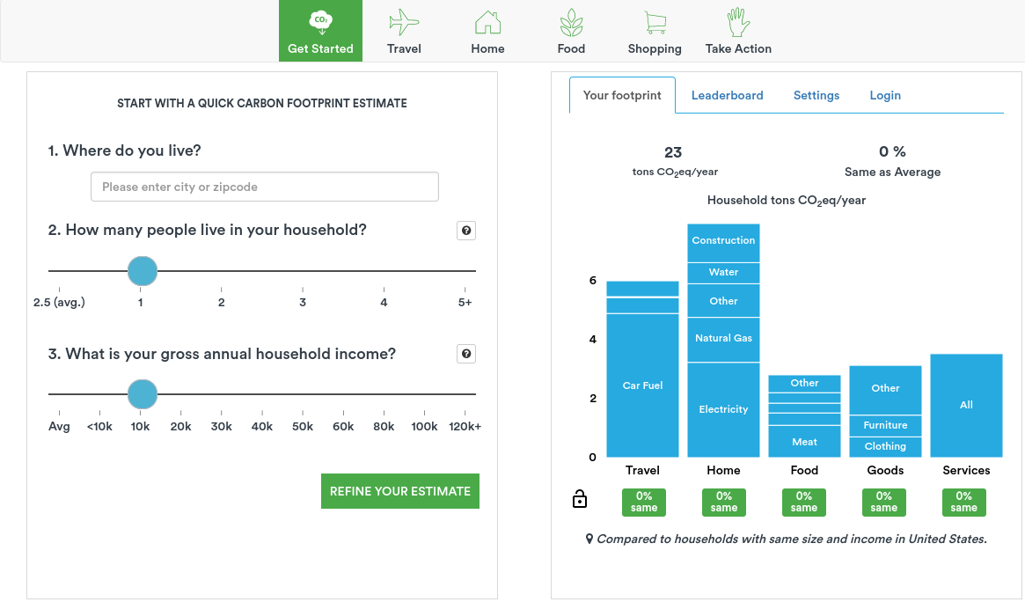

The questions are simple to understand but some questions like the gross anual income of the household, not everyone will know. The graph on the side has lots of useful information to help users to better understand their carbon footprints. The block underneath the graph shows the % better or worse the user is against the average footprint in the US and changes colour from red and green to help the user understand. The graph bars are split into the sections they represent and further split into the subsections they represent and the length of them show how much they produce. If the user hovers over the graph, the exact co2 emission produced of each section is also displayed.

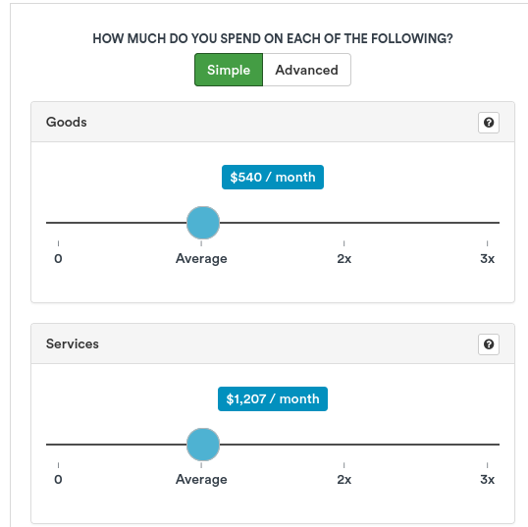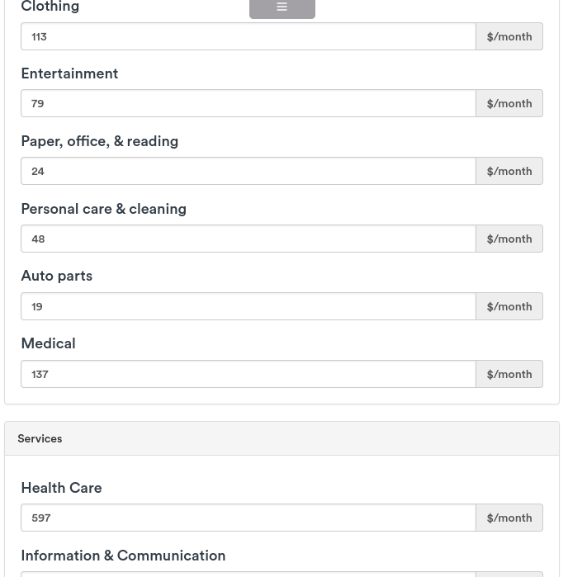

The calculator allows for the user to choose if they would like to have the simple inputs which are vague and are just input slides. The advanced features require inputs for each section which would then lead to a more tailored result.

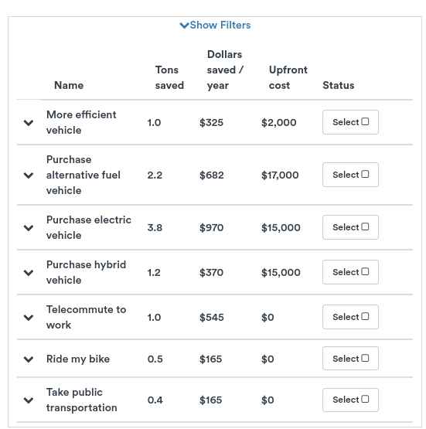

The final page of the calculator, guides users to helpful information to help them to fix their co2 emissions and displays the cost, money saved and co2 reduced by completing.

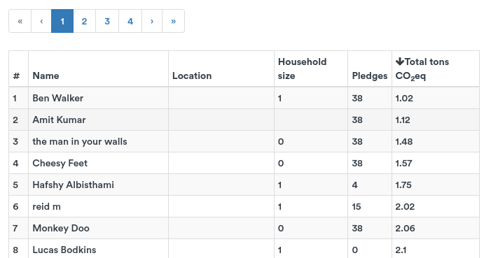The carbon calculator engages users by having a leaderboard to have the users compete with improving their carbon footprint.

The best parts of the carbon calculator are that it has a simple layout, the questions are split into sections about travel, food, etc. It shows the user a reactive graph that changes based on their inputs. Some disadvantages are that it doesn’t show a comparison against the average so the user can’t visually see the difference.

[carbonfootprint.com - Carbon Footprint Calculator](https://www.carbonfootprint.com/calculator.aspx)

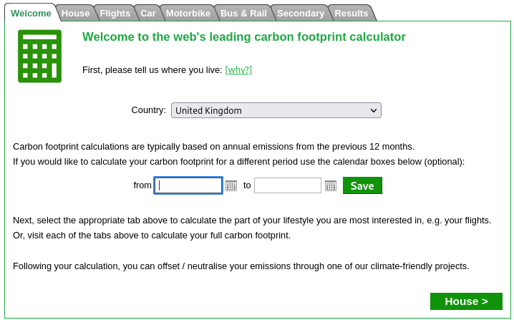

The carbon calculator allows for the users to be more specific the time period they are answering questions for, which is good as some users can’t recall information for the year or the month. It is alos specific to the users countries by allowing the user to select thir country.

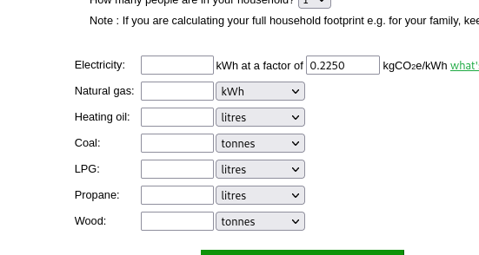

The questions asked, require specific answers and do not have estimate answers for users who do not know the information.

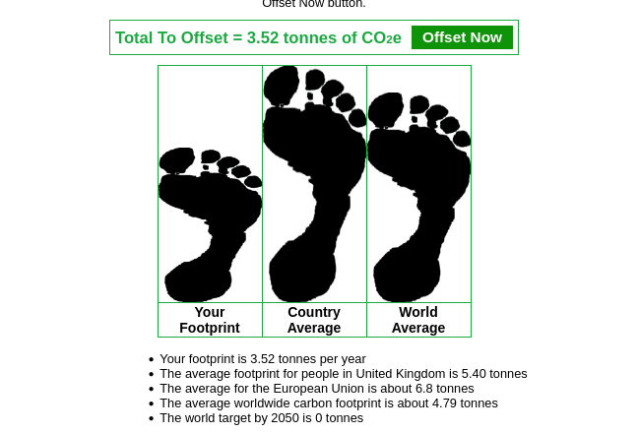

The result compares the user's footprint to the country average and the world average and show the exact values at the bottom. The result doesn’t have a colour scheme so it might be difficult for users to understand as the footprint size may not be enough for them to understand their footprint is low/high.

<https://www.nature.org/en-us/get-involved/how-to-help/carbon-footprint-calculator/>

* Simple layout
* Shows a graph for each section of the calculator

Shows the results in multiple different graphs at the end to show you compared to the average.