MediAssist: A medical RAG system

1. Requirements and Knowledge Base Curation
After deciding on the topic child obesity, 13 papers were collected from PubMed Open Access and WHO. I made sure that they were in pdf format according.
Papers are found in the files folder in the drive. They are of medium length and include topics such as
- Etiology and risk factors
- Diagnosis and differential diagnosis
- Treatment and management strategies
- Long-term complications and comorbidities
- Policy, screening, and prevention
The paper’s sources include:
- Academic journals
- Systematic reviews and meta-analyses
- Position papers from medical organizations

2. Ingestion pipeline and Embedding Module
I then created an ingest.py file which loads the files and then uses RecursiveCharacterTextSplitter in order to create chunks of the documents.
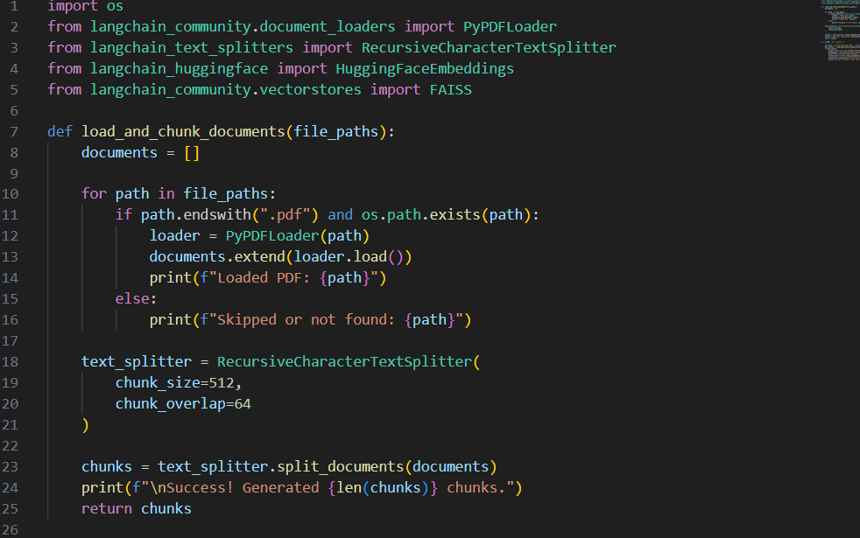
(Note that langchain library was used heavily in this assignment)
After that embeddings were created using Bio_ClinicalBERT model (embeddings were also normalized to ensure semantic similarity) and the FAISS database (which is an open-source library from META which is used for similarity search).
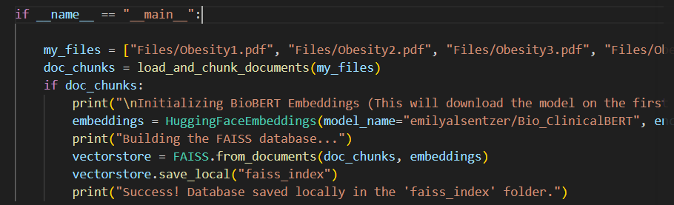

3. Retrieval Engine and Vector Store
Here the embedding model and FAISS database are loaded. THE FAISS is put into a vector store which is then used for the retriever. Here it selects the top 5 chunks per query with a minimum similarity of 0.65
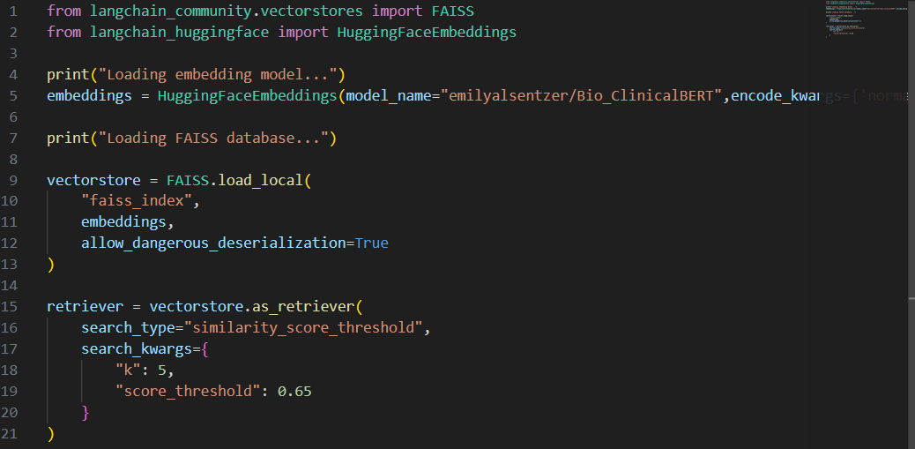

4.LLM integration and prompt engineering
For this assignment I decided to go with groq LLM as it is fast and open source. After going into the website to generate an API key and putting it in a separate file (.env file) for privacy concerns, I loaded the llama-3.3-70b-versatile model and then added the prompt which followed the assignment’s requirements.

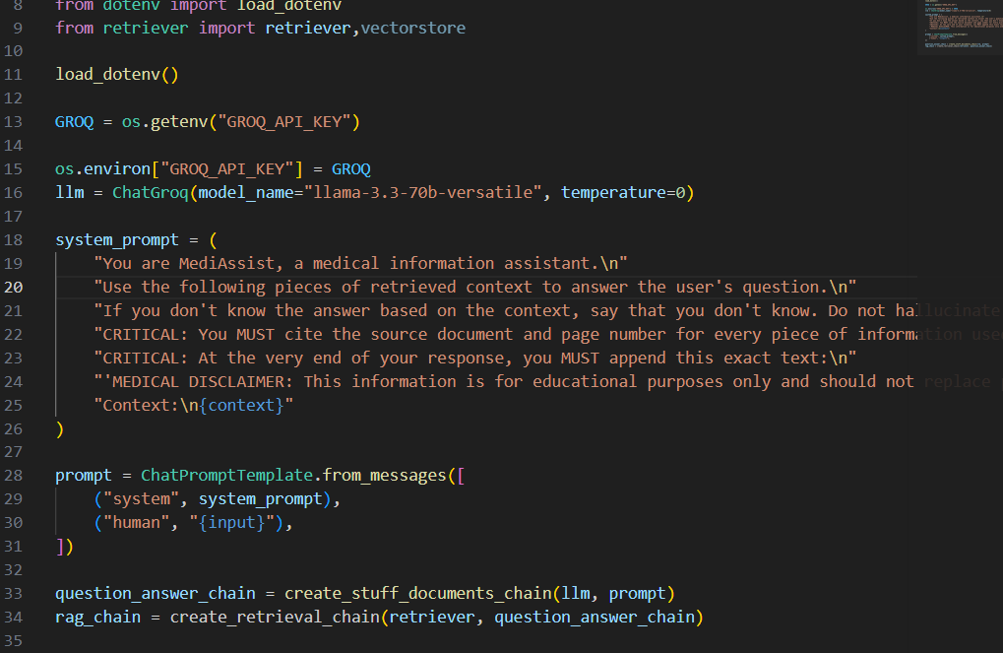Below is the full prompt:
"You are MediAssist, a medical information assistant.\n"
"Use the following pieces of retrieved context to answer the user's question.\n"
"If you don't know the answer based on the context, say that you don't know. Do not hallucinate.\n"
"CRITICAL: You MUST cite the source document and page number for every piece of information used (e.g., [Files/Obesity1.pdf, Page 3]).\n"
"CRITICAL: At the very end of your response, you MUST append this exact text:\n"
"'MEDICAL DISCLAIMER: This information is for educational purposes only and should not replace professional medical advice.'\n\n"
"Context:\n{context}"

It is also worth mentioning that the KB update feature was made by creating a file called kb_admin which contained 3 functions:get_database, add_documents _to_kb and remove_documents_from_kb
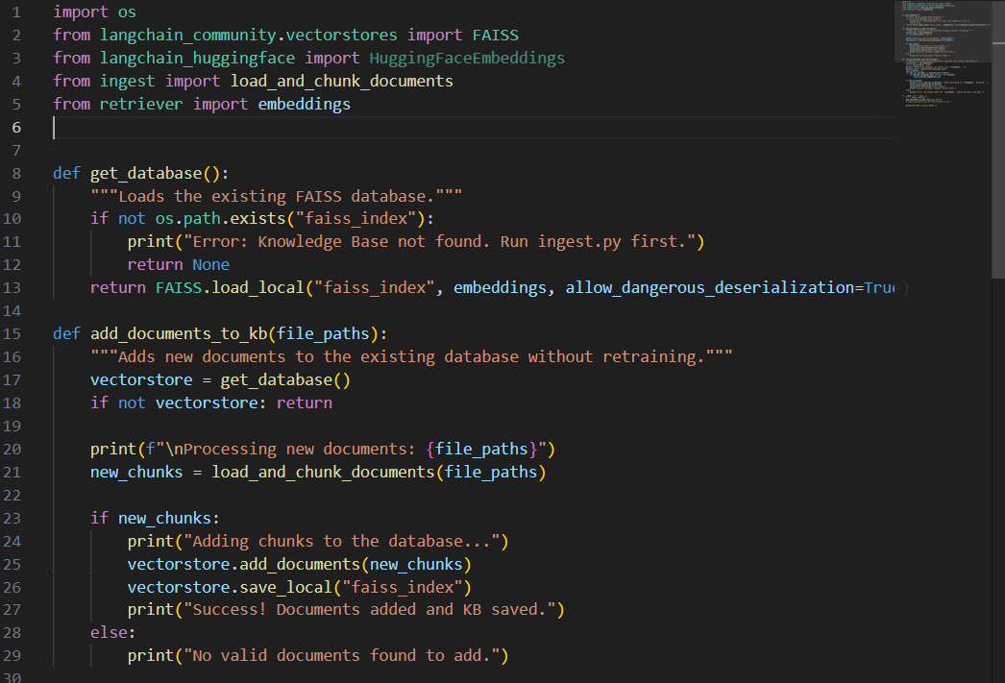
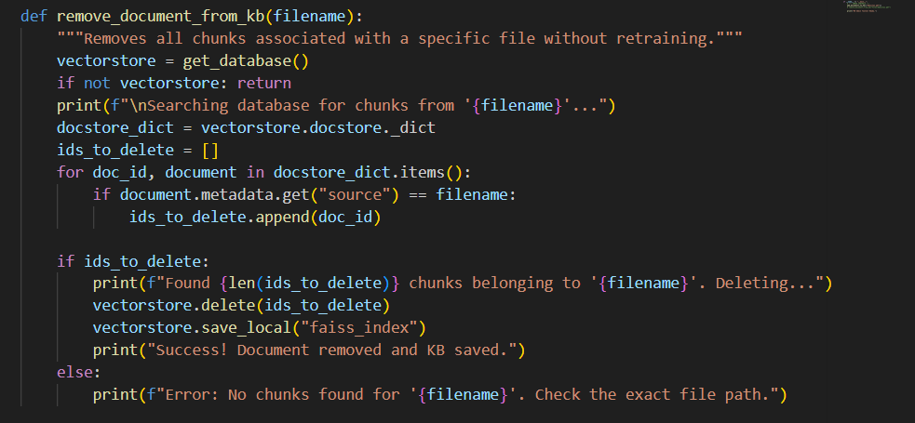

5. Front end and API
To finalize the assignment and make the model usable , FastAPI was used to turn the server on to host the web application which was made by streamlit.
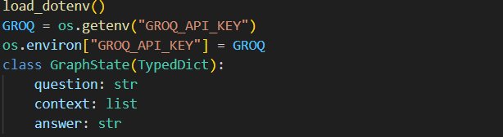

The graph of the RAG system has 2 nodes: retrieve node and generate node
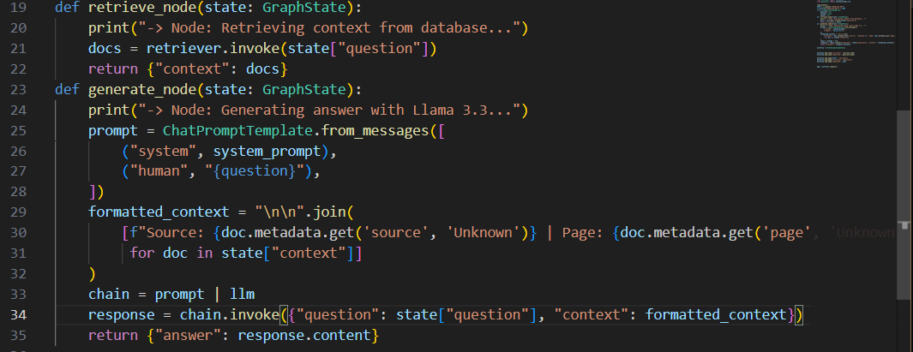

The final graph structure is shown below
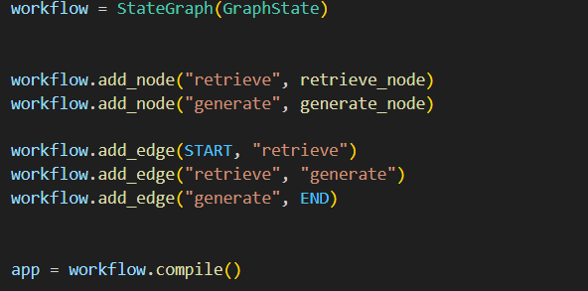
[START]
│
▼
(retrieve) <-- Runs the `retrieve_node` function
│
▼
(generate) <-- Runs the `generate_node` function
│
▼
[END]

Finally the app.py file is used to create the front end of the RAG system

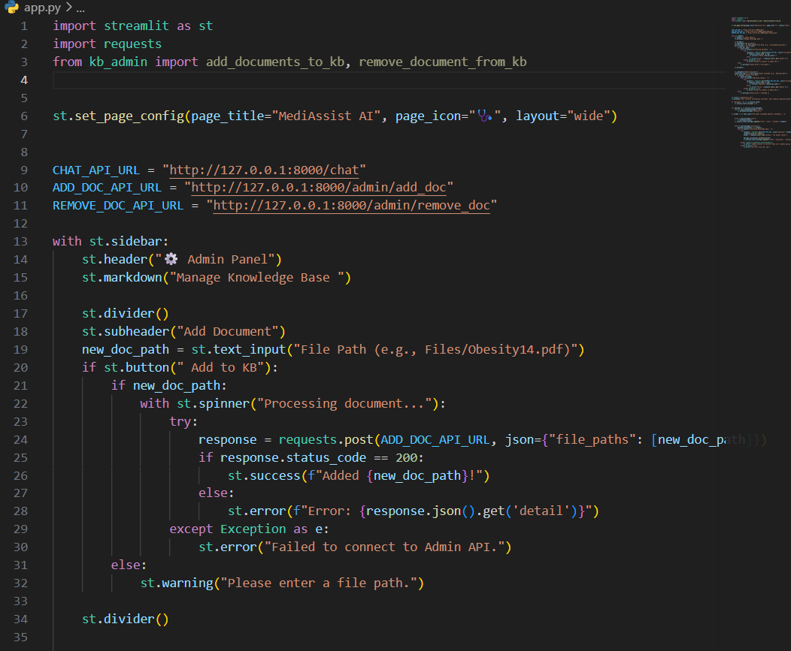
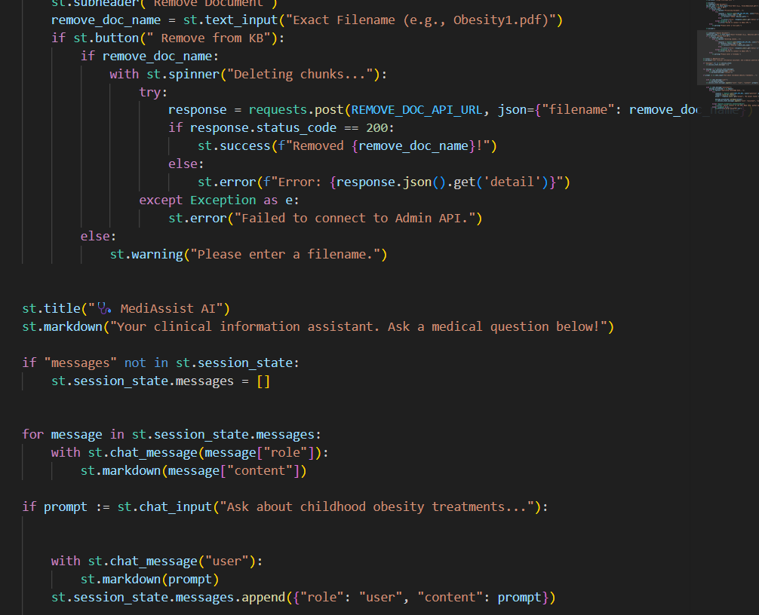
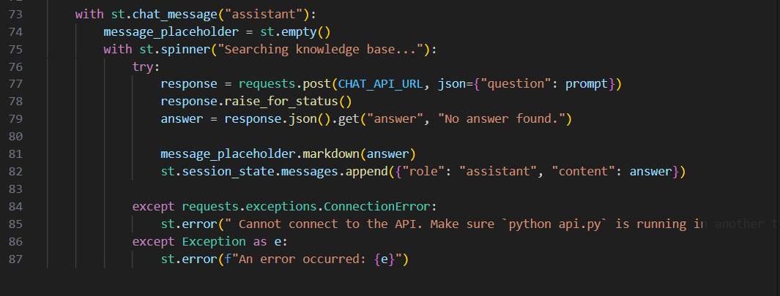

And below is the api,py which includes the api data models and end poitns
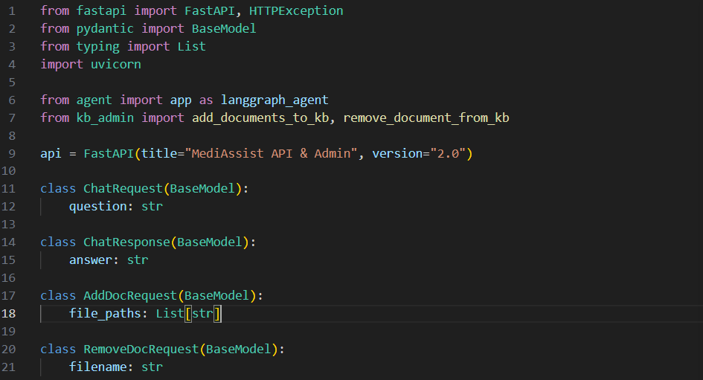
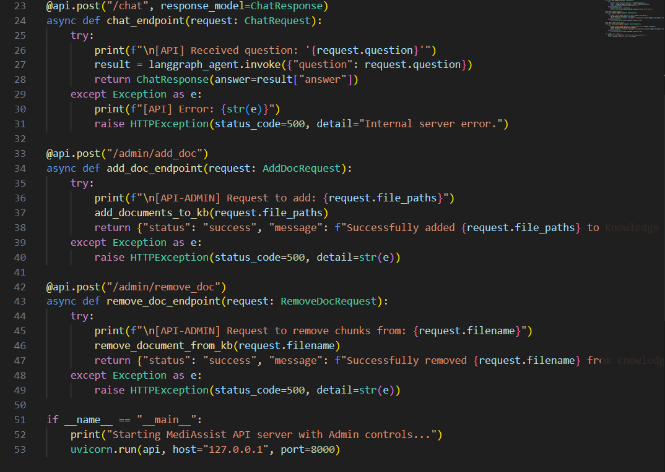
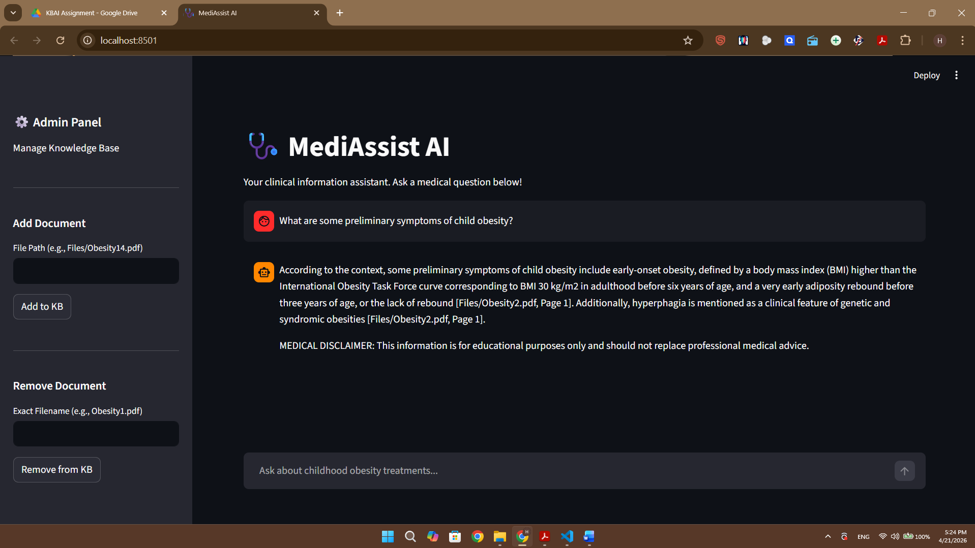

You can also find a video attached in the drive link for the whole demo.

