   

**Agricultural Raw Material Analysis**

A Project Report

submitted in partial fulfillment of the requirements of

Agricultural Raw Material Analysis of price change over a year

by

**HABIBULLAH H,**

[**habibullah8782238@gmail.com,**](mailto:habibullah8782238@gmail.com,) **7FB51D3DADF13549EDB40FF0759BBA72**

Under the Guidance of

**(P. Raja, Master Trainer, Edunet Foundation)**

   

**ACKNOWLEDGEMENT**

I am profoundly grateful to all those who have offered their guidance, support, and encouragement throughout the journey of completing this work. First and foremost, I like to thank **Mr. P. Raja Master Trainer, Edunet Foundation** and their expertise team, for guiding me to complete this project. Their insights and thoughtful guidance consistently inspired me to refine and elevate this project. I am immensely appreciative of the time and effort they devoted to ensuring this work met the highest standards. I am also profoundly thankful for the resources and support extended by my college **MOHAMED SATHAK ENGINEERRING COLLEGE**. Because of their support and providing necessary equipment also providing take **NAAN MUDALVAN** course. I would also like to acknowledge the encouragement and counsel provided by **Mr. S.H. Vishnu Class-in- charge, MSEC**. Due to their feedback and perspectives make me to think more critically and creatively to enhance this project to further extent.

In addition, I owe a debt of gratitude to my friends and family. Their steadfast support, understanding, and patience were a source of strength, particularly during moments of challenge. Their belief in me fueled my perseverance and dedication to this project.

To all those who have played a role, both large and small, in the completion of this work: I offer my sincere and heartfelt thanks. This project would not have been possible without your collective contributions, and I am deeply appreciative of each of you. **THANK YOU ALL**

   

# ABSTRACT

This study conducts a comprehensive analysis of agricultural raw material prices over the years, utilizing exploratory data analysis (EDA) techniques to uncover key insights. The analysis aims to identify both high-range and low-range raw materials based on their pricing trends, providing a clearer picture of market dynamics. By examining percentage changes, we pinpoint materials that have experienced significant price fluctuations, both positively and negatively. Additionally, we explore the overall range of price changes over time, highlighting volatility and stability within the sector. To visualize relationships among various raw materials, a graph is generated to illustrate correlations between price changes, enabling stakeholders to make informed decisions based on data-driven insights. This research serves as a valuable resource for farmers, traders, and policymakers in understanding the agricultural market landscape.

   

**TABLE OF CONTENTS**

Abstract 3

List of Figures 6

List of Tables 7

|  |  |  |  |
| --- | --- | --- | --- |
| **INDEX** | | | |
| **CHAPTER** | **TOPIC** | | **PG.NO** |
| **Introduction** | | | |
| 1.1 | Importance of Agricultural raw material analysis | | **8** |
| 1.2 | Problem Statement | | **10** |
| 1.3 | Motivation | | **10** |
| 1.4 | Objectives | | **11** |
| 1.5 | Scope of the Project | | **14** |
| **Literature Survey** | | | |
| 2.1 | Review of Article | | **13** |
| 2.2 | Methods used | | **14** |
| 2.3 | Limitations of Method used | | **16** |
| **Proposed Methodology** | | | |
| 3.1 | | Data Collection and Preparation | **20** |
| 3.2 | | Univariate Analysis | 21 |
| 3.3 | | Univariate Analysis | 22 |
| 3.4 | | Time Series Analysis | 22 |

   

|  |  |  |
| --- | --- | --- |
| 3.5 | Clustering and Segmentation | 22 |
| 3.6 | Geospatial Analysis | 23 |
| 3.7 | Advantages | 24 |
| **Implementation and Result** | | |
| 4.1 | Results of Agricultural raw material analysis | 25 |
| 4.2 | Results of Agricultural raw material | 25 |
| **Discussion and Conclusion** | | |
| 5.1 | Key finding | 26 |
| 5.2 | Git hub link | 26 |
| 5.3 | conclusion | 26 |
| 6 | REFERNCE | 27 |

   

**LIST OF FIGURES**

|  |  |  |
| --- | --- | --- |
| **Figure No** | **Name of the Figure** | **Page No.** |
| **Figure 1** | Process flow chart of Raw material to finished goods |  |
| **Figure 2** | Different Raw materials Production in different state in India |  |
| **Figure 3** | Data collected on rainfall and error |  |
| **Figure 4** | Chart for crops that has more reduction in production over the year |  |
| **Figure 5** |  |  |
| **Figure 6** |  |  |
| **Figure 7** |  |  |
| **Figure 8** |  |  |
| **Figure 9** |  |  |

   

**LIST OF TABLES**

|  |  |  |
| --- | --- | --- |
| **Table No** | **Name of the table** | **Page No.** |
|  |  |  |
|  |  |  |
|  |  |  |
|  |  |  |
|  |  |  |
|  |  |  |
|  |  |  |
|  |  |  |
|  |  |  |

   

**CHAPTER 1**

**Introduction**

The agricultural sector plays a vital role in the global economy, providing essential raw materials that fuel food production, trade, and industry. As demand for these materials fluctuates due to various factors—such as climate change, market conditions, and consumer preferences—understanding price trends becomes increasingly crucial for stakeholders, including farmers, traders, and policymakers.

This analysis focuses on agricultural raw material prices over the years, employing exploratory data analysis (EDA) to extract meaningful insights from a comprehensive dataset. By examining price trends, we aim to identify which raw materials occupy the high and low ends of the price spectrum, providing clarity on market positioning.

Furthermore, this study delves into the percentage changes in prices, spotlighting materials that have experienced significant fluctuations. Such insights are essential for anticipating market shifts and preparing for potential financial impacts. Additionally, we will assess the overall range of price changes over time, highlighting periods of volatility that could affect planning and strategy.

To enhance our understanding of these relationships, we will utilize a heatmap to visualize correlations between the price changes of different raw materials. This visual representation will allow us to discern patterns and interdependencies that may not be immediately apparent through traditional analysis.

Ultimately, this analysis aims to equip stakeholders with the knowledge needed to navigate the complexities of the agricultural market, fostering informed decision-making that can enhance efficiency, profitability, and sustainability within the sector.

   

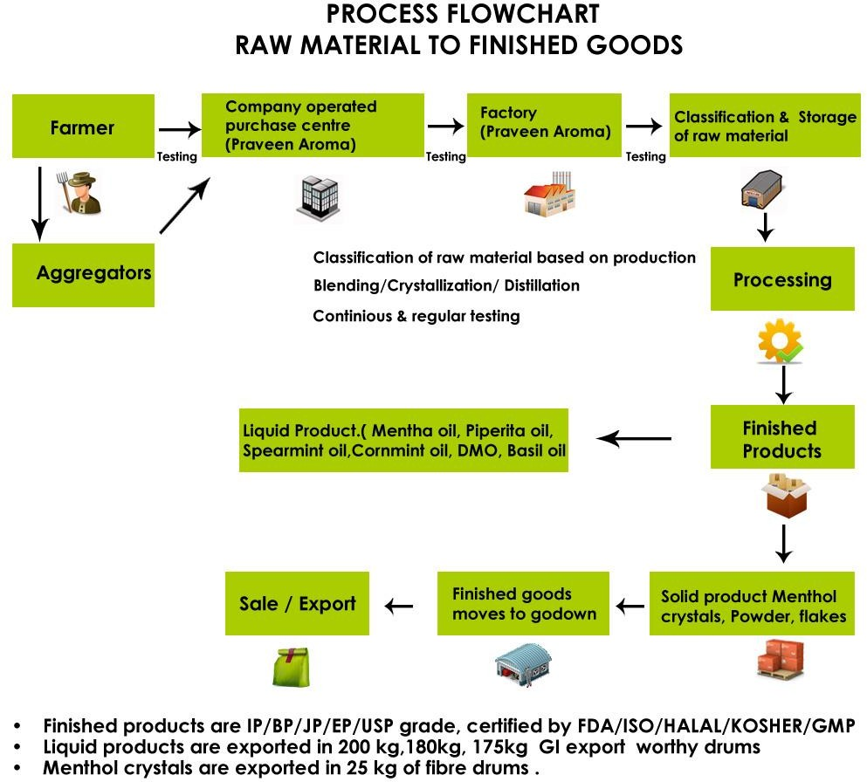

## FIGURE1: Process flow chart of Raw material to finished goods

Historical crop yield information is also important for supply chain operation of companies engaged in industries. These industries use agricultural products as raw material, livestock, food, animal feed, chemical, poultry, fertilizer, pesticides, seed and paper. An accurate estimate of crop production and risk helps these companies in planning supply chain decision like production scheduling. Business such as seed, fertilizer, agrochemical and agricultural

   

machinery industries plan production and marketing activities based on crop production estimates.

* 1. **Problem Statement:**

The agricultural sector is heavily influenced by fluctuations in raw material prices, which can impact production costs, profitability, and market stability. This analysis seeks to address the following challenges within the context of agricultural raw materials:

* + 1. Price Range Identification: Determine which agricultural raw materials fall within high and low-price ranges over the years, providing insights into the market dynamics and the materials that dominate pricing.
    2. Percentage Change Analysis: Identify raw materials that have experienced the highest and lowest percentage changes in price. Understanding these fluctuations can help stakeholders anticipate market trends and adjust strategies accordingly.
    3. Price Change Range Assessment: Analyze the overall range of price changes for agricultural raw materials over the specified period. This will highlight the volatility of the market and assist in forecasting future trends.
    4. Correlation Mapping: Create a heatmap to visualize the correlations between the price changes of different raw materials. This will aid in understanding how the prices of various materials are interconnected, which is crucial for making informed decisions in trading and procurement.

The significance of analyzing agricultural raw material prices lies in its potential to impact various stakeholders and enhance decision-making processes within the agricultural sector.

* 1. **Motivation:**

The choice to analyze agricultural raw material prices stems from several compelling motivations that highlight the importance of this sector in our global economy:

* + 1. Economic Impact: Agricultural raw materials are fundamental to food production, trade, and various industries. Understanding price trends can provide insights into economic stability and growth within this vital sector.
    2. Market Volatility: Prices of agricultural commodities are subject to significant fluctuations due to factors such as climate variability, geopolitical events, and shifts in consumer demand. Analyzing these price dynamics helps stakeholders anticipate and adapt to market changes, thereby minimizing risks and maximizing opportunities.

   

* + 1. Decision-Making Support: Farmers, traders, and policymakers rely on accurate data to make informed decisions. By identifying high and low price ranges, as well as significant percentage changes, this analysis provides actionable insights that can enhance strategic planning and resource management.
    2. Sustainability Goals: As the world moves toward more sustainable agricultural practices, understanding the economic implications of raw material pricing becomes essential. This analysis can inform strategies that promote both profitability and environmental responsibility.
    3. Interconnectedness of Markets: Agricultural markets are often interconnected; changes in one commodity can impact others. By mapping correlations through heatmaps, this analysis reveals these relationships, aiding stakeholders in recognizing potential ripple effects across the market.
    4. Data-Driven Insights: In an era where data availability is unprecedented, leveraging advanced analytical techniques allows us to extract meaningful insights from complex datasets. This not only enhances the understanding of historical trends but also supports predictive modeling for future market conditions.
  1. **Objective:**

The primary objectives of this analysis of agricultural raw material prices are as follows:

* To Find the high range and low range raw materials according to their prices.
* To find High and low %Change materials.
* To Identify the range of prices changed over the years.
* To Map a correlation between them using a heatmap.
  1. **Scope of the Project:**

The scope of this analysis encompasses a detailed exploration of agricultural raw material prices over a specified timeframe, focusing on several key areas:

   

* + 1. **Data Collection and Preparation**: The analysis will begin with the collection of relevant datasets containing historical price information for various agricultural raw materials. This step includes data cleaning, normalization, and preparation for exploratory analysis.
    2. **Exploratory Data Analysis (EDA)**: A comprehensive EDA will be conducted to examine trends, patterns, and anomalies within the dataset. This will involve statistical analysis and visualizations to provide a foundational understanding of price behaviours.
    3. **Price Range Analysis**: The analysis will identify raw materials with high and low- price ranges. This includes calculating mean, median, and quartile values to assess the distribution of prices across different commodities.
    4. **Percentage Change Calculation**: The analysis will involve calculating percentage changes in prices for each raw material, identifying those with the most significant increases and decreases. This will help highlight volatile materials and emerging trends.
    5. **Range of Price Changes**: The study will assess the overall range of price changes over the years, pinpointing periods of stability and volatility. This analysis will contribute to understanding the market's resilience and responsiveness to external factors.
    6. **Correlation Mapping**: A heatmap will be generated to visualize correlations between the price changes of various agricultural raw materials. This will help stakeholders understand interdependencies and potential impacts across different commodities.
    7. **Insights and Recommendations**: The final stage of the analysis will focus on synthesizing the findings into actionable insights and recommendations for stakeholders, including farmers, traders, and policymakers, to enhance decision- making processes.
    8. **Limitations and Future Research**: The analysis will also consider limitations, such as data availability and external factors affecting prices, and suggest areas for future research to further explore agricultural pricing dynamics.

   

**CHAPTER 2**

**Literature Survey**

Agricultural raw material analysis is a crucial aspect in human resources which plays a crucial role in identifying the change in the prices of raw material over the year, calculating

the high range and low range raw material according to the prices growth and drop, map correlation by using the heat map and it is mainly used identify the range of prices change over the year. Raw material variability is a critical factor to manage in the design of supply chains and production operations management systems. In some contexts, this may mean quality control programs for testing inputs to ensure they conform to production system requirements. In other situations, the burden of quality assurance may be shifted upstream to input suppliers, incorporating input quality management in the supply chain via contracting. Food operations management, raw materials variability, and input-output process estimation methods. We start by reviewing academic and practitioner literature in the Operations Management (OM) and Agribusiness areas, finding that there is substantial scope for continued work on operational decision-making in the food and agribusiness industries (Donk & Franson, [Citation2006](https://www.tandfonline.com/doi/full/10.1080/21693277.2022.2083030) Hernandez et al., [Citation2020](https://www.tandfonline.com/doi/full/10.1080/21693277.2022.2083030)). Specifically, there is little work of which we are aware that addresses raw material variability in food manufacturing at an operational level.

* 1. **Review of Article:**

Agricultural raw materials are the backbone of the global food industry and various manufacturing sectors. These include grains (wheat, rice, corn), oils (soybean, palm, sunflower), cotton, and others like coffee, cocoa, and rubber. The prices of agricultural raw materials are highly sensitive to various economic, environmental, and geopolitical factors. This will analyze show how price rate changes in agricultural raw materials impact both producers and consumers, the overall economy, and trade patterns. The focus will be on the recent price fluctuations of key agricultural commodities and the causes and consequences of these price changes.

   

* 1. **Methods used:**

Taking agricultural raw material surveys involves a series of methods and techniques to collect data about crops, livestock, soil conditions, water resources, and other factors that affect agricultural production. These surveys are essential for understanding production levels, forecasting supply, and making decisions about resource management. Below are some common methods and techniques used for conducting agricultural raw material surveys:

* + - **Field Surveys**
      * Visual Inspection: Surveyors Walk through farms or agricultural plots and assess crop health, stage of growth, pest damage, and other visual indicators of productivity.
      * Sample Plots: Researchers establish sample plots within a larger farm area to estimate yield, soil quality, or the presence of pests or diseases. These plots are typically random or systematically placed.
      * Plant and Soil Sampling: Soil samples are collected to analyse nutrient content, pH, texture, and moisture. Plant samples may also be collected to assess the presence of pests or diseases or to evaluate plant health.
      * Thermal Imaging: Thermal sensors can detect temperature variations in soil and plants, helping to monitor water stress and irrigation needs.
    - **Interviews and Surveys with Farmers:**
      * **Structured Interviews**: Surveys can be conducted with farmers to gather data on crop yields, livestock numbers, farming practices, input usage, and challenges faced. These interviews often involve standardized questionnaires.
      * **Focus Groups**: A more qualitative method where a group of farmers or stakeholders discusses issues such as resource availability, market access, and climatic challenges.
      * **Community and Farmer Feedback**: Direct input from local agricultural communities can provide insights into broader trends in agricultural productivity, pest outbreaks, or changes in practices.
    - **Agricultural Census:** A comprehensive, large-scale survey that collects data on agricultural production, land use, crop types, and livestock numbers at the national

   

or regional level. Census data is typically gathered periodically (e.g., every 5 or 10 years) and used for long-term planning and policy development.

* + - **Market Data Collection**

This involves gathering data from agricultural markets, trading posts, and cooperatives to assess the availability, price trends, and demand for raw agricultural materials. Market surveys may involve:

* **Price Monitoring**: Tracking price fluctuations for commodities in different regions or time periods.
* **Sales Records**: Collecting data from wholesalers, processors, and exporters to estimate volumes and trends in raw material production.
  + - **Weather and Climatic Data Collection**

Weather data is essential in assessing agricultural productivity. Surveys can incorporate:

* **Climate Monitoring**: Collecting data on rainfall, temperature, humidity, and other factors affecting crop growth.
* **Historical Weather Data**: Using past weather patterns to predict crop production outcomes and anticipate issues like drought or frost.

## Soil and Water Analysis

* **Soil Testing**: Soil samples are tested in laboratories to assess nutrient levels, pH, organic matter content, and other parameters that influence crop production.
* **Water Quality Surveys**: Analysis of water sources used for irrigation to assess quality, contamination, and availability.
  + - **Farm Equipment and Input Surveys**
* **Inventory and Usage Surveys**: Surveys may be conducted to assess the availability and use of agricultural inputs such as fertilizers, pesticides, machinery, and seeds.
* **Farm Mechanization Data**: Surveying the extent of mechanization in farming practices, including the use of tractors, harvesters, and irrigation systems.
  + - **Statistical and Sampling Techniques**

   

* **Random Sampling**: Data is collected from randomly selected farms or regions to ensure unbiased results and reliable estimates for larger populations.
* **Stratified Sampling**: Dividing the survey area into different strata based on factors like crop type, region, or farming method, and then sampling within each stratum.
  1. **Limitations of the Method used:**

**Sampling Bias**: If the sample is not representative of the entire population, the results may be skewed. For example, focusing only on larger farms or certain regions can miss out on smaller-scale producers.

**Recall Bias**: Farmers may struggle to accurately recall data such as historical yields, input use, or pricing, which can lead to errors or inconsistencies in the data.

**Data Accuracy**: Farmers may underreport or overreport certain information, particularly on sensitive topics like income, input costs, or labor practices.

**Data Interpretation**: Remote sensing data require skilled analysts to interpret, and incorrect interpretation of images (e.g., misidentifying a crop type) can lead to errors in yield estimation or land use analysis.

**Limited Coverage**: Market surveys often focus on specific markets, regions, or commodities, which may not fully represent national or global trends.

**Accuracy of Estimates**: Estimating yield through crop cutting or surveys may not always be accurate, especially if sampling techniques are not well-designed or if environmental factors (e.g., weather conditions, pests) cause variability.

**Weather Variability**: Crop yield estimates can be significantly influenced by weather conditions. Unpredictable weather can cause yield variability, making accurate forecasting and estimation difficult.

   

**CHAPTER 3**

**Proposed Methodology**

An Agricultural Raw Materials Analysis Report provides an overview of various agricultural products, assessing their production, market trends, economic viability, sustainability, and potential for growth. This type of report helps stakeholders, including farmers, suppliers, investors, and policymakers, make informed decisions about agricultural commodities. Below is a general structure for an Agricultural Raw Materials Analysis Report. To calculate the change over Agricultural raw material price rate over a year we are going to use Python Programming by visualization, data collecting, data processing, and data analyzing the collected data to find out what are the raw material price rate changed over a year according to the place and climate changes by generating graph, bar-chart, histogram and also by providing heat map stake holders can easily identify the resources and apply for future investment.

In this project I used Jupiter note to demonstrate the programming by analyzing the various article and government websites and survey has been done in India over various places in a year. The Agricultural raw material analysis is done identifying, calculating and noticing the change of the following things over a year in all over the India

* Production volumes
* Market prices
* Climate data
* Trade flows
* Input costs
* Sustainability metrics

By calculating the **production volume** of raw materials like (Coconut, Mazie, Wheat, Sugarcane, Rice) in which place the more production of the raw material were have been done and comparing to the yielding of the material.

After calculating the production rate, we have to check the demand of raw material in the market depending on the demand of raw material only the **market prices** rate goes up and down. If the demand is low the market prices only drop if the demand is high the market price goes up.

   

The yielding of crops and fibers which has to be yield on which period of the year to get more production all depends on the **climate change.** So, the climate change data is very essential to calculate the production and yield of crops.

We should also have to consider the **trade flow** of the raw material in global economy.

   

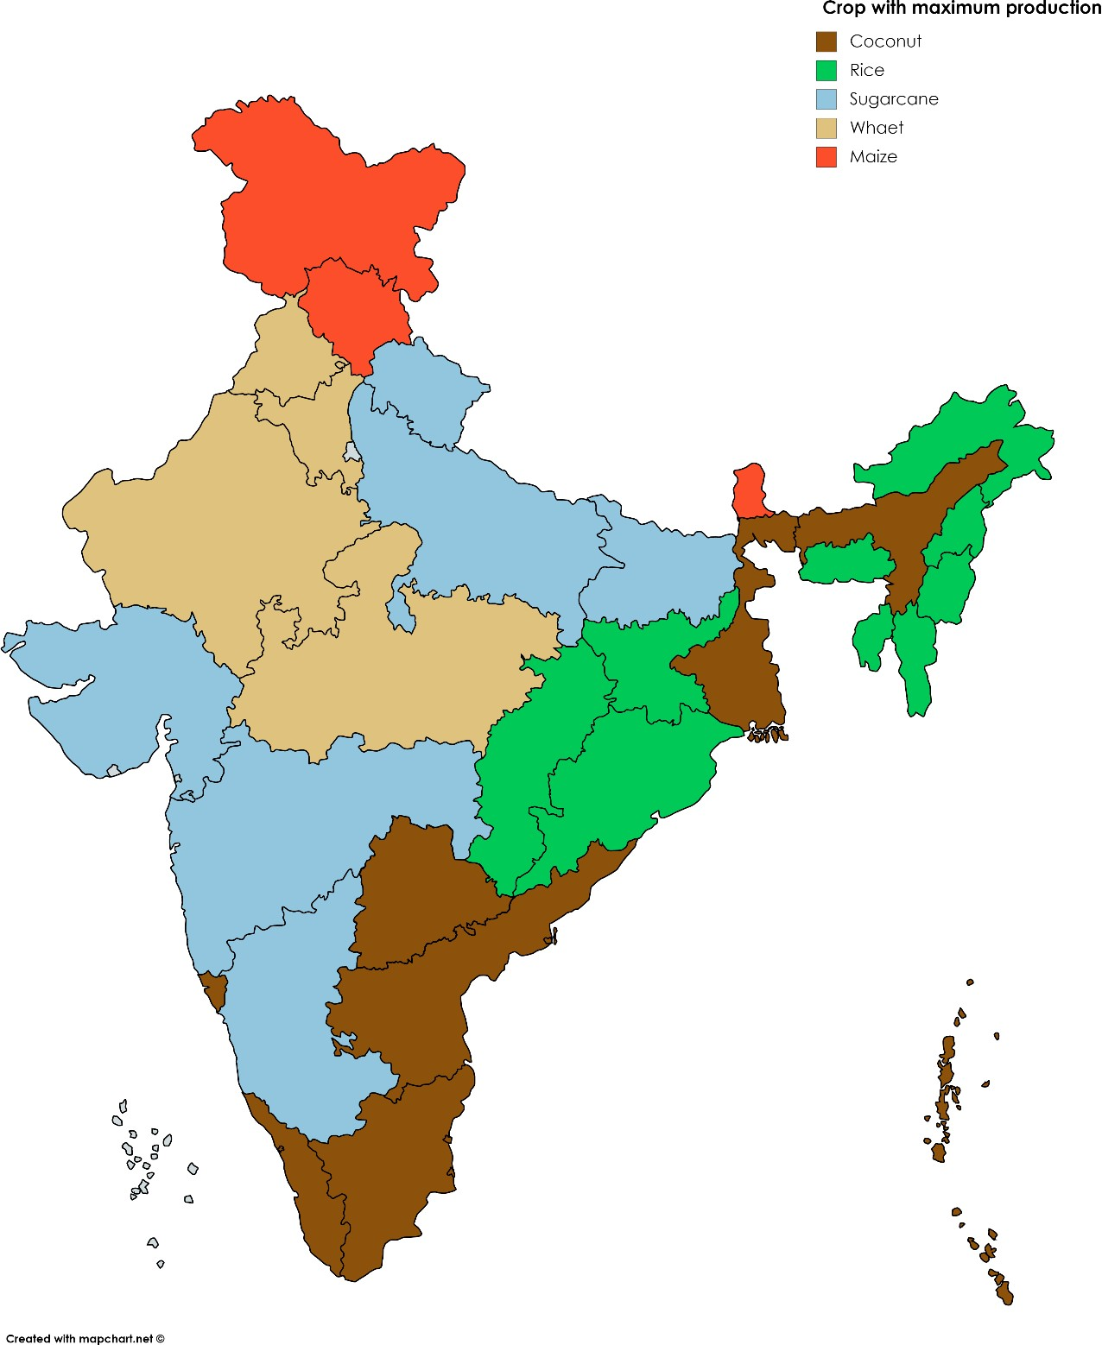

Figure 2: Different Raw materials Production in different state in India

   

* 1. **Data Collection and Preparation:**

In the data collection and preparation method the production, price change, climate change, supply and sustainability metrics were collected and prepared

* + - **Production Data**: Annual production volumes of various crops (e.g., maize, wheat, soybeans, cotton).
    - **Price Data**: Historical prices of key raw materials in global and local markets.
    - **Climate Data**: Temperature, rainfall, and weather-related data which directly affect agricultural productivity.
    - **Supply Chain Data**: Information on logistics, crop yields, and trade routes.
    - **Sustainability Metrics**: Data related to carbon emissions, water use, land degradation, and adoption of sustainable practices.

Once data is collected, it needs to be cleaned and pre-processed. This may involve handling missing values, removing duplicates, correcting inconsistencies, and transforming the data into a suitable format for analysis

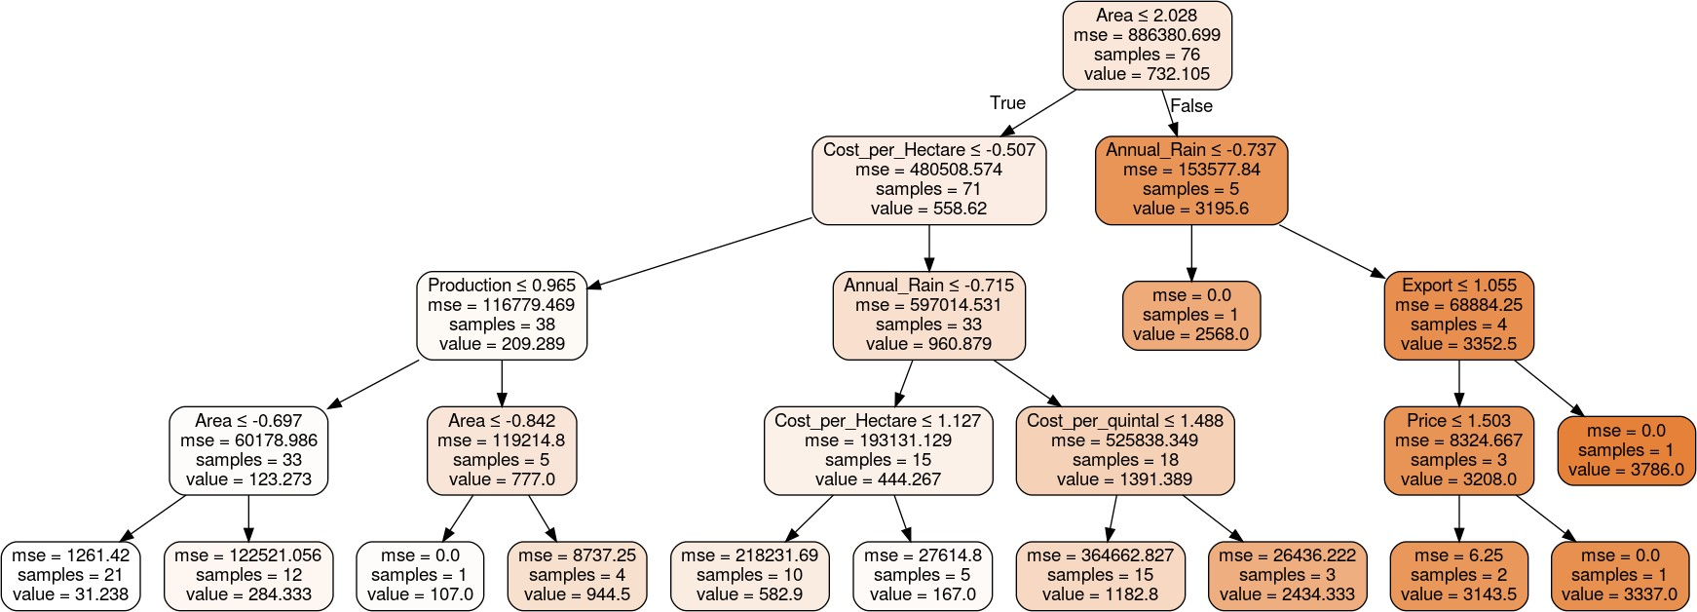

Figure3: Data collected on rainfall and error

   

* 1. **Univariate Analysis**

This step involves the analysis of a single variable in isolation. Common techniques include:

* + - **Summary Statistics**: Calculate the mean, median, mode, standard deviation, and other descriptive statistics for key variables (e.g., prices, production volumes).
    - **Distribution Plot**: Visualizing the distribution of a variable helps identify skewness, kurtosis, or outliers. Common plots include histograms, box plots, and density plots.

## Example:

* + - Distribution of **wheat prices** over the last decade: A histogram could reveal whether wheat prices follow a normal distribution or are highly volatile due to seasonal factors.

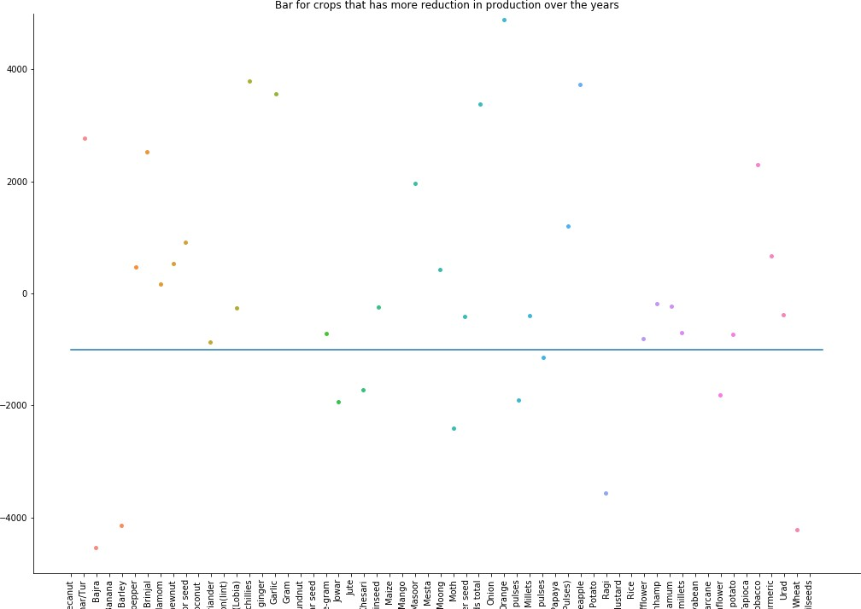

Figure4: Chart for crops that has more reduction in production over the year

   

* 1. **Bivariate Analysis**

In this phase, relationships between two variables are explored to identify potential correlations or patterns.

* + - **Scatter Plots**: Useful for identifying relationships between variables, such as the relationship between rainfall and crop yield.
    - **Correlation Coefficients**: Measure the strength and direction of relationships between numerical variables (e.g., correlation between fertilizer usage and crop yield).
  1. **Time Series Analysis**

Agricultural raw materials data, especially price and production volume data, is often time- dependent. Time series analysis helps uncover trends, seasonality, and cyclic patterns.

* + - **Trend Analysis**: Identifying long-term movements (e.g., consistent increase in global demand for palm oil over decades).
    - **Seasonality**: Identifying seasonal patterns, such as higher maize prices during drought periods.
    - **Autocorrelation**: Checking for autocorrelation in time series data, which could suggest that past values of a variable (e.g., prices) influence future values.

## Example:

* + - **Maize Prices**: Time series analysis of maize prices could show seasonal fluctuations due to harvest cycles and global trade patterns, or long-term trends due to factors like climate change or technological improvements in agriculture.
  1. **Clustering and Segmentation**

Clustering techniques can be used to segment agricultural raw materials into different groups based on similar characteristics, such as production region, crop type, or market behaviour.

* + - **K-means Clustering**: To identify groups of countries or regions with similar production profiles (e.g., high-yield maize-producing regions).
    - **Hierarchical Clustering**: To build a tree-like structure of agricultural commodities based on similarity in market behaviour, price trends, or other features.

   

* 1. **Geospatial Analysis**

Geospatial data (e.g., satellite imagery, GPS data) is crucial in agricultural analysis. EDA can help visualize geographical patterns related to crop production, weather impact, and market distribution.

* + - **Choropleth Maps**: Displaying regional production data or price trends geographically, which helps identify areas of growth or concern.
    - **Heat Maps**: Showing areas with the highest or lowest yields or trade flows.

## Example:

* + - 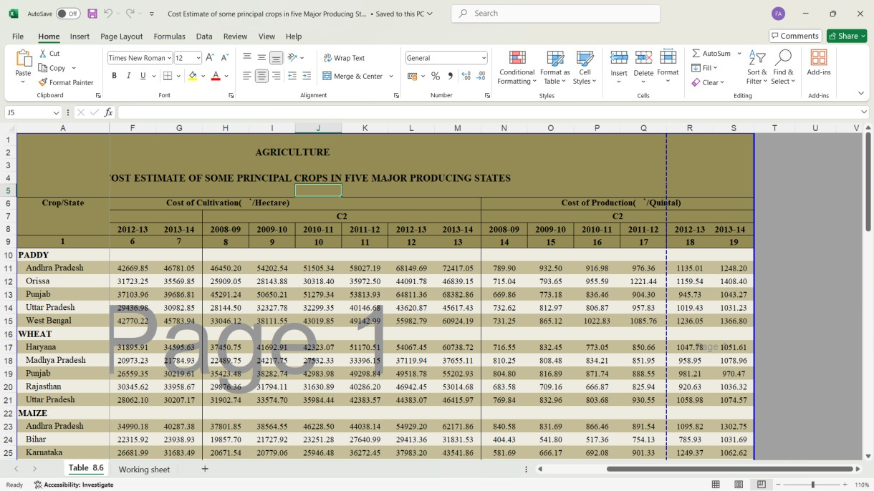**Global Palm Oil Production**: Using maps to visualize the geographic distribution of palm oil production in Southeast Asia, and linking these regions with environmental concerns like deforestation.

   

* 1. **Advantages:**

The advantages of agricultural raw material analysis are vast and touch many areas, from risk management and investment to sustainability and policy planning. By understanding how prices fluctuate and what drives those fluctuations, stakeholders—from farmers to policymakers to investors—can make more informed, data-driven decisions, leading to better management of agricultural resources, improved economic outcomes, and more resilient food systems.

1. Informed Decision Making for Farmers and Producers
2. Price Volatility Management
3. Supply Chain Optimization
4. Market Strategy Development
5. Economic and Policy Planning

   

**CHAPTER 4**

**Implementation and Result**

* 1. **Results of Agricultural raw material analysis**

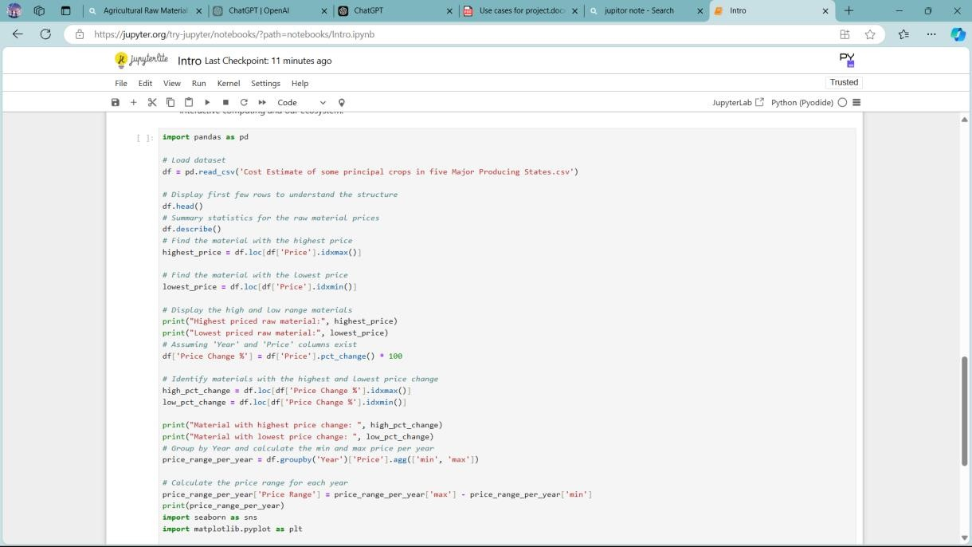

* 1. 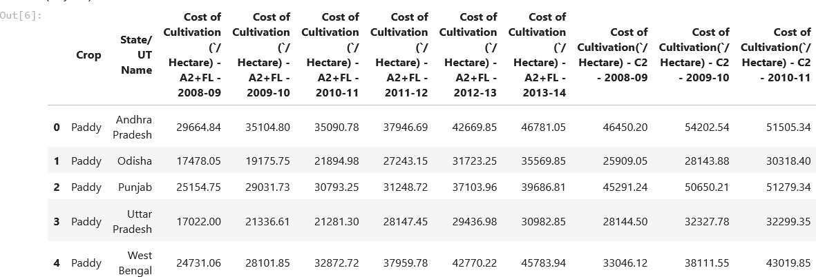**Results of Agricultural raw material**

   

**CHAPTER 5**

**Discussion and Conclusion**

* 1. **Key Findings:** From this we have able to find that the agricultural raw material prices were drastically change over a year according to the climate change and market demand.
  2. **Git Hub Link of the Project**: https://github.com/Habibullah123463/Habibullah.git
  3. **Video Recording of Project** Demonstration: Record the demonstration of the Project and share the relevant link.
  4. **Conclusion:** The project aimed to conduct an **Exploratory Data Analysis (EDA)** of agricultural raw material prices over the years, with the goal of uncovering key insights into price trends, fluctuations, and relationships between variables. The analysis focused on four primary objectives:

Identifying the **high range and low range raw materials** based on their prices. Analysing the **high and low percentage change** in prices for different materials. Determining the **range of price changes** over the years.

Mapping **correlations** between different variables, using a heatmap, to uncover patterns and relationships in the dataset. Through the analysis, we identified the raw materials with the highest and lowest prices over the analyzed period. Materials with **high percentage changes** were often subject to market shocks, such as supply chain disruptions, climate events (e.g., droughts), or sudden changes in global demand.

   

**REFERENCES**

1. Zonin, V. J., Valle Antunes, J. A., & Pinto Leis, R. (2014). Multicriteria analysis of agricultural raw materials: A case study of BSBIOS and PETROBRAS BIOFUELS in Brazil. Energy Policy, 67, 255–263. doi:10.1016/j.enpol.2013.12.029
2. Nilsson, D., Bernesson, S., & Hansson, P.-A. (2011). *Pellet production from agricultural raw materials – A systems study. Biomass and Bioenergy, 35(1), 679–689.* doi:10.1016/j.biombioe.2010.10.016

10.1016/j.biombioe.2010.10.0

1. Lenk, F., Bröring, S., Herzog, P., & Leker, J. (2007). *On the usage of agricultural raw materials – energy or food? An assessment from an economics perspective. Biotechnology Journal, 2(12), 1497–*

*1504.* doi:10.1002/biot.200700153

   