IoTrix Workshop Documentation

Workshop Information
Team Name:Team Gama
Team Members:
- Ifat Jahan Metu(Team Leader)
- Fariha Lubaba
- Lamia Akter
- Md.Habibur Rahman
- Mehzabeen Islam

Objective
The objective of this workshop was to learn the fundamentals of the Internet of Things (IoT), understand the ESP32 development board, set up the Arduino IDE, and gain hands-on experience with IoT programming and circuit simulation.

What is IoT?
The Internet of Things (IoT) is a network of physical devices that are connected to the internet. These devices collect, exchange, and process data automatically using sensors, microcontrollers, and communication technologies like Wi-Fi or Bluetooth.

How IoT Works
An IoT system generally follows these steps:
- Sensors collect data.
- The ESP32 processes the data.
- Data is transmitted through Wi-Fi/Bluetooth.
- Cloud server stores and processes the data.
- Users monitor or control devices using a web or mobile application.

Arduino IDE Setup

Installation Steps
- Install Arduino IDE.
- Open Board Manager.
- Search ESP32.
- Install ESP32 by Espressif Systems.
- Select ESP32 Dev Module from the board menu.
ESP32 DevKit V1

Features
- Dual-Core Processor
- Clock Speed: 240 MHz
- Built-in Wi-Fi
- IEEE 802.11 b/g/n
- Bluetooth Support
- Approximately 30 GPIO Pins
- 4 MB Flash Memory
- 520 KB SRAM

Advantages
- Fast processing
- Low power consumption
- Built-in wireless communication
- Suitable for IoT projects

Equipment Used
- ESP32 DevKit V1
- USB Cable
- Jumper Wires
- LED
- Laptop
- HC-SR04
- DHT11
- Relay Module
- Soil Moisture Sensor

Online Platforms Used
During the workshop, the following online tools were introduced:
- Wokwi (IoT simulation)
- Circuito.io (Circuit Design)
- Cirkit Designer IDE (Circuit Simulation & Design)

GPIO (General Purpose Input/Output)
GPIO pins can be configured as:
- Input
- Output
They are used to read sensor values and control electronic devices like LEDs, relays, and motors.

Digital Signal
Digital signals have only two states:
Value | Meaning
0 | LOW (OFF)
1 | HIGH (ON)
Example:
- LED OFF → 0
- LED ON → 1

Analog Signal
Analog signals can have many voltage levels.
Example:
0V → Minimum
3.3V (ESP32) → Maximum
Analog values are commonly read from sensors.

Programming Concepts Learned
- pinMode()
- digitalWrite()
- HIGH
- LOW
- delay()

Task1:

#define LED1 20
#define LED2 19
#define LED3 21
#define LED4 47
#define LED5 48
#define LED6 45
#define LED7 35
#define LED8 36
#define LED9 37
#define LED10 38

void setup() {
pinMode(LED1, OUTPUT);
pinMode(LED2, OUTPUT);
pinMode(LED3, OUTPUT);
pinMode(LED4, OUTPUT);
pinMode(LED5, OUTPUT);
pinMode(LED6, OUTPUT);
pinMode(LED7, OUTPUT);
pinMode(LED8, OUTPUT);
pinMode(LED9, OUTPUT);
pinMode(LED10, OUTPUT);
}

void loop() {

digitalWrite(LED1, HIGH);
digitalWrite(LED2, HIGH);
digitalWrite(LED3, HIGH);
digitalWrite(LED4, HIGH);
digitalWrite(LED5, HIGH);
digitalWrite(LED6, HIGH);
digitalWrite(LED7, HIGH);
digitalWrite(LED8, HIGH);
digitalWrite(LED9, HIGH);
digitalWrite(LED10, HIGH);

delay(500);

digitalWrite(LED1, LOW);
digitalWrite(LED2, LOW);
digitalWrite(LED3, LOW);
digitalWrite(LED4, LOW);
digitalWrite(LED5, LOW);
digitalWrite(LED6, LOW);
digitalWrite(LED7, LOW);
digitalWrite(LED8, LOW);
digitalWrite(LED9, LOW);
digitalWrite(LED10, LOW);

delay(500);
}
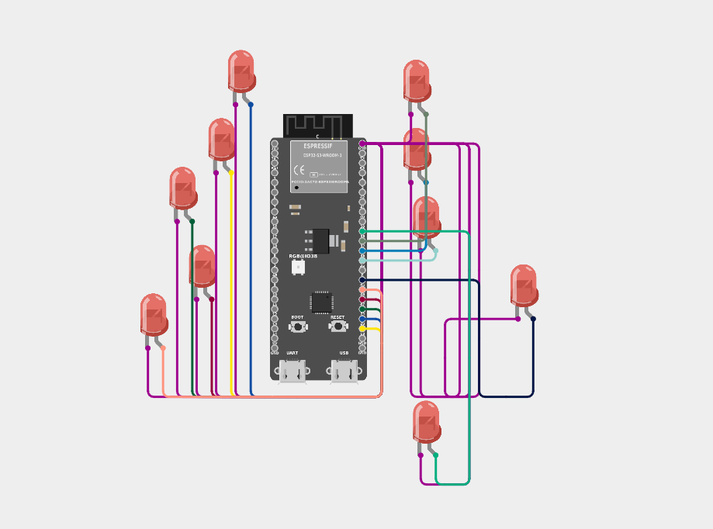

Task 2:

#define TRIG_PIN 5
#define ECHO_PIN 18
#define LED_PIN 2
void setup() {
Serial.begin(115200);
pinMode(TRIG_PIN, OUTPUT);
pinMode(ECHO_PIN, INPUT);
pinMode(LED_PIN, OUTPUT);
}
void loop() {
digitalWrite(TRIG_PIN, LOW);
delayMicroseconds(2);
digitalWrite(TRIG_PIN, HIGH);
delayMicroseconds(10);
digitalWrite(TRIG_PIN, LOW);
long duration = pulseIn(ECHO_PIN, HIGH);
float distance = duration * 0.0343 / 2;
Serial.print("Distance: ");
Serial.print(distance);
Serial.println(" cm");
if (distance <= 10) {
digitalWrite(LED_PIN, HIGH);
} else {
digitalWrite(LED_PIN, LOW);
}
delay(500);
}

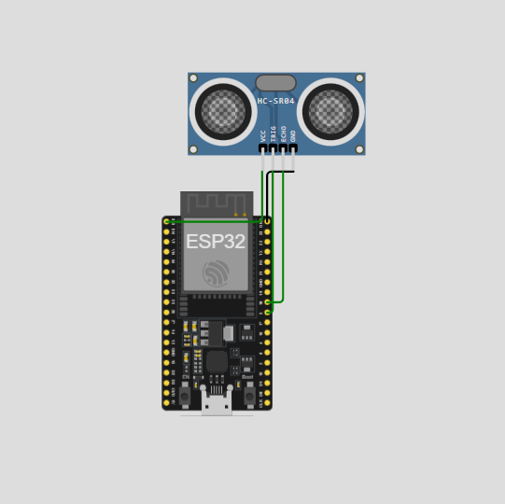

Task 3:

#define SOIL_PIN 34 // Analog Pin

void setup() {
Serial.begin(115200);
}

void loop() {
int sensorValue = analogRead(SOIL_PIN);

Serial.print("Soil Moisture Value: ");
Serial.println(sensorValue);

// Adjust thresholds based on your sensor calibration
if (sensorValue > 3000) {
Serial.println("Soil is DRY");
}
else if (sensorValue > 1800) {
Serial.println("Soil is MOIST");
}
else {
Serial.println("Soil is WET");
}

Serial.println("-------------------");
delay(1000);
}

Task 3.2:
#define SOIL_PIN 34
#define LED_PIN 2

void setup() {
Serial.begin(115200);

pinMode(LED_PIN, OUTPUT);
}

void loop() {

int sensorValue = analogRead(SOIL_PIN);

// Sensor Value → Moisture Percentage
int moisture = map(sensorValue, 4095, 1500, 0, 100);

// Limit between 0 and 100
moisture = constrain(moisture, 0, 100);

Serial.print("Moisture: ");
Serial.print(moisture);
Serial.println("%");

if (moisture > 50) {
digitalWrite(LED_PIN, HIGH); // LED ON
Serial.println("LED ON");
}
else {
digitalWrite(LED_PIN, LOW); // LED OFF
Serial.println("LED OFF");
}

delay(1000);
}

Task 3.3:
#define SOIL_PIN 34
#define LED_PIN 2

void setup() {
Serial.begin(115200);
pinMode(LED_PIN, OUTPUT);
}

void loop() {

int sensorValue = analogRead(SOIL_PIN);

int moisture = map(sensorValue, 4095, 1500, 0, 100);

moisture = constrain(moisture, 0, 100);

Serial.print("Moisture: ");
Serial.print(moisture);
Serial.println("%");

if (moisture < 60) {
Serial.println("Moisture LOW - LED Blinking");

digitalWrite(LED_PIN, HIGH);
delay(500);

digitalWrite(LED_PIN, LOW);
delay(500);
}
else {
Serial.println("Moisture OK - LED OFF");
digitalWrite(LED_PIN, LOW);
delay(1000);
}
}
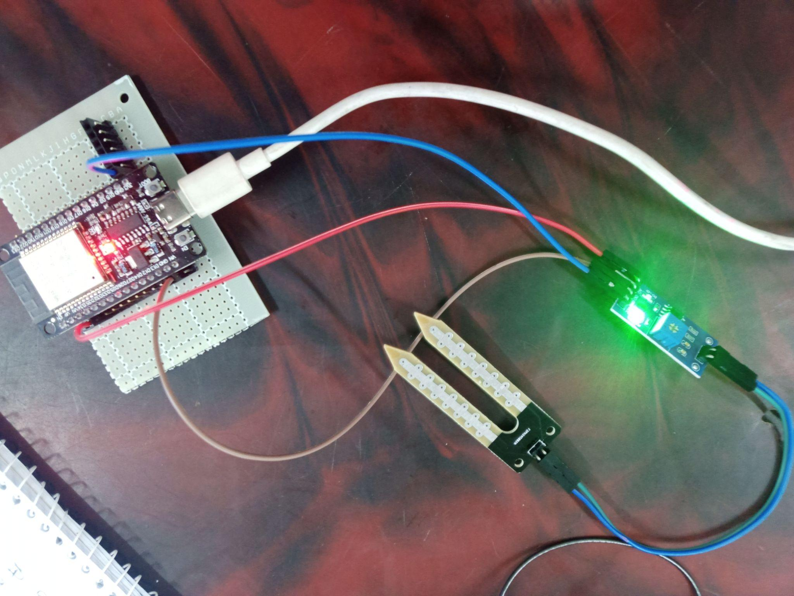

Task 4:

#include <DHT.h>

#define DHTPIN 4
#define DHTTYPE DHT11
#define LED_PIN 2

DHT dht(DHTPIN, DHTTYPE);

unsigned long previousRead = 0;
unsigned long previousBlink = 0;

const unsigned long readInterval = 3500;
unsigned long blinkInterval = 1000;

float humidity = 0;
float temperature = 0;

bool alert = false;
bool ledState = LOW;

void setup() {
Serial.begin(115200);
dht.begin();

pinMode(LED_PIN, OUTPUT);
digitalWrite(LED_PIN, LOW);

Serial.println("DHT11 Sensor Started");
}

void loop() {

unsigned long currentMillis = millis();

if (currentMillis - previousRead >= readInterval) {

previousRead = currentMillis;

humidity = dht.readHumidity();
temperature = dht.readTemperature();

if (isnan(humidity) || isnan(temperature)) {
Serial.println("No DHT11 Detected!");
alert = false;
digitalWrite(LED_PIN, LOW);
return;
}

Serial.print("Temperature: ");
Serial.print(temperature);
Serial.println(" °C");

Serial.print("Humidity: ");
Serial.print(humidity);
Serial.println(" %");

Serial.println("---------------------");

if (humidity > 80 && temperature > 30) {
alert = true;
blinkInterval = 1000;

}

else if (humidity > 70 && temperature > 30) {
alert = true;
blinkInterval = 500;
Serial.println("Warning!");

}

else if (humidity < 70 && temperature < 30) {
alert = false;
digitalWrite(LED_PIN, LOW);
Serial.println("All Good");
}

else {
alert = false;
digitalWrite(LED_PIN, LOW);
}
}

// LED Blink
if (alert) {
if (currentMillis - previousBlink >= blinkInterval) {
previousBlink = currentMillis;
ledState = !ledState;
digitalWrite(LED_PIN, ledState);
}
}
}

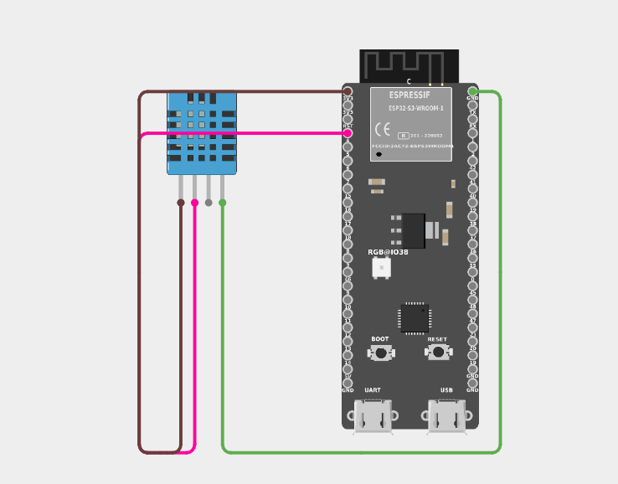

Task 5:
/*
==============================================================================
🎯 HACKATHON STARTER TEMPLATE: ESP32 Local Web Server (DHT11 + Water Sensor)
==============================================================================

📌 Microcontroller: ESP32 Dev Module / ESP32 WROOM

📦 Required Libraries (Install via Arduino Library Manager):
1. "DHT sensor library" by Adafruit
2. "Adafruit Unified Sensor" by Adafruit
(Built-in libraries used: <WiFi.h>, <WebServer.h>)

🔌 Hardware Wiring Guide for ESP32:
-------------------------------------------------------------------------
Sensor Pin | ESP32 Pin | Notes
-------------------------------------------------------------------------
[DHT11 Temperature & Humidity]
- VCC | 3.3V or 5V | Power (+)
- GND | GND | Ground (-)
- DATA / OUT | GPIO 4 | Digital Data Pin

[Water Level Sensor]
- VCC / (+) | 3.3V or 5V | Power (+)
- GND / (-) | GND | Ground (-)
- S / OUT (Signal) | GPIO 34 | Must use ADC1 (GPIO 34, 35, 36, 39)
-------------------------------------------------------------------------

==============================================================================
*/

#include <WiFi.h>
#include <WebServer.h>
#include "DHT.h"

// ------------------------------------------------------------------------------
// ⚙️ CONFIGURATION SECTION [MODIFIED BY PARTICIPANTS]
// ------------------------------------------------------------------------------

// [TODO 1]: Wi-Fi Network Credentials (ESP32 connects to your local router)
#define WIFI_SSID "Fariha Lubaba"
#define WIFI_PASSWORD "12345678"

// [TODO 2]: Hardware Pin Configuration
#define DHTPIN 4 // GPIO pin for DHT11 data
#define DHTTYPE DHT11 // Sensor type
#define WATER_SENSOR_PIN 34 // Analog ADC1 pin for Water Level (GPIO 34)

const int WATER_THRESHOLD = 500; // Threshold for water detection alert

// ------------------------------------------------------------------------------
// 📦 GLOBAL OBJECTS & INITIALIZATION
// ------------------------------------------------------------------------------

DHT dht(DHTPIN, DHTTYPE);
WebServer server(80); // Web server running on HTTP standard port 80

// Global variables to store sensor readings
float temperature = 0.0;
float humidity = 0.0;
int rawWaterLevel = 0;
float waterPercentage = 0.0;
bool waterDetected = false;

// ------------------------------------------------------------------------------
// 🎨 HTML & CSS DASHBOARD TEMPLATE (Stored in Flash Memory)
// ------------------------------------------------------------------------------
const char HTML_DASHBOARD[] PROGMEM = R"rawliteral(
<!DOCTYPE html>
<html lang="en">
<head>
<meta charset="UTF-8">
<meta name="viewport" content="width=device-width, initial-scale=1.0">
<title>ESP32 Local Sensor Dashboard</title>
<style>
* { box-sizing: border-box; margin: 0; padding: 0; font-family: 'Segoe UI', Tahoma, Geneva, Verdana, sans-serif; }
body { background: #0f172a; color: #f8fafc; display: flex; flex-direction: column; align-items: center; min-height: 100vh; padding: 20px; }
header { margin-top: 20px; text-align: center; }
header h1 { font-size: 2rem; color: #38bdf8; margin-bottom: 5px; }
header p { color: #94a3b8; font-size: 0.95rem; }
.status-badge { background: #1e293b; border: 1px solid #334155; padding: 6px 14px; border-radius: 20px; font-size: 0.85rem; color: #4ade80; display: inline-block; margin-top: 10px; }

.grid-container { display: grid; grid-template-columns: repeat(auto-fit, minmax(250px, 1fr)); gap: 20px; width: 100%; max-width: 900px; margin-top: 30px; }

.card { background: #1e293b; border: 1px solid #334155; border-radius: 16px; padding: 25px; text-align: center; transition: transform 0.2s, border-color 0.2s; box-shadow: 0 10px 25px -5px rgba(0,0,0,0.3); }
.card:hover { transform: translateY(-5px); border-color: #38bdf8; }
.card .icon { font-size: 2.5rem; margin-bottom: 10px; }
.card .label { font-size: 0.9rem; color: #94a3b8; text-transform: uppercase; letter-spacing: 1px; }
.card .value { font-size: 2.5rem; font-weight: bold; margin: 10px 0; color: #f8fafc; }
.card .unit { font-size: 1.2rem; color: #94a3b8; }

.alert-card { grid-column: 1 / -1; background: #1e293b; border: 1px solid #334155; }
.alert-box { padding: 15px; border-radius: 10px; font-weight: bold; text-align: center; }
.alert-dry { background: rgba(74, 222, 128, 0.1); color: #4ade80; border: 1px solid rgba(74, 222, 128, 0.3); }
.alert-wet { background: rgba(248, 113, 113, 0.15); color: #f87171; border: 1px solid rgba(248, 113, 113, 0.4); animation: pulse 1.5s infinite; }

@keyframes pulse { 0% { opacity: 1; } 50% { opacity: 0.6; } 100% { opacity: 1; } }
footer { margin-top: auto; padding: 20px 0; color: #64748b; font-size: 0.85rem; }
</style>
</head>
<body>

<header>
<h1>⚡ ESP32 Local Server Dashboard</h1>
<p>Live Real-Time Sensor Telemetry</p>
<div class="status-badge">● System Online</div>
</header>

<div class="grid-container">
<!-- Temperature Card -->
<div class="card">
<div class="icon">🌡️</div>
<div class="label">Temperature</div>
<div class="value"><span id="temp">--</span><span class="unit"> °C</span></div>
</div>

<!-- Humidity Card -->
<div class="card">
<div class="icon">💧</div>
<div class="label">Humidity</div>
<div class="value"><span id="humidity">--</span><span class="unit"> %</span></div>
</div>

<!-- Water Level Card -->
<div class="card">
<div class="icon">🌊</div>
<div class="label">Water Depth Level</div>
<div class="value"><span id="water">--</span><span class="unit"> %</span></div>
</div>

<!-- Water Detection Alert Card -->
<div class="card alert-card">
<div id="alertBox" class="alert-box alert-dry">Checking Water Sensor Status...</div>
</div>
</div>

<footer>ESP32 Local Web Server | Hackathon Starter Kit</footer>

<script>
// Automatic Live Data Update using AJAX/JSON API fetch
function updateSensorData() {
fetch('/api/data')
.then(response => response.json())
.then(data => {
document.getElementById('temp').innerText = data.temperature.toFixed(1);
document.getElementById('humidity').innerText = data.humidity.toFixed(1);
document.getElementById('water').innerText = data.water_percentage.toFixed(1);

const alertBox = document.getElementById('alertBox');
if (data.water_detected) {
alertBox.innerText = '🚨 WARNING: WATER DETECTED!';
alertBox.className = 'alert-box alert-wet';
} else {
alertBox.innerText = '✅ NORMAL: DRY ENVIRONMENT';
alertBox.className = 'alert-box alert-dry';
}
})
.catch(err => console.error("Error fetching data:", err));
}

// Refresh telemetry every 2 seconds
setInterval(updateSensorData, 2000);
updateSensorData();
</script>

</body>
</html>
)rawliteral";

// ------------------------------------------------------------------------------
// 🛠️ SENSOR READING HELPER
// ------------------------------------------------------------------------------
void readSensors() {
float t = dht.readTemperature();
float h = dht.readHumidity();

if (!isnan(t)) temperature = t;
if (!isnan(h)) humidity = h;

rawWaterLevel = analogRead(WATER_SENSOR_PIN);
waterPercentage = (rawWaterLevel / 4095.0) * 100.0;
waterDetected = (rawWaterLevel > WATER_THRESHOLD);
}

// ------------------------------------------------------------------------------
// 🌐 WEB SERVER ROUTE HANDLERS
// ------------------------------------------------------------------------------

// Handler for Main HTML Web Page Route ("/")
void handleRoot() {
readSensors();
server.send(200, "text/html", HTML_DASHBOARD);
}

// Handler for JSON Data API Endpoint ("/api/data")
void handleApiData() {
readSensors();

String json = "{";
json += "\"temperature\":" + String(temperature, 1) + ",";
json += "\"humidity\":" + String(humidity, 1) + ",";
json += "\"raw_water\":" + String(rawWaterLevel) + ",";
json += "\"water_percentage\":" + String(waterPercentage, 1) + ",";
json += "\"water_detected\":" + String(waterDetected ? "true" : "false");
json += "}";

server.send(200, "application/json", json);
}

// Handler for unknown 404 routes
void handleNotFound() {
server.send(404, "text/plain", "404: Route Not Found");
}

// ------------------------------------------------------------------------------
// 🚀 SETUP FUNCTION
// ------------------------------------------------------------------------------
void setup() {
Serial.begin(115200);
delay(500);
Serial.println();
Serial.println("==================================================");
Serial.println("🌐 ESP32 Local Web Server (DHT11 + Water Sensor)");
Serial.println("==================================================");

// Initialize sensors
dht.begin();
pinMode(WATER_SENSOR_PIN, INPUT);

// Connect to Local Wi-Fi Network
Serial.print("📶 Connecting to Wi-Fi: ");
Serial.println(WIFI_SSID);
WiFi.begin(WIFI_SSID, WIFI_PASSWORD);

while (WiFi.status() != WL_CONNECTED) {
delay(500);
Serial.print(".");
}

Serial.println();
Serial.println("✅ Wi-Fi Connected Successfully!");
Serial.print("📍 Open Browser at: http://");
Serial.println(WiFi.localIP());

// Setup Web Server Routes
server.on("/", handleRoot); // Main Dashboard page
server.on("/api/data", handleApiData); // JSON API endpoint for live JavaScript updates
server.onNotFound(handleNotFound);

// Start HTTP Server
server.begin();
Serial.println("🚀 Local Web Server Started!");
}

// ------------------------------------------------------------------------------
// 🔁 MAIN LOOP FUNCTION
// ------------------------------------------------------------------------------
void loop() {
// Keep listening for incoming HTTP requests from web browsers
server.handleClient();
}

