**SCHOOL MANAGEMET SYSTEM**



**Introduction :**

School Management System project is designed by zurb foundation. This is a simple Web based project which is very easy to understand and use. Talking about the system, it contains all the required functions in school which include school History, Teacher Information, Result, Form, About, Contact, Registration and Login. A user is seeing the school history, about the school.

He can contact the school .he can easy to form fill up and registration. He can easy to see result.

He can easy to logging of his own ID. It is a user friendly software.

**Features:**

* History
* Teacher Information
* Result
* Form
* About
* Contact
* Registration
* Login

**Project Objectives :**

* All the records stored in School Management database, so that we can use them in future whenever needed.
* From security point of view this software has a special login name and password allotted to their Administrator.
* Locate any Information wanted by the user.
* Reduced written work and problem of storing the diaries as most of the work done by computer.
* Provide greater speed & reduced time consumption.

**Languages & platform:**

In an Web based system like School Management System, there is a scope for a large number of platforms, languages, web servers and frameworks to choose from. Before selecting from this large array of technologies the following aspects have been kept in mind:

* Performance
* Reliability
* Portability
* Security
* Fast speed
* Cost Constraint
* Time Constraint

The project School Management System have been built by :

* **Visual Studio**
* **Sublime text**
* **Python**
* **Django**
* **HTML**
* **CSS**

**Screenshots:**

**Homepage:**



**Result page:**

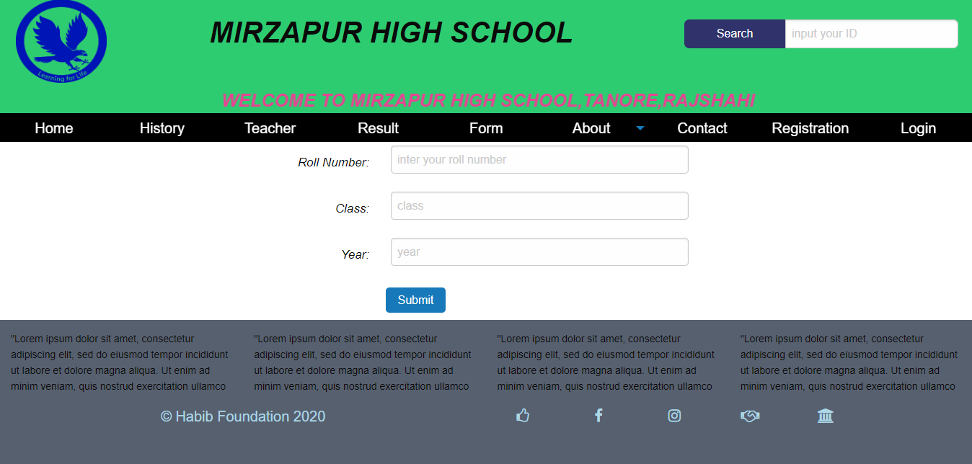

Students input their roll number, class and year then submit. Showing the result.

**From page:**

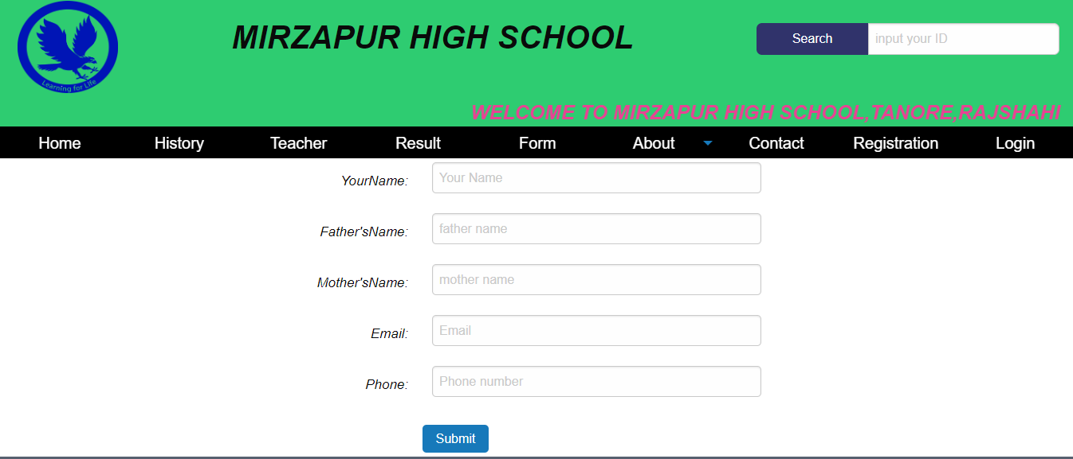

**Registration page:**

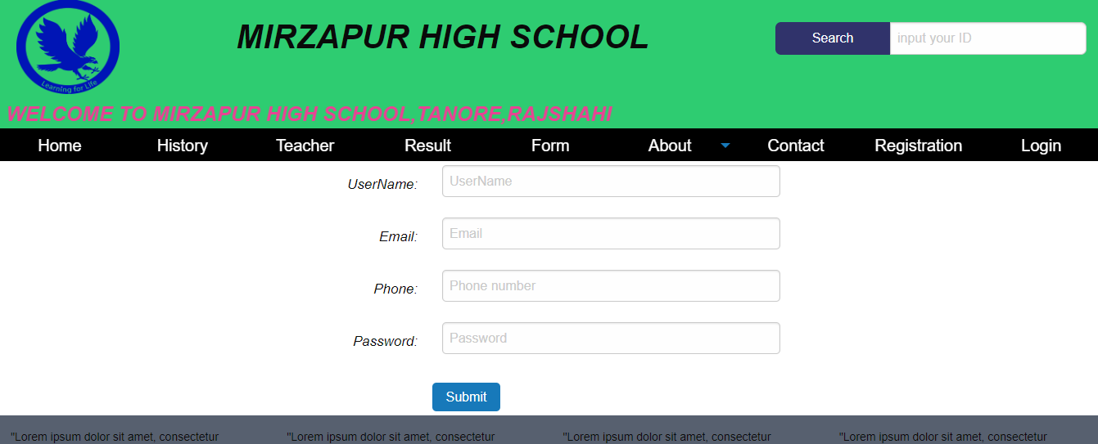

**Login page:**

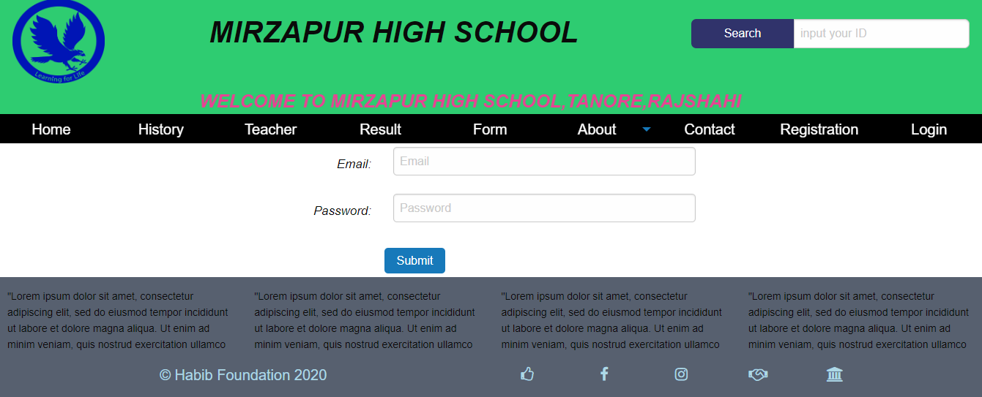

Students can show of their details information.

**Contact page:**

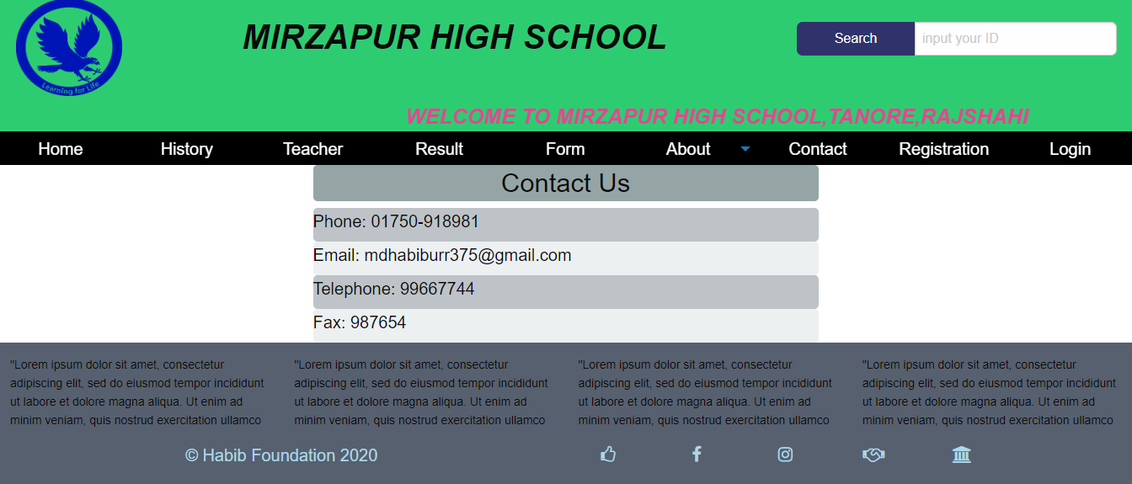

**Reference:**

* + - <http://codecanyon.net/item/ekattor-school-management-> system-pro/6087521
    - <http://www.academia.edu/4699500/SCHOOL_MANAGEME> NT_SYSTEM
    - <http://www.slideshare.net/aki_string/school-> management-system-21413550
    - <http://www.slideshare.net/shitalkr/school-admission-> process-management-documentation

**Conclusion and Future Plane:**

This is my simple project. I want to develop my project future. This project has some limitation.

In future, I want to develop of my limitation.

**Md. Habibur Rahman**

**ID: 172311008**