United International University
School of Business and Economics
Predictive Analytics: Stock, Sales and Tips Models
Result Interpretation Report (Deliverable 4), synthetic dataset
Name: ____________________ Student ID: ______________ Group: ______

1. Summary
I built three predictive models on a synthetic dataset that I generated for this project (a different generator, tickers, stores, dates and seed from the class demo): an LSTM for the BANKNOVA stock, forecasting models for the Gulshan store's daily sales, and regression models for waiter tips. I also saved the best tips pipeline to one file and reloaded it to predict on unseen bills. The headline findings are mixed, and I report them as they came out:
- Stock (LSTM): the LSTM failed to beat a trivial baseline. Its RMSE on the held-out period was $8.4 to $15.4 across three random seeds, against $3.06 for simply predicting "tomorrow = today".
- Sales: the forecasting models worked. SARIMA reached an RMSE of 53.4 units/day (3.4% error) and Holt-Winters 57.7 (3.8%), clearly better than a seasonal-naive baseline (71.4).
- Tips: bill size explains most of the tip. Adding features lifted cross-validated R² only from 0.661 to 0.677. Ridge regression is the model I would deploy.
Caveat: all data is synthetic. Scores describe how well each method fits the data-generating process I wrote, not real markets, stores or restaurants.

2. Data and setup
The workbook has three sheets with the same schema as the demo. Stock_Prices holds 750 trading days (June 2022 onward) for three tickers (BANKNOVA, SOLARIS, RETAILHUB), simulated as random walks with volatility clustering and no built-in predictable pattern. Sales_Data holds 730 daily values for four stores (Gulshan, Dhanmondi, Uttara, Motijheel) with trend, a weekly cycle, annual seasonality, eight short promotions and noise. Waiter_Tips holds 300 bills with tip, party size, day, time, sex and smoker flag. The generator script is included so anyone can reproduce the file.
I chose one series per problem before looking at any results: BANKNOVA for the LSTM and the Gulshan store for sales. As a robustness check I also ran the LSTM on the other two tickers, so the stock conclusion does not rest on one lucky or unlucky series.

3. Stock price prediction (LSTM)
Closing prices were turned into 20-day sliding windows to predict the next day, using an LSTM(32) followed by a Dense(16) layer. The first 80% of windows (584) are the training set and the last 146 windows (24 Sep 2024 to 15 Apr 2025) are the test set. I made two changes to the class demo's approach: the scaler is fitted on the training period only (fitting it on all data leaks the test-period price range into training), and early stopping uses the last 15% of the training windows, not the test set.
Ticker | LSTM seed 42 | LSTM seed 43 | LSTM seed 44 | Naive (yesterday) | Test days above training max
BANKNOVA (primary) | $13.82 | $15.37 | $8.44 | $3.06 | 48%
SOLARIS | $8.26 | $7.91 | $5.54 | $3.48 | 0%
RETAILHUB | $9.76 | $23.04 | $8.97 | $7.03 | 17%
Table 1. Test-period RMSE of the LSTM (three seeds) versus a "no-change" baseline.
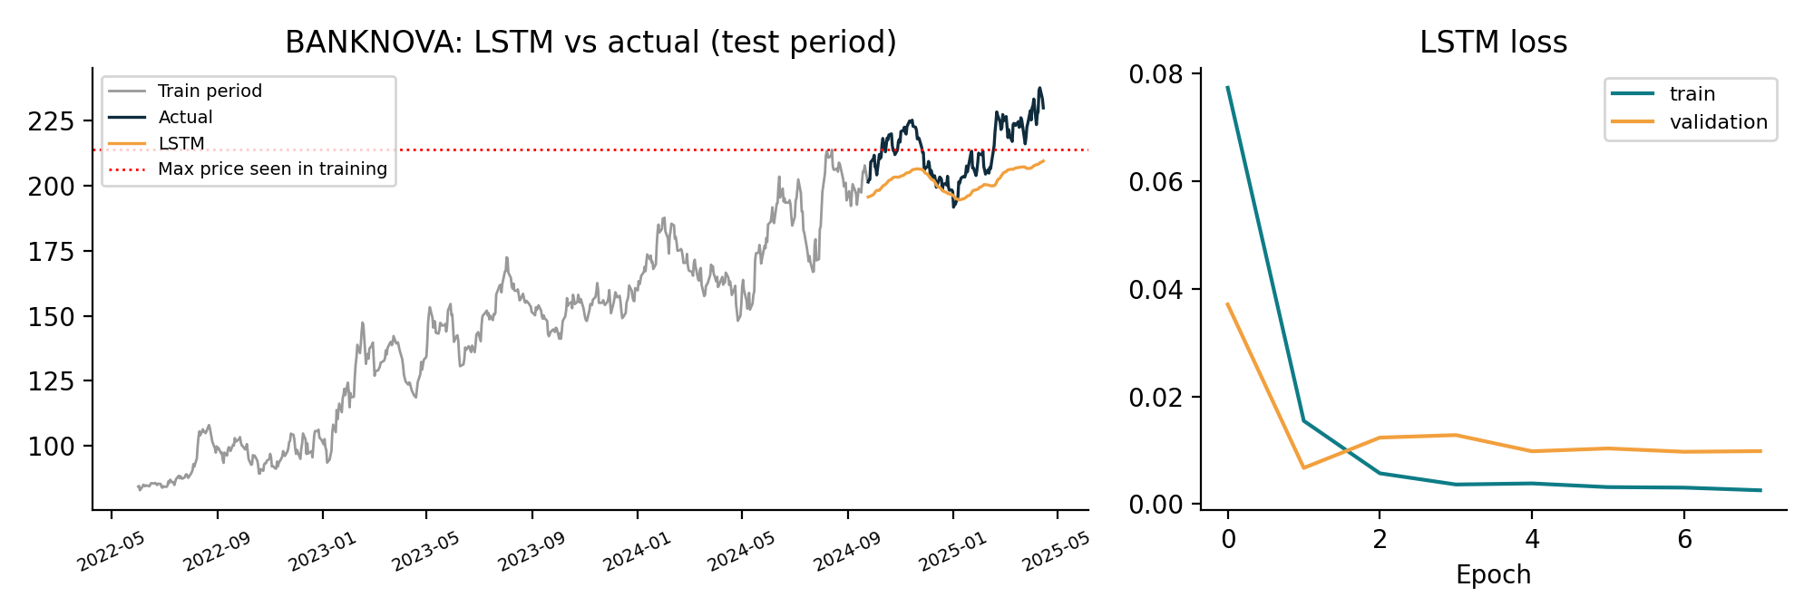
Figure 1. BANKNOVA: the LSTM forecast flattens out near the highest price it saw in training (dotted line).
The result is clear and not flattering: on all three tickers and in all nine runs the LSTM is worse than predicting yesterday's close. This is expected, because the simulated returns carry no learnable pattern, so the best possible forecast of tomorrow is today. Two further problems show up in the numbers. First, the seed-to-seed spread is large (RETAILHUB ranges from 8.97 to 23.04), so any single RMSE would be misleading. Second, the primary ticker trended up, and 48% of its test days were above the highest price in the training data. A model trained on scaled prices cannot output values outside what it has seen, so the forecast stalls near $210 while the actual price climbs to $238 (average error of -$11.9). This is the classic weakness of price-level LSTMs on trending series.

4. Sales forecasting (Gulshan store)
The Gulshan series (730 days) was decomposed with a 7-day period. The trend rises from about 872 to 1,204 units/day, and the weekly pattern is strong: Saturday is +211 and Friday +173 against the average, while Tuesday is -151. The 60 final days (1 May to 29 Jun 2025) were held out and every model was fitted only on the 670 days before.
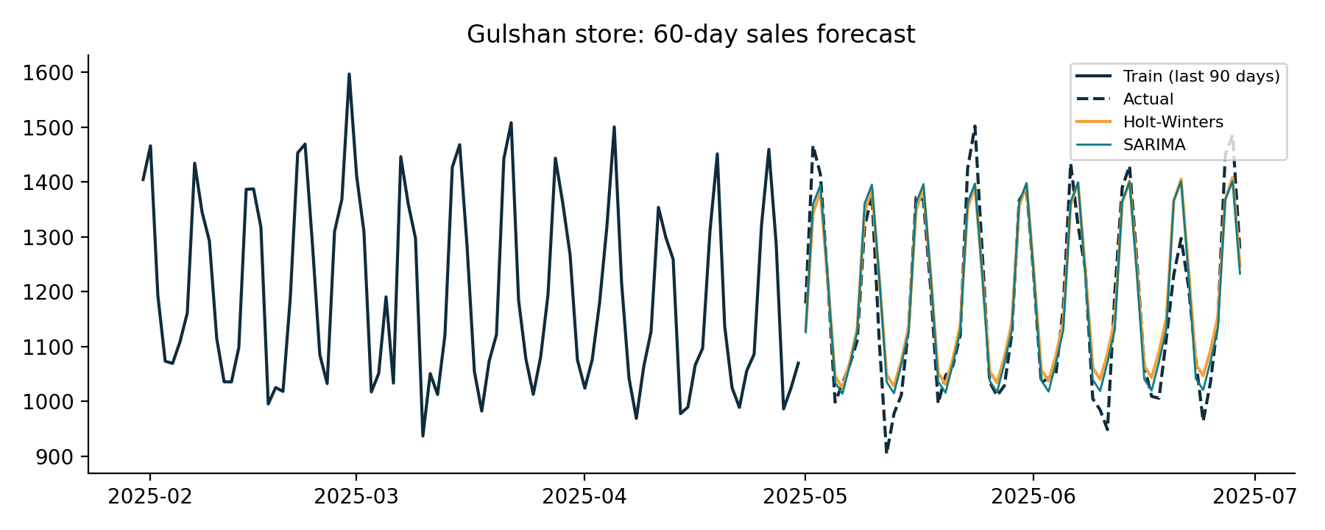
Figure 2. 60-day forecasts for Gulshan: Holt-Winters and SARIMA both track the weekly cycle.
Model | RMSE | MAE | MAPE
SARIMA(1,1,1)(1,0,1,7) | 53.4 | 40.1 | 3.4%
Holt-Winters (trend add, seasonal mult) | 54.7 | 40.6 | 3.5%
Holt-Winters (damped trend, seasonal add) | 56.0 | 42.4 | 3.6%
Holt-Winters (trend add, seasonal add) | 57.7 | 43.8 | 3.8%
Seasonal naive (same weekday last week) | 71.4 | 58.4 | 4.9%
Mean of training data | 189.9 | 149.2 | 11.8%
Table 2. Sales forecast accuracy on the held-out 60 days (average daily sales in the test window: 1,179).
All time-series models beat the baselines, and the structured models cut the seasonal-naive error by roughly a fifth to a quarter. Note that the top four models are separated by only about 4 RMSE units on 60 test days, which is within the noise I would expect, so I would not claim SARIMA is truly better than Holt-Winters; the demo's additive Holt-Winters is a perfectly good choice. The real gap is between these models and the naive ones. One limit to be aware of: with only two years of history, none of these 7-day-period models can learn the annual cycle that exists in the data, and a test window in mid-year hides that weakness.

5. Why the split must be by time
A random split would put days from the middle of the series into the training set, so the model would be asked to predict a day whose neighbours on both sides it has already seen. For a smooth price or sales series, that is just interpolation, and it produces an RMSE far lower than anything the model could achieve when forecasting an unknown future. Windows also overlap (each 20-day window shares 19 days with the next), so a shuffled split leaks nearly identical examples across train and test. A time-based split respects reality: we only ever predict forward from the past. My own LSTM result shows the value of this: with a time split the model is exposed as worse than the naive baseline, and a shuffled split would likely have hidden that and reported a flattering score.

6. Waiter tips regression
The baseline uses total_bill only. Refinements add all features (sex, smoker, day, time, size) with plain linear regression, then Ridge with the penalty chosen by cross-validation (alpha = 8.5), then Random Forest in two forms. With 300 rows a single 60-row test set is noisy, so I report both the 80/20 hold-out result and the mean of 5 repeats of 5-fold cross-validation on all rows.
Model | Test R² | Test RMSE | Train R² | CV R² | CV RMSE
Baseline (bill only) | 0.626 | 0.894 | 0.688 | 0.661 | 0.833
Linear Regression (all) | 0.684 | 0.822 | 0.703 | 0.675 | 0.815
Ridge (alpha by CV) | 0.685 | 0.820 | 0.702 | 0.677 | 0.813
Random Forest (default) | 0.651 | 0.864 | 0.945 | 0.617 | 0.884
Random Forest (leaf size 5) | 0.674 | 0.834 | 0.790 | 0.643 | 0.855
Table 3. All tips models. Bold row: model chosen for deployment (best cross-validated RMSE).
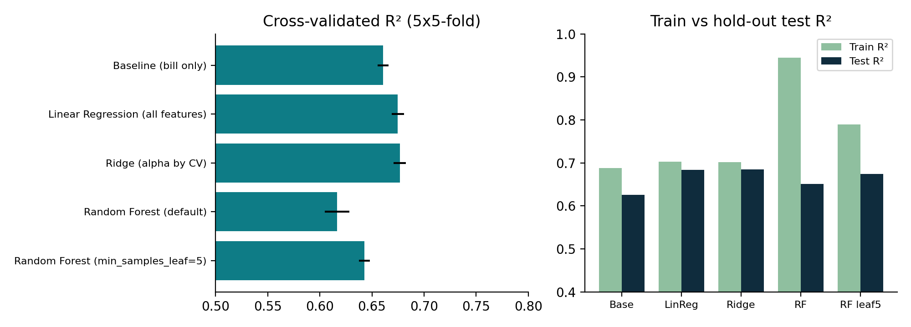
Figure 3. Left: cross-validated R² with spread across repeats. Right: train versus hold-out R².
Refinement helped only a little. On cross-validation R² moves from 0.661 to 0.677 (+0.016), and RMSE drops from 0.833 to 0.813, about 2.4%, or 2 cents on an average tip of $3.16. The hold-out split shows a larger jump (0.626 to 0.685), but that is partly the luck of one 60-row split; cross-validation is the more trustworthy figure. The reason is simple: bill size has a 0.82 correlation with the tip, tippers pay about 15.4% on average, and the Random Forest assigns 85% of its importance to the bill. Day, time, party size, sex and smoking status add small effects (for example Saturday +$0.25 and lunch -$0.20 on the linear model), and what remains is unexplained noise of about $0.79 per tip. Random Forest did worse than the linear models: its training R² of 0.945 against a CV R² of 0.617 is textbook overfitting, because the underlying relationship is close to a straight line that a 300-row forest can only approximate.
Deployment choice: Ridge. It has the best cross-validated RMSE and R², the smallest gap between train and test, coefficients I can read and explain, and a 4 KB file. A model that wins on R² alone is not enough; the Random Forest's large overfitting gap is a reason to reject it even though its hold-out R² looks fine.
I saved the full pipeline (one-hot encoding, scaling and Ridge together, refitted on all 300 rows) to tips_pipeline.joblib, reloaded it in a fresh step, confirmed it gives identical predictions to the in-memory model, and predicted three unseen bills:
Bill | Party | Day / time | Predicted tip | Tip as % of bill
$45.00 | 4 | Sat dinner | $6.20 | 13.8%
$18.50 | 2 | Thu lunch | $2.37 | 12.8%
$72.00 | 6 | Sun dinner | $9.10 | 12.6%
Table 4. Predictions from the reloaded pipeline. The $72 bill is above any bill in the training data (max $54.04), so treat that prediction as an extrapolation.

7. Limitations and improvements
- Synthetic data. The stocks are random walks by construction, so "no model beats the naive baseline" is partly built in; on real markets the picture may differ slightly but the difficulty is real. Sales and tips follow clean formulas that real data would not.
- Short history and a single series. Two to three years of data, one ticker and one store drive the main results. The LSTM seed spread shows how unstable a single run is.
- Small tips sample. 300 rows limit what a Random Forest can learn and make test scores noisy, which is why I used repeated cross-validation.
Improvement ideas. LSTM: predict daily returns (or price changes) instead of price levels so trending series do not push the test data outside the training range, add volume and moving averages, and always report against the naive baseline over several seeds. Sales: add an annual seasonal term or Fourier features and a promotion indicator, and use rolling-origin cross-validation instead of one 60-day window. Tips: collect more rows and test the bill-per-person feature and interaction terms; at 300 rows, I would not expect a large jump.

8. Deployment of the stock and sales models
The tips model is deployed as a single saved pipeline and a request-time prediction, which is natural because each prediction depends only on the inputs of one bill. The same pattern would apply to the other two, with one difference: they need fresh data every day.
- Scheduled batch job (daily, after market close or after the store's sales close): load the latest prices or sales from the database, refit or update the model if needed (the LSTM also needs its saved scaler), generate the next-day or next-week forecast, and write it to a table. Retraining can run less often, for example weekly, with the model file versioned.
- On-demand API: a small FastAPI service loads the saved model once at startup and returns the most recent stored forecast or a tips prediction when a request arrives. Forecasts for a given day do not change during the day, so computing them in the batch job and serving them from storage is cheaper and more reliable than running the model on every request.
- Monitoring: log each forecast and compare it against the actual value once it arrives. Given the stock results above, any production stock model should be tracked against the "yesterday" baseline and switched off if it cannot beat it.
In short, sales forecasting is ready to be deployed as a scheduled forecast, the tips model is ready as an on-demand service, and the stock LSTM should not be used for decisions in its current form.

