# APPROVAL CERTIFICATE

This project entitled "*Khulla Mann*" prepared and submitted by "Bishal Devkota","Ena Gurung","Pabita Pun" under the supervision of "Er. Sujan Tamrakar" in partial fulfillment of the requirements for the Degree of Bachelor of Engineering in Software Engineering has been examined and is recommended for approval and acceptance.

**Date of Evaluation:** July 4th, 2019

**……………………………………**

**Er. Sujan Tamrakar**

(Project Supervisor)

**…………………………………**

**Er. Sujan Tamrakar**

(Project Head)

**Research and Development**

**Gandaki College of Engineering and Science**

**…………………………………**

**Mr. Ashok Raj Parajuli**

(Vice Principal)

**Gandaki College of Engineering and Science**

**Abstract**

Donation is a self-satisfactory process where a donor donates money. In our society, people neither donate nor ask for donation because they think that the process of searching for a donor or donee is complex.

“*Khulla Mann*” is a web application designed to solve the problem of interested donors and donee by providing a platform to donee where they can request for donation and donors can choose their own donees. Our project gives the systematic way of interaction of donors and donees which helps in digitalization of donation.

**TABLE OF CONTENTS**

APPROVAL CERTIFICATE…………………………………………….i

LIST OF FIGURES……………………………………………………....v

LIST OF SYMBOLS AND ABBREVIATIONS………………………..vi

Chapter 1………………………………………………………………….1

INTRODUCTION………………………………………………………..1

1.1. BACKGROUND....………………………………………………….1

1.2. PROBLEM STATEMENT...………...………………………………1

1.3. OBJECTIVES...……………………………………………………...2

1.4. IMPLICATIONS...…………………………………………………..2

Chapter 2………………………………………………………………….3

LITERATURE REVIEW………………………………………………...3

Chapter 3………………………………………………………………….5

TOOLS AND METHODOLOGY………………………………………..5

3.1. REQUIRED TOOLS…...……………………………………………5

3.2. IMPLEMENTATION AND CHALLENGES…………………..…...6

3.1.1. USE CASE DIAGRAM………………………………...……...7-10

3.1.2. SYSTEM SEQUENCE DIAGRAM…...………………………...11

3.1.3. ENTITY RELATIONSHIP DIAGRAM…………………………12

CHAPTER 4……………………………………………………………13

TIMELINE CHART……………………………………………………13

BIBLIOGRAPHY……………………………………………………...14

**LIST OF FIGURES**

Figure 3.1 Use Case Diagram for Donee…………………………………7

Figure 3.2 Use Case Diagram for Donor....................................................8

Figure 3.2 Use Case Diagram for Admin...................................................9

Figure 3.4 SSD of Donor and Donee………...………………………….10

Figure 3.5 Entity Relationship Diagram ………………………………..12

Figure 3.6 Timeline Diagram…………………………………………...13

**LIST OF SYMBOLS AND ABBREVIATIONS**

SSD : SYSTEM SEQUENCE DIAGRAM

ER: ENTITY RELATIONSHIP

# Chapter 1

# INTRODUCTION

## 1.1. BACKGROUND

Donating money to those in need can be personally satisfying, but due to some factors like lack of awareness, platform, etc., people are unable to donate. Similarly, organizations seek help due to disasters or accidents but they feel difficulty in finding the perfect donor and don’t try to find donations in the online platform. In today’s world, everything has become modern and people use technology for their work so our project *Khulla Mann* promotes online donation. *Khulla Mann* is a web application that provides a platform that connects the donors and donee.

**1.2. PROBLEM STATEMENT**

Donating or receiving money has always been a challenge, whether it’s money needed for personal creative cause, or for an organization. The innovation of the internet has made the donation process of money for any cause more quick, accessible and simple. In today’s context, finding a perfect donor (who can donate as donees want) has been a challenge that can be solved by our project since *Khulla Mann* act as a bridge between donors and their suitable donees. In addition, it is more useful for international donors as they can find information about donees to whom they can donate money.

**1.3. OBJECTIVES**

# The main objective of this project is to make the easy interaction between donor and donee. Some benefits of our project are as follows:

# • The ability to help organizations build a relationship with their supporters.

# • Provides a platform for donees where they can request for a donation.

# • Donors can easily get information about donees.

# 1.4. IMPLICATIONS

In today’s modern world people still use a manual donation process which is time-consuming and ineffective. On the other hand, everything which we do online is more effective and people are considerate about that thing. So, our project helps in the promotion of online donation which helps people in finding a piece of information about donees whom they can donate money.

# Chapter 2

# LITERATURE REVIEW

We have found many donation-based sites in the market which have already been developed. Unlike those sites, *Khulla Mann* provides a platform for the organizations to request for a donation. It also helps the donor to find an organization as per their choice and contact them to donate money.

Our project has many unique features that help the organization to grow their impact online by allowing them to create their own articles which are displayed on our homepage, and the donors can view those articles and decide to donate to their preferred organization.

Some of the donation-based sites are as follows:

* Kickstarter (Kickstarter, 2009): Kickstarter is a funding platform that promotes creative projects such as art, music and dance, films, games, design, and technology.
* CrowdRise (CrowdRise, 2010): CrowdRise is designed for nonprofit organizations, charities, event fundraisers, and corporate foundations. This site separates nonprofits by the method of fundraising through events like a run/walk or by the celebrity-backed campaign.
* Fundly (Fundly, 2009): Fundly is a user-friendly crowd funding platform to fund personal projects or to raise money for charitable causes. Its simple social tools and other fun, easy-to-use features make it easy to publicize any campaign.
* Start Some Good (Start Some Good): It is a crowd funding platform for dynamic social impact projects and organizations. This site offers Crowd funding 101, a free nine-part email course for nonprofits and social entrepreneurs and only charges fees if the campaign reaches its tipping point.
* Rally (Rally, 2009): This site is used by organizations and individuals including charities, entrepreneurs, students, political campaigns or for other social causes. It is a user-friendly site with an appealing presentation with no minimum donation.

**Chapter 3**

**Tools and Methodology**

**3.1.REQUIRED TOOLS**

We use following tools while creating our project because it gives better outcome:

* HTML and CSS : for designing
* MySQL database : for storage
* PHP : for server programming
* MS word : for preparing proposal
* LUCIDCHART: for UML diagram
* MS PowerPoint : for creating slides
* Adobe XD : for designing wireframe

**3.2. IMPLEMENTATION ISSUES AND CHALLENGES**

While implementation, our system will face some challenges like how to distinguish real donees, whether donor trusts our system or not. This challenge can be tackled by our project by providing the organizational verification where donee verified themselves by submitting their documents in the organization that can be used to build trust with donors as donors can also have those documents of donees. Hence, *Khulla Mann* builds a trustworthy relationship between donors and donees.

**3.1.1 USE CASE DIAGRAM**

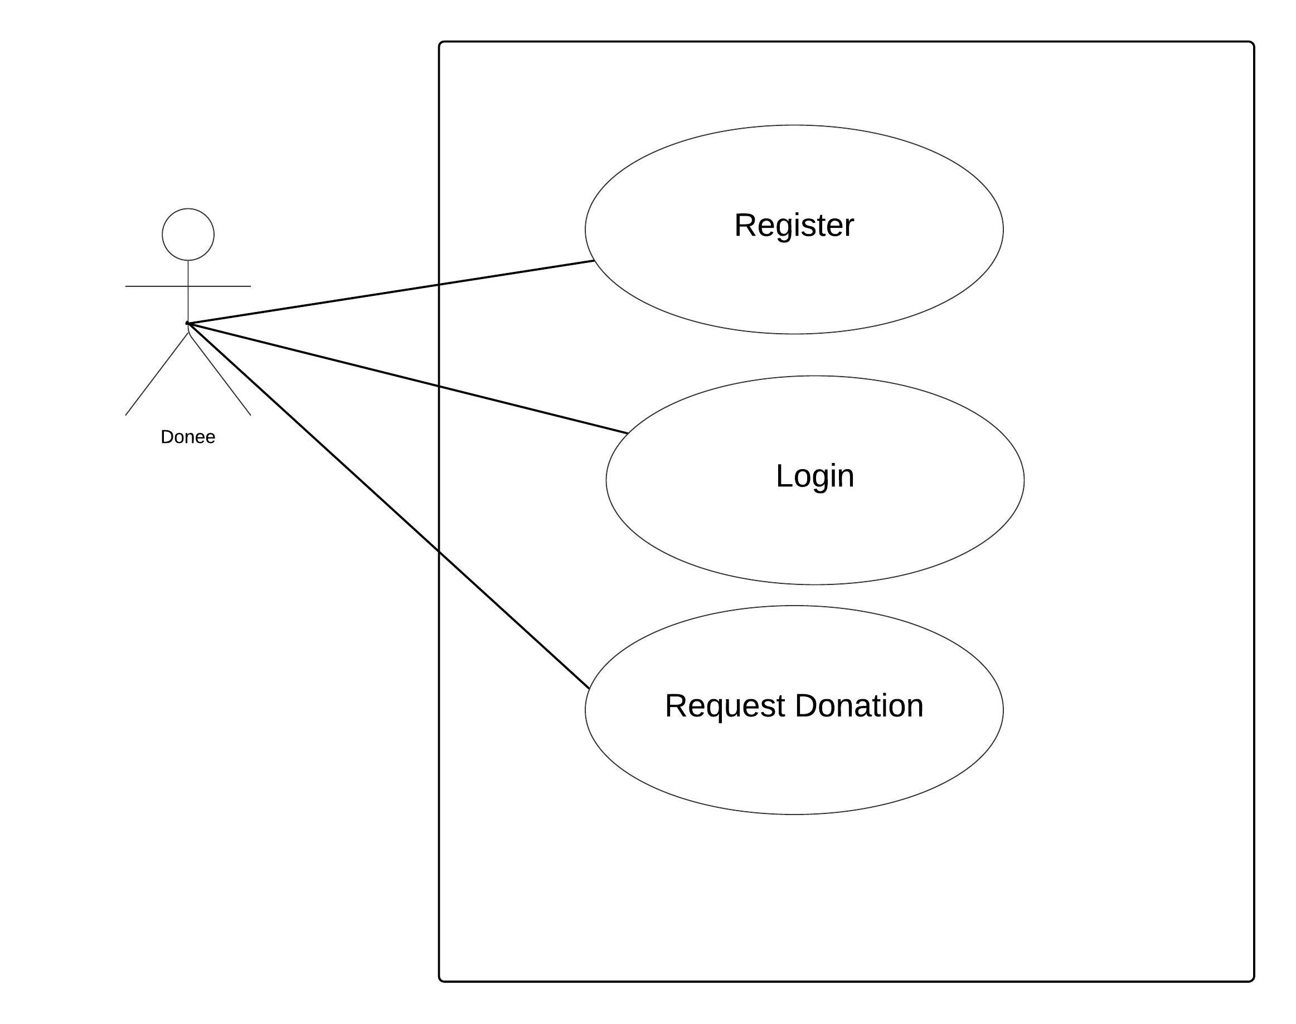

**Fig.3.1 Use case diagram of Donee**

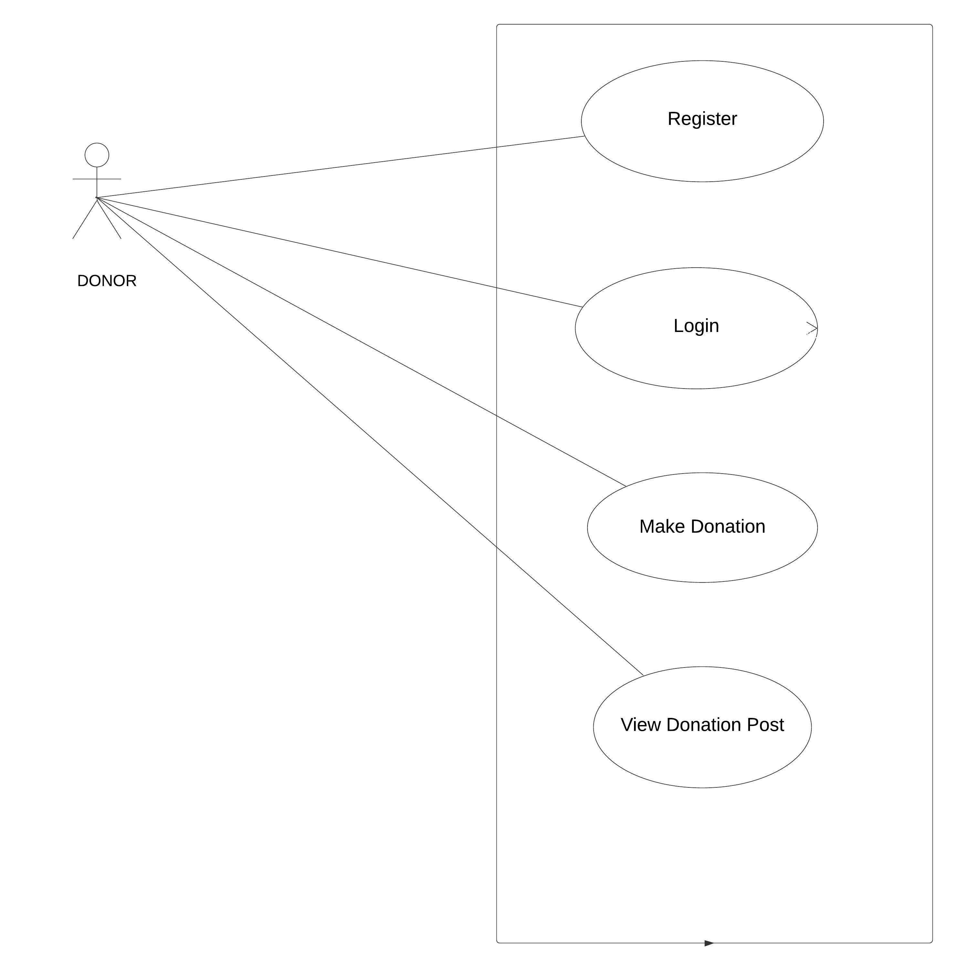

**Fig.3.2 Use case diagram of Donor**

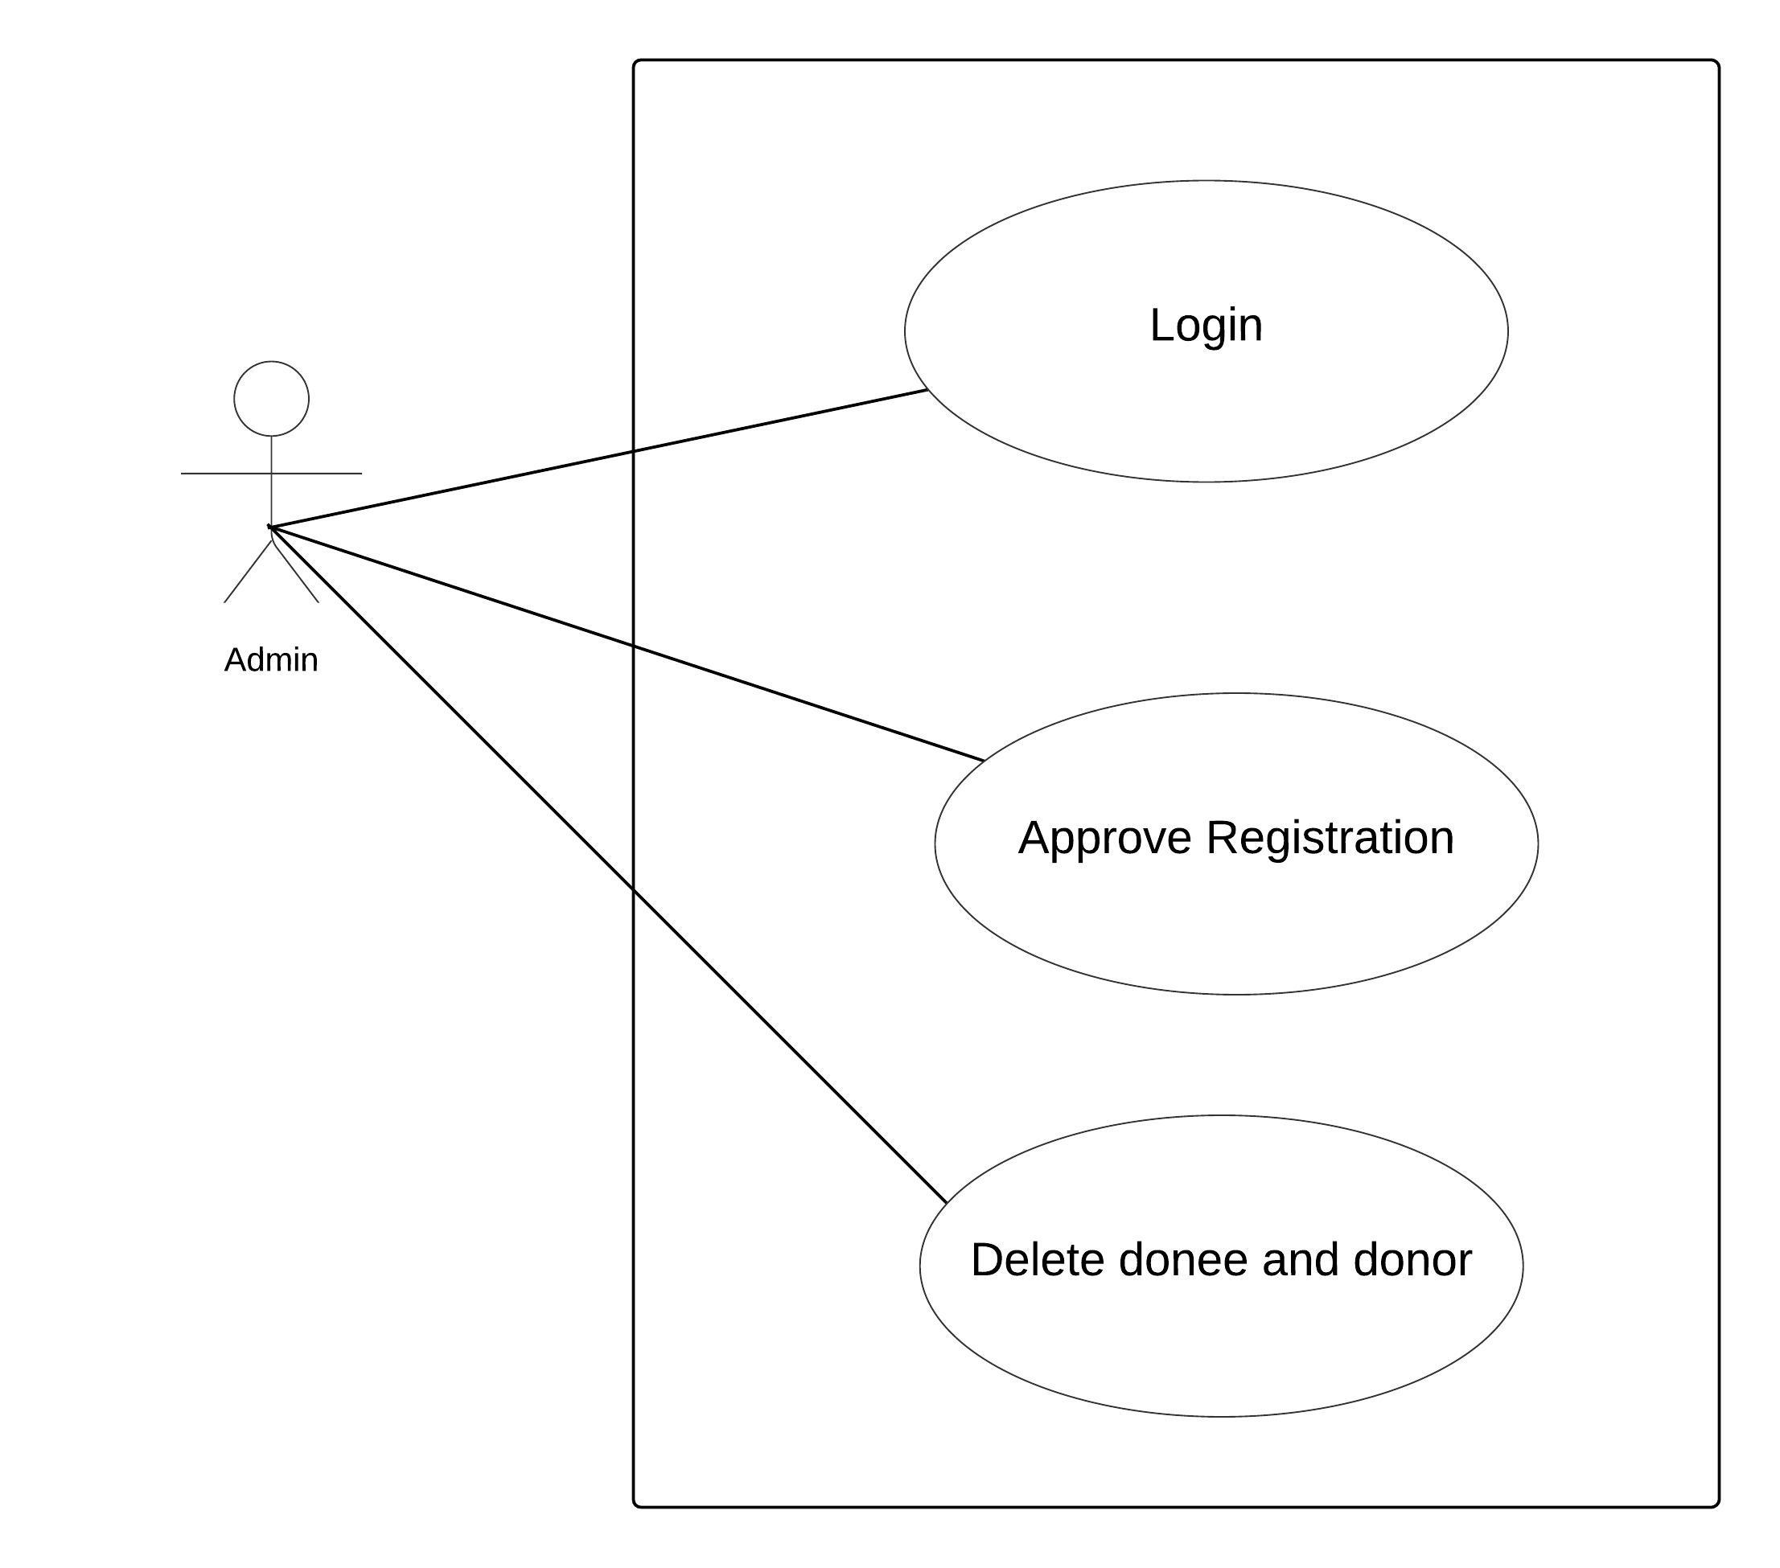

**Fig.3.3 Use case diagram of Admin**

**Use Case UC1:**

The general steps involved in Use case diagram of admin use case are as follows:

Step 1: Admin has to login first.

Step 2: Admin approves registration.

Step 3: Admin delete donee and donor.

**Use Case UC2:**

The general steps involved in use case diagram of donee use case are as follows:

Step 1: Donee has to register first.

Step 2: Then, donee will login in their account.

Step 3: Donee will request for donation through their account.

**Use Case UC3:**

The general steps involved in use case diagram of donor use case are as follows:

Step 1: Donor has to register first.

Step 2: Then, donor will login in their account.

Step 3: Donor view donation posts.

Step 4: Donor makes donation.

**3.1.2 SYSTEM SEQUENCE DIAGRAM**

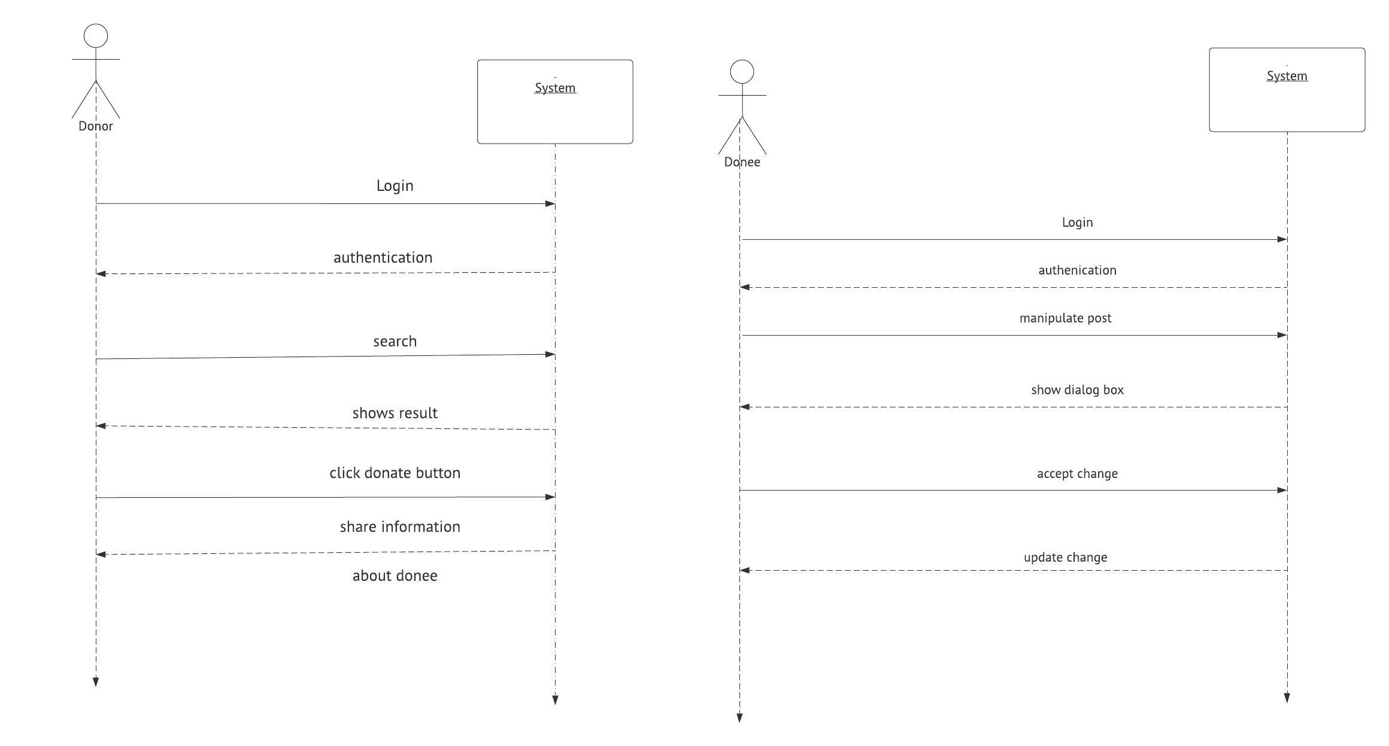

**Fig.3.4 SSD of Donor and Donee**

**3.1.3 ENTITY RELATIONSHIP DIAGRAM**

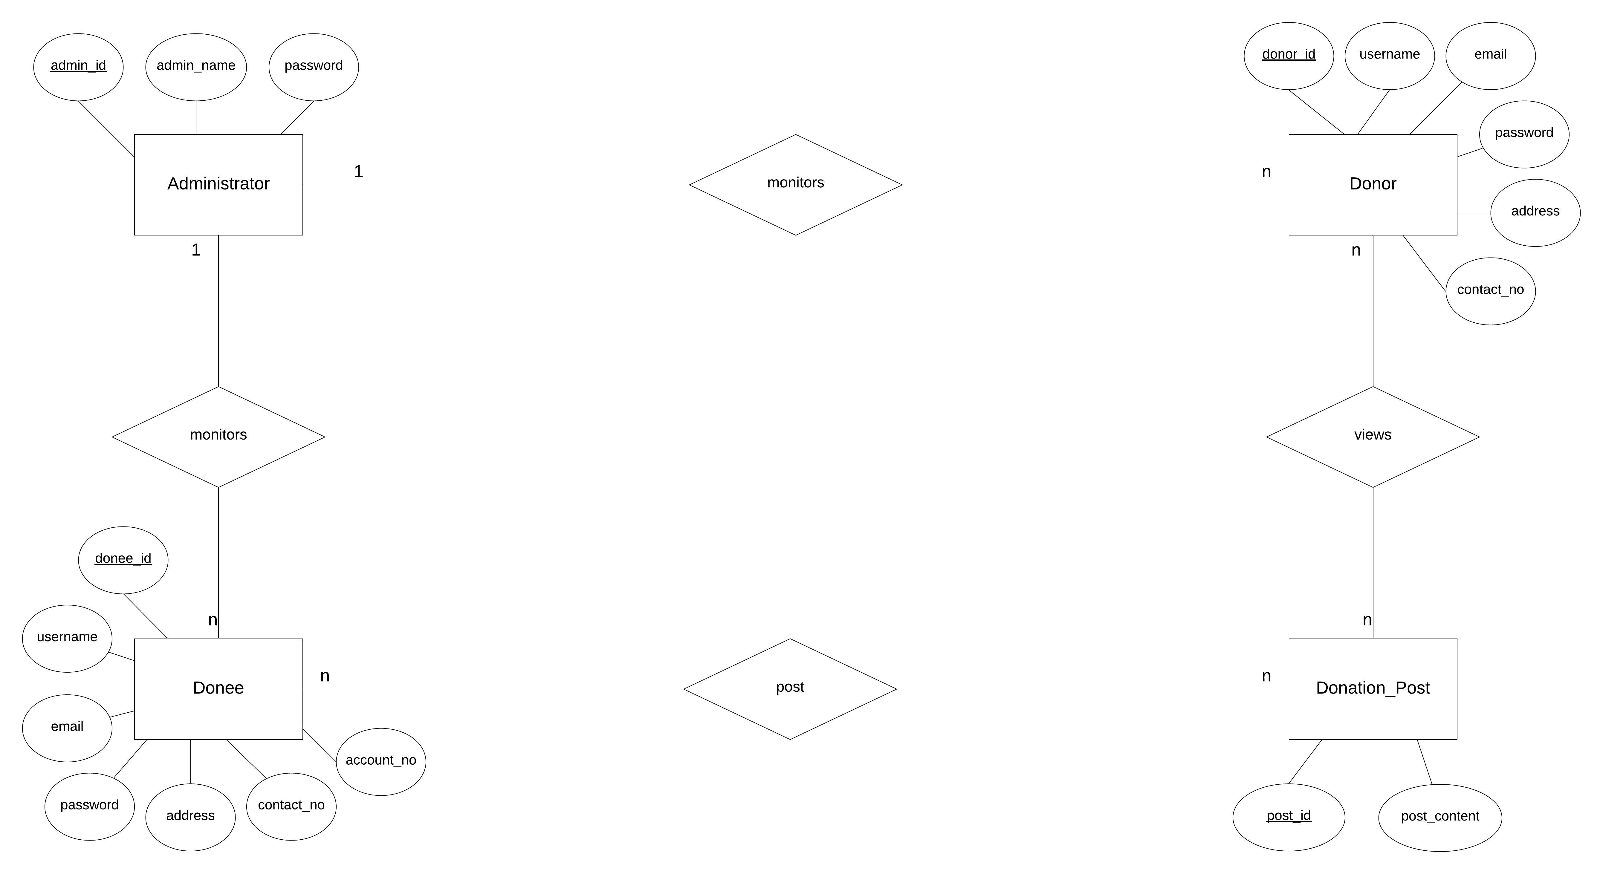

**Fig.3.5 ER-diagram of *Khulla Mann***

**Chapter 4**

**TIMELINE CHART**

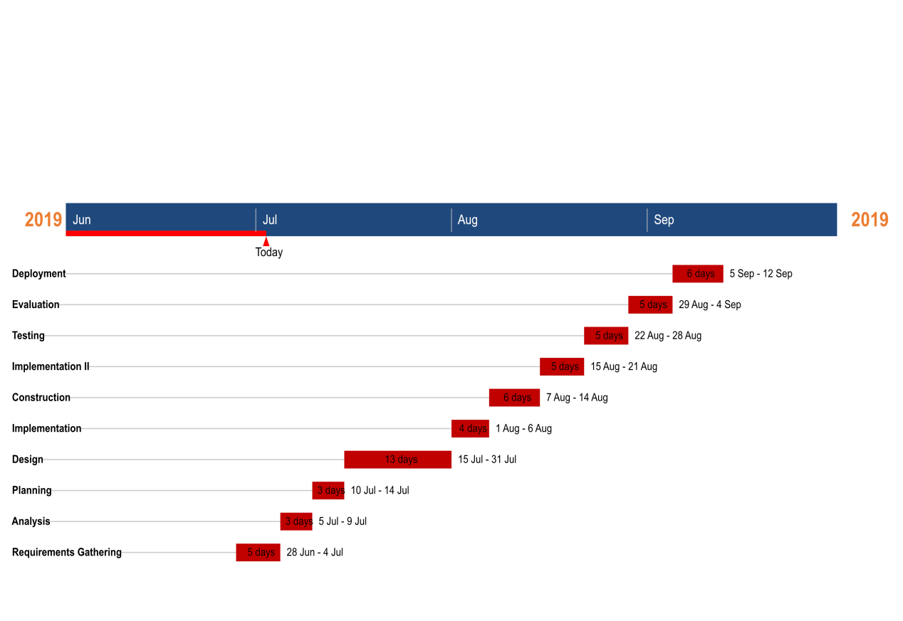

**Fig.3.6 TIMELINE CHART**

**BIBLIOGRAPHY**

CrowdRise.(2010, May 19) Retrieved July 2019, from *https://www.crowdrise.com*

Fundly.(2009) Retrieved July 2019, from *https://fundly.com*

Kickstarter.(2009, April 28) Retrieved July 2019, from *https://www.kickstarter.com*

Rally.(2009) Retrieved July 2019, from *https://rally.org*

Start Some Good.(n.d.) Retrieved July 2019, from *https://startsomegood.com*