# APPROVAL CERTIFICATE

# ABSTRACT

Every school, college, and university maintain the attendance of the students. There is still paper-based attendance system that needs paper for marking students’ attendance. This manual attendance record system is not efficient and requires more time to arrange record and to calculate the average attendance of each student.

“ATTEND” is an Android mobile application for taking attendance of students. Besides taking attendance, this system can be used to generate a systematic report of each individual student and graph of every class attendance as well. Attendance data can be stored safely and it also saves the time to convert the papers’ attendance to digital format.

**TABLE OF CONTENTS**

APPROVAL CERTIFICATE i

ABSTRACT ii

LIST OF ABBREVIATIONS v

LIST OF FIGURES vi

INTRODUCTION 1

1.1 BACKGROUND 1

1.2 PROBLEM STATEMENT 1

1.3 OBJECTIVE 1

1.4 IMPLICATION 2

LITERATURE REVIEW 3

2.1 BIOMETRIC ATTENDANCE SYSTEM 3

2.2 RADIO-FREQUENCY IDENTIFICATION 4

TOOLS AND METHODOLOGY 5

3.1 REQUIRED TOOLS 5

3.2 DESIGN 6

3.2.1 USECASE DIAGRAMS 6

3.2.2 SYSTEM SEQUENCE DIAGRAM 8

3.2.3 ENTITY RELATIONSHIP DIAGRAM 9

TIMELINE CHART 10

Bibliography 11

# LIST OF ABBREVIATIONS

ERD : Entity Relationship Diagram

SSD : System Sequence Diagram

SQL : Structured Query Language

UML : Unified Modeling Language

XML : Extensible Markup Language

# LIST OF FIGURES

Figure 3.1: Use Case Diagram for Administrator

Figure 3.2: Use Case Diagram for Teacher

Figure 3.3: SSD for Attendance System

Figure 3.4: ER Diagram for Attendance System

Figure 4.1: Timeline Chart

# Chapter 1

# INTRODUCTION

## BACKGROUND

Most of the educational institutes uses manual process to monitor the students’ attendance. In a manual system, teacher will mark down the students’ daily attendance in the record book, then at the end of the month the teacher is responsible to update the record by calculating the percentage of students’ attendance. So, we thought of taking the classic approach to a modern android mobile application to take the students’ attendance.

## PROBLEM STATEMENT

The current problem is the management of students’ attendance still done in a manual process. In this process, the educational institute must spend lots of money to buy paper and pens. Furthermore, there is a possibility of misplacing the attendance sheets. Not only this but later they need to calculate the percentage of students’ attendance.

## OBJECTIVE

The main objective of our project is to implement and deliver a well-functioning attendance system.

## IMPLICATION

This system can be used by all educational institutions to manage their students’ attendance easily and systematically.

Chapter 2

# LITERATURE REVIEW

Most educational institution’s administrators are concerned about student irregular attendance, which may affect the student's overall academic performance and finally, it affects the student's growth in education. The manual process of taking and maintaining attendance is non-efficient. Therefore, the student attendance management system is required to assist the faculty and the lecturer. There are many proposals for Attendance Systems in the literature and in the market. In this section, we will mention briefly a few of these proposals.

## 2.1 BIOMETRIC ATTENDANCE SYSTEM

Biometrics are biological measurements- or physical characteristics - that can be used to identify individuals. Finger mapping, facial recognition, and retina scans are all forms of biometric technology. Face recognition and fingerprint matching are the most popular biometric technique used to develop the attendance system. In the proposal (Shehu, 2010) ,it uses real-time face detection algorithms integrated on an existing Learning Management System (LMS). It automatically detects and registers students attending a lecture. The system represents a supplemental tool for instructors, combining algorithms used in machine learning with adaptive methods used to track facial changes during a longer period of time. In the proposal (Saraswati, 2010), it uses a fingerprint verification technique. They propose a system in which fingerprint verification is done by using the extraction of minutiae technique and the system that automates the whole process of taking attendance. The biometric attendance system requires integration and/or additional hardware and cannot be reset once compromised.

## 2.2 RADIO-FREQUENCY IDENTIFICATION

RFID based attendance system comprises of hardware, known as interrogators or readers and tags also known as labels as well as RFID software and RFID middleware. RFID tags are of two types, which include Active tags and Passive tags. Depending on mobility, RFID readers are classified into two types, fixed RFID and mobile RFID. In this system, each student is issued an RFID tag. Whenever the card is placed near the reader, it will take attendance. The RFID attendance system is secured, but there is a chance of misusing the cards. One person can give another person’s attendance if he/she had an RFID card. If the card was swiped for more than once, there is a chance of giving attendance for the next days also if the code is not written properly.

Chapter 3

# TOOLS AND METHODOLOGY

## 3.1 REQUIRED TOOLS

The tools required are:

1. Java, MySQL, HTML, CSS, PHP and JavaScript language
2. Android Software Development Kit and Android Studio
3. XML: For UI designs
4. GitHub: For Version Control
5. Apache: For Server

## 3.2 DESIGN

### 3.2.1 USECASE DIAGRAMS

There are two users of our system and their use cases are shown below:

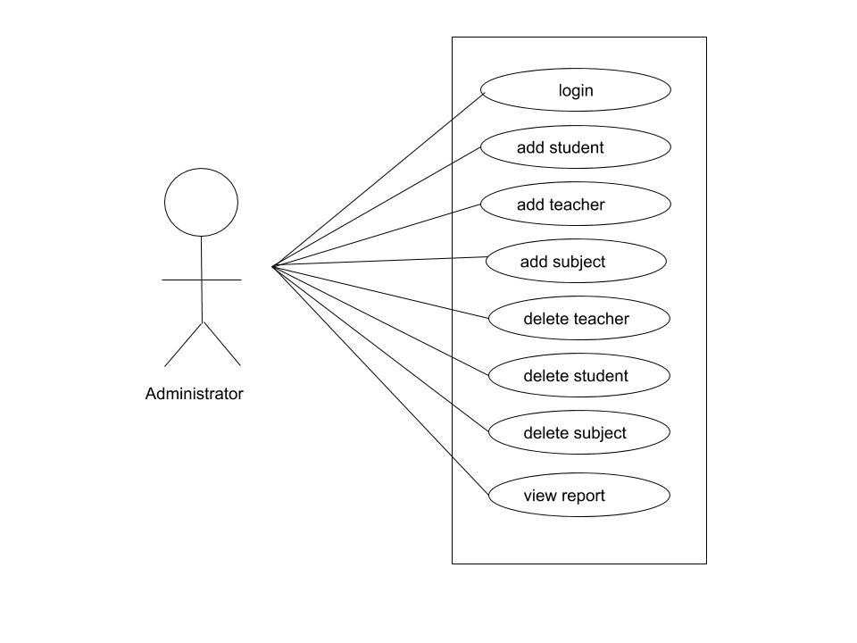Figure 3.1: Use case diagram for administrator

As shown in above use case diagram for administrator, administrator can log in to the system. Administrator can add and delete the information of student, teacher and their subjects. Administrator can view the report of each class.

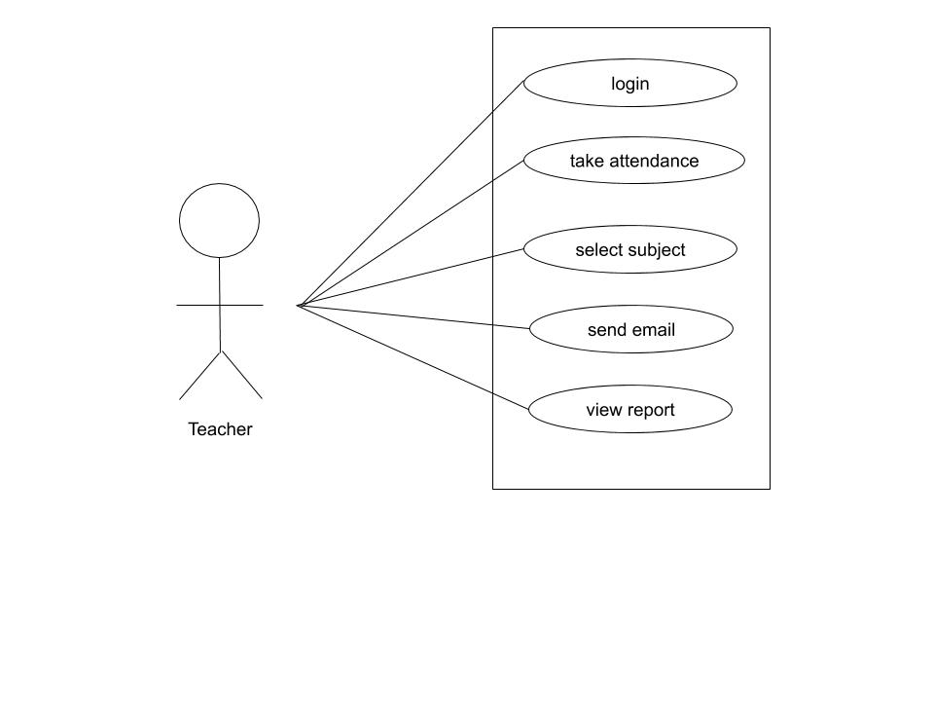

Figure 3.2: Use case diagram for teacher

As shown in above use case diagram for teacher, teacher can log in to the system. Teacher selects subject and marks the attendance of students. Teacher can view the report of each class.

### 3.2.2 SYSTEM SEQUENCE DIAGRAM

Figure 3.3: System Sequence Diagram

Abovesequence diagram illustrates how the system interacts with the user (administrator and teacher). It shows how our system interacts with user to perform different functions.

### **3.2.3 ENTITY RELATIONSHIP DIAGRAM**

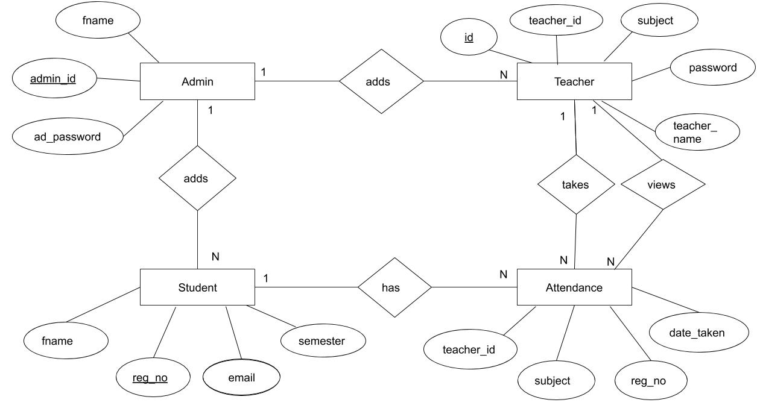

3.4: ER Diagram

Chapter 4

# TIMELINE CHART

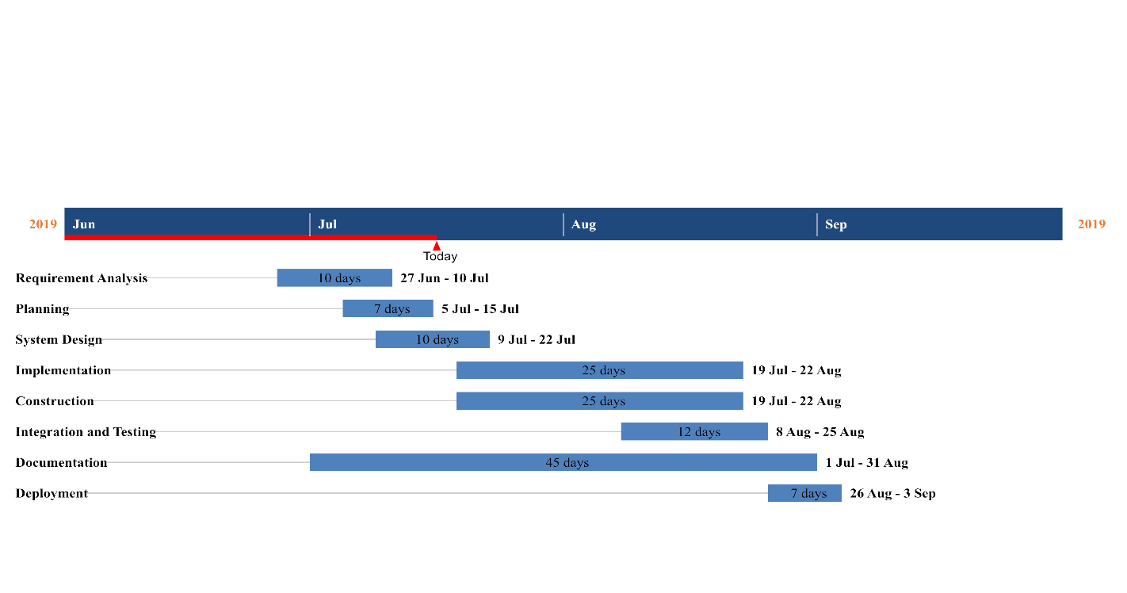Figure 4.1: Timeline Chart

# Bibliography

Saraswati, C., 2010. An Efficient Automatic Attendance System using Fingerprint Verification Technique. *International Journal on Computer Science and Engineering.*

Shehu, V., 2010. Information Technology Interfaces. *Using real time computer vision algorithms in automatic attendance management systems.*