Software Requirements Specification

June 21, 2020

Hotel Management System

Marah Al-hallak

Hiba Mohamad Agha

<<Any comments inside double brackets such as these are *not* part of this SRS but are comments upon this SRS example to help the reader understand the point being made.

Refer to the SRS Template for details on the purpose and rules for each section of this document.

This work is based upon the submissions of the Spring 2004 CS 310. The students who submitted these team projects were Thomas Clay, Dustin Denney, Erjon Dervishaj, Tiffanie Dew, Blake Guice, Jonathan Medders, Marla Medders, Tammie Odom, Amro Shorbatli, Joseph Smith, Jay Snellen, Chase Tinney, and Stefanie Watts. >>

# Table of Contents

# 

Contents

Table of Contents i

1.0. Introduction 1

1.1. Purpose 1

1.2. Scope of Project 1

1.3. Glossary 2

1.4. References 2

1.5. Overview of Document 3

2.0. Overall Description 4

2.1 System Environment 4

2.2 Functional Requirements Specification 4

2.2.1 Recipient Use Case 4

2.2.2 Manager Use Case 5

# 1.0. Introduction

## 1.1. Purpose

The purpose of this document is to present a detailed description of the Hotel Booking System. It will explain the purpose and features of the system, the interfaces of the system, what the system will do, the constraints under which it must operate and how the system will react to external stimuli. This document is intended for both the stakeholders and the developers of the system and will be proposed to the Regional Historical Society for its approval.

## 1.2. Scope of Project

The introducing software, Hotel Management System which is going to be implemented will automate the major operations of the hotel. The Reservation System is to keep track in room and hall reservation and check availability. The Room Management System is for manage all room types room services. The Inventory Control System will keep track in all inventories of the hotel and guest details will handled by guest management. Administration department will monitor the all. There is three End Users for HMS. The End Users are Owner, Manager and Receptionist. Owner can access to all system functionalities without any restrictions. Manager can access to all system functionalities with limited restrictions. Receptionist can only access to the Reservation management section. To keep restrictions for each End User levels HMS can create different Login functions.

The objectives of the automated Hotel Management System is to simplify the day to day processes of the hotel. The system will be able to handle many services to take care of all customers in a quick manner. As a solution to the large amount of file handling happening at the hotel, this software will be used to overcome those drawbacks. Safety, easiness of using and most importantly the efficiency of information retrieval are some benefits the development team going to present with this system. The system should be user appropriate, easy to use, provide easy recovery of errors and have an overall end user high subjective satisfaction.

## 1.3. Glossary

|  |  |
| --- | --- |
| **Term** | **Definition** |
| Manager | Person managing the hotel system |
| Database | Collection of all the information monitored by this system. |
| Owner | Person who controls the system |
| Recipient | Person who receipt guests and find rooms for them |
| Guest | Anyone visiting the hotel to stay. |

## 1.4. References

IEEE. *IEEE Std 830-1998 IEEE Recommended Practice for Software Requirements Specifications.* IEEE Computer Society, 1998.

## 1.5. Overview of Document

The next chapter, the Overall Description section, of this document gives an overview of the functionality of the product. It describes the informal requirements and is used to establish a context for the technical requirements specification in the next chapter.

The third chapter, Requirements Specification section, of this document is written primarily for the developers and describes in technical terms the details of the functionality of the product.

Both sections of the document describe the same software product in its entirety, but are intended for different audiences and thus use different language.

# 2.0. Overall Description

## 2.1 System Environment

The Hotel Management System has three active actors and one cooperating system.

The Receptionist who receipt guests and find room for them , Manager manages rooms and staff , and Owner

## 2.2 Functional Requirements Specification

### 2.2.1 Recipient Use Case

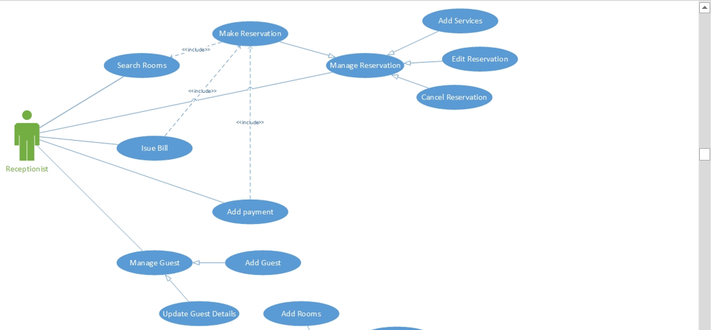

#### Use case: Search Rooms

**Brief Description**

The recipient search for an appropriate room for the new guest considering the Period, Check-in, Check-out, Guest

#### Use case: Issue Bill

**Brief Description**

Recipient issues a validated printed bill contains Billing no, Quantity, Price, Taxes, Date, Services, Unit

#### Use case: Add Payments

The Recipient records the new payments in the database as Total, pay time, Credit card details

### 2.2.2 Manager Use Case

غغهع‘

#### Use case: Manage Rooms

**Brief Description**

The Manager Adds, deletes, and edit details for a room

#### Use case: Manage staff

**Brief Description**

The Manager Adds, deletes, and edit details for staff

#### Use case: Manage inventory

**Brief Description**

The Manager Adds, deletes, and edit details for items in inventory

#### Use case: Reports

**Brief Description**

Manager makes daily financial reports

### 2.2.3 Owner Use case

### 

#### Use case: set room rate

**Brief Description**

The Owner sets room rate to hotel room in system

#### Use case: View financial reports

**Brief Description**

Owner can view a financial report for specific time

#### Use case: Take backup

**Brief Description**

Owner can take a backup for system

#### Use case: Manage Users

**Brief Description**

Owner can add, edit, delete users

## 2.3 User Characteristics

## Owner:-

Hotel owner has the privilege of Monitoring and authorization of all the tasks handle by the system. He can access every function performed by the system. Owner of the company as well as the system can access to the administration panel which is consider the core of the system. As the main authorized person of the company owner gets the ability to manage the other users including their user levels and privileges. Taking backups of the system and restoring system can also be done by the Owner. Meanwhile he will be able to take all the kinds of reports available in the system. As the owner of the system and the company he has the power to set room rates as well. Hotel owner has the sole right of deleting a staff member from the system database.

##### Manager:

Manager is responsible for managing resources available in hotel management system. Manager also has most of the privileges mentioned above except the things regarding the payment handling. The reason for using a Manager is to reduce the work load done by the owner that cannot be assigned to the receptionist, as those tasks seem much responsible. The user level, Manager has the authority to take all the reports available in the system but here also except the reports related to financial stuff, hotel income. Manager has other abilities that receptionist, user level has. Such as, adding new staff member to the system, Modifying them or removing them, Adding new guests to the system, Modifying them and removing them from the system, Adding new inventory to the system, Modifying them and removing them. Adding new room types to the system, modifying them and removing them

##### Receptionist:

As a hotel receptionist, he or her role will be to attain the goals of bookings and to ensure that all guests are treated with a high standard of customer service. Hierarchically receptionist role has the least accessibility to the system functions. Receptionist plays the boundary role of the system. He or she can perform limited functions such as registering new guest to the system, make reservations, Sending e-mail reminders to clients for booking confirmation. Management of hotel will prefer to hire receptionist who have a good standard of general education and possibly in subjects such as English, math and IT.

## Non-Functional Requirements

## 2.4.1 Performance Requirements

Performance requirements define acceptable response times for system functionality. Although the system is developed suiting for the least system performances, the performance of the system will highly depend on the performance of the hardware and software components of the installing computer. When consider about the timing relationships of the system the load time for user interface screens shall take no longer than two seconds. It makes fast access to system functions. The log in information shall be verified within five seconds causes’ efficiency of the system. Returning query results within five seconds makes search function more accurate.

## 2.4.2 Safety Requirements

There are several user levels in hotel management system, Access to the various subsystems will be protected by a user log in screen that requires a user name and password. This gives different views and accessible functions of user levels through the system. Maintaining backups ensure the system database security. System can be restoring in any case of emergency.

## 2.4.3 Security Requirements

Customer Service Representatives and Managers and owner will be able to log in to the Hotel Management System. Customer Service Representatives will have access to the Reservation/Booking and subsystems. Managers will have access to the Management subsystem as well as the Reservation/Booking subsystems. Owner has the maximum privilege to all subsystems. Access to the various subsystems will be protected by a user log in screen that requires a user name and password.

## 2.4.4 Software Quality Attributes

* Availability: - The system shall be available during normal hotel operating hours
* Correctness: - extent to which program satisfies specifications, fulfills user’s mission objectives
* Efficiency: - How much less number of resources and time are required to achieve a particular task through the system.
* Flexibility: - Ability to add new features to the system and handle them conveniently.
* Integrity: - How the system would insecure the information in the system and how it avoids the data losses. Referential integrity in database tables and interfaces
* Maintainability: - How easy is to keep the system as it is and correct defects with making changes.
* Portability: - The Hotel Management System shall run in any Microsoft Windows environment
* Reliability: - Specify the factors required to establish the required reliability of the software system at time of delivery. Mean time between failures and mean time to recovery
* Reusability: - What is the ability to use the available components of the system in other systems as well.
* Testability: - Effort needed to test to ensure performs as intended
* Usability: - How easily a person can be taken the benefits of the system and the user friendliness.
* Robustness: – Strength of the system to handle system functions accurately and maintain the database without facing to unexpected failures
* Maintainability: – What design, coding standards must be adhered to exclusions created

# 3.0. Requirements Specification

## 3.1 External Interface Requirements

## User Interfaces

* User friendly dashboard of system
* Login interface is used to login to the system using username and password for three different users
* Make a new reservation interface
* View reservations interface
* Staff management interface
* Users management interface
* Guests management interface
* Rooms Management interface

## Hardware Interfaces

Section 2.4 includes the requirements of the desktop computer where the system going to be installed. A specific computer must match with the above mentioned requirements in order to gain the maximum benefits from the system in an efficient manner.

Reservation alerts will be sent to the one of the member of hotel staff as an e-mail notification. So there is a need of broadband internet connection. Client should able to keep a stable internet connection.

A laser printer will be needed when printing bills and several reports

## Software Interfaces

The computer this software going to be install need to have Windows Operating System equal or above, Windows 7. On that Windows platform .Net 4.0 will be installed and that will be the platform the particular software will be run. There will be an ADO.NET data transmission with the Microsoft SQL Server Management Studio Express 2010 R2 edition that will be installed in the same computer.

## Communications Interfaces

When a specific reservation reserved at the same time an e-mail notification will be sent to both relevant staff member’s e-mail account and guest’s account. Guest will be notified in the check-out date. To achieve that functionality, it requires having a stable internet connection. Mostly a broadband connection with the client’s computer will provide the efficient service.