What are the six main reasons that people choose to use Python?
- Python is easy to learn and use: Python's simple and has straight-forward syntax with an emphasis on natural language. For new programmer it has very good documentation and developer support. Plus, the developer community is incredibly active. That means any time someone needs help or support, they can get it in a timely manner.
- Python Has huge collection of Libraries: Python has vast libraries available for reference, from NumPy and SciPy for scientific computing to Django for web development.
- Compatible with Major Platforms and Systems: Python is supported by many operating system. As Python is an interpreted programming language. It allows you to you to run the same code on multiple platforms without recompilation.
- Python is flexible: Python is used in a wide array of industries and for a long list of different usages, from websites and web applications to systems administration, voice over IP, and desktop apps. You’re not bound to a single platform or domain, and it offers the same experience everywhere.
- Job Prospects: Python is an open-source programming language. Enterprises are using open-source software to build business-critical applications. That's because dynamic languages are an excellent solution for fast time-to-market for enterprise applications. Hence there are many job opportunities for software engineers.
- Python gives you tried and tested scalability: Python makes easier to perform coding and testing simultaneously by adopting test driven development (TDD) approach. You can easily write the required tests before writing code and use the tests to assess the application code continuously. No one can really predict when your user numbers will start surging and scalability will become a priority. This is why it’s a good idea to use a language that scales great and, as we’ve mentioned above, is easy to maintain.
Name four notable companies or organizations using Python today.
- Google: Python is one of the official Google server-side languages. “Python where we can, C++ where we must.”
- Facebook: Python is currently responsible for multiple services in infrastructure management.
- Spotify: Use python primarily for data analysis and back-end services.
- Quora
Why might you not want to use Python in an application?
- Python is slower than several widely used programming languages including Java and C++.
- Python is not a very good language for mobile development.
- Python's memory consumption is also high because of the flexibility of the data-types.

What can you do with Python?
- Web Development
- Machine Learning
- Data Analysis / Visualization
- Game Development
- Desktop Application
What’s the significance of the Python import this statement?
The import statement allows us to import one or more modules into our Python program. In a Python file, this will be declared at the top of the code. For Example, to use randint() which calls the function to return a random integer we need to import random module, shown as following:
- import random

- for i in range(10):
- print(random.randint(1, 25))

Why does “spam” show up in so many Python examples in books and on the Web?
Variable name in Python, built upon NumPy and SciPy for the analysis and manipulation of 3D and 2D data sets in material science, be they from x-ray tomography, random fields or any other source.
What is your favorite color?
Green
What is the Python interpreter?
The Python interpreter takes the code that we write and converts it into the language that the computer’s hardware understands. The Python interpreter is a bytecode interpreter: its input is instruction sets called bytecode. Bytecode is an intermediate representation of Python code: it expresses the source code that you wrote in a way the interpreter can understand.
What is source code?
Source code is the language or string of words, numbers, letters and symbols that a computer programmer uses. It can be read and easily understood by a human being. Source code will be transformed into binary machine code (1’s and 0’s) tells a computer what to perform. It the foundation of every thing we do on a computer. Python is an open-source programming language.

What is byte code?
Bytecode is program code that has been compiled from source code into low-level code designed for a software interpreter. Bytecode is an intermediate representation of Python code: it expresses the source code that you wrote in a way the interpreter can understand.
What is the PVM?
A parallel virtual machine (PVM) is a distributed computing system that's created through a series of parallel computers, which are all merged together to be displayed as a unified virtual machine. This software framework creates a distributed computing architecture from a parallel connected system that works as a single unit to process any high-end computing task. Python automatically stores byte code in files with a .pyc extension.
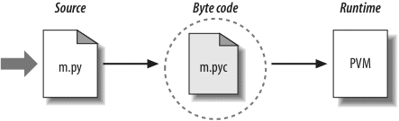
Name two or more variations on Python’s standard execution model.
Name of different variations on Python’s execution model are as follows:
- CPython
- Jython
- IronPython
All implement the same Python language but execute programs in different ways.
How are CPython, Jython, and IronPython different?
- CPython: It is coded in portable ANSI C language code. CPython allows Python to script C and C++ components. CPython tends to run the fastest, be the most complete, and be more robust than the alternative systems.
- Jython: It is targeted for integration with the Java programming language. Jython’s goal is to allow Python code to script Java applications. Jython includes integration support that allows Python code to import and use Java classes as though they were coded in Python. Jython is slower and less robust than CPython.
- IronPython: IronPython is designed to allow Python programs to integrate with applications coded to work with Microsoft’s .NET Framework for Windows, as well as the Mono open-source equivalent for Linux. IronPython allows Python programs to act as both client and server components, accessible from other .NET languages.
What are Stackless and PyPy?
Stackless is a Python programming language interpreter which doesn’t depend upon C call stack for its own stack. It uses the C stack but the stack is cleared between function calls.
PyPy is an alternative implementation of the Python programming language to CPython (which is the standard implementation). PyPy often runs faster than CPython because PyPy is a just-in-time compiler while CPython is an interpreter. we start with source code written in RPython, apply the RPython translation toolchain, and end up with PyPy as a binary executable.
How can you start an interactive interpreter session?
To start a Python interactive session, just open a command-line or terminal and then type in python, or python3 depending on your Python installation, and then hit Enter.
Where do you type a system command line to launch a script file?
You type system command lines in whatever your platform provides as a system console: a Command Prompt window on Windows; an xterm or terminal window on Unix, Linux, and Mac OS X; and so on.
Name four or more ways to run the code saved in a script file.
- Using the python Command
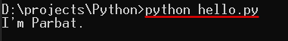
- Running Modules With the -m Option
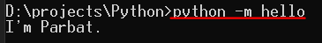
- Using the Script Filename
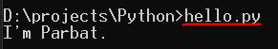
- IDE GUI selections such as IDLE’s Run→Run Module menu option.


Name two pitfalls related to clicking file icons on Windows.
- When we run the scripts that prints something then exit, output file also disappears immediately after the program execute. Because of which we cannot view the output.
- Error Message generated by our script also appear in output window that closes before we can examine its contents.
Why might you need to reload a module?
By Default, Python loads a module once per process only. Therefore, if we changed its source code and want to run the new version without stopping and restarting Python, we’ll have to reload it. We must import a module at least once before we can reload it.
How do you run a script from within IDLE?
Within the text edit window of the file, select the window’s Run→Run Module menu option. This runs the window’s source code as a top-level script file and displays its output back in the interactive Python shell window.
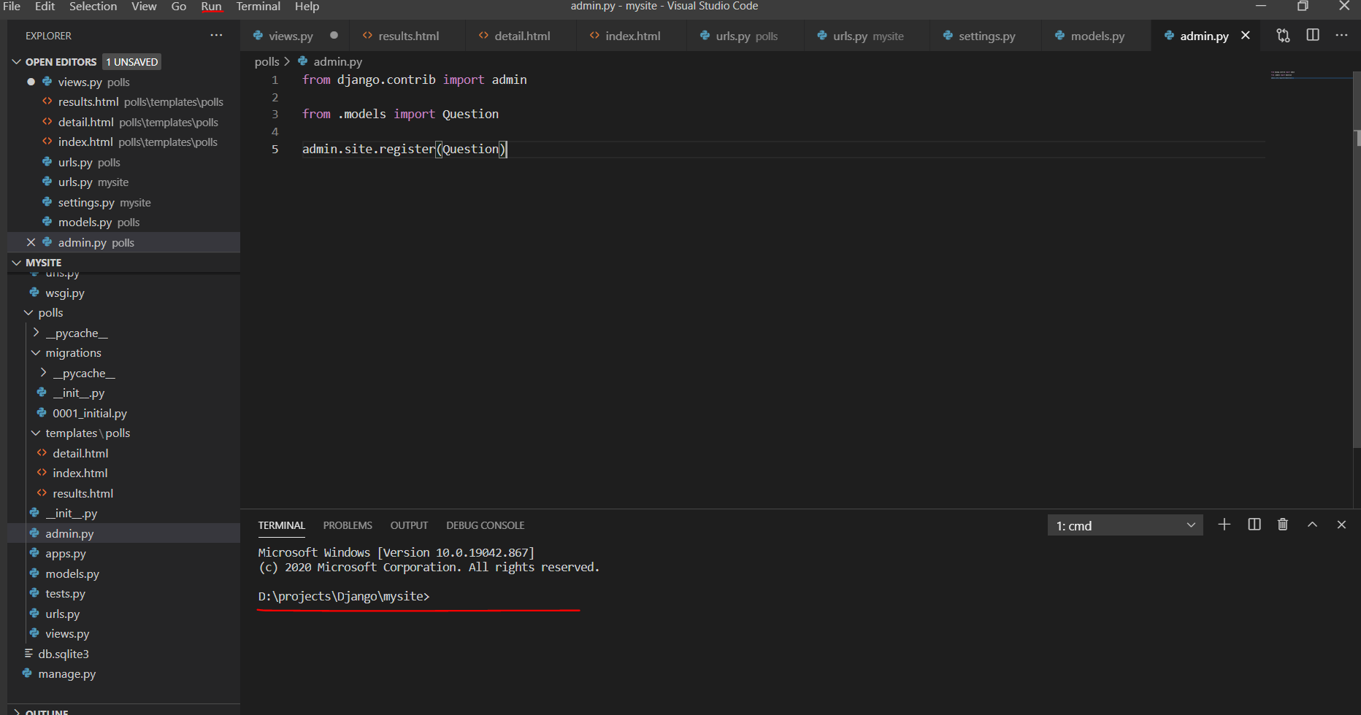
Name two pitfalls related to using IDLE.
- IDLE can still be hung by some types of programs—especially GUI programs that perform multithreading.
- Opening a file editor window or a shell window isn’t clear.

What is a namespace, and how does it relate to module files?
A namespace is just a package of variables (i.e., names). It takes the form of an object with attributes in Python. Each module file is automatically a namespace. A package of variables reflecting the assignments made at the top level of the file. Namespaces help avoid name collisions in Python programs: because each module file is a self-contained namespace, files must explicitly import other files in order to use their names.
Name four of Python’s core data types.
- Numbers
- Strings
- Lists
- Dictionaries
- Tuples
- Files
Why are they called “core” data types?
Because they are part of Python language in other word, they are effectively built into the Python language this implies that there is a specific syntax for generating most of them. we must call the built-in open function to create a file object.
What does “immutable” mean, and which three of Python’s core types are considered immutable?
Object that cannot be changed after it is created are known as immutable. The three Python’s core types object that are immutable are Numbers, strings, and tuples.
What does “sequence” mean, and which three types fall into that category?
A sequence is a positionally ordered collection of objects. Strings, lists, and tuples are all sequences in Python.
What does “mapping” mean, and which core type is a mapping?
Mapping denotes an object that maps keys to associated values. Python’s dictionary is the only mapping type in the core type set. Mappings do not maintain any left-to-right positional ordering.
What is “polymorphism,” and why should you care?
Polymorphism is a concept of Object-Oriented Programming, which means multiple forms or more than one form. Polymorphism enables using a single interface with input of different datatypes, different class or may be for different number of inputs. This turns out to be a key idea behind using Python well—not constraining code to specific types makes that code automatically applicable to many types.

