1. Business Concept Model

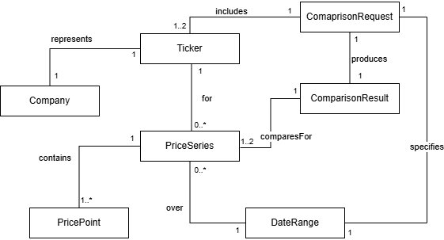

2. Use Case

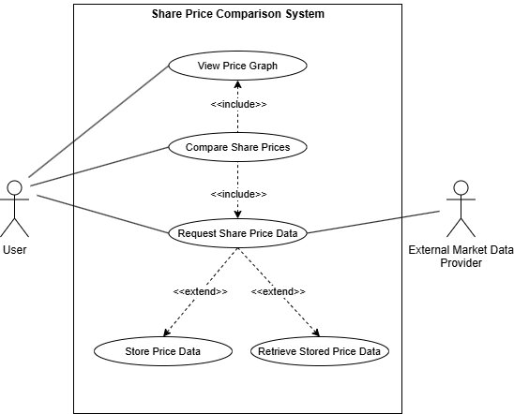

Use Case 1: Request Share Price Data
Actor: User
Goal: Obtain daily share price information for a selected ticker over a specified date range.
Actor Action | System Response
User opens request function | System displays input fields
User enters ticker symbol | System records ticker
User enters date range | System records dates
User submits request | System validates inputs
 | System checks date range limit
 | System requests data from external provider
 | System converts data into PriceSeries and PricePoints
 | System stores data locally
 | If external fails, system retrieves stored data
 | System returns price series
User views result | System displays data

Alternative Scenarios
Invalid Input | • System rejects request due to invalid ticker or dates  • User must re-enter valid input
Date Range Too Large | • System detects range exceeds 2 years  • System prompts user to adjust range
External Source Unavailable | • System fails to retrieve data from API  • Attempts local retrieval
Local Data Available | • Stored data exists  • System returns stored PriceSeries
No Data Available | • External & local retrieval both fail  • System informs user

Use Case 2: Compare Share Prices
Actor: User
Goal: Compare one or two companies’ share prices over a selected date range.
Actor Action | System Response
User opens comparison function | System displays input fields
User enters ticker | System records ticker
User enters date range | System records dates
User submits request | System validates input
 | System retrieves data for first ticker
 | System retrieves data for second ticker (if present)
 | System builds PriceSeries objects
 | System creates ComparisonResult
 | System sends result to display
User views result | System displays graph

Alternative Scenarios
One Ticker Only | - System creates a single-series comparison  - Displays single-company graph
One Dataset Missing | - One ticker fails retrieval  - System shows partial comparison or error
Both Datasets Missing | - No data retrieved  - System informs user
Invalid Input | - System rejects invalid ticker or date range

Use Case 3: View Price Graph
Actor: User
Goal: View a graphical representation of one or two price series.
Actor Action | System Response
User requests graph | System receives data to display
 | System prepares chart data
 | System generates graph
 | System labels graph
User views graph | System displays graph

Alternative Scenarios
Single Series | - System displays one line graph
Incomplete Data | - Missing points result in partial graph or error
Rendering Failure | - Graph cannot be generated  - System displays error

System Interfaces

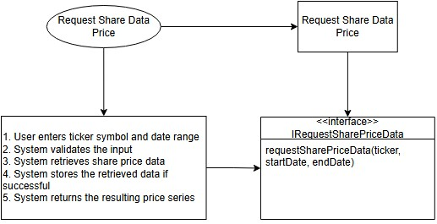

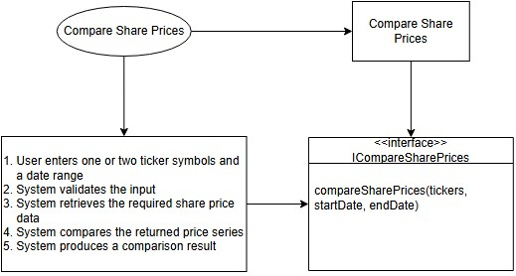

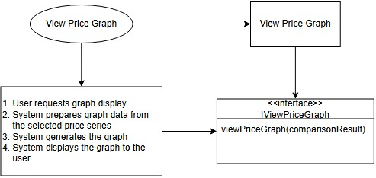

Business Type Model
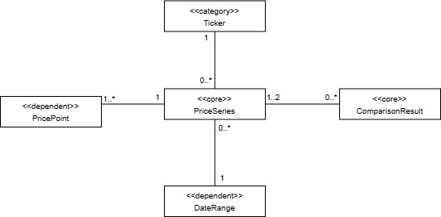
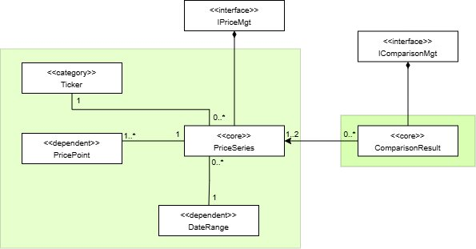
Core/Dependent/Categories
Initial System Architecture
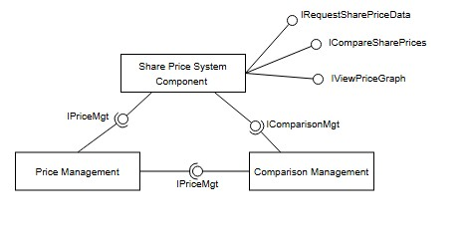
The initial system architecture was derived from the previously identified system interfaces and business interfaces. Following the starting assumption from the design process, one business component was allocated per business interface, and one system component was used to support all identified use cases. Therefore there are three main components: System Component, Price Management Component and Comparison Management Component.
The System Component implements the three system interfaces derived from the use cases: IRequestSharePriceData, ICompareSharePrices, and IViewPriceGraph. These interfaces were grouped into a single component because they are all user-facing, belong to the same application-level behaviour, and are likely to evolve together.
The Price Management Component implements the business interface IPriceMgt. This component is responsible for the price-series responsibility region, including the associated Ticker, DateRange, and PricePoint business types. These functions were grouped together because they all relate directly to obtaining, structuring, and managing share price series data.
The Comparison Management Component implements the business interface IComparisonMgt. This component is responsible for creating and managing ComparisonResult objects. It was kept separate from the price management responsibilities because comparison logic forms a distinct business concern, even though it depends on price-series data.
In this architecture, the System Component is the only component that implements more than one interface. Both business components implement only one interface each. A dependency exists between the Comparison Management Component and the Price Management Component though, as a comparison result is constructed from one or two price series.
The initial system architecture is derived at a coarse-grained level from the identified system interfaces and business interfaces. It translates well to the higher-level architecture of the component diagram from Sprint 1 that is refined in the implementation into more concrete components, including the User Interface, Comparison Service, Price Repository, Local Price Store, and Market Data Provider.

Business Interfaces
IPriceMgt
This interface is responsible for the price management region centred on PriceSeries, including Ticker, DateRange, and PricePoint.
Operation | Parameters | Return Type | Purpose
getPriceSeries | ticker, startDate, endDate | PriceSeries | Obtains the price series for a given ticker over a specified date range
storePriceSeries | priceSeries | void | Stores the retrieved price series for later offline use
validateDateRange | startDate, endDate | void | As the date range is a business rule, this business interface is needed

IComparisonMgt
This interface is responsible for the comparison region centred on ComparisonResult.
Operation | Parameters | Return Type | Purpose
createComparisonResult | tickers, startDate, endDate | Comparison Result | Creates a comparison result for one or two requested tickers over the specified date range
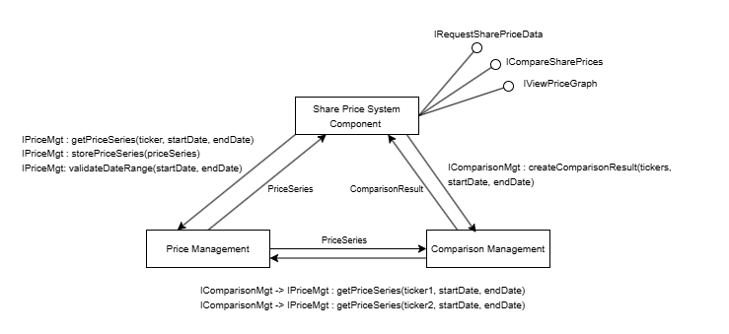
Collaboration Diagram
Initial System Architecture
The initial system architecture was derived from the system interfaces and business interfaces, resulting in three primary components:
- System Component
- Price Management Component
- Comparison Management Component
The System Component implements the system interfaces (IRequestSharePriceData, ICompareSharePrices, IViewPriceGraph). These are grouped together as they are user-facing operations driven by the same actor and are likely to evolve together.
The Price Management Component implements IPriceMgt and is responsible for managing price-series data, including PriceSeries, Ticker, DateRange, and PricePoint. These elements form a cohesive responsibility region centred on price data.
The Comparison Management Component implements IComparisonMgt and is responsible for producing ComparisonResult instances from one or two price series.
A dependency exists from the Comparison Management Component to the Price Management Component, as comparison operations require price-series data. The dependency is unidirectional, with price management remaining independent.

Architectural Principles
The architecture satisfies the Acyclic Dependencies Principle, as all dependencies form a directed acyclic structure: the System Component depends on both business components, and the Comparison Management Component depends on the Price Management Component, with no cycles present.
It also adheres to the Dependency Inversion Principle, as components depend on interfaces (IPriceMgt, IComparisonMgt) rather than concrete implementations. This ensures that high-level components remain independent of lower-level details.
A clear separation of concerns is maintained:
- the System Component handles orchestration,
- the Price Management Component handles data management,
- the Comparison Management Component handles comparison logic.
The grouping of price-related types reflects the Common Reuse Principle, as these elements are typically used together when processing share price data.

