# **ALX AICE: Milestone #1 Worksheet**

| **Tip: Review the** [**rubric for this milestone here**](https://docs.google.com/document/d/1CfpzexbUq72I6PITtX-IM5eXTrvhB5egyx-ZsrQB6jE/copy)**. It will guide you in achieving a good passing score.** |
| --- |

**Step 1: AI Toolkit**

Locate your own [copy of the AI Toolkit](https://docs.google.com/spreadsheets/d/11HJQIo3FncvMSBTs4fZ413aPBSmLrhXnfoXx5dqoeqA/copy) from your activity on [Building Your AI Toolkit.](https://intranet.alxswe.com/projects/100378)

Next, Click **"Share"** (under the 3 dots) and adjust the settings so that it looks like this:

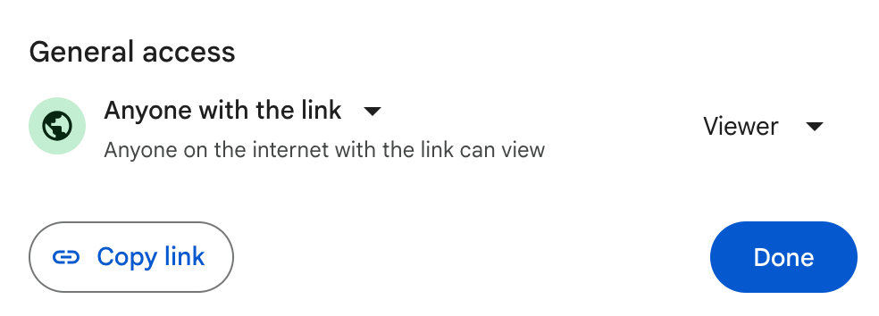

# **Then, copy the link and paste it into the box below.**

**Step 1: Your AI Toolkit**

| [AICE AI ToolKit_Habtamu_Wolde](https://docs.google.com/spreadsheets/d/1_lzTTNa11FUXXYNQqW-rTbZUhrh-9mqUyAPHh2iEo50/edit?usp=sharing) |
| --- |

*If you need more help with this, Google for video instructions on sharing files in Google Drive, or ask a peer.*

**Step 2: Reflection on the use of AI**

Take some time to think about the things you have learned about AI and how it may impact your future. After that, write a brief paragraph that answers the questions in the box below.

**To pass this part of your milestone, your reflection paragraph must answer all three questions. You can also write out the answers to each question in three separate sentences.**

**Step 2: Reflection on the use of AI**

| 1. *Which aspects of interacting with AI in your daily life are you most excited or concerned about?* 2. *In what ways do you think AI will impact your current or future career?* 3. *What are some of the ethical challenges posed by AI that you are most worried or curious about?* |
| --- |

**Reflection Paragraph here**

| Answers  1. In My Daily Life of using AI i feel both excited and concerned about some ideas. From these concepts, the most excited thing about using Ai to enhance and simplify daily chores of the life are, when i look for something specific and the thought that googling might give me vast answers to my random questions, I would love to ask those questions to ChatGPT, and it gives me answers which are specific and relevant. Nevertheless, the fact that these large language models can peek at the things I have requested and use it as a data source for its model enhancement purpose concerns me because my data might get the chance to be presented to someone as a response.  2. AI will have changed everyone’s daily life activities. Currently, I am using large language models like ChatGPT, Bard and Gemini for my Research as a text grammar checker, and the other AI that has changed my daily life is Duolingo. It helps me to learn a new language, currently I am learning Spanish and I enjoyed it. For the coming days and Years AI is going to be more useful for me to simplify my life.  3. I do not have experienced ethical challenges posed by AI that worried me for now, on the other hand it helped me in many aspects. |
| --- |



**Please go back to Savanna and continue with your learning content. You will be prompted on when to return to complete Part B.**

**Step 3: Target industry & role reflection and PICS**

Locate your [Personal Mission Statement Workshee](https://docs.google.com/document/d/1qEUdRGH5D37fKGXfN2oK-cby2zu0Rcg3X_U3Cp0PCSY/copy)t in your personal ALX AICE Google Drive.

**Make sure you have filled out the following in your personal mission statement worksheet:**

***Part 1: Reflection on Your Target Industry And Role***

* *Industry Exploration*
* *Role Identification*
* *Writing Your Industry Focus Statement*

***PART 2: Write down your PICS (You must state at least 2)***

* *Passions: What would you get out of bed for in the morning if money wasn’t an issue?*
* *Interests: What are you most curious about?*
* *Causes: What keeps you up at night?*
* *Strengths: What is your superhero power?*

Once you have confirmed that, click "Share" (under the 3 dots) and adjust the settings so that it looks like this:



Copy the link and paste it in the box below.

**Step 3 Target industry and role reflection and PICS**

| [Personal Mission Statement Worksheet - ALX_AICE_Habtamu_Wolde](https://docs.google.com/document/d/1S4YYFe20k3XBs1WmT_8cssfdPn6u7sBcqK-PAkOv1ZM/edit?usp=sharing) |
| --- |

**Step 4: AiCE Skills Tracker**

Locate your [AiCE Skills Tracker](https://docs.google.com/spreadsheets/d/1_N42QcmTeCikG3NiCePnsQFLTE8p8FU-lyAZ18Hnpog/copy) in your personal ALX AICE Google Drive.

Next, click "Share" (under the 3 dots) and adjust the settings so that it looks like this:



Copy the link and paste it in the box below.

**Step 4: AiCE Skills Tracker**

| [AICE Skills Tracker_Habtamu_Wolde](https://docs.google.com/spreadsheets/d/1K3ZNov2SZx7PwdaOc_ng7hnKBx5AeQXeyYJ0wkjjFo8/edit?usp=sharing) |
| --- |

| **Tip: Before submitting your milestone please check your work following the guidelines in the** [**rubric**](https://docs.google.com/document/d/1CfpzexbUq72I6PITtX-IM5eXTrvhB5egyx-ZsrQB6jE/copy) **again.** |
| --- |