ALX AICE: Milestone #3 Worksheet

| **Simulation Recap** |
| --- |
| You started by creating a work plan and project board. Then, you learned about data analysis and used your new knowledge to analyze some data given to you to prepare for next week’s task on data visualization. Finally, you closed the week with a professionally written email highlighting all the progress made on VacAI. The email was addressed to your manager and teammates at Waga.  Congratulations on all your hard work and dedication this week! We are confident that the knowledge you gained will propel you forward in your career. Let’s finish the week strong by completing Milestone 3 using the instructions provided.  **Tip:** [**Check out the rubric**](https://docs.google.com/document/d/1G_hf1-BxlKdtnTB7y-6CZQDtDJsC0-b2VJxNU3WqWw8/copy) **before submitting your Milestone Worksheet.** |

**Step 1: AI Toolkit**

To access your AI Toolkit, Go to your personal ALX AICE Google Drive, then locate your updated [AI Toolkit Spreadsheet.](https://docs.google.com/spreadsheets/d/11HJQIo3FncvMSBTs4fZ413aPBSmLrhXnfoXx5dqoeqA/copy) Make sure your AI Toolkit is updated and contains prompts and workflow optimization processes from the following activities:

* Try Out Chat GPT For Task Management
* Research Sprint
* Writing prompt

Next, Click **"Share"** (under the 3 dots) and adjust the settings so that it looks like this:

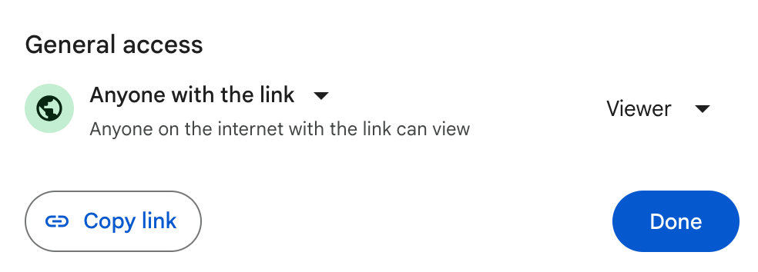

# **Then, copy the link and paste it in the box below;**

**Step 1: Your AI Toolkit**

| [AICE AI ToolKit_Habtamu_Wolde](https://docs.google.com/spreadsheets/d/1_lzTTNa11FUXXYNQqW-rTbZUhrh-9mqUyAPHh2iEo50/edit?usp=sharing) |
| --- |

*If you need more help with this, Google for video instructions on sharing files in Google Drive, or ask a peer.*

**Step 2: Project Plan/Work Plan**

Locate your [**Project Plan/Work plan sheet**](https://docs.google.com/spreadsheets/d/14kQfLicS7S1DxqdpdDMY_ixTvboRH7loA4s0_icDxWA/copy)

Ensure you have completely filled out the two tabs “**Project Plan” and “ChatGPT Project Board” Tabs.**

*For the project plan tab, make sure you add tasks you want to complete this week based on the instructions in* [*this activity*](https://intranet.alxswe.com/projects/100555) *in the lines with the blue text.*

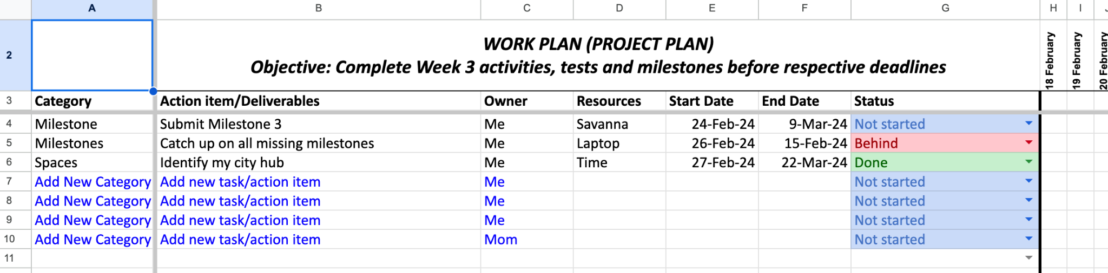

*For the ChatGPT Project Board, make sure you add details that you get after asking ChatGPT to create a project board following the instructions* [*from this activity.*](https://intranet.alxswe.com/concepts/102193)

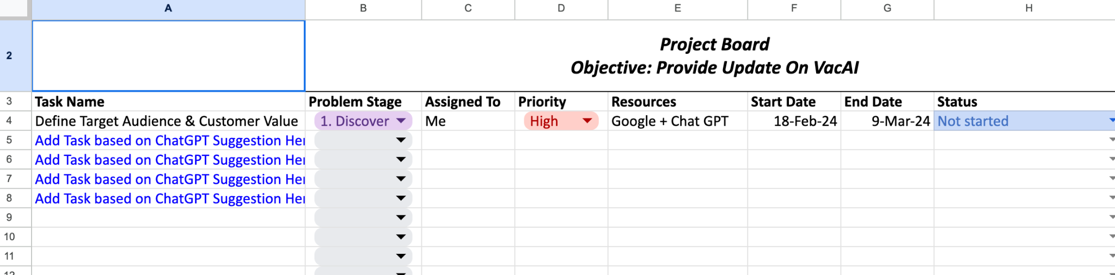

After confirming that you have filled your worksheet correctly, Click **"Share"** (under the 3 dots) and adjust the settings to *“Anyone with the link can view.”*



Next, paste the link in the box below;

**Step 2: Project Plan/Work Plan**

| [Project Plan/Work plan Template_ALX AiCE](https://docs.google.com/spreadsheets/d/1Br4ShNWh0x8X8-ljKaswvRp-ov06vkzVjAHfLTzQhfA/edit?usp=sharing) |
| --- |

**Step 3: Research Worksheet**

Locate your [ALX AiCE Research Worksheet](https://docs.google.com/document/d/1uA2oaWjPJNlbWYWtJXwBw8bkUVZzeYkrrsDKyAkQiik/copy).

**Make sure you complete Parts A, B, and C of the worksheet.**

**Part A:**

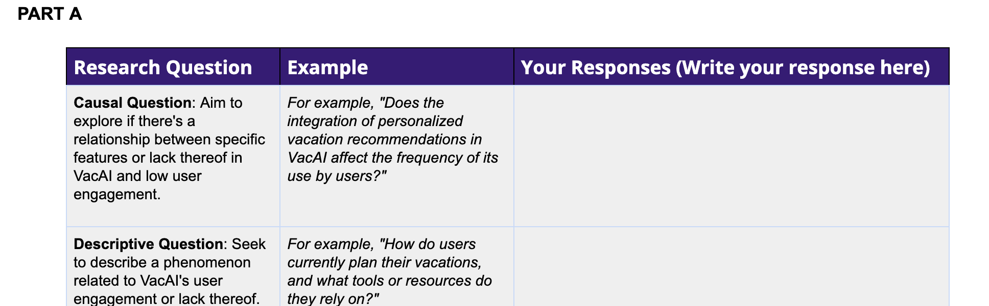

Create research questions, you would typically ask when researching the vacation and hospitality industry, so you get a clear understanding of why users might not use VacAI (Waga Vacation app)

**Part B:**

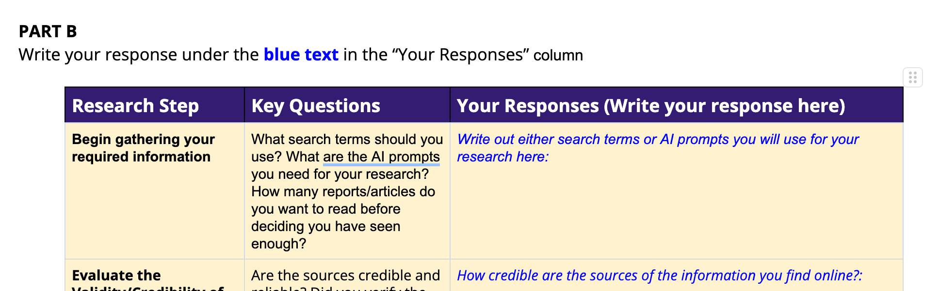

Follow the research steps and provide answers to the text highlighted **in blue under “Your response column”**

**Part C:**

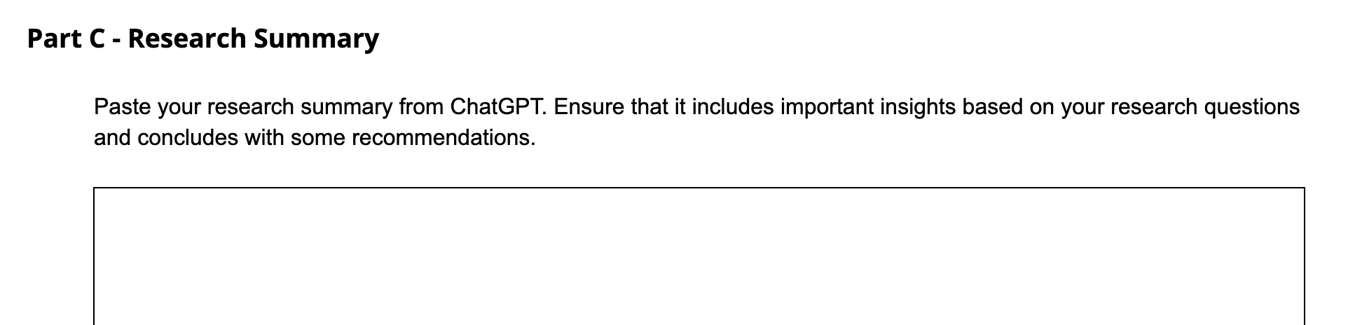

Paste your research questions from part a, and your response in part b into ChatGPT and ask it to create a research summary that can guide you as you progress through the simulation activity at Waga.

After confirming that, save the worksheet as a PDF file and upload it to your designated AiCE Google Drive.

Then, Click **"Share"** (under the 3 dots) and adjust the settings to *“Anyone with the link can view.”* Next, paste the link in the box below;

**Step 3: AiCE Research Worksheet**

| [ALX AiCE Research Worksheet](https://docs.google.com/document/d/1QbrySCojMsm1-XFA0QrK1wfAWmN6UknTcG4kVfcGZJY/edit?usp=sharing) |
| --- |

**Step 4: Data Cleaning**

Locate your updated [Data Cleaning worksheet](https://docs.google.com/spreadsheets/d/1Mx_a4rZR_CD4E7GBTV651epEeCpBuT6hpoh6vKvwNAE/copy).

Make sure you have provided answers to these questions in your worksheet:

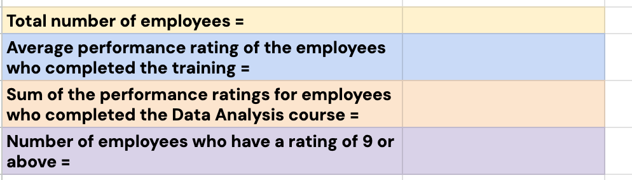

After confirming that, Click **"Share"** (under the 3 dots) and adjust the settings to *“Anyone with the link can view.”* Next, paste the link in the box below;



**Step 4: Data Cleaning Worksheet**

| [Data Cleaning Practice Activity _ AiCE](https://docs.google.com/spreadsheets/d/1YcV4dtRBbT7xh23yOYbHv0iT0XUN-95M-m1O41Oi5uE/edit?usp=sharing) |
| --- |

**Step 5: Your Email to Colleagues**

Open up your ["Email to Colleagues" from your writing prompt activity.](https://intranet.alxswe.com/concepts/102266)

Copy and paste the email you manually wrote into the box below and indicate how long it took you to complete the email in minutes.

**Step 5a: Email to Colleagues (Manual)**

| **Subject: Weekly Update: VacAI Project Progress, Challenges and Next Steps**  **Hello Dear Team Members!**  I hope this email finds you all well! I am writing this email to share with you, the progress of my task at hand in the project of re-launching VacAi. I personally have been active since the start of the project doing according to my plan. [Here you can find my project plan](https://docs.google.com/spreadsheets/u/0/d/1Br4ShNWh0x8X8-ljKaswvRp-ov06vkzVjAHfLTzQhfA/edit).   However, Dear Team members, recently, I came across different questions about the failing of our VacAi. Here below are my questions:  1. How does the absence of real-time customer support and assistance within VacAi affect user satisfaction and engagement levels in the vacation and hospitality industry segment?  2. What are the primary pain points identified by users within the VacAi app related to vacation planning and hospitality experiences?  3. Are there significant differences in user engagement and satisfaction levels between different age groups using the VacAi app for vacation planning and hospitality experiences?  I hope my team will overcome it and be once again a great team behind the successful relaunch of our VacAi. Feel free if you have any questions or additional insights regarding my plan and other things also.   With regards! Habtamu Wolde  **It took me 6 minutes to write this email.** |
| --- |

**Copy and paste the email from ChatGPT in the box below.**

**Step 5b: Email to Colleagues (ChatGPT)**

| **Subject: Weekly Update: VacAI Project Progress and Key Concerns**  **Dear Team,**  I trust this email finds you in good spirits. I'm pleased to provide an update on our ongoing efforts towards the relaunch of VacAi. I've been diligently working according to the project plan we've outlined. You can review the detailed plan [at this link](https://docs.google.com/spreadsheets/u/0/d/1Br4ShNWh0x8X8-ljKaswvRp-ov06vkzVjAHfLTzQhfA/edit).  However, as we progress, I've encountered some pertinent questions regarding the challenges we face with VacAi's previous performance. These questions are crucial for our understanding and eventual success:   1. How does the absence of real-time customer support and assistance within VacAi impact user satisfaction and engagement levels within the vacation and hospitality industry segment? 2. What are the primary pain points identified by users within the VacAi app concerning vacation planning and hospitality experiences? 3. Are there notable variations in user engagement and satisfaction levels across different age groups using the VacAi app for vacation planning and hospitality experiences?   Addressing these queries will not only enhance our understanding of the issues but also pave the way for effective solutions. I'm confident that with our collective effort, we can overcome these challenges and contribute to the success of VacAi's relaunch.  Please feel free to share any questions, insights, or suggestions you may have regarding my plan or any other aspect of the project.  Best Regards,  Habtamu Wolde |
| --- |

**Step 6: Reflection on the use of AI**

Take a moment to reflect on everything you’ve learned and how AI might shape your future. Then, create a short paragraph based on your reflection; your paragraph should answer the questions in the box below;

**Reflection on the use of AI**

| *Do you think AI can effectively help you manage your time?*  *How can AI help you analyze data?*  *How can you improve your prompts?* |
| --- |

**Step 6: Write Your Reflection Response Here**

| As an AI student, I've learned a great deal about the capabilities and potential of artificial intelligence in various aspects of life. Regarding time management, AI can indeed be highly effective. Through algorithms and machine learning, AI can analyze patterns in tasks and priorities to optimize scheduling and productivity.  When it comes to data analysis, AI excels at processing vast amounts of information swiftly and accurately. By employing techniques like natural language processing and deep learning, AI can extract insights, identify trends, and make predictions from complex datasets, aiding in decision-making processes across industries.  As for improving prompts, AI can continuously enhance its abilities through feedback mechanisms and ongoing training on diverse datasets. By incorporating user feedback, monitoring performance, and refining language generation algorithms, AI can tailor prompts more effectively to user needs and preferences, ensuring clearer communication and better outcomes. |
| --- |