Sports Center Membership System

Project Plan

# Introduction

The project plan is a formal document designed to guide the control and execution of our project which is a Sports Center Membership System. This project is built keeping in mind various daily activities of a sport center and the software automates all this sport center functionality for easy operation.

This project plan contains information about project team and roles, provides us to document and communicate stakeholder products and project expectations. Also, it is helpful to control schedule and manage associated risks.

# Project organization

Our team consists of five members and instructor, which are:

**Instructor :**Tuğba GÜRGEN ERDOĞAN .

**E-mail :** [**tugba@cs.hacettepe.edu.tr**](mailto:tugba@cs.hacettepe.edu.tr)

**Project Manager:** Aycan ÖZMEN; Leads the team and does the planning of the project specifically and keeps the project team focused on the right goal.

**E-mail:** [**ozmenycn@gmail.com**](mailto:ozmenycn@gmail.com) **Phone : 0541 862 4420**

**Software Analyst:** İlayda KAYA; Checks the programs to ensure they are meeting the needs and demands of users.

**E-mail:** [**ilaydakayaa18@gmail.com**](mailto:ilaydakayaa18@gmail.com) **Phone : 0506 965 2928**

**Software Architect:** Şule KARAŞLAR; Defines the software architecture, makes the key technical  
decisions and overall design of the system**.**

**E-mail:** [**s.karaslar@gmail.com**](mailto:s.karaslar@gmail.com) **Phone : 0537 515 2160**

**Software Configuration Manager:** Uğurcan ÇİFTCİ; Manage, organize and control the changes in the documents, codes and other entities during the development life cycle.

**E-mail:** [**ugurciftci006@hotmail.com**](mailto:ugurciftci006@hotmail.com) **Phone : 0539 279 4590**

**Software Tester:** Mustafa DANYILDIZ; Tests software for bugs, errors, defects or any problem that can affect the performance of the application.

**E-mail:** [**mstfdnyldz@gmail.com**](mailto:mstfdnyldz@gmail.com) **Phone :0531 861 3721**

Our project progress will be trackable through a GitHub page.

# Project practices and measurements

In our project, we will use "scrum methodology" which is preferred by many software developers today. Scrum is one of the Agile Project Management methods. There were 3 main reasons for choosing scrum:

1. Progresses and problems in the project can be seen by the entire project team on a daily basis.
2. Parts of the project are delivered at regular intervals and inspected by team members.
3. If there are new requirements for the product, evaluation is not done from the beginning. The requirements are appropriately adapted to the project.

All these factors prevent complexity in the project stages and the product initially designed is achieved quickly and in the desired manner.

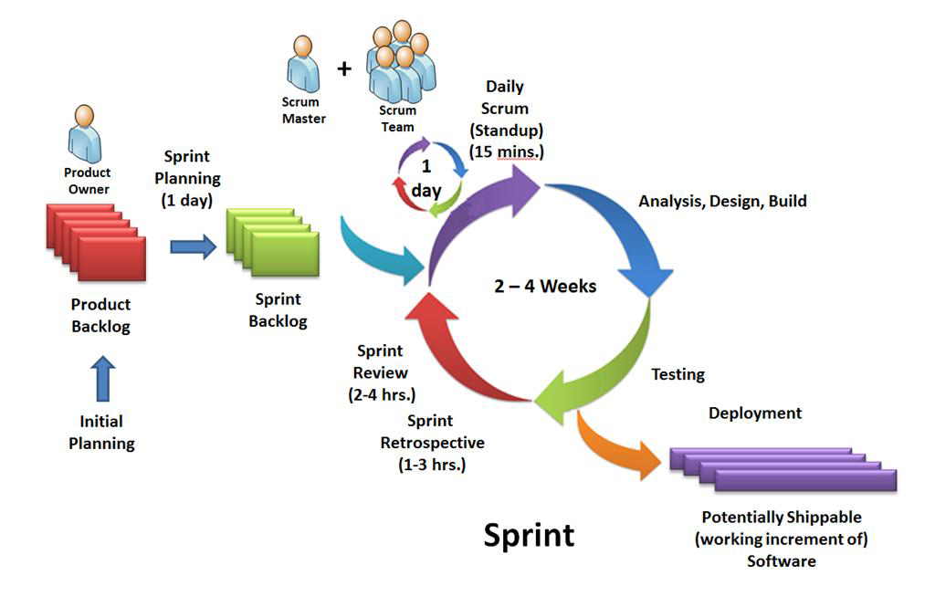

The above picture shows a sample scrum process. (*This image was taken from kocsistem.com.tr*)

* The project owner collects all the features and functions that the project should have. In our project, this task will be performed by all team members together.
* The work to be done after a certain plan is made is determined. We will begin to do the work with cycles that last no more than 2 or 3 weeks. These cycles are called “sprints”.
* We will collect feedback as a result of sprints. We will try to develop the important requirements identified in these feedbacks. These requirements, which are determined at the end of sprints, are called “Sprint Backlog”.
* During the sprint process, we will come together every 2 or 3 days to explain the progress of tasks on everyone.
* During the sprint we will update the “Burndown Chart” graph. This graph is the remaining requirement / elapsed time graph. So that the progress in the project can be seen clearly and the tasks can be rearranged according to the remaining time.
* When the sprint is over we will do the analysis of the process and we will set the requirements for a new sprint and launch a new sprint.

The most important contribution of the scrum methodology to us is to make regular feedback and short-term planning. This methodology will both help us to see progress clearly and help to intervene immediately with a new problem or need that may arise.

# Project milestones and objectives

|  |  |  |  |
| --- | --- | --- | --- |
| **Iteration** | **Primary objectives** (risks and use case scenarios) | **Scheduled start or milestone** | **Target velocity** |
| I1 | •**Software Vision & Project Plan**  **Risk:** The detail of the vision and project plan can cause many changes in progressive stages.  **Mitigate Risk:** The vision and project plan must be kept simple to meet expectations and achieve goals. | From:2/3/2018 To:13/3/2018 | 8 hours |
| I2 | • **Software Requirements**  **Risk:** Estimating the bad requirement causes unexpected situations and increases the cost  **Mitigate Risk:** A well-prepared requirement document helps to easily complete goals on estimated dates. | From:13/3/2018 To:23/3/2018 | 20 hours |
| I3 | • **Architectural Notebook & System Test Case Definitions**  **Risk:** Failure of group members to agree on architecture and incorrect test cases can lead to a product that cannot satisfy customers.  **Mitigate Risk:** Architectural and test cases should be defined according to the requirements of the customers. | From:23/3/2018 To:6/4/2018 | 25 hours |
| I4 | **• Software Design Description & Coding Standard**  **Risk:** Choosing an inappropriate development environment and not designing regularly makes the job difficult, increases the cost and time spent.  **Mitigate Risk:** The development environment must be competent in the work to be done and coding standards have to be determined. | From:6/4/2018 To:27/4/2018 | 35 hours |
| I5 | •**Software Test Report &Presentation**  **Risk:** Untested components reduce product quality and cannot determine the current status of the project.  **Mitigate Risk:** All components should be tested and documented appropriately, a document containing information about the performed actions (run test cases, detected bugs, spent time etc.) and the results of this performance (failed/passed test cases, the number of bugs and crashes etc.). | From:27/4/2018 To:18/5/2018 | 30 hours |

# Deployment

The product's progress and demo will be displayed on git………………

# Lessons learned

The first thing to do in order for a project to proceed correctly is a detailed analysis. It is difficult to correct the problems that may arise in the projects that started without detailed analysis.

After the analysis is done, the work to be done must be identified and these works should be separated into smaller pieces. So that progress is made step by step and the project is built on a solid basis.

It is also important to make a proper distribution of the tasks among the team members along with all these steps and to be in communication at all times. So, the process progresses faster.