Sports Center Membership System

Vision

# Introduction

This document contains general planning of product, description of stakeholders and envisioned core requirements for the system.

# Positioning

## Problem Statement

|  |  |
| --- | --- |
| The problem of | Organizing and managing the member processes of a sport center |
| affects | Sport center members, instructors, and managers |
| the impact of which is | Easily managing user processes within the center |
| a successful solution would be | A user-friendly, easily operable, fast, responsive system |

## Product Position Statement

|  |  |
| --- | --- |
| For | Sport centers |
| Who | Members, instructors, and managers of the sport center |
| The (product name) | Sports Center Membership System |
| That | User-friendly, easily operable, responsive |
| Unlike | A traditional documented registration process |
| Our product | Web-based, one solution for every platform |

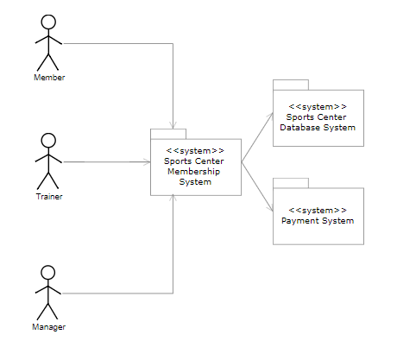

Figure 1.Context Diagram of Sports Center Membership System

# Stakeholder Descriptions

## Stakeholder Summary

| **Name** | **Description** | **Responsibilities** |
| --- | --- | --- |
| Project Manager | The project manager distributes the duties and coordinates communication each stakeholder and generally keeps the project team focused on the right goal. | • Planning  • Setting goals  • Time Management  • Budget Allocation and Cost Estimates  • Implementation and Monitoring |
| Software Architect | A software architect is a software expert who makes high-level design choices and dictates technical standards, including software coding standards, tools, and platforms. | • Design, develop and execute software solutions to address business issues  • Evaluate and recommend tools, technologies, and processes to ensure the highest quality product platform  • Interpret business requirements to articulate the business needs to be addressed  • Troubleshoot code level problems quickly and efficiently |
| Software Analyst | In a software development team, a software analyst is the person who studies the software application domain, prepares software requirements, and specification documents. The software analyst is the seam between the software users and the software developers. | • Performing complex analysis, designing and programming to meet business requirements  • Maintaining, managing and modifying all software systems and applications  • Developing, maintaining and managing systems, software tools, and applications  • Coordinating and supporting software professionals in installing and analyzing applications and tools  • Analyzing, developing and implementing testing procedures, programming, and documentation  • Analyzing, designing and developing modifications and changes to existing systems to enhance performance |
| Software Configuration Manager | The configuration manager provides the overall Configuration Management (CM) infrastructure and environment to the product development team. | • Supporting the product development activity  • Writing the CM Plan and reporting progress statistics based on change requests |
| Software Tester | A software tester is an individual that tests software for bugs, errors, defects or any problem that can affect the performance of computer software or an application. | • Identifying the most appropriate implementation approach for a given test  • Implementing individual tests  • Setting up and executing the tests  • Logging outcomes and verifying test execution  • Analyzing and recovering from execution errors |
| Controller | Instructor is a controller for this project. | • Controlling project phases  • Guiding each group |

## User Environment

As long as a member uses the sports center, he/she can access and use the application.

Users can access the application with a computer or a mobile device. Our project is a web-based application and needs an internet connection to use.

# Product Overview

## Needs and Features

|  |  |  |  |
| --- | --- | --- | --- |
| **Need** | **Priority** | **Features** | **Planned Release** |
| Login | 1 | Enables user to login to the system | Release 1 |
| Logout | 2 | Enables user to logout from the system | Release 1 |
| View monthly body development | 1 | Enables member to follow monthly body development | Release 2 |
| Change profile information | 1 | Enables user to change profile information | Release 2 |
| Weekly course schedule | 1 | Enables member to see weekly course schedule and select one of these. | Release 2 |
| Payment type | 3 | Enables member to pay course fee with online. | Release 2 |
| Get an appointment from trainer | 2 | Enables member to get an appointment from trainer | Release 3 |
| Trainer information | 2 | Enables member to see trainer information | Release 3 |
| Weekly course schedule | 1 | Enables manager to add, delete and update courses. | Release 3 |
| Trainer and branches | 2 | Enables manager to add and delete trainers and branches. | Release 3 |

# Other Product Requirements

|  |  |  |
| --- | --- | --- |
| **Requirement** | **Priority** | **Planned Release** |
| MySQL as the database | 1 | Release 1 |
| Interface | 2 | Release 2 |
| Risk analysis | 1 | Throughout the project |
| Security | 1 | Release 3 |
| Fast and responsive | 1 | Throughout the project |
| Stability | 1 | Throughout the project |
| User-friendly | 2 | Release 2 |