Console Games Sales War

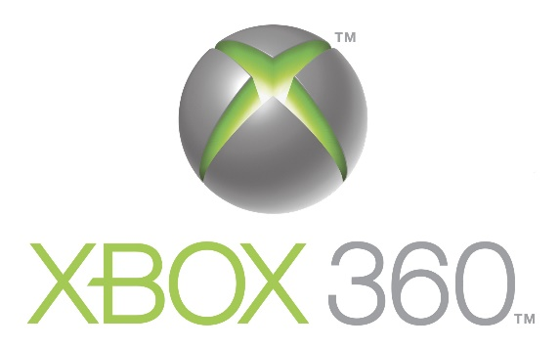

VS



The database I have chosen to analyse is that of videogame sales for all games with sales greater than 100,000 copies. Out of all the database the part that interests us for analysis and comparison are the sales of the 3 most popular consoles of the generation that started in 2006: PS3, Xbox360 and Wii. We want to compare these consoles and see if there was one that was a clear standout winner in videogame sales and what were the strong points of each console.

To do so we will create dashboards with the objective of answering the following business questions:

* Which console has the highest amount of sales?
* How did the console sales change during the years?
* Were some consoles more dominant in some regions than in others?
* What was the strongest genre for each console?
* And the strongest age rating?
* For each genre was there a predominant age rating?
* Is there a relationship between critics rating and amount of sales?
* What were the games with the highest amount of sales?
* Did games receive the same rating for different consoles and did they sell the same?

The sketches of the dashboards we are going to make to answer the questions are the following:

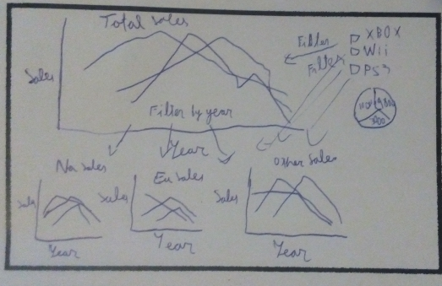

The first dashboard answers the first three questions. We are able to filter all graphs by console and year allowing us to compare the sales performance of the consoles over time through the three biggest regions and overall.

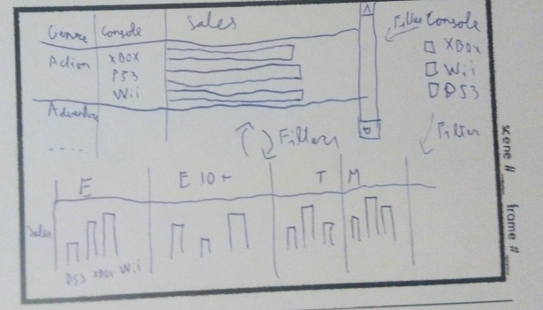

The second dashboard lets us answer the three next questions. The graphs are able to filter each other and once again compare the overall sales of the consoles based on genres and age ratings.

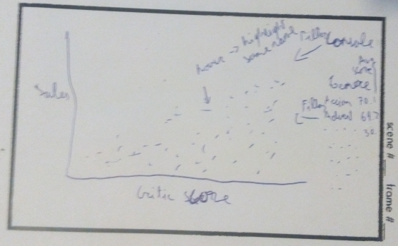

The final dashboard allows us to answer the last three questions. With this scatterplot with a name and platform level of detail we are able to see whether critic score affects the ratings and see which games are the most sold. Also, hovering over the dots should highlight other games with the same name allowing us to compare the same game for different consoles if it exists. Additionally, there is a filter for genre that allows us to get further understanding of the market divided by genres.

The final dashboards are available at:

<https://public.tableau.com/views/Ventasvideoconsolas/ConsoleSales?:embed=y&:display_count=yes>

For the dashboards, I have chosen a colour code to be followed through all of them assigning a different colour to each of the consoles: Blue for PS3, green for Xbox and orange for Wii. This should allow to easily distinguish between the consoles. Also, all the dashboards have a legend that allows to filter by console so it is possible to focus the analysis on just one console or compare between two.

In the first dashboard, there is a year filter in the total sales graph. This filters the pie chart of total sales by year and deploys new bar charts for the sales of each region for easier comparison. There is also a highlight function by console that allows us to focus more on its individual performance without need of filtering through the legend. The graphs for all the regions have the same scale to allow easier comparison. We can answer the questions and get more information from this dashboard. We can see the consoles have similar total game sales, Wii started the strongest but was the first one to fade in popularity and that Xbox was more popular than PS3 in NA but less in the other regions.

In the second dashboard, there is a filter between both graphs to select both age rating and genre. By filtering by platform in a single click we can see which was the most prominent for a console, such as sports for Wii or shooters for Xbox which is expected as their controllers are designed to better suit these games with Wii registering movements and Xbox having the triggers that resemble those of guns. We can also see that PS3 is the most popular platform for action games and that Wii is dominating in the games for all the family but is very far behind in the mature rating games. By filtering through genre we can see that action games sales are mostly with mature ratings while teenage ratings are the ones dominating in fighting games.

In the third dashboard, we removed Wii sports as it was an outlier since it was included with the console in most regions and it had over 80 million sales affecting greatly the scale of the graph. We are able to filter both by platform and genre once again and hovering over a game will highlight all the games with the same name. We can see an overall pattern of higher scored games having greater sales. This is confirmed by the regression lines for each console that show the tendency of higher scores causing higher sales. We can also see that most of the exceptional performers were of the Wii console with only Kinect Adventures for Xbox and Grand Theft Auto V for PS3 having over 20 million sales but 6 Wii games exceeding that amount. We can also see how sales and ratings differ for the same game across different consoles: by hovering over Grand Theft Auto V we can see that is has the same score but the sales for PS3 are higher but in Call of Duty Black Ops you can see similar score but the Xbox sales being higher and Wii being much further behind both in sales and score.

Overall we have some very interactive dashboards that allow us to answer all the previously mentioned questions. However, they are not limited to that and allow further exploration to compare game sales between the consoles and, even though they are very similar in total sales, we can get a much better understanding of each console´s strengths and weaknesses.