Đề bài cho mình một đoạn như sau :

lyl, rwns dmsfm rn wkmrx myf iyrx pynljorw, jn luy ejvvynl lxrqjljsmrw pynljorw jm ojyl mrh.

lyl jn knkrwwi pxsh luy ymq sp trmkrxi ls yrxwi pyexkrxi.

eypsxy lyl, ojylmrhyny cxycrxy hrmi lujmvn psx luy luxyy hrjm qrin.

luyi gwyrm luyjx uskny rmq qygsxrly fjlu pwsfyxn nkgu rn dkhbkrl lxyy sx cyrgu ewsnnsh.

r ukvy rhskml sp pssq fjww ey eskvul eypsxy lyl psx hrdjmv lxrqjljsmrw qjnuyn. ermu gukmv, ermu lyl, vjs gur, asj rmq hkl, …rmq grmqjyn rxy luy pssqn lurl hknl uroy sm lyl uswjqrin.

qkxjmv lyl, cyscwy ojnjl luyjx xywrljoyn’ ushyn rmq vjoy fjnuyn.

usfyoyx, luy ojylmrhyny eywjyoy lurl luy pjxnl ojnjlsx r prhjwi xygyjoyn jm luy iyrx qylyxhjmyn luyjx psxlkmy psx luy ymljxy iyrx, cyscwy myoyx ymlyx rmi uskny sm luy pjxnl qri fjluskl eyjmv jmojlyq pjxnl.

rmsluyx gknlsh jn vjojmv wkgdi hsmyi, fujgu jn ckl jmls r xyq ymoywscy rn r nihesw sp wkgd rmq fjnu psx r myf rvy.

lxrqjljsmrwwi, ywqyxn fjww vjoy wkgdi hsmyi ls gujwqxym rmq luy swqynl cyscwy jm luy prhjwi. usfyoyx, msfrqrin, cyscwy grm vjoy jl ls rmismy jmgwkqjmv pxjymqn, crxymln, myjvuesxn,…

eynjqyn, ojylmrhyny knkrwwi vs ls crvsqrn sx lyhcwyn ls cxri psx uyrwlu, fyrwlu, nkggynn,…

ls ojylmrhyny, lyl jn luy urccjynl ljhy sp rww iyrx rxskmq, hyheyxn jm r prhjwi grm vrluyx lsvyluyx, fujgu jn r hyrmjmvpkw hynnrvyn sp wkmrx myf iyrx pynljorw.

rww jm rww, lyl jn rww reskl ergd ls sxjvjmn, ey vssq ls sluyxn, ymtsi luy cxygjskn hshyml, rmq fjnu psx luy eynl ls gshy.

luy pwrv jn: dgng{lyl_lyl_lyl_lyl_qym_xsj__gukg_grg_erm_mrh_hsj_lurl_mujyk_nkg_dusy__wko_pxsh_wkwkkkkkkkkkkkk}

+ Mình nghĩ ngay đến kiểu thế chữ (Monoalphabetic Substitution Cipher) và sử dụng tool <https://www.boxentriq.com/code-breaking/cryptogram>

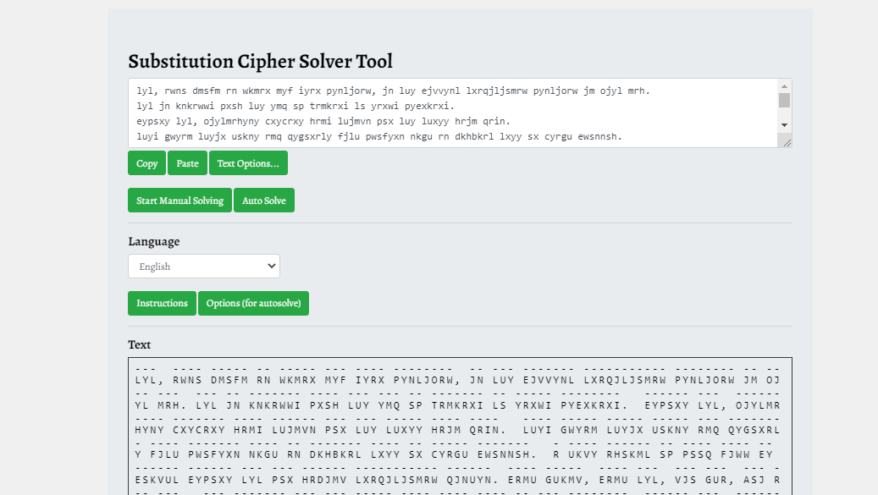

+ Cho vào giải và ta được flag rồi

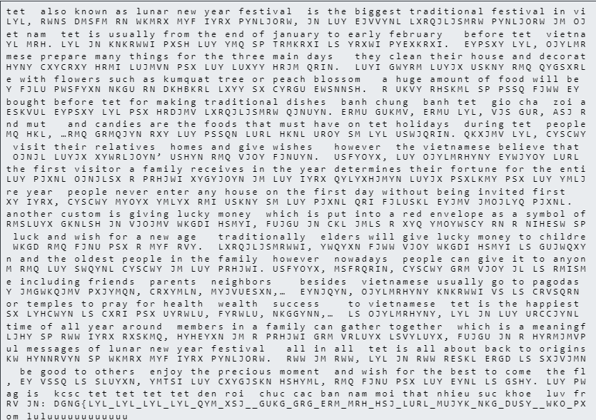

Flag: KCSC{tet_tet_tet_tet_den_roi__chuc_cac_ban_nam_moi_that_nhieu_suc_khoe__luv_from_luluuuuuuuuuuuu}