Sentiment Analysis of Mark Carney’s Appointment as Canadian Prime Minister

Introduction
The appointment of Mark Carney as Prime Minister of Canada, succeeding Justin Trudeau outside the traditional electoral process amidst a period of political turbulence, sparked considerable public reaction. This project investigates the sentiment of Canadians towards this transition across three prominent online platforms: Reddit, Google News, and YouTube. Through the application of sentiment analysis techniques, I have categorized public opinion into positive, negative, and neutral classifications, aiming to identify dominant themes, key terms, and provide deeper insights into the evolving Canadian political landscape.

Methodology

Data Collection
To capture a broad spectrum of public reaction, I collected textual data from the following online sources:
- Reddit: Comments and discussions within relevant political subreddits where users actively debated Carney’s appointment.
- Google News: User-generated comments posted on news articles covering the leadership transition.
- YouTube: Comments posted on news reports, interviews featuring Mark Carney, and opinion pieces discussing his appointment.

Data Cleaning & Merging
The collected data underwent a rigorous cleaning and preparation process:
- Duplicate comments and discussions were identified and removed to ensure the analysis focused on unique expressions of sentiment.
- Unnecessary characters, special symbols, and non-relevant textual elements were eliminated to improve the quality of the text data for analysis.
- The data from Reddit, Google News, and YouTube was integrated into a structured database utilizing SQL, facilitating efficient querying and analysis across platforms.
- Text preprocessing techniques were applied, including tokenization (splitting text into individual words), lemmatization (reducing words to their base form), and the removal of common English stop words (e.g., "the," "a," "is") to focus on meaningful content.

Sentiment Analysis Approach
To comprehensively analyze public sentiment, I employed the following strategies:
- VADER & TextBlob Sentiment Scoring: Recognizing that neutral sentiment can sometimes mask underlying opinions, I conducted a closer examination of the vocabulary used in statements classified as neutral to identify potential subtle positive or negative biases.
- Neutral Sentiment Deep Dive: Recognizing that neutral sentiment can sometimes mask underlying opinions, I conducted a closer examination of the vocabulary used in statements classified as neutral to identify potential subtle positive or negative biases.
- Keyword Analysis: To uncover the core themes driving positive and negative sentiment, I performed frequency analysis of the words appearing in comments classified under each sentiment category. This helped identify the dominant topics and arguments associated with each viewpoint.

Results

Overall Sentiment Distribution
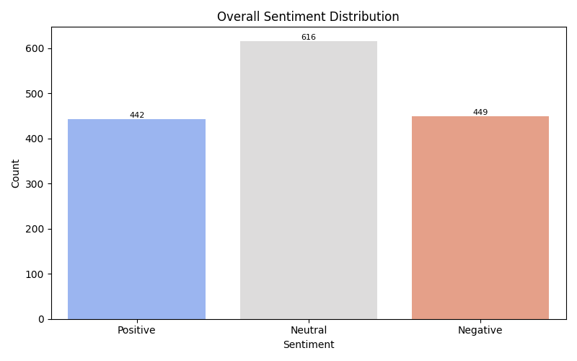

The overall sentiment distribution reveals that neutral sentiment constitutes the largest portion of the collected data, accounting for 616 occurrences. Interestingly, positive sentiment (442 occurrences) and negative sentiment (449 occurrences) are almost equally represented, indicating a significant division in public opinion regarding Mark Carney’s appointment. This near balance suggests a more polarized reaction compared to initial observations.

Sentiment by Source
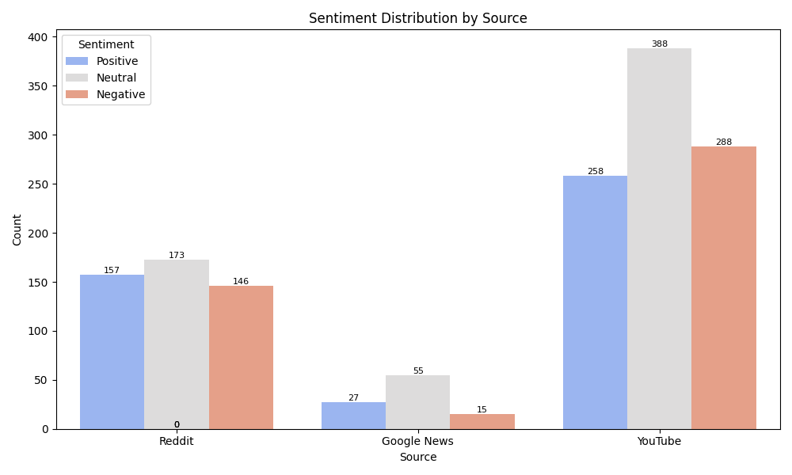

- Reddit: Exhibits a relatively balanced distribution of positive, neutral, and negative sentiment, suggesting a platform where diverse opinions are freely expressed.
- Google News: Shows a strong inclination towards neutral and positive sentiment, with a notably low volume of negative comments. This may reflect the nature of discussions around news articles or the demographics of commenters on this platform.
- YouTube: Presents the highest proportion of negative sentiment among the three sources, although it also contains a substantial amount of positive discussion. This indicates YouTube as a platform where strong and potentially contrasting opinions are prevalent.

Deeper Analysis

Word Cloud Visualizations
To further illustrate the key themes associated with each sentiment category, word clouds were generated based on the frequency of terms within positive, negative, and neutral comments. The size of each word in the cloud is proportional to its frequency.
- Positive Sentiment:
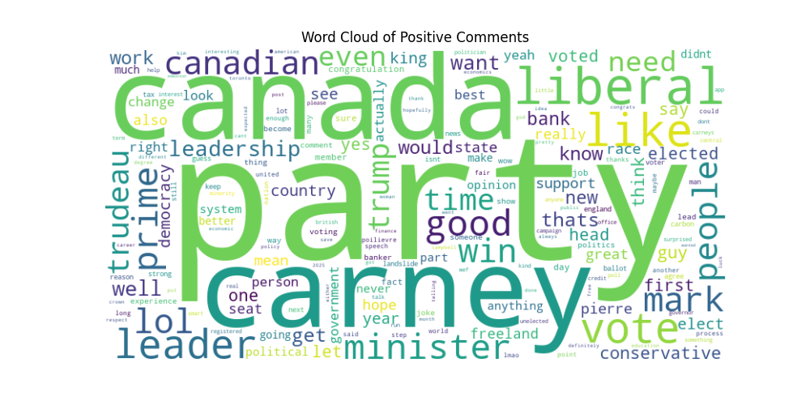
The word cloud of positive comments reveals a strong association with terms such as 'leader,' 'Canada,' 'carney,' 'party,' and 'vote,' indicating key areas of positive discussion surrounding the appointment.
- Negative Sentiment:
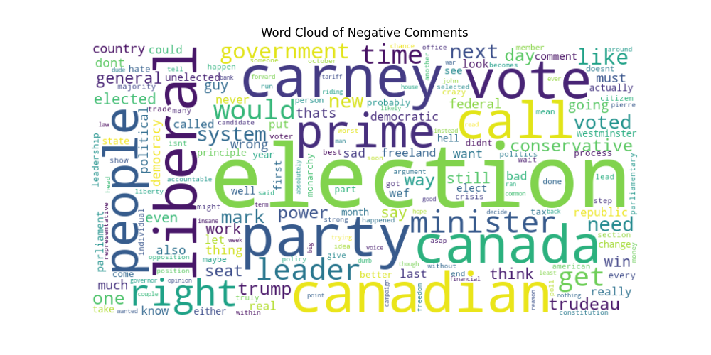
Conversely, the word cloud for negative comments highlights terms like 'election,' 'liberal,' 'canada,' 'carney,' and 'party,' suggesting the central themes of criticism and opposition.

Neutral Sentiment: Hidden Bias?
A closer examination of the keywords within the 'neutral' comments revealed the presence of terms such as 'election,' 'wasn’t elected,' and 'government' with notable frequency. This suggests that while these statements were classified as neutral by the sentiment analysis tools, they often contained undertones of dissatisfaction related to the non-electoral nature of the appointment and broader governmental concerns. This highlights a limitation of standard sentiment analysis in fully capturing nuanced expressions of opinion.

Positive Sentiment Breakdown
The most frequent keywords identified in positive comments include 'leader,' 'support,' 'win,' 'Canada,' and 'party.' These terms suggest that individuals expressing positive sentiment often lauded Mark Carney’s perceived leadership qualities, expressed support for his appointment, anticipated positive outcomes ('win'), and linked his appointment to a positive future for 'Canada' and a specific 'party.' Many positive comments specifically praised Carney’s prior credentials, his experience in leadership roles, and his potential to bring stability to the country.

Negative Sentiment Breakdown
The dominant keywords in negative comments include 'election,' 'liberal,' 'unelected,' 'wrong guy,' and 'crisis.' This vocabulary indicates that a significant portion of the negative sentiment stemmed from opposition to the appointment without a national 'election,' criticism directed towards the 'liberal' party (implying a partisan divide), concerns about Carney being 'unelected,' direct disapproval of him as the 'wrong guy' for the role, and anxieties about the current 'crisis' or political situation. The sentiment suggests a strong preference among these commenters for a democratic election process to determine the country’s leader.

Key Takeaways

- Public opinion is significally divided: The near-equal distribution of positive and negative sentiment underscores a notable polarization in public reaction to Mark Carney’s appointment.
- Neutral sentiment may mask underlying dissatisfaction: The presence of critical keywords within neutral statements suggests that a portion of the seemingly neutral responses may represent subdued expressions of disapproval regarding the political process.
- YouTube is a hub for contentious discussions: The platform exhibited the highest concentration of both strong positive and negative opinions, indicating it as a key arena for polarized political discourse.
- Concerns about electoral legitimacy are evident: The prominence of keywords such as 'election' and 'unelected' within negative and even neutral comments points to a potential crisis of legitimacy in the public perception of this non-electoral leadership transition.

Conclusion & Recommendations
This sentiment analysis provides valuable insights into the immediate public reaction to Mark Carney’s appointment as Prime Minister of Canada. The findings reveal a deeply divided populace with significant concerns regarding the legitimacy of the transition.
For Future Research:
- Future studies could analyze the evolution of public sentiment over time, particularly in response to policy announcements and key events during Carney’s tenure.
- Investigating sentiment variations based on self-identified political ideology could provide a more granular understanding of the partisan dimensions of public opinion.
For Political Campaigns & Analysts:
- Addressing the underlying concerns about electoral legitimacy should be a priority in political communication strategies.
- Actively engaging with digital audiences on platforms like YouTube, where strong sentiments are concentrated, is crucial for effective communication and outreach.

For Data Scientists & NLP Researchers:
- Further development of sentiment analysis models is needed to better capture the nuances within neutral statements and identify subtle expressions of opinion.
- Exploring advanced machine learning models, such as BERT and GPT-based sentiment classifiers, may yield a more sophisticated understanding of public sentiment in politically charged contexts.

Final Thought
This analysis underscores the critical role of transparency and democratic processes in political transitions. Understanding the multifaceted nature of public sentiment across diverse online platforms is essential for leaders to effectively engage with the citizenry and build trust in governance.

