

Sudhanshu Patel | [Course Title] | [Date]

Image source Identification

[Report Subtitle]

**Abstract**

**Introduction**

In the real world, images are generally accepted as a proof of occurrence of an event. In this era because of enormous availability of image capturing devices and image sharing platform, Photos becomes a part of our life. But since copying, downloading, forging or redistribution of images becomes easier and easier because of the availability of automated powerful tools to create & manipulate a digital image. So there is need of tools to verify the authenticity of an image in order to reduce forgery and backtrack origin of controversial images.

Different digital cameras use different pipeline architecture or hardware so a series of different artifacts left on the image during image acquisition phase. These artifacts are the basis of our technique to identify Source camera in Blind fashion (Without using watermarks).

During image capturing phase digital camera performs a series of complex operation including focusing using lenses to interpolation of the different color channel, Color Filter Array (CFA), brightness adjustment etc. Since these operations are noninvertible, So they left traces of artifacts in the final image, and we can use these traces as a footprint in order to trace back source camera.

There are different approaches based on different traces of footprint have been proposed. Example : Using traces of CFA interpolation ([3][4]),effect of lens distortion([6]), traces due to auto white balance algorithm([7]) and exploiting traces of dust particle on acquisition sensors.

Kharrazi et al. identified a set of 34 features ( average pixel value(3 features), RGB pair Correlation(3 features), Neighbour distribution center of mass(3 feature),RGB pair energy ratio(3 feature),Wavelet domain statistics (9 feature),Image Quality Metrics(13 features)) that can be used for source identification. They tested the performance of these features for classification of the image based on their origin. They found the accuracy of 93.42% for two cameras and accuracy of 88,02% for three cameras using multiclass SVM classifier.

In this thesis, we try to improve the performance of result by enhancing feature extracting method & classification techniques.

**Classification Techniques:**

Support Vector Machine:

Support vector machine (SVM) is a supervised learning algorithm. It can be used for both classification & regression problem. Support vector machine is a mathematical model of drawing the best possible hyper plan to classify two set of data in n-dimensional space (n = number of features ).

Each feature represent value of a particular coordinate in n-dimensional space, So we plot data items as a point in space and SVM try to find the best hyperplane to classify data into two classes.

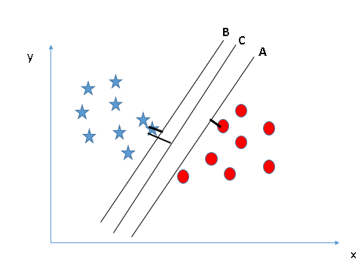

SVM finds the best hyperplane by maximizing distance between nearest data point (of both class) and the hyperplane (as shown in above fig).

SVM has the characteristic to ignore outliers and find the most optimal hyper-plane that classifies data into two classes.

**Tuning of parameters of SVM**

**Kernel :** Kernel decides type of hyperplane. There are a variety of kernels available like ‘rbf’ and “poly” used for nonlinear hyperplane and ‘linear’ kernel used for linear hyperplane.

**Gamma** : ‘gamma’ also known as kernel coefficient for ‘rbf’ ,’poly’ and ‘sigmoid’ kernels. Higher value of gamma try to fit the training data exactly, and so it leads to overfitting problem.

**C** : Penalty parameter of the error term. It controls the trade-off between smooth decision boundary and classify the training point correctly.

So for the better generalization of result we should look for effective combination of these parameters and avoid overfitting .

Decision Tree :

Decision tree is a supervised learning algorithm, and is mostly used in classification problem. In this technique we split the sample (population) in two or more homogeneous set (subpopulation) based on splitter in the input variable. Creation of sub-population increases homogeneity of resultant sub-population.

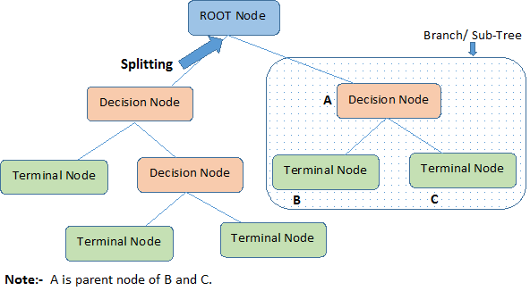

Root Node: Represent entire population.

Splitting: Process of breaking a node into subnodes.

Decision tree does not require lots of data cleaning because it is not influenced by outliers and null values, and also Data type constraints is not there because it can handle both numerical and categorical data. But Decision tree are very prone to overfitting.

Artificial Neural Network:

Artificial neural network is a computational model of biological neurons. Information that passes through the network effect the weights of neurons because neural network changes (or learn) based on the input-output data.

Neural network has remarkable ability to detect pattern in very complicated data which goes unnoticed by humans or machine. So ANN are used as random function approximation tools.

A neuron is building block of ANN. For a single neuron

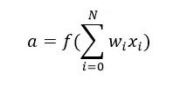

Where,

* **a** is output of neuron (become input of next layer neuron)
* f() represent activation function, (there are many transfer function like linear, Sigmoid, Elliot, Symmetric Elliot,ReLU etc)
* w and x represents weight and input
* b represent bias

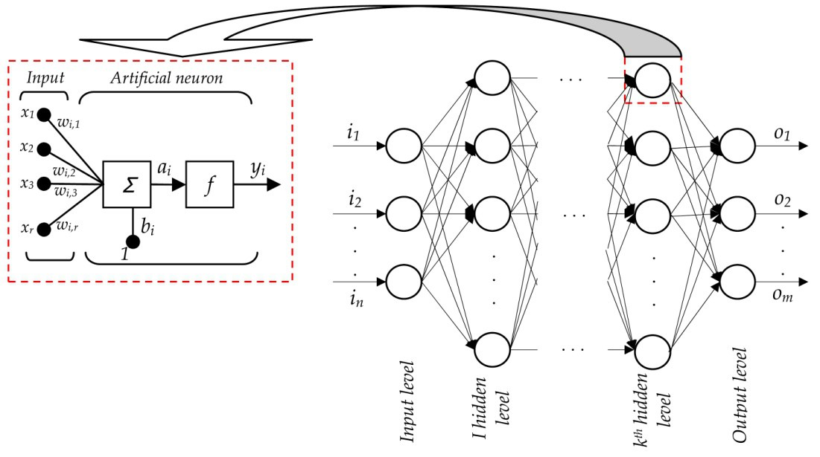

Network Consist of a number of layers each layer consist of few neurons. Output of a layer becomes input of next layer except last layer ( known as output layer) , Output of output layer is result. All layers between input layer and output layer are called hidden layer.

ANN is uses supervised learning algorithm to train itself. Process of learning

* Initialize random weights to all neurons
* Feed forward.
* Find error in result (i.e difference of expected result – output of feed-forward).
* Backpropagate error & modify weights in order to minimize the error.
* Repeat the process until error minimized to desired extent.