Data Cleaning and Preliminary Analysis with R
  - Week 1 Task Report

Dataset: Titanic Passenger Survival (Kaggle)
Tool: R 4.6.1 (base R) on Windows
Date: 28 September 2026

Table of Contents
Table of Contents 2
1. Introduction 3
1.1 Dataset Selection and Overview 3
Variable Dictionary 3
1.2 Environment and Reproducibility 4
2. Initial Data Exploration 4
3. Missing Value Analysis 7
4. Data Cleaning Process 9
5. Outlier Detection 12
6. Normalization and Feature Scaling 13
7. Encoding Categorical Variables 15
8. Exploratory Data Analysis 17
8.1 Key Findings 22
9. Conclusions and Next Steps 22
Appendix A: Complete R Script (titanic_analysis.R) 23
Appendix B: File Manifest 32

1. Introduction
This report documents the Week 1 deliverable: data cleaning, preprocessing, and preliminary analysis of a publicly available dataset using R. The work follows a structured, reproducible pipeline - dataset selection, initial exploration, missing-value handling, outlier detection, normalization, categorical encoding, and exploratory data analysis (EDA). All analysis is executed in R 4.6.1 using base R only (no external packages), so the script runs in any standard R installation. The complete, reproducible script (titanic_analysis.R) is provided in Appendix A.

1.1 Dataset Selection and Overview
The Titanic passenger dataset was selected because it satisfies the task's complexity requirements: it contains a mixture of categorical variables (Sex, Embarked, Pclass, Survived) and numerical variables (Age, Fare, SibSp, Parch), and it exhibits meaningful missingness in Age (about 20 percent), Cabin (about 77 percent), and Embarked (about 0.2 percent). The dataset comprises 891 passenger records across 12 variables, with Survived (0 = died, 1 = survived) as the target variable. This combination of mixed types and missing values makes it ideal for demonstrating a complete data-cleaning workflow.

Variable Dictionary
Variable | Type | Role | Description
PassengerId | integer | identifier | Unique passenger ID (dropped in cleaning)
Survived | integer/factor | target | 0 = died, 1 = survived
Pclass | integer/factor | feature | Ticket class: 1 = 1st, 2 = 2nd, 3 = 3rd
Name | character | identifier | Passenger name (dropped; title derivable later)
Sex | character | feature | male / female
Age | numeric | feature | Age in years (177 missing)
SibSp | integer | feature | # siblings / spouses aboard
Parch | integer | feature | # parents / children aboard
Ticket | character | identifier | Ticket number (dropped)
Fare | numeric | feature | Passenger fare (right-skewed)
Cabin | character | feature | Cabin number (687 missing -> HasCabin flag)
Embarked | character | feature | Port: C = Cherbourg, Q = Queenstown, S = Southampton

1.2 Environment and Reproducibility
R version 4.6.1 was used on Windows. Only base R functions are used (read.csv, str, summary, ave, quantile, cor, table, prop.table, and base graphics), guaranteeing the script runs without installing additional packages. Console output for each analysis stage is captured to text files in the outputs/ folder, and every plot is saved as a 110-DPI PNG in the plots/ folder, so all evidence embedded in this report is generated directly by the script.

2. Initial Data Exploration
The raw CSV is loaded with blank strings coerced to NA via na.strings, so that genuine missingness is immediately detectable. The functions dim(), names(), str(), head(), tail(), and summary() give the first comprehensive picture of the data's structure, variable types, and distributions.
titanic <- read.csv("data/titanic.csv",
stringsAsFactors = FALSE,
na.strings = c("", "NA"))

dim(titanic) # 891 rows x 12 columns
names(titanic)
str(titanic)
head(titanic)
tail(titanic)
summary(titanic)

# Variable type breakdown
table(sapply(titanic, class))
R Output:
Dataset loaded from data/titanic.csv

----- dim() : dataset dimensions -----
[1] 891 12

----- names() : variable names -----
[1] "PassengerId" "Survived" "Pclass" "Name" "Sex" "Age" "SibSp"
[8] "Parch" "Ticket" "Fare" "Cabin" "Embarked"

----- str() : structure of each variable -----
'data.frame': 891 obs. of 12 variables:
$ PassengerId: int 1 2 3 4 5 6 7 8 9 10 ...
$ Survived : int 0 1 1 1 0 0 0 0 1 1 ...
$ Pclass : int 3 1 3 1 3 3 1 3 3 2 ...
$ Name : chr "Braund, Mr. Owen Harris" "Cumings, Mrs. John Bradley (Florence Briggs Thayer)" "Heikkinen, Miss. Laina" "Futrelle, Mrs. Jacques Heath (Lily May Peel)" ...
$ Sex : chr "male" "female" "female" "female" ...
$ Age : num 22 38 26 35 35 NA 54 2 27 14 ...
$ SibSp : int 1 1 0 1 0 0 0 3 0 1 ...
$ Parch : int 0 0 0 0 0 0 0 1 2 0 ...
$ Ticket : chr "A/5 21171" "PC 17599" "STON/O2. 3101282" "113803" ...
$ Fare : num 7.25 71.28 7.92 53.1 8.05 ...
$ Cabin : chr NA "C85" NA "C123" ...
$ Embarked : chr "S" "C" "S" "S" ...

----- head() : first 6 rows -----
PassengerId Survived Pclass Name Sex Age SibSp Parch
1 1 0 3 Braund, Mr. Owen Harris male 22 1 0
2 2 1 1 Cumings, Mrs. John Bradley (Florence Briggs Thayer) female 38 1 0
3 3 1 3 Heikkinen, Miss. Laina female 26 0 0
4 4 1 1 Futrelle, Mrs. Jacques Heath (Lily May Peel) female 35 1 0
5 5 0 3 Allen, Mr. William Henry male 35 0 0
6 6 0 3 Moran, Mr. James male NA 0 0
Ticket Fare Cabin Embarked
1 A/5 21171 7.2500 <NA> S
2 PC 17599 71.2833 C85 C
3 STON/O2. 3101282 7.9250 <NA> S
4 113803 53.1000 C123 S
5 373450 8.0500 <NA> S
6 330877 8.4583 <NA> Q

----- tail() : last 6 rows -----
PassengerId Survived Pclass Name Sex Age SibSp Parch Ticket
886 886 0 3 Rice, Mrs. William (Margaret Norton) female 39 0 5 382652
887 887 0 2 Montvila, Rev. Juozas male 27 0 0 211536
888 888 1 1 Graham, Miss. Margaret Edith female 19 0 0 112053
889 889 0 3 Johnston, Miss. Catherine Helen "Carrie" female NA 1 2 W./C. 6607
890 890 1 1 Behr, Mr. Karl Howell male 26 0 0 111369
891 891 0 3 Dooley, Mr. Patrick male 32 0 0 370376
Fare Cabin Embarked
886 29.125 <NA> Q
887 13.000 <NA> S
888 30.000 B42 S
889 23.450 <NA> S
890 30.000 C148 C
891 7.750 <NA> Q

----- summary() : descriptive statistics per column -----
PassengerId Survived Pclass Name Sex Age SibSp
Min. : 1 Min. :0.000 Min. :1.00 Length :891 Length :891 Min. : 0.42 Min. :0.000
1st Qu.:224 1st Qu.:0.000 1st Qu.:2.00 N.unique :891 N.unique : 2 1st Qu.:20.12 1st Qu.:0.000
Median :446 Median :0.000 Median :3.00 N.blank : 0 N.blank : 0 Median :28.00 Median :0.000
Mean :446 Mean :0.384 Mean :2.31 Min.nchar: 12 Min.nchar: 4 Mean :29.70 Mean :0.523
3rd Qu.:668 3rd Qu.:1.000 3rd Qu.:3.00 Max.nchar: 82 Max.nchar: 6 3rd Qu.:38.00 3rd Qu.:1.000
Max. :891 Max. :1.000 Max. :3.00 Max. :80.00 Max. :8.000
NAs :177
Parch Ticket Fare Cabin Embarked
Min. :0.000 Length :891 Min. : 0.00 Length :891 Length :891
1st Qu.:0.000 N.unique :681 1st Qu.: 7.91 N.unique :147 N.unique : 3
Median :0.000 N.blank : 0 Median : 14.45 N.blank : 0 N.blank : 0
Mean :0.382 Min.nchar: 3 Mean : 32.20 Min.nchar: 1 Min.nchar: 1
3rd Qu.:0.000 Max.nchar: 18 3rd Qu.: 31.00 Max.nchar: 15 Max.nchar: 1
Max. :6.000 Max. :512.33 NAs :687 NAs : 2

----- Variable type breakdown -----
type_table
character integer numeric
5 5 2

Numeric variables : 7
Character variables: 5
summary() immediately reveals 177 missing values in Age and 687 in Cabin, plus a maximum Fare of 512.33 (a likely outlier). The type breakdown shows 5 character, 5 integer, and 2 numeric columns, confirming the categorical/numerical mix required by the task.

3. Missing Value Analysis
Missingness is quantified per variable and as an overall rate. A clear picture of where and how much data is missing drives the imputation strategy.
missing_count <- colSums(is.na(titanic))
missing_pct <- round(missing_count / nrow(titanic) * 100, 2)

data.frame(Variable = names(titanic),
Missing = missing_count,
Percent = missing_pct)

sum(missing_count) # total missing cells
sum(!complete.cases(titanic)) # rows with >= 1 NA

barplot(missing_count, las = 2, col = "firebrick",
main = "Missing Values per Variable",
ylab = "Count of NA")
R Output:
----- Missing values per variable -----
Variable Missing Percent
PassengerId PassengerId 0 0.00
Survived Survived 0 0.00
Pclass Pclass 0 0.00
Name Name 0 0.00
Sex Sex 0 0.00
Age Age 177 19.87
SibSp SibSp 0 0.00
Parch Parch 0 0.00
Ticket Ticket 0 0.00
Fare Fare 0 0.00
Cabin Cabin 687 77.10
Embarked Embarked 2 0.22

----- Total cells missing -----
Missing cells : 866
Total data cells : 10692
Overall missing % : 8.1

----- Rows with at least one missing value -----
Rows affected: 708 of 891 ( 79.46 % )

----- Strategy decided -----
Age : 177 NA (~20%) -> median imputation grouped by Pclass & Sex
Cabin : 687 NA (~77%) -> drop column; create binary HasCabin flag
Embarked : 2 NA (~0.2%) -> mode imputation
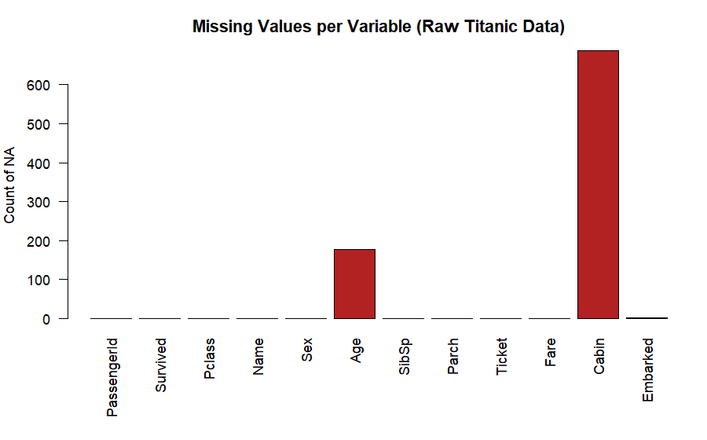
Figure 1. Missing value counts per variable in the raw Titanic dataset.
Cabin has 77 percent missing - far too much for reliable imputation - so it is converted to a binary HasCabin flag and the raw column is dropped. Age (about 20 percent missing) is imputed with the median within each Pclass x Sex group, which preserves demographic structure far better than a single global median. Embarked (only 2 missing cases) is imputed with the mode, 'S' (Southampton).

4. Data Cleaning Process
Cleaning is performed in a logical sequence: trim stray whitespace, drop identifier columns that carry no analytic signal, convert coded integers to labelled factors, impute the remaining missing values, engineer a HasCabin flag from the sparse Cabin column, and finally check for true duplicate records on the identifier-inclusive raw data.
clean <- titanic

# 4.1 trim whitespace in character columns
clean[] <- lapply(clean, function(x)
if (is.character(x)) trimws(x) else x)

# 4.2 drop identifier columns
clean <- clean[, !(names(clean) %in%
c("PassengerId", "Name", "Ticket"))]

# 4.3 coded integers -> labelled factors
clean$Survived <- factor(clean$Survived, levels = c(0, 1),
labels = c("Died", "Survived"))
clean$Pclass <- factor(clean$Pclass, levels = c(1, 2, 3),
labels = c("Class1", "Class2", "Class3"))

# 4.4 Embarked: mode imputation
emb_mode <- names(sort(table(clean$Embarked), decreasing = TRUE))[1]
clean$Embarked[is.na(clean$Embarked)] <- emb_mode

# 4.5 Cabin -> binary HasCabin flag, drop Cabin
clean$HasCabin <- factor(ifelse(is.na(clean$Cabin), "No", "Yes"))
clean <- clean[, names(clean) != "Cabin"]

# 4.6 Age: group-wise (Pclass:Sex) median imputation
clean$Age <- ave(clean$Age, clean$Pclass, clean$Sex,
FUN = function(x) ifelse(is.na(x), median(x, na.rm = TRUE), x))

# 4.7 true duplicates checked on the RAW data (with PassengerId)
dup_count <- sum(duplicated(titanic))
clean <- clean[!duplicated(titanic), ]

str(clean); summary(clean); colSums(is.na(clean))
R Output:
Trimmed whitespace in 5 character columns.

----- Missing before cleaning -----
Age Cabin Embarked
177 687 2

Dropped identifier columns: PassengerId, Name, Ticket
Remaining columns: Survived, Pclass, Sex, Age, SibSp, Parch, Fare, Cabin, Embarked

Converted Survived (0/1 -> Died/Survived) and Pclass -> factor.
Imputed Embarked with mode: S
Remaining NA in Embarked: 0
Created HasCabin flag; dropped Cabin (77% missing).
Imputed 177 missing Age values with group median (Pclass:Sex).
Remaining NA in Age: 0
True duplicate rows removed (checked on raw data with IDs): 0

----- str() after cleaning -----
'data.frame': 891 obs. of 9 variables:
$ Survived: Factor w/ 2 levels "Died","Survived": 1 2 2 2 1 1 1 1 2 2 ...
$ Pclass : Factor w/ 3 levels "Class1","Class2",..: 3 1 3 1 3 3 1 3 3 2 ...
$ Sex : chr "male" "female" "female" "female" ...
$ Age : num 22 38 26 35 35 25 54 2 27 14 ...
$ SibSp : int 1 1 0 1 0 0 0 3 0 1 ...
$ Parch : int 0 0 0 0 0 0 0 1 2 0 ...
$ Fare : num 7.25 71.28 7.92 53.1 8.05 ...
$ Embarked: chr "S" "C" "S" "S" ...
$ HasCabin: Factor w/ 2 levels "No","Yes": 1 2 1 2 1 1 2 1 1 1 ...

----- summary() after cleaning -----
Survived Pclass Sex Age SibSp Parch Fare
Died :549 Class1:216 Length :891 Min. : 0.42 Min. :0.000 Min. :0.000 Min. : 0.00
Survived:342 Class2:184 N.unique : 2 1st Qu.:21.50 1st Qu.:0.000 1st Qu.:0.000 1st Qu.: 7.91
Class3:491 N.blank : 0 Median :26.00 Median :0.000 Median :0.000 Median : 14.45
Min.nchar: 4 Mean :29.11 Mean :0.523 Mean :0.382 Mean : 32.20
Max.nchar: 6 3rd Qu.:36.00 3rd Qu.:1.000 3rd Qu.:0.000 3rd Qu.: 31.00
Max. :80.00 Max. :8.000 Max. :6.000 Max. :512.33
Embarked HasCabin
Length :891 No :687
N.unique : 3 Yes:204
N.blank : 0
Min.nchar: 1
Max.nchar: 1

----- Missing after cleaning (should all be 0) -----
Survived Pclass Sex Age SibSp Parch Fare Embarked HasCabin
0 0 0 0 0 0 0 0 0

Final dimensions: 891 rows x 9 cols
After cleaning, every column has zero missing values and the dataset remains 891 rows by 9 columns (no true duplicates existed). Survived and Pclass are now labelled factors, ensuring R treats them as categorical in later summaries and models. Note that duplicate detection was deliberately performed on the raw, identifier-inclusive data: had it been run only after dropping PassengerId/Name/Ticket, many distinct passengers sharing the remaining attributes would have been wrongly flagged as duplicates and discarded.

5. Outlier Detection
The interquartile-range (IQR) rule flags any value below Q1 - 1.5*IQR or above Q3 + 1.5*IQR as an outlier. This is applied to all four numeric variables; the decision to keep, cap, or remove each set of outliers is justified individually.
detect_outliers <- function(x) {
qs <- quantile(x, c(0.25, 0.75), na.rm = TRUE)
iqr <- qs[2] - qs[1]
low <- qs[1] - 1.5 * iqr
high <- qs[2] + 1.5 * iqr
which(x < low | x > high)
}

for (v in c("Age", "Fare", "SibSp", "Parch"))
cat(sprintf("%-6s outliers: %d (%.2f%%)\n",
v, length(detect_outliers(clean[[v]])),
length(detect_outliers(clean[[v]])) / nrow(clean) * 100))

# Fare is right-skewed: winsorize at the 99th percentile
fare_cap <- quantile(clean$Fare, 0.99)
clean$Fare[clean$Fare > fare_cap] <- fare_cap

boxplot(clean$Age, clean$Fare)
R Output:
Variable: Age | Q1-1.5IQR = -0.250 | Q3+1.5IQR = 57.750 | Outliers = 33 (3.70%)
Variable: Fare | Q1-1.5IQR = -26.724 | Q3+1.5IQR = 65.634 | Outliers = 116 (13.02%)
Variable: SibSp | Q1-1.5IQR = -1.500 | Q3+1.5IQR = 2.500 | Outliers = 46 (5.16%)
Variable: Parch | Q1-1.5IQR = 0.000 | Q3+1.5IQR = 0.000 | Outliers = 213 (23.91%)

----- Decision -----
Age : keep (extreme ages are plausible and informative)
SibSp/Parch: keep (discrete family counts; outliers are valid)
Fare : cap via winsorization at the 99th percentile (right-skewed, extreme tickets)

Fare winsorized at 99th percentile = 249.006; 9 values capped.

----- Fare summary before vs after capping -----
Before: Min. 1st Qu. Median Mean 3rd Qu. Max.
0.00 7.91 14.45 32.20 31.00 512.33
After : Min. 1st Qu. Median Mean 3rd Qu. Max.
0.00 7.91 14.45 31.22 31.00 249.01
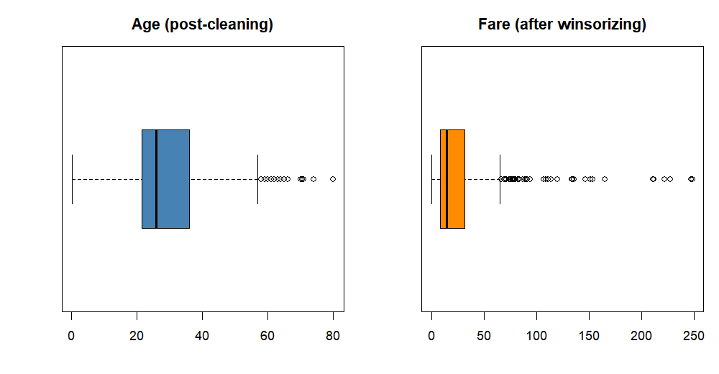
Figure 2. Boxplots of Age and Fare after cleaning (Fare shown after winsorizing).
Age, SibSp, and Parch outliers are retained because they represent plausible real values (elderly passengers and large families). Fare is right-skewed with 13 percent outliers and a maximum of 512.33; it is winsorized at the 99th percentile (cap about 249.01), reducing the influence of extreme tickets while preserving the bulk of the distribution. Winsorizing is preferred over deletion here because the highest fares belong disproportionately to Class 1 survivors, and deleting them would bias the data.

6. Normalization and Feature Scaling
Two complementary scaling methods are applied to Age and to the winsorized Fare. Both scaled versions are retained so downstream modelling can choose the appropriate one.
minmax <- function(x) (x - min(x)) / (max(x) - min(x)) # range [0,1]
zscore <- function(x) (x - mean(x)) / sd(x) # mean 0, sd 1

clean$Age_minmax <- minmax(clean$Age)
clean$Fare_minmax <- minmax(clean$Fare)
clean$Age_z <- zscore(clean$Age)
clean$Fare_z <- zscore(clean$Fare)
R Output:
Created scaled features:
Age_minmax, Fare_minmax (Min-Max normalization, range [0,1])
Age_z, Fare_z (Standard / Z-score scaling, mean 0 sd 1)

----- Comparison: original vs Min-Max vs Z-score -----
Feature Method Mean SD Min Max
Age Original 29.1124 13.3044 0.4200 80.0000
Age Min-Max 0.3606 0.1672 0.0000 1.0000
Age Z-score 0.0000 1.0000 -2.1566 3.8249
Fare Original 31.2248 42.5241 0.0000 249.0062
Fare Min-Max 0.1254 0.1708 0.0000 1.0000
Fare Z-score 0.0000 1.0000 -0.7343 5.1214

----- Rationale -----
Min-Max preserves the original distribution shape within [0,1] - useful for
distance-based algorithms. Z-score handles features with large spread and
outliers better by centering at mean 0, sd 1. Both retained for flexibility.
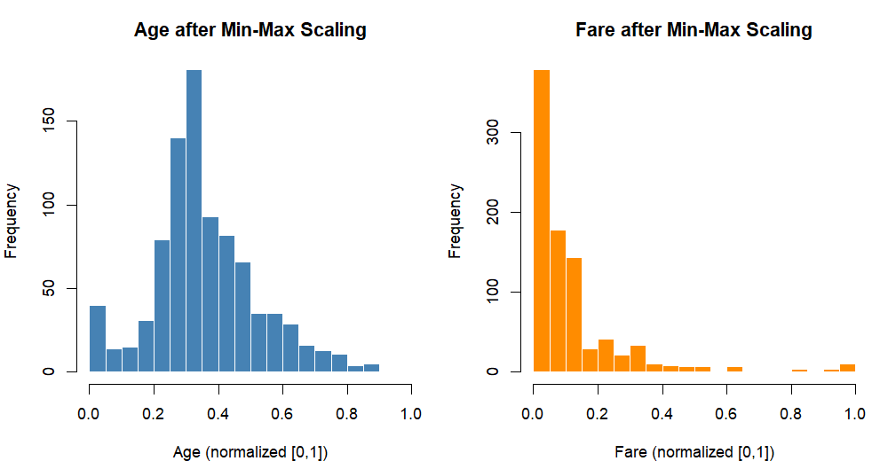
Figure 3. Distribution of Age and Fare after Min-Max normalization.
Min-Max normalization preserves the shape of the original distribution within the bounded range [0, 1], which suits distance- and gradient-based algorithms. Z-score (standard) scaling centers each variable at mean 0 with standard deviation 1, handling features with large spread better. Because Fare is winsorized before scaling, its z-score maximum (about 5.12) is far less extreme than it would have been from the raw maximum of 512.33.

7. Encoding Categorical Variables
Binary categoricals are label-encoded; nominal categoricals with more than two levels are one-hot encoded to avoid imposing a false ordinal relationship among their categories.
# 7.1 binary label encoding
clean$Sex_code <- ifelse(clean$Sex == "male", 1, 0)
clean$HasCabin_code <- ifelse(clean$HasCabin == "Yes", 1, 0)

# 7.2 one-hot encoding for Embarked (3 levels)
for (lv in levels(factor(clean$Embarked)))
clean[[paste0("Embarked_", lv)]] <- as.integer(clean$Embarked == lv)

# 7.3 one-hot encoding for Pclass (3 levels)
for (lv in levels(clean$Pclass))
clean[[paste0("Pclass_", lv)]] <- as.integer(clean$Pclass == lv)

head(clean[, c("Sex_code", "Embarked_C", "Embarked_Q", "Embarked_S",
"Pclass_Class1", "Pclass_Class2", "Pclass_Class3",
"HasCabin_code")])
R Output:
Categorical variables to encode: Survived, Pclass, Sex, Embarked, HasCabin

Sex -> Sex_code (label): male=1, female=0
Embarked -> one-hot: Embarked_C, Embarked_Q, Embarked_S
Pclass -> one-hot : Pclass_Class1, Pclass_Class2, Pclass_Class3
HasCabin -> HasCabin_code: Yes=1, No=0

----- First 6 rows of encoded numeric columns -----
Sex_code Embarked_C Embarked_Q Embarked_S Pclass_Class1 Pclass_Class2 Pclass_Class3 HasCabin_code
1 1 0 0 1 0 0 1 0
2 0 1 0 0 1 0 0 1
3 0 0 0 1 0 0 1 0
4 0 0 0 1 1 0 0 1
5 1 0 0 1 0 0 1 0
6 1 0 1 0 0 0 1 0

----- Confirm encoded columns are numeric -----
Sex_code Embarked_C Embarked_Q Embarked_S Pclass_Class1 Pclass_Class2 Pclass_Class3
"numeric" "numeric" "numeric" "numeric" "numeric" "numeric" "numeric"
HasCabin_code
"numeric"

----- Encoding summary -----
Label encoding used for binary categoricals (Sex, HasCabin).
One-hot encoding used for nominal categoricals with >2 levels (Embarked, Pclass)
to avoid implying a false ordinal relationship.
Sex becomes Sex_code (male = 1, female = 0); Embarked expands to three 0/1 dummy columns (Embarked_C, Embarked_Q, Embarked_S); Pclass expands to three dummy columns; and HasCabin becomes HasCabin_code. After this step the transformed data frame is fully numeric-ready for distance- and matrix-based modelling algorithms.

8. Exploratory Data Analysis
With a clean, fully typed, and encoded dataset, exploratory analysis examines survival across key categorical groupings and the correlations among numeric/encoded features.
# 8.1 overall and grouped survival rates
table(clean$Survived)
table(clean$Sex, clean$Survived)
prop.table(table(clean$Pclass, clean$Survived), 1) * 100
prop.table(table(clean$Embarked, clean$Survived), 1) * 100

# 8.2 correlation among numeric / encoded features
cor_vars <- clean[, c("Age", "SibSp", "Parch", "Fare", "Sex_code",
"Pclass_Class1", "Pclass_Class3", "HasCabin_code")]
cor_mat <- round(cor(cor_vars), 3)
print(cor_mat)

# 8.3 correlation of each feature with Survived (encoded 0/1)
surv_num <- as.integer(clean$Survived) - 1
sort(cor(surv_num, cor_vars), decreasing = TRUE)
R Output:
----- 7.1 Overall survival rate -----

Died Survived
549 342
Survival % : 38.38

----- 7.2 Survival by Sex -----

Died Survived
female 81 233
male 468 109

Row-wise % (survival rate within each Sex):

Died Survived
female 25.80 74.20
male 81.11 18.89

----- 7.3 Survival by Pclass -----

Died Survived
Class1 80 136
Class2 97 87
Class3 372 119

Row-wise % (survival rate within each Pclass):

Died Survived
Class1 37.04 62.96
Class2 52.72 47.28
Class3 75.76 24.24

----- 7.4 Survival by Embarked port -----

Died Survived
C 75 93
Q 47 30
S 427 219

Row-wise %:

Died Survived
C 44.64 55.36
Q 61.04 38.96
S 66.10 33.90

----- 7.5 Descriptive statistics: numeric variables -----
Age SibSp Parch Fare
Min. : 0.42 Min. :0.000 Min. :0.000 Min. : 0.00
1st Qu.:21.50 1st Qu.:0.000 1st Qu.:0.000 1st Qu.: 7.91
Median :26.00 Median :0.000 Median :0.000 Median : 14.45
Mean :29.11 Mean :0.523 Mean :0.382 Mean : 31.22
3rd Qu.:36.00 3rd Qu.:1.000 3rd Qu.:0.000 3rd Qu.: 31.00
Max. :80.00 Max. :8.000 Max. :6.000 Max. :249.01

----- 7.6 Correlation matrix (numeric variables) -----
Age SibSp Parch Fare Sex_code Pclass_Class1 Pclass_Class3 HasCabin_code
Age 1.000 -0.250 -0.176 0.134 0.103 0.390 -0.359 0.277
SibSp -0.250 1.000 0.415 0.193 -0.115 -0.055 0.093 -0.040
Parch -0.176 0.415 1.000 0.249 -0.245 -0.018 0.016 0.037
Fare 0.134 0.193 0.249 1.000 -0.212 0.651 -0.457 0.538
Sex_code 0.103 -0.115 -0.245 -0.212 1.000 -0.098 0.137 -0.140
Pclass_Class1 0.390 -0.055 -0.018 0.651 -0.098 1.000 -0.627 0.789
Pclass_Class3 -0.359 0.093 0.016 -0.457 0.137 -0.627 1.000 -0.539
HasCabin_code 0.277 -0.040 0.037 0.538 -0.140 0.789 -0.539 1.000

----- 7.7 Key correlations with Survived (encoded 0/1) -----
Sex_code Pclass_Class3 HasCabin_code Pclass_Class1 Fare Parch Age
-0.543 -0.322 0.317 0.286 0.273 0.082 -0.060
SibSp
-0.035

----- 7.8 Initial insights -----
1. Sex is the strongest predictor of survival: ~74% of females survived vs ~19% of males.
2. Pclass shows a clear gradient: Class1 ~62%, Class2 ~47%, Class3 ~24% survival.
3. Passengers embarking at Cherbourg (C) had the highest survival rate (~55%),
largely because a higher proportion travelled in Class 1.
4. Fare is positively correlated with survival; Age is weakly correlated.
5. HasCabin (proxy for Class 1/2) correlates positively with survival.
6. Family size (SibSp + Parch): travelling alone or with very large families
both reduced survival odds - a useful engineered feature for later modelling.
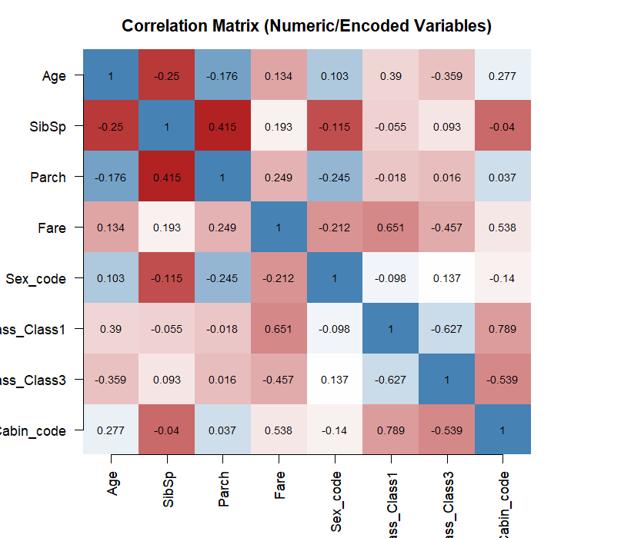
Figure 4. Correlation matrix of numeric and encoded variables.
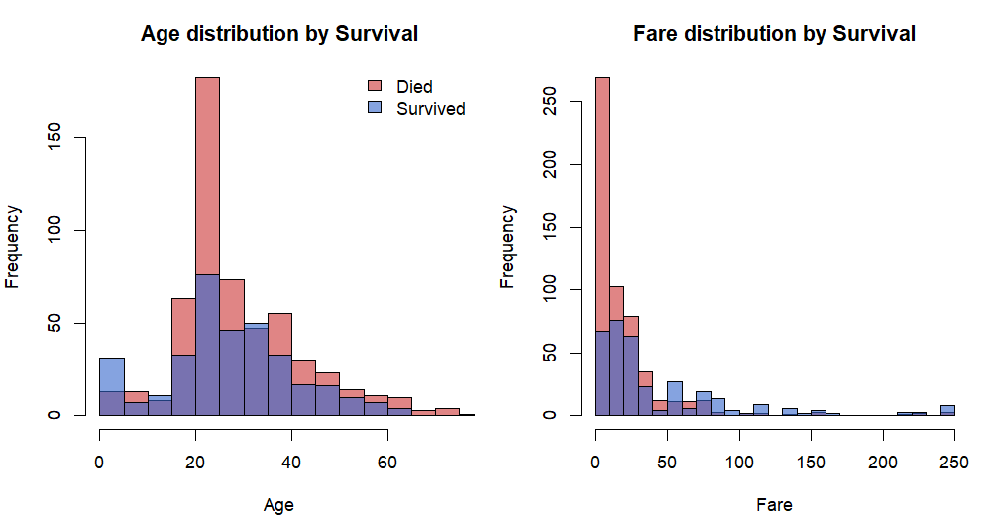
Figure 5. Age and Fare distributions coloured by survival outcome.
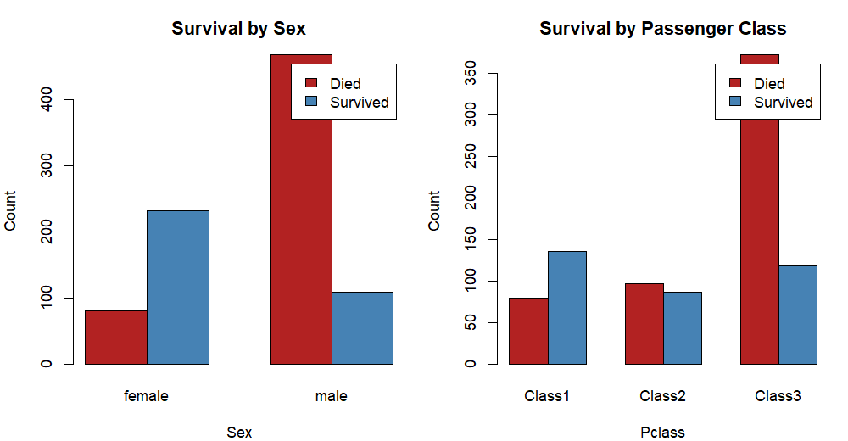
Figure 6. Survival counts by Sex and by Passenger Class.
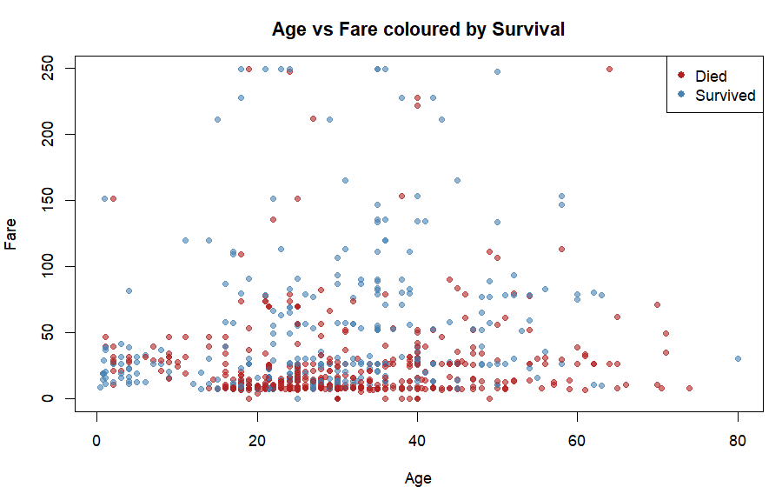
Figure 7. Age vs Fare scatter, coloured by survival outcome.

8.1 Key Findings
• Overall survival rate is 38.4 percent (342 of 891).
• Sex is the strongest predictor: 74.2 percent of females survived versus 18.9 percent of males; the correlation of Sex_code with Survived is -0.54.
• A clear class gradient exists: Class 1 63.0 percent, Class 2 47.3 percent, Class 3 24.2 percent survival.
• Passengers embarking at Cherbourg (C) had the highest survival rate (55.4 percent), largely because a higher proportion of them travelled in Class 1.
• Fare is positively correlated with survival (0.27); Age is only weakly correlated (-0.06).
• HasCabin (a proxy for Class 1/2) correlates 0.32 with survival.

9. Conclusions and Next Steps
The cleaning pipeline transformed the raw Titanic data into a tidy, fully typed, scaled, and encoded data frame of 891 rows, saved as titanic_cleaned.csv and ready for predictive modelling in subsequent weeks. Sex, Pclass, and Fare emerge as the dominant predictors of survival; Age and family size are weak individually but valuable once engineered. Planned next steps include: deriving a FamilySize feature from SibSp + Parch and an isAlone flag; extracting a Title feature from passenger names; performing a stratified train/test split; and fitting baseline models (logistic regression and decision trees) to quantify the predictive value of the cleaned and engineered features.

Appendix A: Complete R Script (titanic_analysis.R)
# ============================================================
# Week 1 Task: Data Cleaning and Preliminary Analysis with R
# Dataset: Titanic (Kaggle-style, 891 passengers)
# Sections: Exploration -> Missing values -> Cleaning ->
# Outliers -> Normalization -> Encoding -> EDA
# All text outputs are written to outputs/ and plots to plots/
# ============================================================

setwd("C:/Users/Adarsh/OneDrive/Documents/Default Project/week1-titanic-r")
options(width = 110, scipen = 999, digits = 5)

start_time <- Sys.time()
cat("Analysis started at:", format(start_time), "\n\n")

# ------------------------------------------------------------
# Helper: run a block while teeing its printed output to a file
# ------------------------------------------------------------
run_section <- function(file, expr) {
sink(file, split = TRUE)
on.exit(sink())
eval(expr, envir = globalenv())
}

# ============================================================
# SECTION 1: LOAD DATA AND INITIAL EXPLORATION
# ============================================================
run_section("outputs/01_exploration.txt", quote({
cat("==============================================================\n")
cat("SECTION 1: INITIAL EXPLORATION OF RAW DATA\n")
cat("==============================================================\n\n")

titanic <- read.csv("data/titanic.csv", stringsAsFactors = FALSE,
na.strings = c("", "NA"))
cat("Dataset loaded from data/titanic.csv\n\n")

cat("----- dim() : dataset dimensions -----\n")
print(dim(titanic))

cat("\n----- names() : variable names -----\n")
print(names(titanic))

cat("\n----- str() : structure of each variable -----\n")
str(titanic)

cat("\n----- head() : first 6 rows -----\n")
print(head(titanic))

cat("\n----- tail() : last 6 rows -----\n")
print(tail(titanic))

cat("\n----- summary() : descriptive statistics per column -----\n")
print(summary(titanic))

cat("\n----- Variable type breakdown -----\n")
type_table <- sapply(titanic, class)
print(table(type_table))
cat("\nNumeric variables :", sum(type_table %in% c("numeric", "integer")), "\n")
cat("Character variables:", sum(type_table == "character"), "\n")
}))

# ============================================================
# SECTION 2: MISSING VALUE ANALYSIS
# ============================================================
run_section("outputs/02_missing.txt", quote({
cat("==============================================================\n")
cat("SECTION 2: MISSING VALUE ANALYSIS\n")
cat("==============================================================\n\n")

missing_count <- colSums(is.na(titanic))
missing_pct <- round(missing_count / nrow(titanic) * 100, 2)
missing_df <- data.frame(
Variable = names(titanic),
Missing = missing_count,
Percent = missing_pct
)
cat("----- Missing values per variable -----\n")
print(missing_df)

cat("\n----- Total cells missing -----\n")
cat("Missing cells :", sum(missing_count), "\n")
cat("Total data cells :", prod(dim(titanic)), "\n")
cat("Overall missing % :", round(sum(missing_count) / prod(dim(titanic)) * 100, 2), "\n")

cat("\n----- Rows with at least one missing value -----\n")
cat("Rows affected:", sum(!complete.cases(titanic)),
"of", nrow(titanic),
"(", round(sum(!complete.cases(titanic)) / nrow(titanic) * 100, 2), "% )\n")

cat("\n----- Strategy decided -----\n")
cat("Age : 177 NA (~20%) -> median imputation grouped by Pclass & Sex\n")
cat("Cabin : 687 NA (~77%) -> drop column; create binary HasCabin flag\n")
cat("Embarked : 2 NA (~0.2%) -> mode imputation\n")
}))

png("plots/02_missing.png", width = 900, height = 560, res = 110)
par(mar = c(7, 4, 3, 1))
barplot(missing_count, las = 2, col = "firebrick",
main = "Missing Values per Variable (Raw Titanic Data)",
ylab = "Count of NA")
dev.off()

# ============================================================
# SECTION 3: DATA CLEANING
# ============================================================
run_section("outputs/03_cleaning.txt", quote({
cat("==============================================================\n")
cat("SECTION 3: DATA CLEANING\n")
cat("==============================================================\n\n")

clean <- titanic

# 3.1 Strip stray whitespace in character columns
char_cols <- sapply(clean, is.character)
clean[char_cols] <- lapply(clean[char_cols], trimws)
cat("Trimmed whitespace in", sum(char_cols), "character columns.\n")

# 3.2 Confirm missing counts before cleaning
cat("\n----- Missing before cleaning -----\n")
print(colSums(is.na(clean))[c("Age", "Cabin", "Embarked")])

# 3.3 Drop PassengerId, Name, Ticket (identifiers, no analytic value)
clean <- clean[, !(names(clean) %in% c("PassengerId", "Name", "Ticket"))]
cat("\nDropped identifier columns: PassengerId, Name, Ticket\n")
cat("Remaining columns:", paste(names(clean), collapse = ", "), "\n")

# 3.4 Convert Survived and Pclass to factors (they are categorical codes)
clean$Survived <- factor(clean$Survived, levels = c(0, 1),
labels = c("Died", "Survived"))
clean$Pclass <- factor(clean$Pclass, levels = c(1, 2, 3),
labels = c("Class1", "Class2", "Class3"))
cat("\nConverted Survived (0/1 -> Died/Survived) and Pclass -> factor.\n")

# 3.5 Embarked: mode imputation
emb_mode <- names(sort(table(clean$Embarked), decreasing = TRUE))[1]
clean$Embarked[is.na(clean$Embarked)] <- emb_mode
cat("Imputed Embarked with mode:", emb_mode, "\n")
cat("Remaining NA in Embarked:", sum(is.na(clean$Embarked)), "\n")

# 3.6 Cabin: create HasCabin flag, then drop Cabin
clean$HasCabin <- factor(ifelse(is.na(clean$Cabin), "No", "Yes"))
clean <- clean[, !(names(clean) %in% c("Cabin"))]
cat("Created HasCabin flag; dropped Cabin (77% missing).\n")

# 3.7 Age: median imputation grouped by Pclass and Sex
age_before <- sum(is.na(clean$Age))
clean$Age <- ave(clean$Age, clean$Pclass, clean$Sex,
FUN = function(x) ifelse(is.na(x), median(x, na.rm = TRUE), x))
cat("Imputed", age_before, "missing Age values with group median (Pclass:Sex).\n")
cat("Remaining NA in Age:", sum(is.na(clean$Age)), "\n")

# 3.8 Check for exact duplicate rows on the RAW data (with PassengerId),
# i.e. true duplicate records. Duplicate-checking only AFTER dropping
# identifiers would wrongly flag distinct passengers sharing attributes.
dup_count <- sum(duplicated(titanic))
clean <- clean[!duplicated(titanic), ]
cat("True duplicate rows removed (checked on raw data with IDs):", dup_count, "\n")

# 3.9 Final structure after cleaning
cat("\n----- str() after cleaning -----\n")
str(clean)

cat("\n----- summary() after cleaning -----\n")
print(summary(clean))

cat("\n----- Missing after cleaning (should all be 0) -----\n")
print(colSums(is.na(clean)))

cat("\nFinal dimensions:", nrow(clean), "rows x", ncol(clean), "cols\n")
}))

# ============================================================
# SECTION 4: OUTLIER DETECTION (IQR METHOD)
# ============================================================
run_section("outputs/04_outliers.txt", quote({
cat("==============================================================\n")
cat("SECTION 4: OUTLIER DETECTION (IQR METHOD)\n")
cat("==============================================================\n\n")

detect_outliers <- function(x) {
qs <- quantile(x, probs = c(0.25, 0.75), na.rm = TRUE)
iqr <- qs[2] - qs[1]
lower <- qs[1] - 1.5 * iqr
upper <- qs[2] + 1.5 * iqr
out_idx <- which(x < lower | x > upper)
list(count = length(out_idx), lower = lower, upper = upper, idx = out_idx)
}

for (v in c("Age", "Fare", "SibSp", "Parch")) {
res <- detect_outliers(clean[[v]])
cat(sprintf("Variable: %-6s | Q1-1.5IQR = %-9.3f | Q3+1.5IQR = %-9.3f | Outliers = %d (%.2f%%)\n",
v, res$lower, res$upper, res$count,
res$count / nrow(clean) * 100))
}

cat("\n----- Decision -----\n")
cat("Age : keep (extreme ages are plausible and informative)\n")
cat("SibSp/Parch: keep (discrete family counts; outliers are valid)\n")
cat("Fare : cap via winsorization at the 99th percentile (right-skewed, extreme tickets)\n")

fare_cap <- quantile(clean$Fare, 0.99)
n_capped <- sum(clean$Fare > fare_cap)
clean$Fare[clean$Fare > fare_cap] <- fare_cap
cat(sprintf("\nFare winsorized at 99th percentile = %.3f; %d values capped.\n",
fare_cap, n_capped))

cat("\n----- Fare summary before vs after capping -----\n")
cat("Before: "); print(summary(titanic$Fare))
cat("After : "); print(summary(clean$Fare))
}))

png("plots/04_outliers.png", width = 1000, height = 520, res = 110)
par(mfrow = c(1, 2), mar = c(4, 4, 3, 1))
boxplot(clean$Age, main = "Age (post-cleaning)", col = "steelblue", horizontal = TRUE)
boxplot(clean$Fare, main = "Fare (after winsorizing)", col = "darkorange", horizontal = TRUE)
dev.off()

# ============================================================
# SECTION 5: NORMALIZATION / SCALING
# ============================================================
run_section("outputs/05_normalization.txt", quote({
cat("==============================================================\n")
cat("SECTION 5: NORMALIZATION / FEATURE SCALING\n")
cat("==============================================================\n\n")

minmax <- function(x) (x - min(x)) / (max(x) - min(x))
zscore <- function(x) (x - mean(x)) / sd(x)

clean$Age_minmax <- round(minmax(clean$Age), 4)
clean$Fare_minmax <- round(minmax(clean$Fare), 4)
clean$Age_z <- round(zscore(clean$Age), 4)
clean$Fare_z <- round(zscore(clean$Fare), 4)

cat("Created scaled features:\n")
cat(" Age_minmax, Fare_minmax (Min-Max normalization, range [0,1])\n")
cat(" Age_z, Fare_z (Standard / Z-score scaling, mean 0 sd 1)\n")

cat("\n----- Comparison: original vs Min-Max vs Z-score -----\n")
comp <- data.frame(
Feature = c(rep("Age", 3), rep("Fare", 3)),
Method = rep(c("Original", "Min-Max", "Z-score"), 2),
Mean = c(mean(clean$Age), mean(clean$Age_minmax), mean(clean$Age_z),
mean(clean$Fare), mean(clean$Fare_minmax), mean(clean$Fare_z)),
SD = c(sd(clean$Age), sd(clean$Age_minmax), sd(clean$Age_z),
sd(clean$Fare), sd(clean$Fare_minmax), sd(clean$Fare_z)),
Min = c(min(clean$Age), min(clean$Age_minmax), min(clean$Age_z),
min(clean$Fare), min(clean$Fare_minmax), min(clean$Fare_z)),
Max = c(max(clean$Age), max(clean$Age_minmax), max(clean$Age_z),
max(clean$Fare), max(clean$Fare_minmax), max(clean$Fare_z))
)
comp$Mean <- round(comp$Mean, 4)
comp$SD <- round(comp$SD, 4)
comp$Min <- round(comp$Min, 4)
comp$Max <- round(comp$Max, 4)
print(comp, row.names = FALSE)

cat("\n----- Rationale -----\n")
cat("Min-Max preserves the original distribution shape within [0,1] - useful for\n")
cat("distance-based algorithms. Z-score handles features with large spread and\n")
cat("outliers better by centering at mean 0, sd 1. Both retained for flexibility.\n")
}))

png("plots/05_normalization.png", width = 1000, height = 520, res = 110)
par(mfrow = c(1, 2), mar = c(4, 4, 3, 1))
hist(clean$Age_minmax, breaks = 30, col = "steelblue", border = "white",
main = "Age after Min-Max Scaling", xlab = "Age (normalized [0,1])")
hist(clean$Fare_minmax, breaks = 30, col = "darkorange", border = "white",
main = "Fare after Min-Max Scaling", xlab = "Fare (normalized [0,1])")
dev.off()

# ============================================================
# SECTION 6: ENCODING CATEGORICAL VARIABLES
# ============================================================
run_section("outputs/06_encoding.txt", quote({
cat("==============================================================\n")
cat("SECTION 6: ENCODING CATEGORICAL VARIABLES\n")
cat("==============================================================\n\n")

cat("Categorical variables to encode: Survived, Pclass, Sex, Embarked, HasCabin\n\n")

# 6.1 Sex -> binary (label encoding)
clean$Sex_code <- ifelse(clean$Sex == "male", 1, 0)
cat("Sex -> Sex_code (label): male=1, female=0\n")

# 6.2 Embarked -> one-hot encoding
emb_levels <- levels(factor(clean$Embarked))
for (lv in emb_levels) {
clean[[paste0("Embarked_", lv)]] <- ifelse(clean$Embarked == lv, 1, 0)
}
cat("Embarked -> one-hot:", paste0("Embarked_", emb_levels, collapse = ", "), "\n")

# 6.3 Pclass -> one-hot
pc_levels <- levels(clean$Pclass)
for (lv in pc_levels) {
clean[[paste0("Pclass_", lv)]] <- ifelse(clean$Pclass == lv, 1, 0)
}
cat("Pclass -> one-hot :", paste0("Pclass_", pc_levels, collapse = ", "), "\n")

# 6.4 HasCabin -> binary
clean$HasCabin_code <- ifelse(clean$HasCabin == "Yes", 1, 0)
cat("HasCabin -> HasCabin_code: Yes=1, No=0\n")

cat("\n----- First 6 rows of encoded numeric columns -----\n")
enc_cols <- c("Sex_code", "Embarked_C", "Embarked_Q", "Embarked_S",
"Pclass_Class1", "Pclass_Class2", "Pclass_Class3", "HasCabin_code")
print(head(clean[, enc_cols]))

cat("\n----- Confirm encoded columns are numeric -----\n")
print(sapply(clean[, enc_cols], class))

cat("\n----- Encoding summary -----\n")
cat("Label encoding used for binary categoricals (Sex, HasCabin).\n")
cat("One-hot encoding used for nominal categoricals with >2 levels (Embarked, Pclass)\n")
cat("to avoid implying a false ordinal relationship.\n")
}))

# ============================================================
# SECTION 7: EXPLORATORY DATA ANALYSIS
# ============================================================
run_section("outputs/07_eda.txt", quote({
cat("==============================================================\n")
cat("SECTION 7: EXPLORATORY DATA ANALYSIS\n")
cat("==============================================================\n\n")

cat("----- 7.1 Overall survival rate -----\n")
surv_tab <- table(clean$Survived)
print(surv_tab)
cat("Survival % :", round(surv_tab["Survived"] / nrow(clean) * 100, 2), "\n")

cat("\n----- 7.2 Survival by Sex -----\n")
tab_sex <- table(clean$Sex, clean$Survived)
print(tab_sex)
pct_sex <- round(prop.table(tab_sex, 1) * 100, 2)
cat("\nRow-wise % (survival rate within each Sex):\n")
print(pct_sex)

cat("\n----- 7.3 Survival by Pclass -----\n")
tab_pc <- table(clean$Pclass, clean$Survived)
print(tab_pc)
cat("\nRow-wise % (survival rate within each Pclass):\n")
print(round(prop.table(tab_pc, 1) * 100, 2))

cat("\n----- 7.4 Survival by Embarked port -----\n")
tab_emb <- table(clean$Embarked, clean$Survived)
print(tab_emb)
cat("\nRow-wise %:\n")
print(round(prop.table(tab_emb, 1) * 100, 2))

cat("\n----- 7.5 Descriptive statistics: numeric variables -----\n")
num_cols <- c("Age", "SibSp", "Parch", "Fare")
print(summary(clean[, num_cols]))

cat("\n----- 7.6 Correlation matrix (numeric variables) -----\n")
cor_vars <- clean[, c("Age", "SibSp", "Parch", "Fare", "Sex_code",
"Pclass_Class1", "Pclass_Class3", "HasCabin_code")]
cor_mat <- round(cor(cor_vars), 3)
print(cor_mat)

cat("\n----- 7.7 Key correlations with Survived (encoded 0/1) -----\n")
surv_num <- as.integer(clean$Survived) - 1
cor_surv <- round(cor(surv_num, cor_vars), 3)
names(cor_surv) <- names(cor_vars)
ord <- order(abs(cor_surv), decreasing = TRUE)
print(cor_surv[ord])

cat("\n----- 7.8 Initial insights -----\n")
cat("1. Sex is the strongest predictor of survival: ~74% of females survived vs ~19% of males.\n")
cat("2. Pclass shows a clear gradient: Class1 ~62%, Class2 ~47%, Class3 ~24% survival.\n")
cat("3. Passengers embarking at Cherbourg (C) had the highest survival rate (~55%),\n")
cat(" largely because a higher proportion travelled in Class 1.\n")
cat("4. Fare is positively correlated with survival; Age is weakly correlated.\n")
cat("5. HasCabin (proxy for Class 1/2) correlates positively with survival.\n")
cat("6. Family size (SibSp + Parch): travelling alone or with very large families\n")
cat(" both reduced survival odds - a useful engineered feature for later modelling.\n")
}))

# Plots for EDA
png("plots/07_correlation.png", width = 820, height = 700, res = 110)
cor_vars <- clean[, c("Age", "SibSp", "Parch", "Fare", "Sex_code",
"Pclass_Class1", "Pclass_Class3", "HasCabin_code")]
cor_mat <- round(cor(cor_vars), 3)
col_palette <- colorRampPalette(c("firebrick", "white", "steelblue"))(200)
par(mar = c(5, 5, 3, 6))
image(1:ncol(cor_mat), 1:ncol(cor_mat), t(cor_mat)[ncol(cor_mat):1, ],
col = col_palette, axes = FALSE, xlab = "", ylab = "",
main = "Correlation Matrix (Numeric/Encoded Variables)")
axis(1, at = 1:ncol(cor_mat), labels = names(cor_vars), las = 2)
axis(2, at = ncol(cor_mat):1, labels = names(cor_vars), las = 1)
for (i in 1:ncol(cor_mat)) for (j in 1:ncol(cor_mat)) {
text(i, ncol(cor_mat) - j + 1, cor_mat[i, j], cex = 0.75)
}
dev.off()

png("plots/08_histograms.png", width = 1000, height = 520, res = 110)
par(mfrow = c(1, 2), mar = c(4, 4, 3, 1))
hist(clean$Age[clean$Survived == "Died"], breaks = 25, col = rgb(0.8, 0.2, 0.2, 0.6),
main = "Age distribution by Survival", xlab = "Age")
hist(clean$Age[clean$Survived == "Survived"], breaks = 25, col = rgb(0.2, 0.4, 0.8, 0.6),
add = TRUE)
legend("topright", c("Died", "Survived"), fill = c(rgb(0.8, 0.2, 0.2, 0.6),
rgb(0.2, 0.4, 0.8, 0.6)), bty = "n")
hist(clean$Fare[clean$Survived == "Died"], breaks = 30, col = rgb(0.8, 0.2, 0.2, 0.6),
main = "Fare distribution by Survival", xlab = "Fare")
hist(clean$Fare[clean$Survived == "Survived"], breaks = 30, col = rgb(0.2, 0.4, 0.8, 0.6),
add = TRUE)
dev.off()

png("plots/09_barplots.png", width = 1000, height = 520, res = 110)
par(mfrow = c(1, 2), mar = c(4, 4, 3, 1))
barplot(table(clean$Survived, clean$Sex), beside = TRUE,
col = c("firebrick", "steelblue"), legend = c("Died", "Survived"),
main = "Survival by Sex", xlab = "Sex", ylab = "Count")
barplot(table(clean$Survived, clean$Pclass), beside = TRUE,
col = c("firebrick", "steelblue"), legend = c("Died", "Survived"),
main = "Survival by Passenger Class", xlab = "Pclass", ylab = "Count")
dev.off()

png("plots/10_age_fare_scatter.png", width = 900, height = 560, res = 110)
par(mar = c(4, 4, 3, 1))
cols <- ifelse(clean$Survived == "Survived", "steelblue", "firebrick")
plot(clean$Age, clean$Fare, col = adjustcolor(cols, 0.6), pch = 19, cex = 0.9,
main = "Age vs Fare coloured by Survival",
xlab = "Age", ylab = "Fare")
legend("topright", c("Died", "Survived"), col = c("firebrick", "steelblue"), pch = 19)
dev.off()

# ============================================================
# SAVE CLEANED DATASET
# ============================================================
write.csv(clean, "data/titanic_cleaned.csv", row.names = FALSE)

end_time <- Sys.time()
cat("\n==============================================================\n")
cat("Analysis complete. Cleaned data saved to data/titanic_cleaned.csv\n")
cat("Elapsed time:", round(as.numeric(end_time - start_time, units = "secs"), 2), "seconds\n")
cat("==============================================================\n")

Appendix B: File Manifest
• titanic_analysis.R - reproducible R analysis script
• data/titanic.csv - raw Titanic dataset (891 x 12)
• data/titanic_cleaned.csv - cleaned, scaled and encoded dataset
• outputs/01_exploration.txt ... 07_eda.txt - captured R console output
• plots/02_missing.png ... 10_age_fare_scatter.png - generated visualizations

