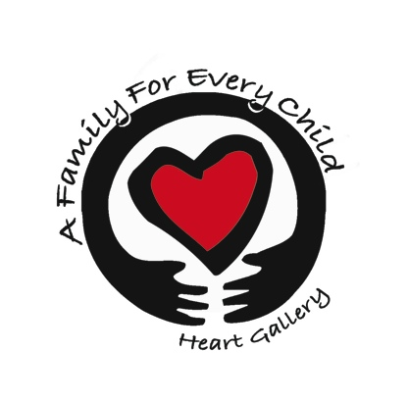
A Family For Every Child
(541) 343-2856/(877) 343-2856
Fax (541) 343-2866
www.afamilyforeverychild.org

Authorization of Release of Information

To Our Clients: We can serve you better if we are able to work with other agencies that know you and your family, or who may have information regarding adoption for your family. By signing this form, you are giving permission for these organizations to release information about your situation, and you are giving our agency permission to share information with other agencies as you work toward your goal of adoption.
_______________________________________________________________________________

I/We, ____________________________________________, agree that the agencies and individuals listed below may share and exchange information about my family and my circumstances. I may cancel this authorization for release at any time, but understand that the cancellation will not affect any information that was released before the cancellation. I understand that information about my/our case is confidential and protected by state and federal law. I approve the release of this information. I understand what this agreement means. I am signing on my own and have not been pressured to do so.

Applicant(s) Initial | Release Information* To/From | Purpose
 | State Offices to Services to Children and Families (SCF)/Department of Social and Health Services (DSHS)/Department of Human Services (DHS) staff and attorneys | To evaluate my situation and to plan/coordinate services for me and my family
 | Other agencies; including private adoption agencies | To evaluate my situation and to plan/coordinate services for me and my family
 | A child's CASA, a child's attorney, an Indian child's tribe, a representative of the RCWAC, and members of the adoption committee | To evaluate my situation and to plan/coordinate services for me and my family
 | - Medical  - Mental Health  - Therapy  - Other: _________________________ | To evaluate my situation and to plan/coordinate services for me and my family
* This information includes all confidential information, such as home studies, file notes, reports, evaluations, recommendations, and progress reports. This authorization is valid for one year from the date of signature.
________________________________ _____________________________
Applicant 1 Date
________________________________ _____________________________
Applicant 2 Date

