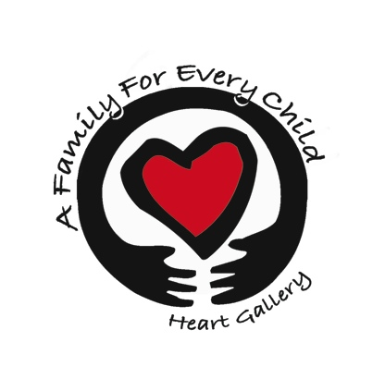
A Family For Every Child
(541) 343-2856/(877) 343-2856
Fax (541) 343-2866
www.afamilyforeverychild.org

Adoptive Parent Preferences

Applicant Names: ________________________________________________________
(Additional comments are welcomed - please respond on back of sheet)
Please indicate all that are acceptable.

Sex of infant/child: ___ Male ___ Female ___ Either

Age Age Range Preference (please check all that apply)
___ birth to 3 months ___ 7 to 9 years
___ 3 months to 6 months ___ 10 to 12 years
___ 6 months to 1 year ___ 13 to 15 years
___ 1 to 3 years ___ 16 and older
___ 4 to 6 years

Sibling Groups ___ Yes ___ No ___ Two ___ Three ___Four or more
___ All Boys ___ All Girls ___ Mixed Group

Religion ___ none ___ Protestant (specify) ___ Catholic ___ Jewish ___ Other (specify)

Appearance of Child (State specific characteristics of appearance you would like in a child, such as color of hair, eye color, possibility of being tall or short, etc.) ______________________

____________________________________________________________________________

Is it important that a child match you physically? ___ Yes ___ No

Intellectual Potential ___ Disabled ___ Slow ___ Average ___ Above Average

Health Problems Acceptable
___ Resolved problems only
___ Only very minor problems (glasses, orthodontia, etc.)
___ Medical problems requiring some on-going medical attention (cerebral palsy, severe allergies, epilepsy, diabetes, sight and hearing problems, orthopedic problems, etc.)
___ Terminal Condition (cystic fibrosis, muscular dystrophy, etc.)

Adoptive Parent Preferences (continued)

Backgrounds Acceptable
___ Any background would be considered
___ Concerned about background conditions (mental illness, dev disabled, epilepsy, diabetes, unknown father or parents, child product of incest, terminal condition, drug use, etc.)
___ Concern about adverse environmental conditions (deprivation, neglect, physical/mental/sexual abuse)

Acceptable Behavior
___ lying ___ talking back ___ bad manners
___ odd food habits ___ hyperactive ___ destructiveness
___ stealing ___ bed wetting ___ sexual acting out
___ poor school work ___ aggressiveness ___ masturbation
___ dependency/immaturity ___ lack of affection ___ profane language
___ withdrawn ___ poor peer relationships
___ cont'd contact with siblings ___ cruelty to other children/animals

Legal Status
___ Foster adopt ___ Half free/legal risk ___ Fully free only

Circumstances of Conception/Birth
___ rape - father unknown
___ rape - father known
___ child born of relatives
___ limited information on parents
___ married couple

Prenatal Condition
___ premature ___ alcohol or drug abuse by mother during pregnancy
___ smoking during pregnancy ___ alcohol/drug abuse by parents prior to pregnancy
___ treated VD in mother ___ limited or no prenatal care
___ untreated VD in mother ___ difficult birth
___ caffeine used during pregnancy ___ crack baby
___ fetal alcohol syndrome

Birth Parent Contact
Birth parents have the option of requesting pictures & non-identifying information up through the age of 6 months. Beyond the age of 6 months, to what kind of contact with the birth parents through this agency would you agree?
___ pictures up to age ____________
___ letters from birth parents (non-identifying, through the agency)
___ letters to birth parents (non identifying information, through the agency)
___ gifts (such as birthdays) from the birth parent up to age _____ through the agency
___ other ______________________________________________________________

