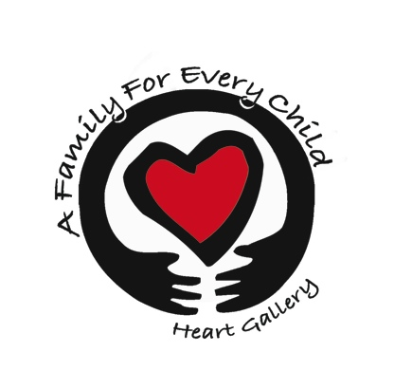
A Family For Every Child
(541) 343-2856/(877) 343-2856
Fax (541) 343-2866
www.afamilyforeverychild.org

Child Welfare/Foster Parents Records Request
By applying to be adoptive parents, we are requesting any and all information that may apply to you pertaining to the Child Welfare system, in regards to Child Welfare history or Foster parent history.

Foster Parent History:
I have____ / have not ____been a foster parent.
If so:
Date of Certification _____________________
County of Certification ___________________

Child Welfare History:
Have you ever had an investigation with DHS? ________ Date of investigation _______________

Reason for investigation: _____________________________________________________________________________________
_____________________________________________________________________________________

Outcome of investigation:
__________________________________________________________________________________________________________________________________________________________________________

County Where Investigated_____________________________________________
DHS Case Worker_____________________________________________________

Have you applied for adoption with another Agency in any state, or DHS in the State of Oregon in the last 10 years?
Yes____________________ NO_____________________

Agency:___________________________________________ Date:_________________________

Outcome:______________________________________________________________________________________________________________________________________________________________________________________________________________________________________________________________________

