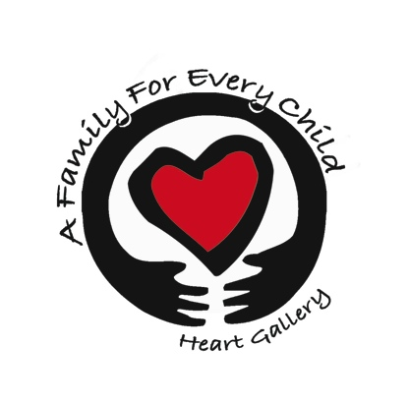
A Family For Every Child
(541) 343-2856/(877) 343-2856
Fax (541) 343-2866
www.afamilyforeverychild.org

Guardianship Information Sheet

In the event of our deaths, we ________________________________ plan to have the following person(s) care for our children.

Name(s): ______________________________________________________________

Address: ______________________________________________________________

______________________________________________________________________

We have discussed this plan with them and they have agreed to provide guardianship. We understand this is not a legally binding document and will create a legally binding statement upon finalization of adoption regarding custody of our children in the event of our deaths. This form is only for purposes of adoption.

The following is required information of guardians (mark N/A if not applicable):

 | Father | Mother | Child | Child | Child
Name
Age
Marital Status
Education
Living with Parents?
Type of Employment

List other children including items listed above, if known:

