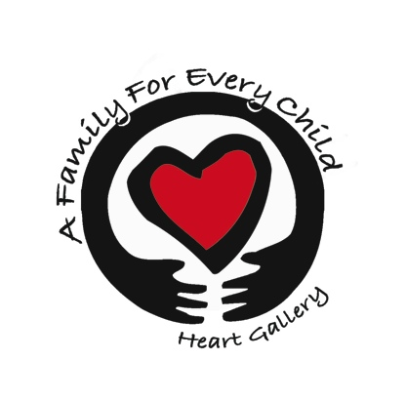
A Family For Every Child
(541) 343-2856/(877) 343-2856
Fax (541) 343-2866
www.afamilyforeverychild.org
Autobiography
Adoptive Parent #2

It is required that you write or type a narrative autobiography about yourself using this outline as a guide.
The outline below will help us learn more about you, your interests, your family, your history, and your motivation to adopt.
You may “free-write” your own story, using the questions below as a guide, or you may write a short summary to answer each question. How you choose to develop the final autobiography is up to you.
Please include as much detail as possible and make sure that you cover all areas thoroughly. Your Adoption Worker will use this information, along with your interviews, to compose and write your family’s Home Study.

Describe your childhood and adolescence
- Describe your childhood home or homes. What do you miss about them?
- What was your home life like? Describe your family’s lifestyle. Did you have an absent parent?
- What are some of your earliest childhood memories? Who was there and what happened?
- Did you work as a child? Did you work as a young adult? For who, where, and what did you do?
- Did you play any musical instruments? What were some activities and hobbies that you enjoyed?
- Who were your best friends when you were growing up? What were their ethnicities? Describe them.
- What are your happiest and saddest memories? Who was involved? How did they affect you?
- What event stands out as the most significant crisis for you? How did it affect you?
- Were there any other significant adults in your life who helped you develop as a person? How?
- What were your goals when you were young? How have they changed or developed?
Describe your family
- How did you and your siblings get along? What were some activities you enjoyed together?
- How has that relationship either grown or changed since you were children? Do you still talk?
- How did your parents get along? Describe any problems (alcoholism, abuse, divorce, unemployment)
- How did these problems affect you? Were you closer to one parent?
- If you had any step-siblings, describe your relationship with them.
- How did your parent(s) discipline you? Were they strict or lenient? Were you punished excessively?

Autobiography
Adoptive Parent #2 page 2

- What did your parents expect from you (educationally, chores, etc.)? How did you know expectations?
- Who in your family are you most like? Why?
- When you were young, whom did you get along easily? Whom was the most difficult? Why?
- What were acceptable ways for members of your family to show happiness, love, and affection?
- How did your family members express anger, disappointment, and frustration?
- What were your Grandparents like? How have they changed as you have grown? Were you close?
- Where are your Grandparents now? If deceased, how did their death(s) affect you?
Describe Yourself

- Describe yourself. (i.e. are you tall, short, stocky, thin, your physical characteristics).
- What kind of an emphasis do you put on grooming? Do you prefer to dress casual or formal?
- Describe your personality, as you see yourself. Are you quiet and reserved or outgoing and friendly?
- Do you get to know people right away or do you like to take a while? Explain why.
- Are you ambitious and energetic or relaxed and easygoing? Explain why.
- What are your personal strengths and weaknesses?
- What is your most important accomplishment up to this point? Describe it and it’s affect on you.
- What are some of your future goals? How do you plan to accomplish them? How long?
- Briefly describe how you think others see you.
- Describe your spiritual beliefs. Are you actively involved in a church or group? How often?
- What is your feeling toward involvement in religion, faith, restrictions, concepts, etc.?
Describe your home and family
- Describe the relationship with your partner(if applicable). How did you meet? What do you like best?
- How do you and your partner celebrate accomplishments? How do you handle disappointments?
- Describe some of the strengths and vulnerabilities in your relationship? How do they affect you?
- What types of activities do you and your partner enjoy together? How often?
- How do you make decisions and solve problems together? How do you express yourselves?
- How do you like to see your home? Neat? Cluttered? What are your favorite areas? Why?
Autobiography
Adoptive Parent #2 page 3

- Describe your attitude towards TV. What is acceptable? How should viewing be controlled?
- Who manages money in your home? How are decisions about saving and spending made?
- What kinds of activities do you like to do in your household? How do you plan for these?
- Does your family attend any cultural or ethnic events? Describe them and what you enjoy.
- Briefly describe any children you have. What are their feelings about adding to the family?
- Describe your feelings towards discipline. How should it be done, when, and by whom?
- If you are already a parent, describe your current methods of discipline and their effectiveness.
Areas around adoption
- Describe your reasons for wanting to adopt. Why do you want to add to your family now?
- Have you planned the number of children you hope to have? How many and why?
- How do you think adding a child will impact your current situation and family’s lifestyle?
- Describe your family’s views of different ethnicities, cultures, religions, and traditions?
- Do you or anyone in your household speak another language? Whom and what language(s)?
- What types of features and characteristics in a child do you feel would fit best with your family?
- Briefly describe your neighborhood and community. How will this area benefit your adopted child?
- How do you feel about communication with birth parents or other family members?
- How will you help your adopted child understand adoption? Your current children?
- How important is physical resemblance between parent and child? How will you explain differences?

