Attributions Doc

1. Cream brick texture / “improved palm tree texture”
   1. 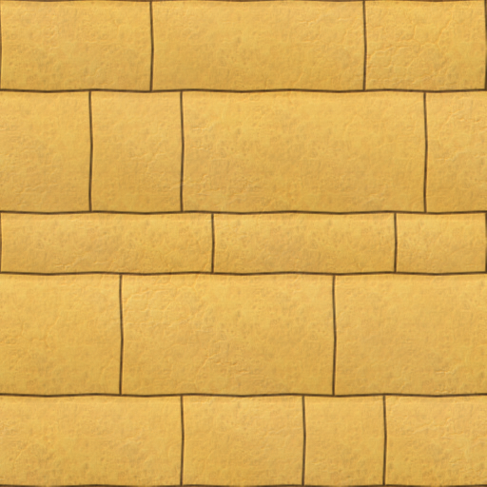
   2. Posted by user fraang on 25 Jul 2011, 22:17 at <https://forum.freegamedev.net/viewtopic.php?f=18&t=1619&start=25>
   3. Under license CC-BY-SA or CC-0, “whatever we want”, indicating whichever one we can use that best lets us use the texture
      1. 