**ORPHANAGE MANAGEMENT SYSTEM**

* By Sivaramakrishnan S

<https://www.linkedin.com/in/srkjs/>

**Overview:**

Orphanage Management System is an online Web Application through which the user can get details about the available orphanages. The system enables the user to Login/Signup and perform donations, request adoption and book a visit to the orphanage.

There is a provision provided for the admins of the orphanage management system to login and access the details of the donations, adoption requests and bookings done through the system.

**Technologies:**

+ HTML

+ CSS

+ JavaScript

+ Java Server Pages (JSP)

+ Java Servlets

+ SQL

**Applications:**

+ Browser – Google Chrome

+ Database – MySQL Workbench

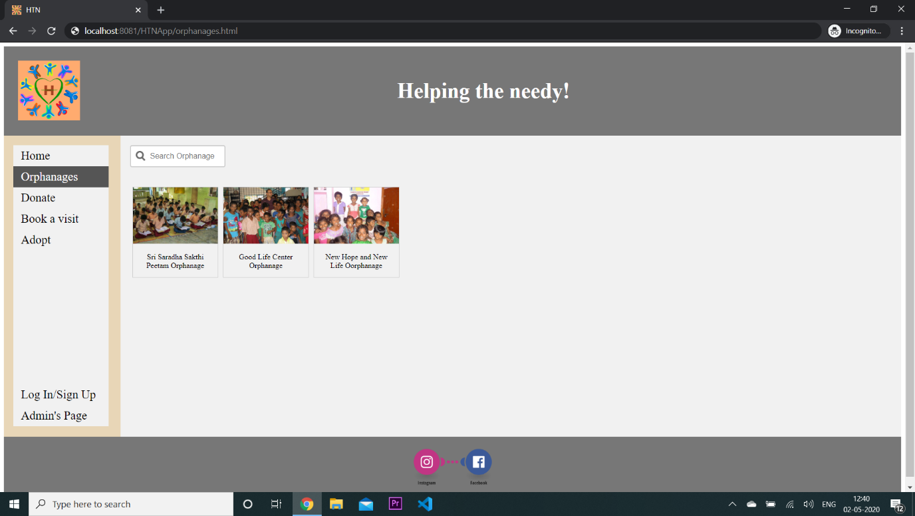**Screenshots:**

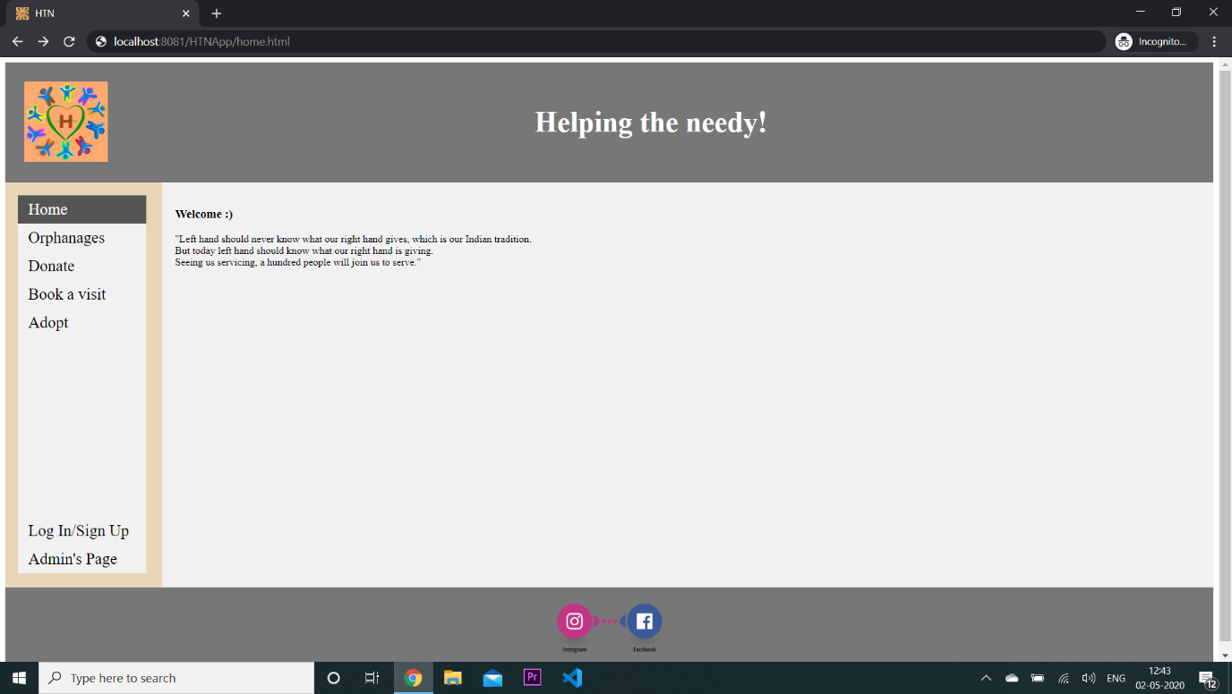Before Login -

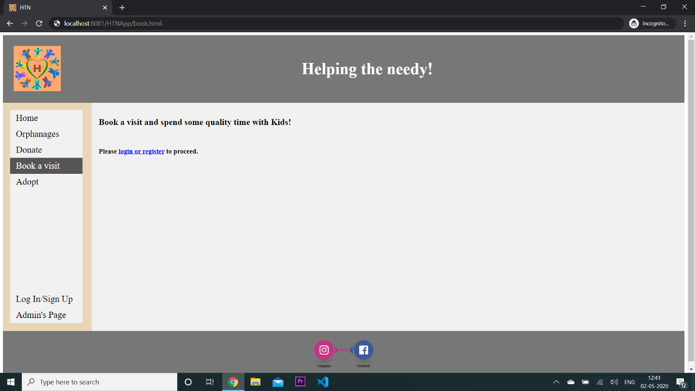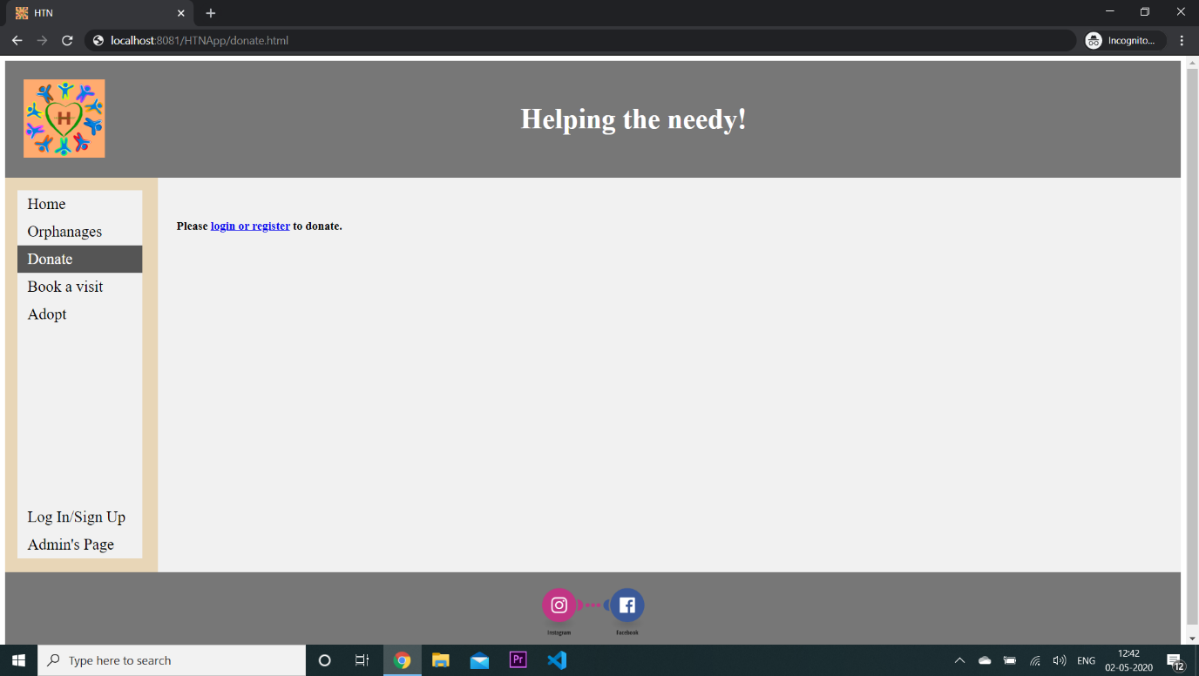

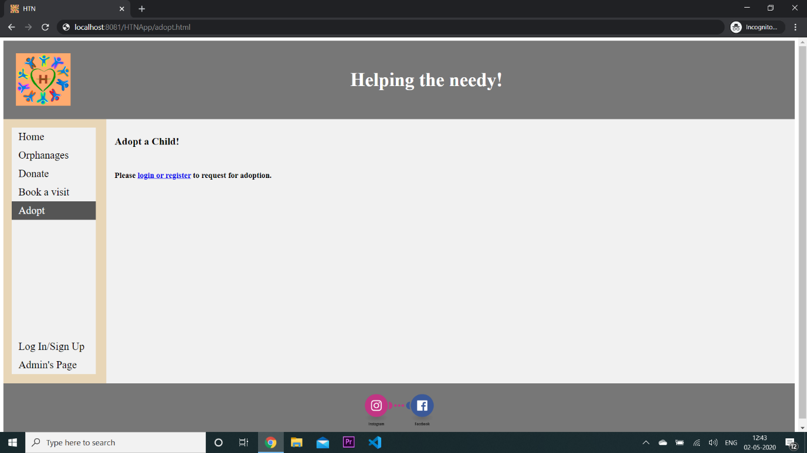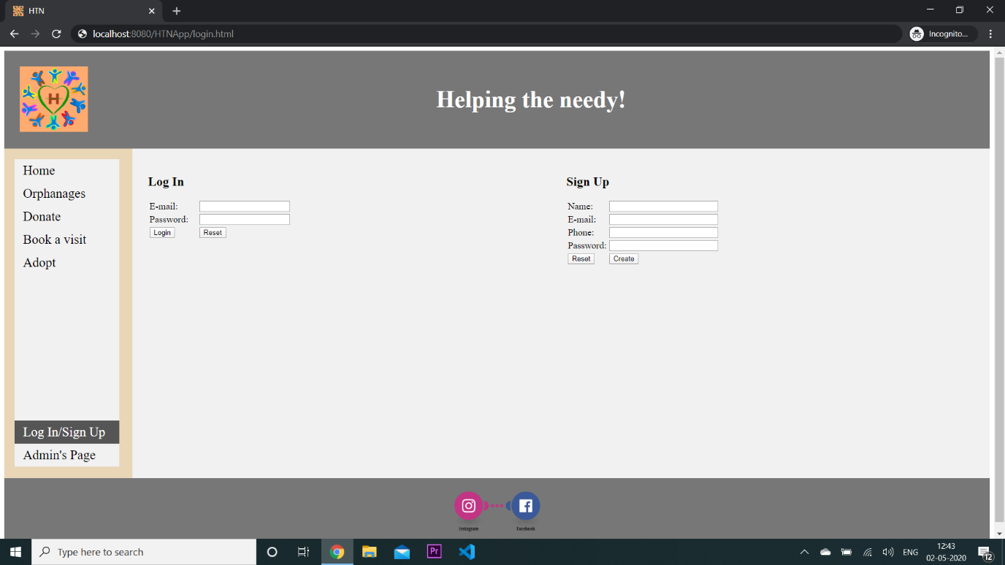

After Login -

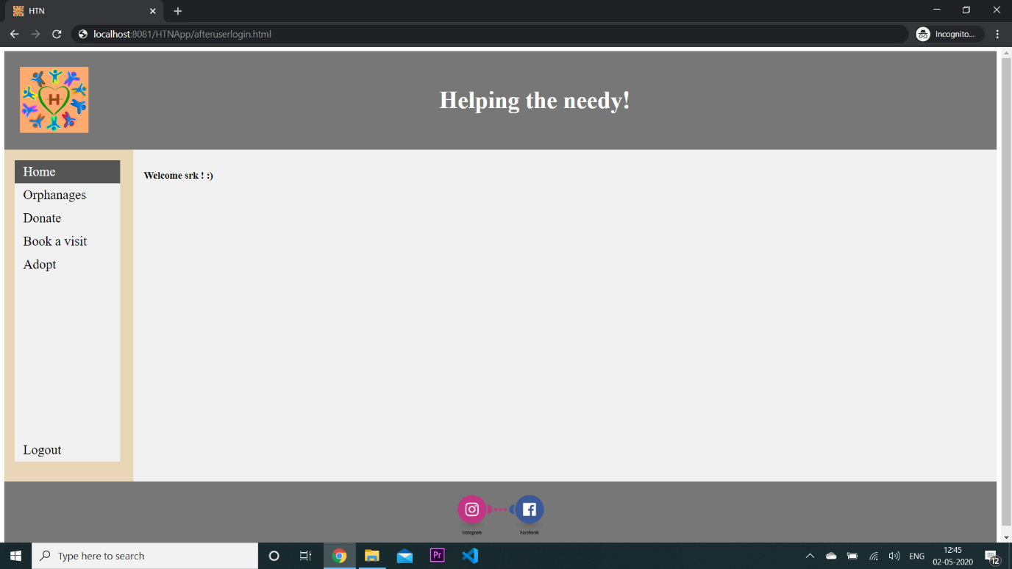

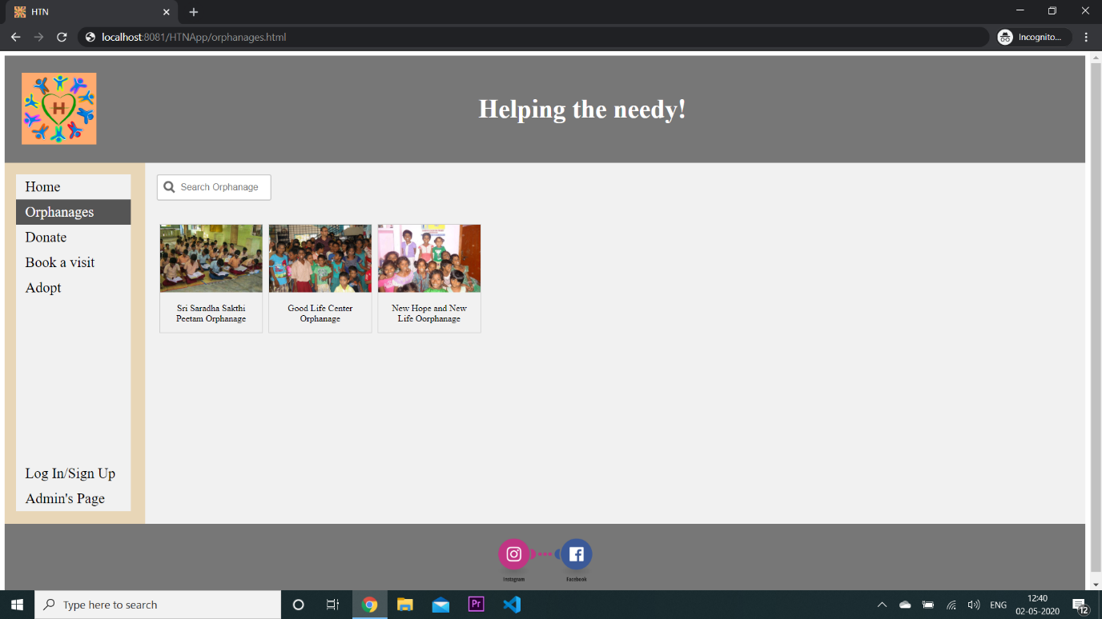

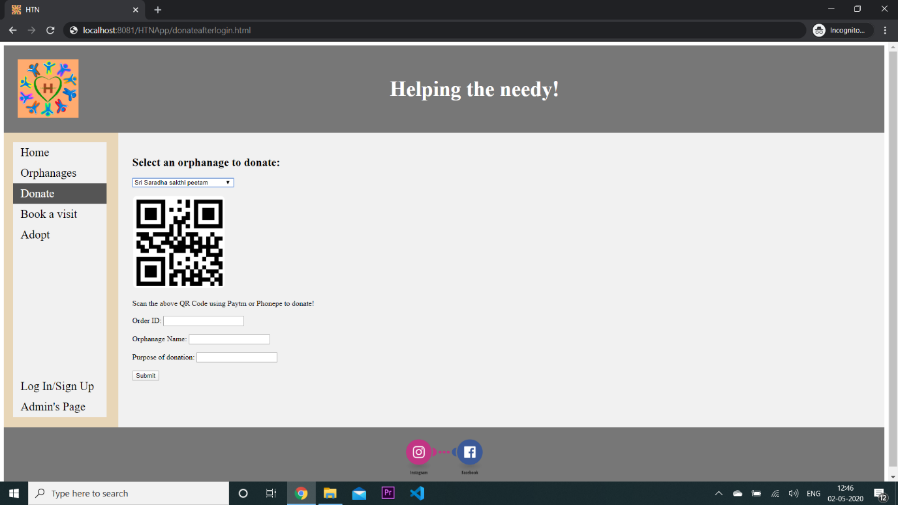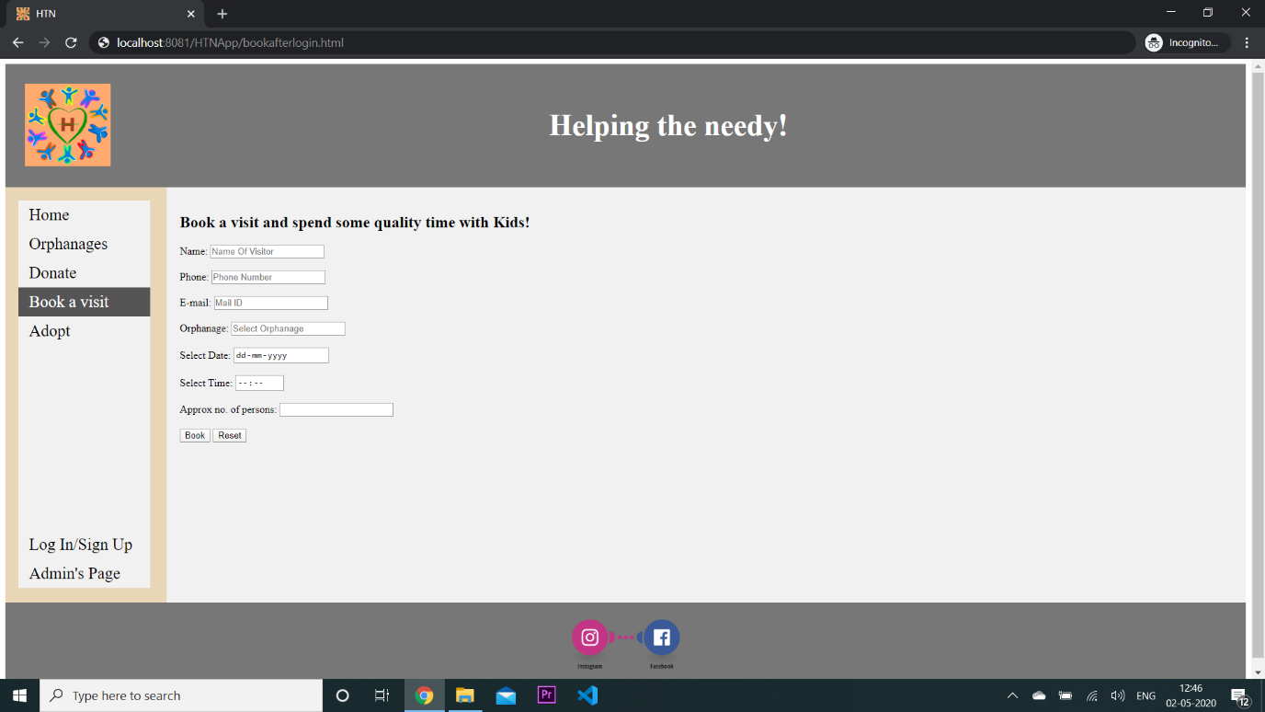

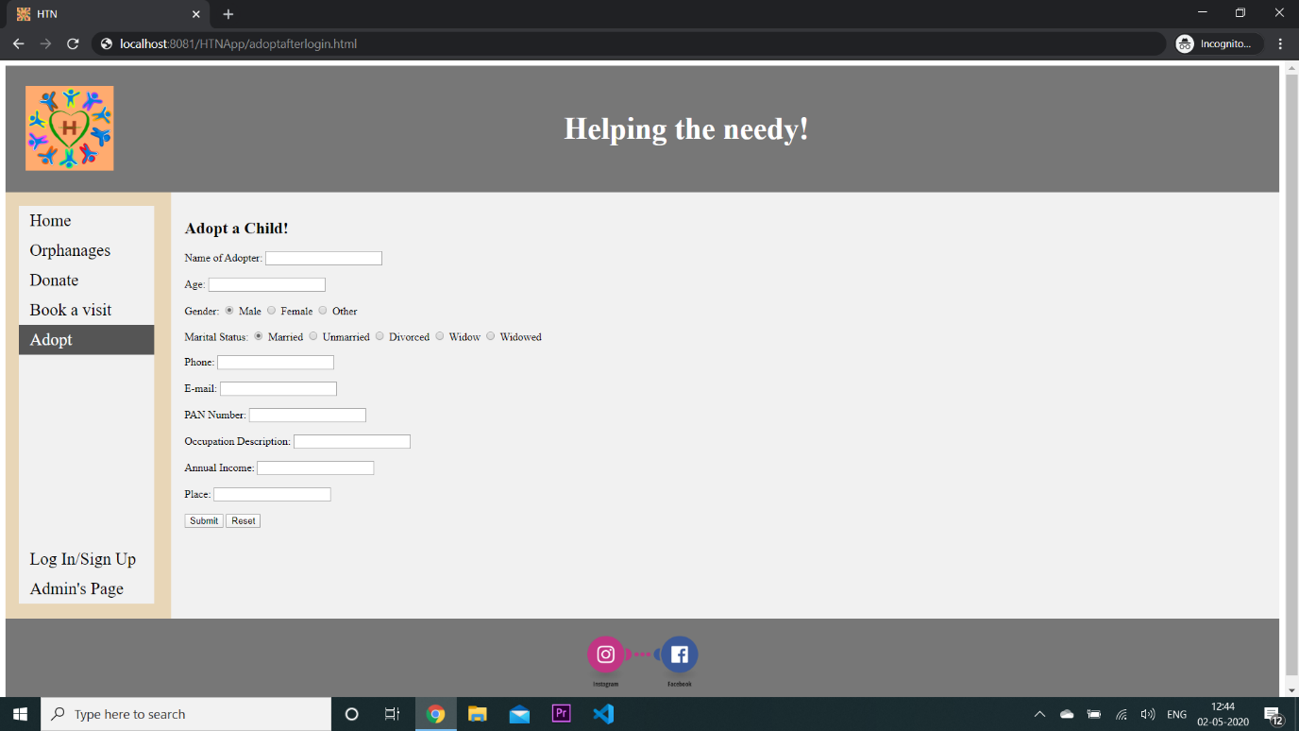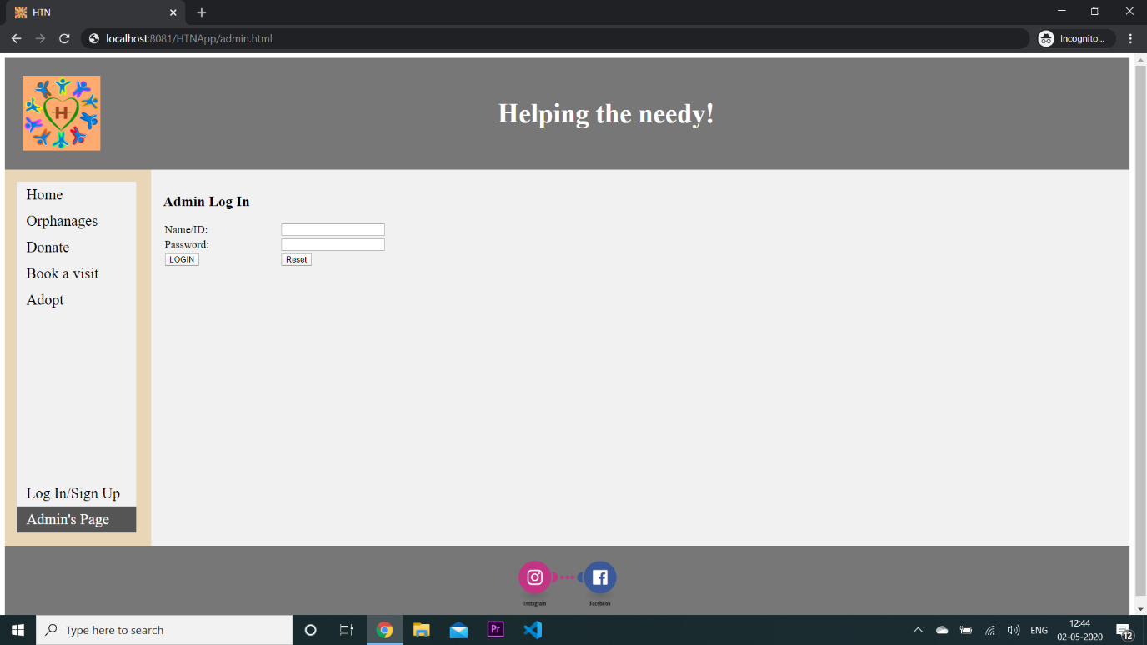

Admin Login -

