01. Introduce

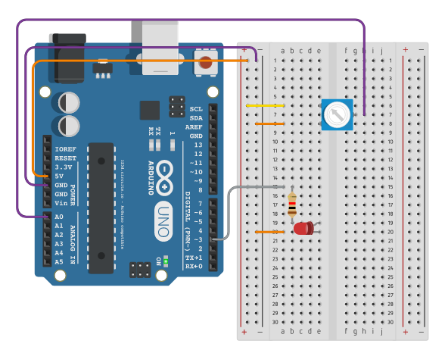

This is a system with a potentiometer as input and a LED as output.

Turn over the potentiometer and the LED will get lighter or darker.

02. Explain

a. Every sensor needs power to turn on, also needs grounded to make it circuit. So power come from (a,6) with “+”, and go (a,8) out with “-”.

b. When you turn over the potentiometer, it’ll give you value 0~1023 to Arduino form it’s output pin in the middle(g,7).

c. Once Arduino gets the value, the code will let Arduino make LED get light correspond with the value. And Arduino use digital pin 3(PWM) to control the power so that the LED will have different current to get different light.

d. Before current come through LED, it needs a resistance to prevent too much current come through. Otherwise it might get burned. This also applies in other output components.

03. Circuitry Principles

1. It’s hard to get shocked, so don't worry about it.
2. a row share the same current, like (a,6) to (e,6), but (f,6) to (j,6) is different if you plug different voltages.
3. Only “+” and “-” columns share same voltages.
4. You need to notice that every sensors’ and components’ positive pin and negative pin put into right voltage. Or some of them might not working, and another will get heated, the others work fine.

04. Safety Principles

1. Keep table dry

05. Step-by-Step Explanation & Building of New Model

1. Chose sensors for input and output.
2. Lookup it's detail, like what's output looks like? Which pin is positive or negative?
3. For example, Input: pushbottom

|  |  |
| --- | --- |
|  | Step1. prepare arduino and board |
|  | Step2. Place the button. Top and side views of a pushbutton  Because push button’s design is :  pushbutton schematic  So it's more convenient to use when place in the middle. |
|  | Step3. Link voltage 5V to “+”.  Then left side column “+” will be 5V.  3.3V is fine, but normally we use 5V. |
|  | Step4. Link ground to “-”  Then left side column “-” will be grounded |
|  | Step5. Link voltage to push button.  And because of push button’s character so that the whole row 6 is 5V. |
|  | Step6.Place register  In the real world, there are a lot of noises will interfere electronic devices. So sometimes we’ll add registers to reduce interactions. In this case, we place register in order to reduce noise rather than protect sensor at push button’ negative pin. |
|  | Step7. Link push button to digital pin2 to receive current when button pressed. |
|  | Step8. Add code |