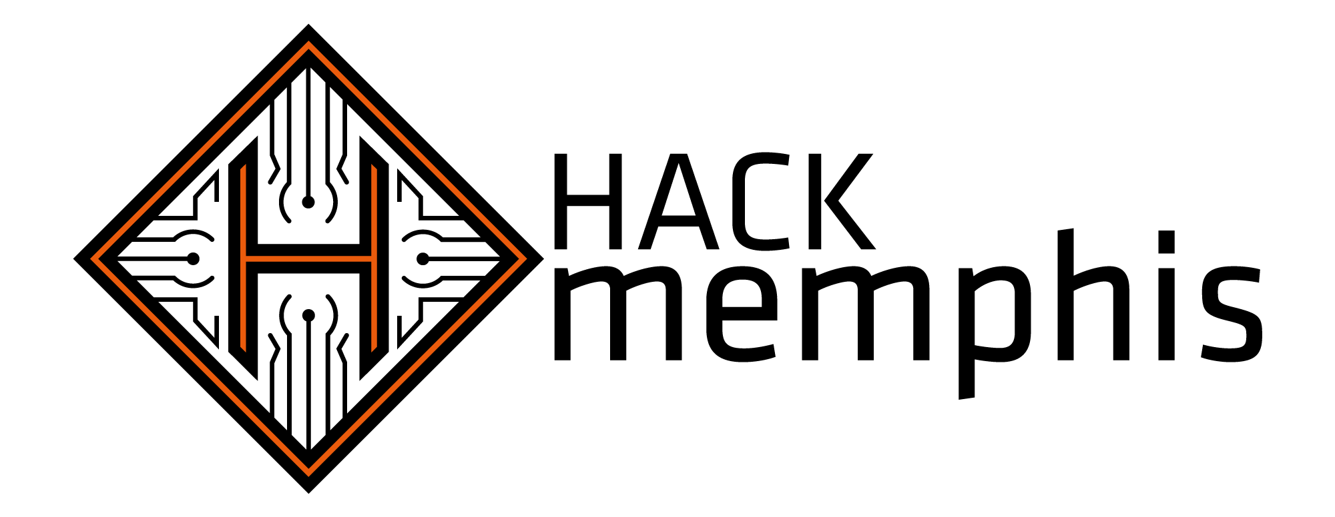

Bringing together local tech communities to develop hardware and software projects in Memphis.

Sponsorship Prospectus
2013

September 14-15, 2013 (tentative)
Venue TBD

http://www.HACKmemphis.com

At HACK memphis we are creating an ecosystem for hosting a developers' weekend designed to forge a community of hackers and makers in Memphis. We are inviting development enthusiasts of all types - hardware and software, professional and amateur - from the metro area to come together and make incredible things - and we want you to be a part of it!

This event will thrive with your generous support, and we truly hope that you will be energized to join us in this endeavor. The packages detailed below outline our needs and what we can offer to potential sponsors; however, if you feel that none of these packages suit your company, please contact us and we'll work with you!

If you have any questions, feel free to contact our sponsorship coordinator:

Jordan Kasper 512.699.3540 jordan@HACKmemphis.com

Package: Diamond $3,000 - limit 3
- Choose to become an industry exclusive (+$1000, see below)
- Logo on event badges
- Display banner at the event
- Choose to be exclusive lanyard sponsor (+$200; first come, first serve)
- 10 min. presentation at the event
- Reserve up to 6 hours at the sponsor table (see below)
- Logo on event t-shirts and bags (if produced)
- Logo on any printed materials
- Logo and link on the web site
- Three or more shout-outs on our social media channels (all channels)
- Ability to put swag on our swag table at the event

Package: Gold $1,000 - unlimited
- 3 min. announcement at the event
- Reserve a 2 hour block at the sponsor table (see below)
- Logo on event t-shirts and bags (if produced)
- Logo on any printed materials
- Logo and link on the web site
- Two or more shout-outs on our social media channels (any channel)
- Ability to put swag on our swag table at the event

Package: Silver $250 – unlimited
- Shout-out announcement at the event
- Logo on any printed materials
- Logo and link on the web site
- At least one shout-out on our social media channels (any channel)
- Ability to put swag on our swag table at the event

Package: Community $100 – unlimited
- Logo and link on the web site
- At least one shout-out on our social media channels (any channel)
- Ability to put swag on our swag table at the event

Extras
Sponsor Table
Gold sponsors and above may reserve a block of time at the "sponsor table" at the event. This table will be located in a prime spot at the venue and guarantees a high value and volume of traffic. Sponsors may display whatever they like at the table, but should clear the display with the sponsorship coordinator first.

Exclusivity
Diamond sponsors may choose to become an industry exclusive sponsor for an additional $1,000. HACKmemphis will NOT accept sponsorships from another company in the same industry. This bonus will only take effect once the sponsorship amount is received in full.
Interesting Statistics

We want you to know who we expect to attend, and we're happy to tell you that we have interest from many of the local user groups and maker organizations in the Memphis area.

Developer Meetups
Meetups & User Groups | Membership / Reach | Regular Attendance
Java User Group | 145 | 20
PHP User Group | 277 | 12
Python User Group | 50 | 15
.NET User Group | 50 | 12
Midsouth Makers | 117 | 8
Ruby User Group | 18 | 10

We are currently expecting between 30 and 50 software and hardware developers to attend, but will have better estimates by mid-Summer.

