Call:
lm(formula = TotalTime ~ TotalL3Miss + TotalINST + AvgL3Miss +
AvgINST + MAR + AvgUserSpaceUtil + AvgMemoryUsed + AvgPageDirty +
AvgROCL3Miss + AvgROCPageDirty + TotalPageDirty + MAR:AvgMemoryUsed,
data = cpu_data_set)

Residuals:
Min 1Q Median 3Q Max
-5.7939 -0.8200 0.0606 0.8013 13.5336

Coefficients:
Estimate Std. Error t value Pr(>|t|)
(Intercept) 2.431e+01 2.140e+00 11.360 < 2e-16 ***
TotalL3Miss -5.665e-06 7.315e-07 -7.745 5.87e-13 ***
TotalINST -4.706e-03 6.866e-04 -6.854 1.01e-10 ***
AvgL3Miss 1.457e-07 1.797e-08 8.110 6.53e-14 ***
AvgINST 1.194e-04 1.577e-05 7.573 1.63e-12 ***
MAR 8.745e-03 1.711e-03 5.113 7.82e-07 ***
AvgUserSpaceUtil 6.133e-02 7.027e-02 0.873 0.38391
AvgMemoryUsed 3.578e-07 4.972e-08 7.195 1.46e-11 ***
AvgPageDirty -1.134e-01 3.551e-02 -3.194 0.00165 **
AvgROCL3Miss -8.795e+00 9.497e+00 -0.926 0.35558
AvgROCPageDirty -9.293e+01 9.902e+01 -0.938 0.34923
TotalPageDirty 3.418e-02 1.075e-02 3.181 0.00172 **
MAR:AvgMemoryUsed -2.569e-10 5.103e-11 -5.033 1.13e-06 ***
---
Signif. codes: 0 ‘***’ 0.001 ‘**’ 0.01 ‘*’ 0.05 ‘.’ 0.1 ‘ ’ 1

Residual standard error: 1.758 on 187 degrees of freedom
Multiple R-squared: 0.9995, Adjusted R-squared: 0.9995
F-statistic: 3.121e+04 on 12 and 187 DF, p-value: < 2.2e-16

Call:
lm(formula = TotalTime ~ TotalL3Miss + TotalINST + AvgL3Miss +
AvgINST + MAR + AvgUserSpaceUtil + AvgMemoryUsed + AvgPageDirty +
AvgROCL3Miss + AvgROCPageDirty + TotalPageDirty + MAR:AvgMemoryUsed,
data = memory_data_set)

Residuals:
Min 1Q Median 3Q Max
-171.260 -6.272 0.418 7.833 106.255

Coefficients:
Estimate Std. Error t value Pr(>|t|)
(Intercept) 2.229e+01 1.531e+01 1.456 0.147146
TotalL3Miss -1.676e-05 5.257e-06 -3.188 0.001686 **
TotalINST -2.505e-02 6.863e-03 -3.650 0.000341 ***
AvgL3Miss 4.624e-08 4.125e-09 11.209 < 2e-16 ***
AvgINST 1.069e-04 1.072e-05 9.979 < 2e-16 ***
MAR 1.508e-02 6.509e-03 2.317 0.021583 *
AvgUserSpaceUtil 3.924e+00 7.307e-01 5.371 2.35e-07 ***
AvgMemoryUsed 1.119e-08 4.085e-07 0.027 0.978172
AvgPageDirty 1.455e-01 6.382e-01 0.228 0.819943
AvgROCL3Miss 6.038e+02 1.980e+02 3.049 0.002632 **
AvgROCPageDirty -3.741e+02 2.328e+03 -0.161 0.872479
TotalPageDirty 6.080e-01 7.191e-02 8.455 8.40e-15 ***
MAR:AvgMemoryUsed -7.961e-11 2.471e-10 -0.322 0.747708
---
Signif. codes: 0 ‘***’ 0.001 ‘**’ 0.01 ‘*’ 0.05 ‘.’ 0.1 ‘ ’ 1

Residual standard error: 21.37 on 184 degrees of freedom
(3 observations deleted due to missingness)
Multiple R-squared: 0.9951, Adjusted R-squared: 0.9947
F-statistic: 3086 on 12 and 184 DF, p-value: < 2.2e-16

Call:
lm(formula = TotalTime ~ AvgUserSpaceUtil + AvgMemoryUsed + AvgPageDirty +
AvgROCPageDirty + TotalPageDirty, data = vm_cpu_data_set)

Residuals:
Min 1Q Median 3Q Max
-78.151 -6.515 1.753 9.656 75.333

Coefficients:
Estimate Std. Error t value Pr(>|t|)
(Intercept) 2.603e+01 7.291e+00 3.570 0.00045 ***
AvgUserSpaceUtil 1.643e-01 1.367e-01 1.202 0.23096
AvgMemoryUsed 5.462e-07 1.890e-07 2.891 0.00428 **
AvgPageDirty -4.678e+00 7.785e-02 -60.085 < 2e-16 ***
AvgROCPageDirty -2.213e+03 9.188e+02 -2.409 0.01695 *
TotalPageDirty 1.416e+00 2.345e-02 60.402 < 2e-16 ***
---
Signif. codes: 0 ‘***’ 0.001 ‘**’ 0.01 ‘*’ 0.05 ‘.’ 0.1 ‘ ’ 1

Residual standard error: 16.96 on 194 degrees of freedom
Multiple R-squared: 0.9519, Adjusted R-squared: 0.9506
F-statistic: 767.1 on 5 and 194 DF, p-value: < 2.2e-16

Call:
lm(formula = TotalTime ~ AvgUserSpaceUtil + AvgMemoryUsed + AvgPageDirty +
AvgROCPageDirty + TotalPageDirty, data = vm_memory_data_set)

Residuals:
Min 1Q Median 3Q Max
-147.792 -9.949 1.528 13.034 120.553

Coefficients:
Estimate Std. Error t value Pr(>|t|)
(Intercept) -5.930e+01 1.846e+01 -3.212 0.00155 **
AvgUserSpaceUtil 3.118e-01 3.641e-01 0.856 0.39290
AvgMemoryUsed -9.667e-07 4.279e-07 -2.259 0.02498 *
AvgPageDirty 1.859e+00 8.530e-01 2.179 0.03054 *
AvgROCPageDirty -1.392e+03 3.270e+03 -0.426 0.67081
TotalPageDirty 1.531e+00 1.533e-02 99.867 < 2e-16 ***
---
Signif. codes: 0 ‘***’ 0.001 ‘**’ 0.01 ‘*’ 0.05 ‘.’ 0.1 ‘ ’ 1

Residual standard error: 30.21 on 191 degrees of freedom
(3 observations deleted due to missingness)
Multiple R-squared: 0.9897, Adjusted R-squared: 0.9895
F-statistic: 3685 on 5 and 191 DF, p-value: < 2.2e-16

Call:
lm(formula = cpu_data_set$TotalTime ~ cpu_data_set$TotalL3Miss +
cpu_data_set$TotalINST + cpu_data_set$AvgL3Miss + cpu_data_set$AvgINST +
cpu_data_set$MAR + cpu_data_set$AvgUserSpaceUtil + cpu_data_set$AvgMemoryUsed +
cpu_data_set$AvgPageDirty + cpu_data_set$AvgROCL3Miss + cpu_data_set$AvgROCPageDirty +
cpu_data_set$TotalPageDirty + cpu_data_set$MAR:cpu_data_set$AvgMemoryUsed +
vm_cpu_data_set$AvgUserSpaceUtil + vm_cpu_data_set$AvgMemoryUsed +
vm_cpu_data_set$AvgPageDirty + vm_cpu_data_set$AvgROCPageDirty +
vm_cpu_data_set$TotalPageDirty)

Residuals:
Min 1Q Median 3Q Max
-5.7939 -0.8200 0.0606 0.8013 13.5336

Coefficients: (5 not defined because of singularities)
Estimate Std. Error t value Pr(>|t|)
(Intercept) 2.431e+01 2.140e+00 11.360 < 2e-16 ***
cpu_data_set$TotalL3Miss -5.665e-06 7.315e-07 -7.745 5.87e-13 ***
cpu_data_set$TotalINST -4.706e-03 6.866e-04 -6.854 1.01e-10 ***
cpu_data_set$AvgL3Miss 1.457e-07 1.797e-08 8.110 6.53e-14 ***
cpu_data_set$AvgINST 1.194e-04 1.577e-05 7.573 1.63e-12 ***
cpu_data_set$MAR 8.745e-03 1.711e-03 5.113 7.82e-07 ***
cpu_data_set$AvgUserSpaceUtil 6.133e-02 7.027e-02 0.873 0.38391
cpu_data_set$AvgMemoryUsed 3.578e-07 4.972e-08 7.195 1.46e-11 ***
cpu_data_set$AvgPageDirty -1.134e-01 3.551e-02 -3.194 0.00165 **
cpu_data_set$AvgROCL3Miss -8.795e+00 9.497e+00 -0.926 0.35558
cpu_data_set$AvgROCPageDirty -9.293e+01 9.902e+01 -0.938 0.34923
cpu_data_set$TotalPageDirty 3.418e-02 1.075e-02 3.181 0.00172 **
vm_cpu_data_set$AvgUserSpaceUtil NA NA NA NA
vm_cpu_data_set$AvgMemoryUsed NA NA NA NA
vm_cpu_data_set$AvgPageDirty NA NA NA NA
vm_cpu_data_set$AvgROCPageDirty NA NA NA NA
vm_cpu_data_set$TotalPageDirty NA NA NA NA
cpu_data_set$MAR:cpu_data_set$AvgMemoryUsed -2.569e-10 5.103e-11 -5.033 1.13e-06 ***
---
Signif. codes: 0 ‘***’ 0.001 ‘**’ 0.01 ‘*’ 0.05 ‘.’ 0.1 ‘ ’ 1

Residual standard error: 1.758 on 187 degrees of freedom
Multiple R-squared: 0.9995, Adjusted R-squared: 0.9995
F-statistic: 3.121e+04 on 12 and 187 DF, p-value: < 2.2e-16

Call:
lm(formula = memory_data_set$TotalTime ~ memory_data_set$TotalL3Miss +
memory_data_set$TotalINST + memory_data_set$AvgL3Miss + memory_data_set$AvgINST +
memory_data_set$MAR + memory_data_set$AvgUserSpaceUtil +
memory_data_set$AvgMemoryUsed + memory_data_set$AvgPageDirty +
memory_data_set$AvgROCL3Miss + memory_data_set$AvgROCPageDirty +
memory_data_set$TotalPageDirty + memory_data_set$MAR:memory_data_set$AvgMemoryUsed +
vm_memory_data_set$AvgUserSpaceUtil + vm_memory_data_set$AvgMemoryUsed +
vm_memory_data_set$AvgPageDirty + vm_memory_data_set$AvgROCPageDirty +
vm_memory_data_set$TotalPageDirty)

Residuals:
Min 1Q Median 3Q Max
-171.260 -6.272 0.418 7.833 106.255

Coefficients: (5 not defined because of singularities)
Estimate Std. Error t value Pr(>|t|)
(Intercept) 2.229e+01 1.531e+01 1.456 0.147146
memory_data_set$TotalL3Miss -1.676e-05 5.257e-06 -3.188 0.001686 **
memory_data_set$TotalINST -2.505e-02 6.863e-03 -3.650 0.000341 ***
memory_data_set$AvgL3Miss 4.624e-08 4.125e-09 11.209 < 2e-16 ***
memory_data_set$AvgINST 1.069e-04 1.072e-05 9.979 < 2e-16 ***
memory_data_set$MAR 1.508e-02 6.509e-03 2.317 0.021583 *
memory_data_set$AvgUserSpaceUtil 3.924e+00 7.307e-01 5.371 2.35e-07 ***
memory_data_set$AvgMemoryUsed 1.119e-08 4.085e-07 0.027 0.978172
memory_data_set$AvgPageDirty 1.455e-01 6.382e-01 0.228 0.819943
memory_data_set$AvgROCL3Miss 6.038e+02 1.980e+02 3.049 0.002632 **
memory_data_set$AvgROCPageDirty -3.741e+02 2.328e+03 -0.161 0.872479
memory_data_set$TotalPageDirty 6.080e-01 7.191e-02 8.455 8.40e-15 ***
vm_memory_data_set$AvgUserSpaceUtil NA NA NA NA
vm_memory_data_set$AvgMemoryUsed NA NA NA NA
vm_memory_data_set$AvgPageDirty NA NA NA NA
vm_memory_data_set$AvgROCPageDirty NA NA NA NA
vm_memory_data_set$TotalPageDirty NA NA NA NA
memory_data_set$MAR:memory_data_set$AvgMemoryUsed -7.961e-11 2.471e-10 -0.322 0.747708
---
Signif. codes: 0 ‘***’ 0.001 ‘**’ 0.01 ‘*’ 0.05 ‘.’ 0.1 ‘ ’ 1

Residual standard error: 21.37 on 184 degrees of freedom
(3 observations deleted due to missingness)
Multiple R-squared: 0.9951, Adjusted R-squared: 0.9947
F-statistic: 3086 on 12 and 184 DF, p-value: < 2.2e-16

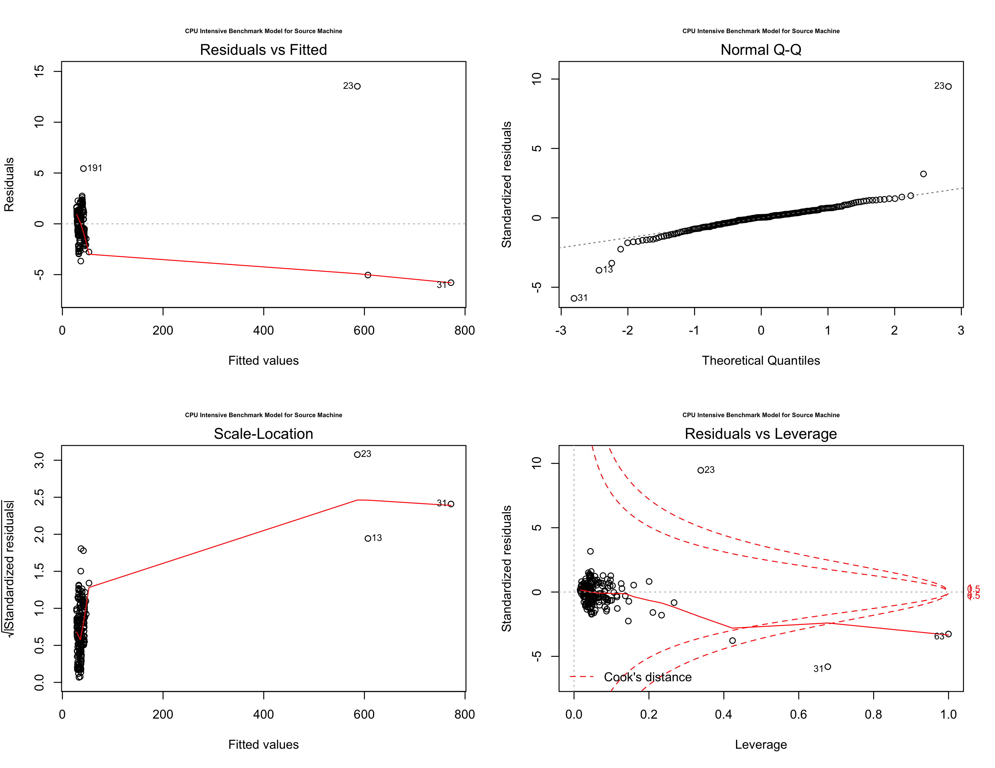
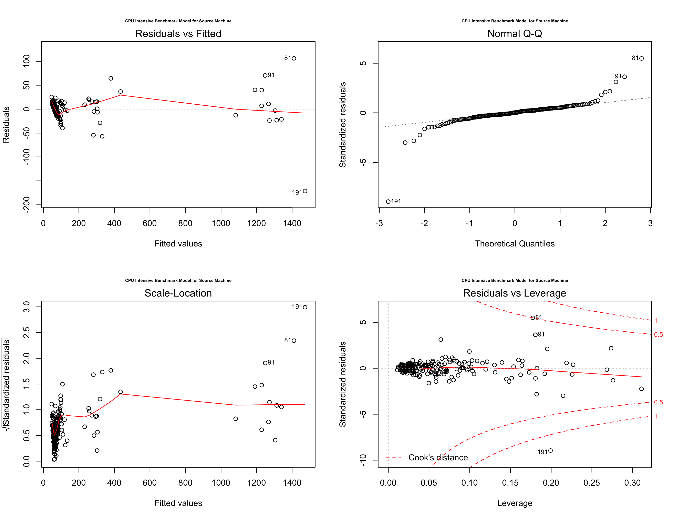
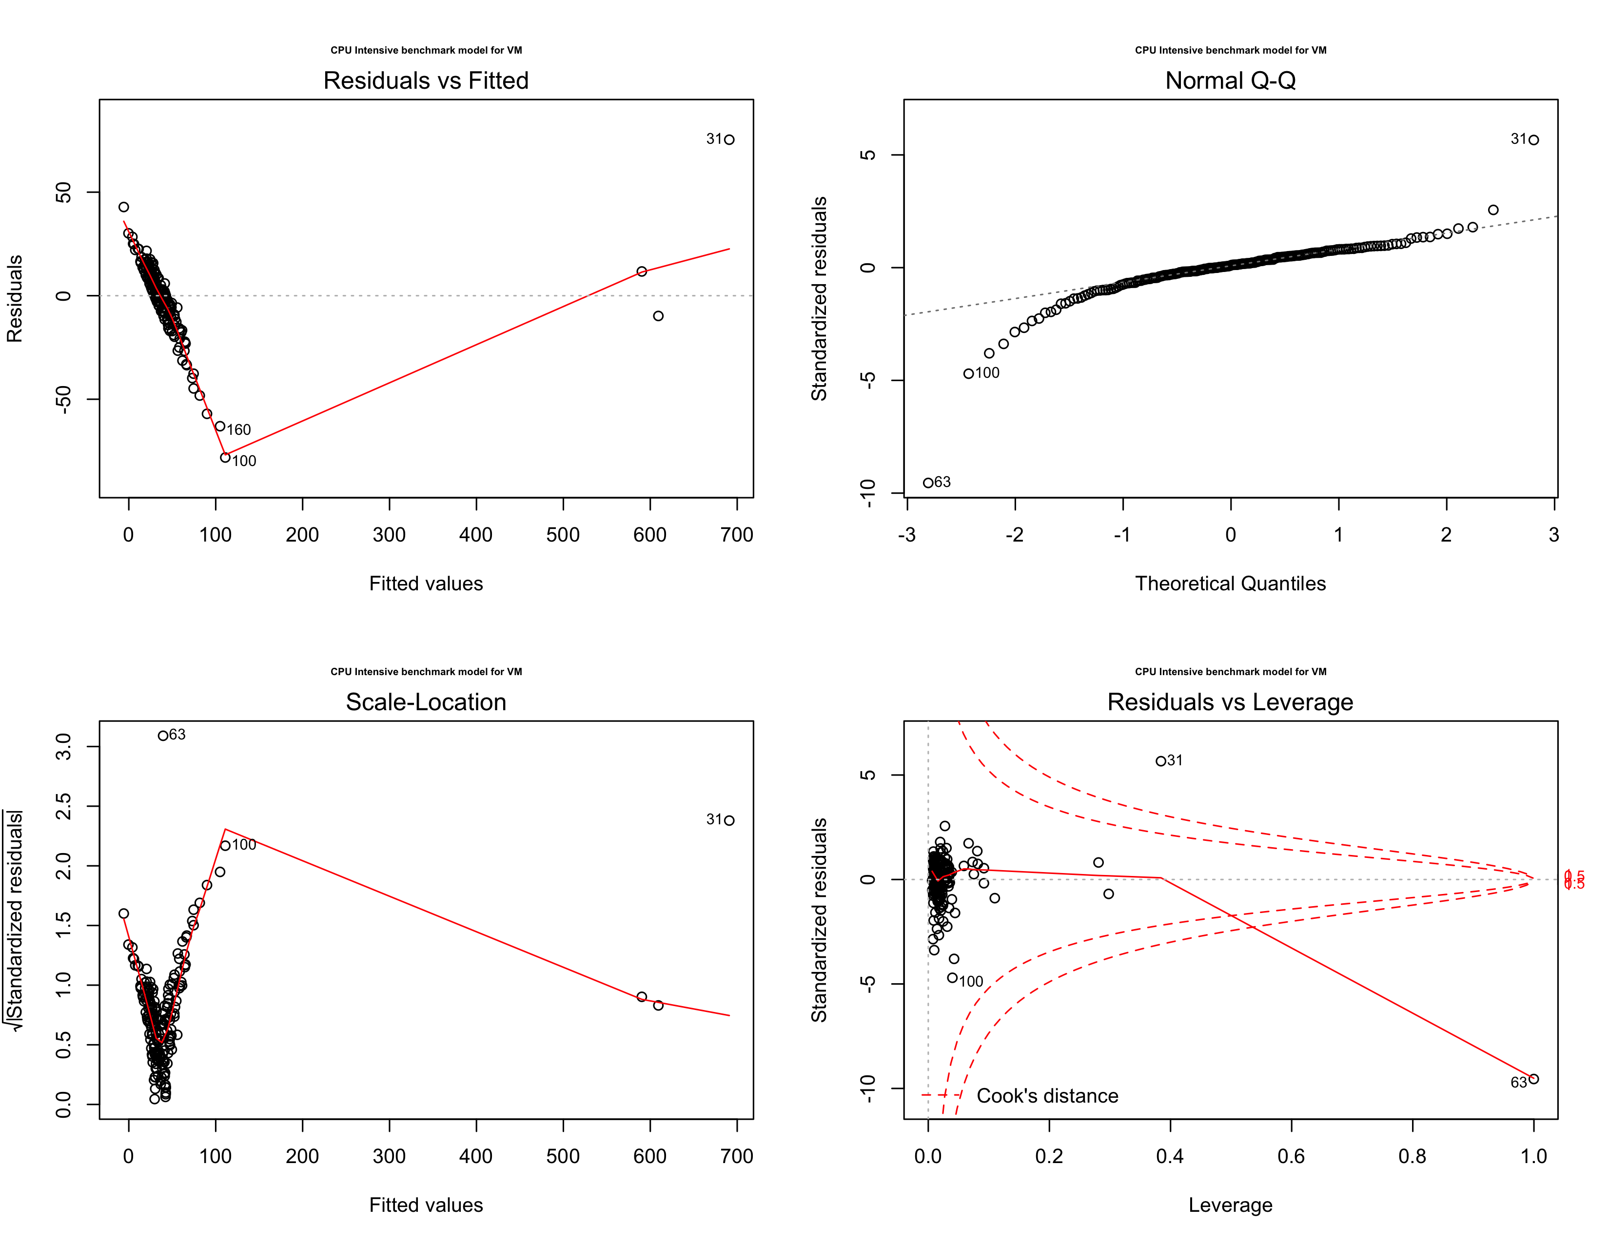
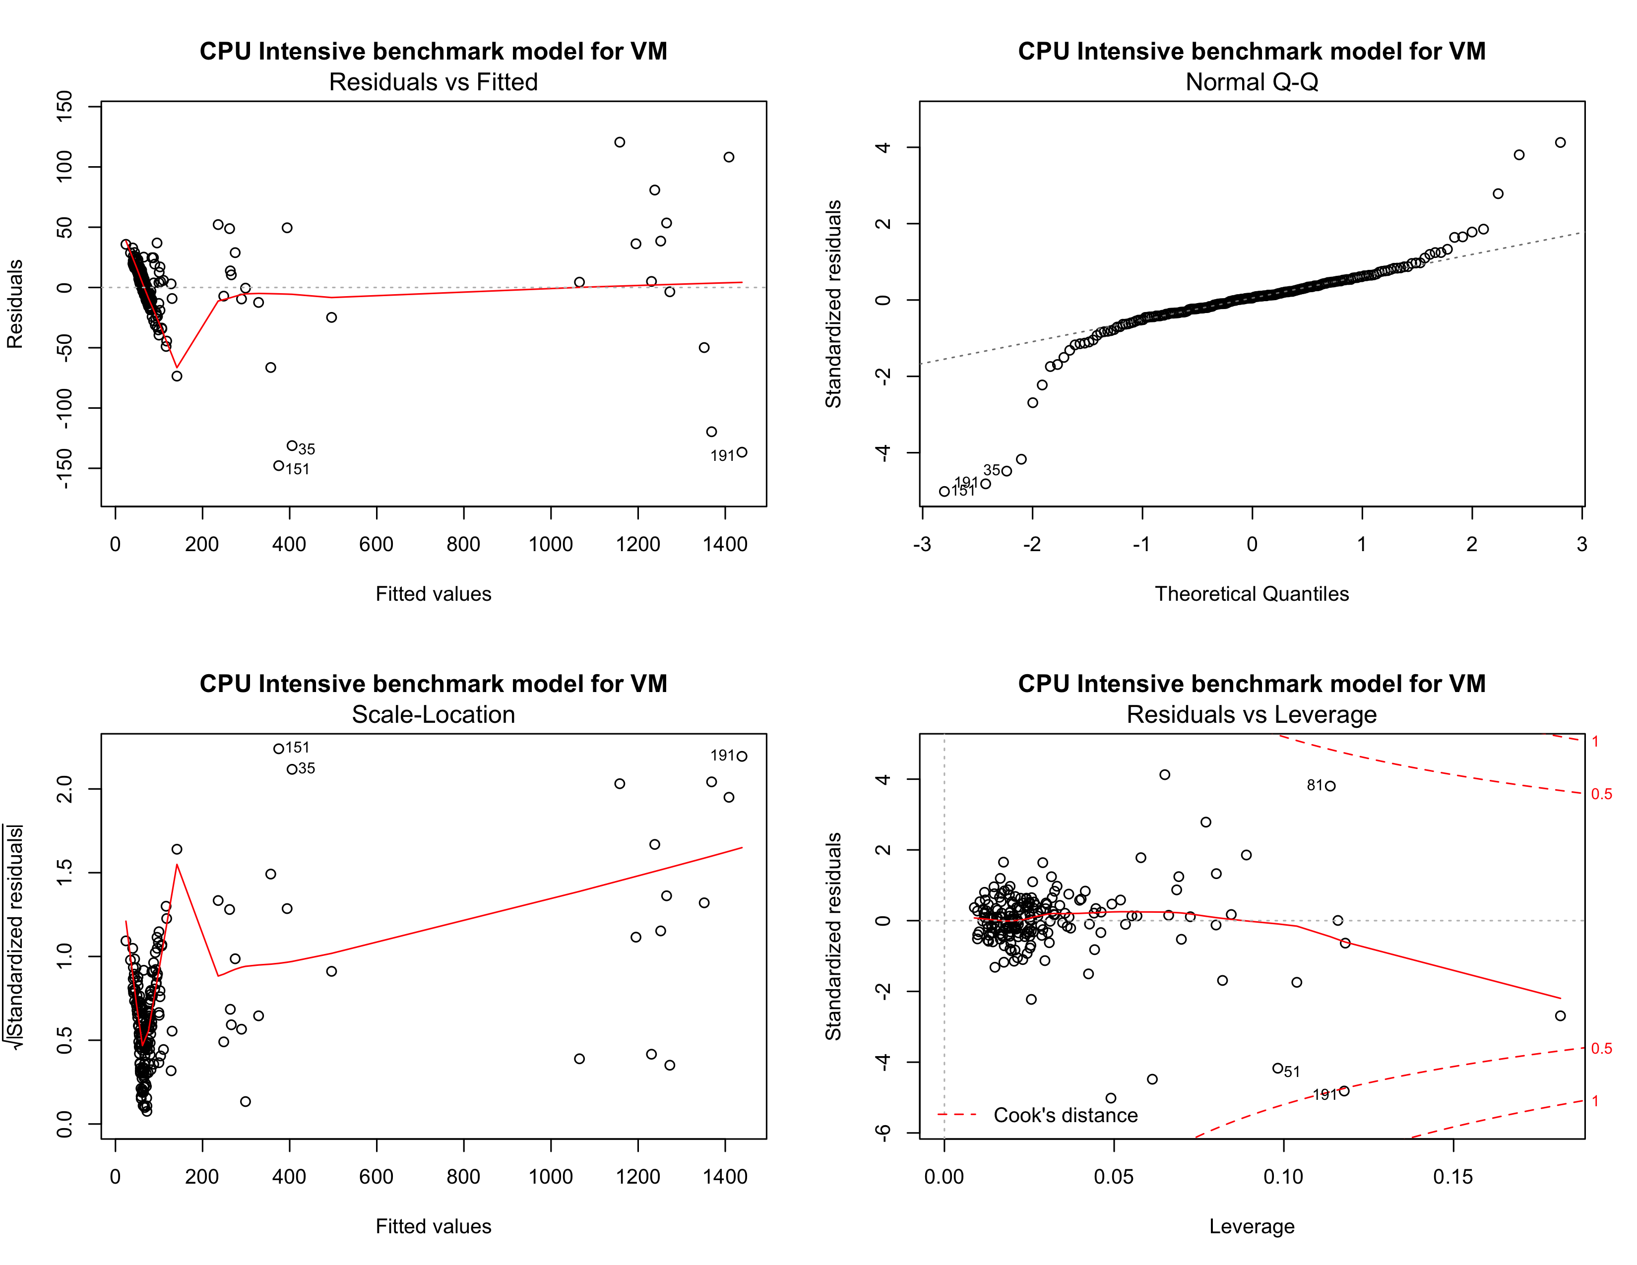
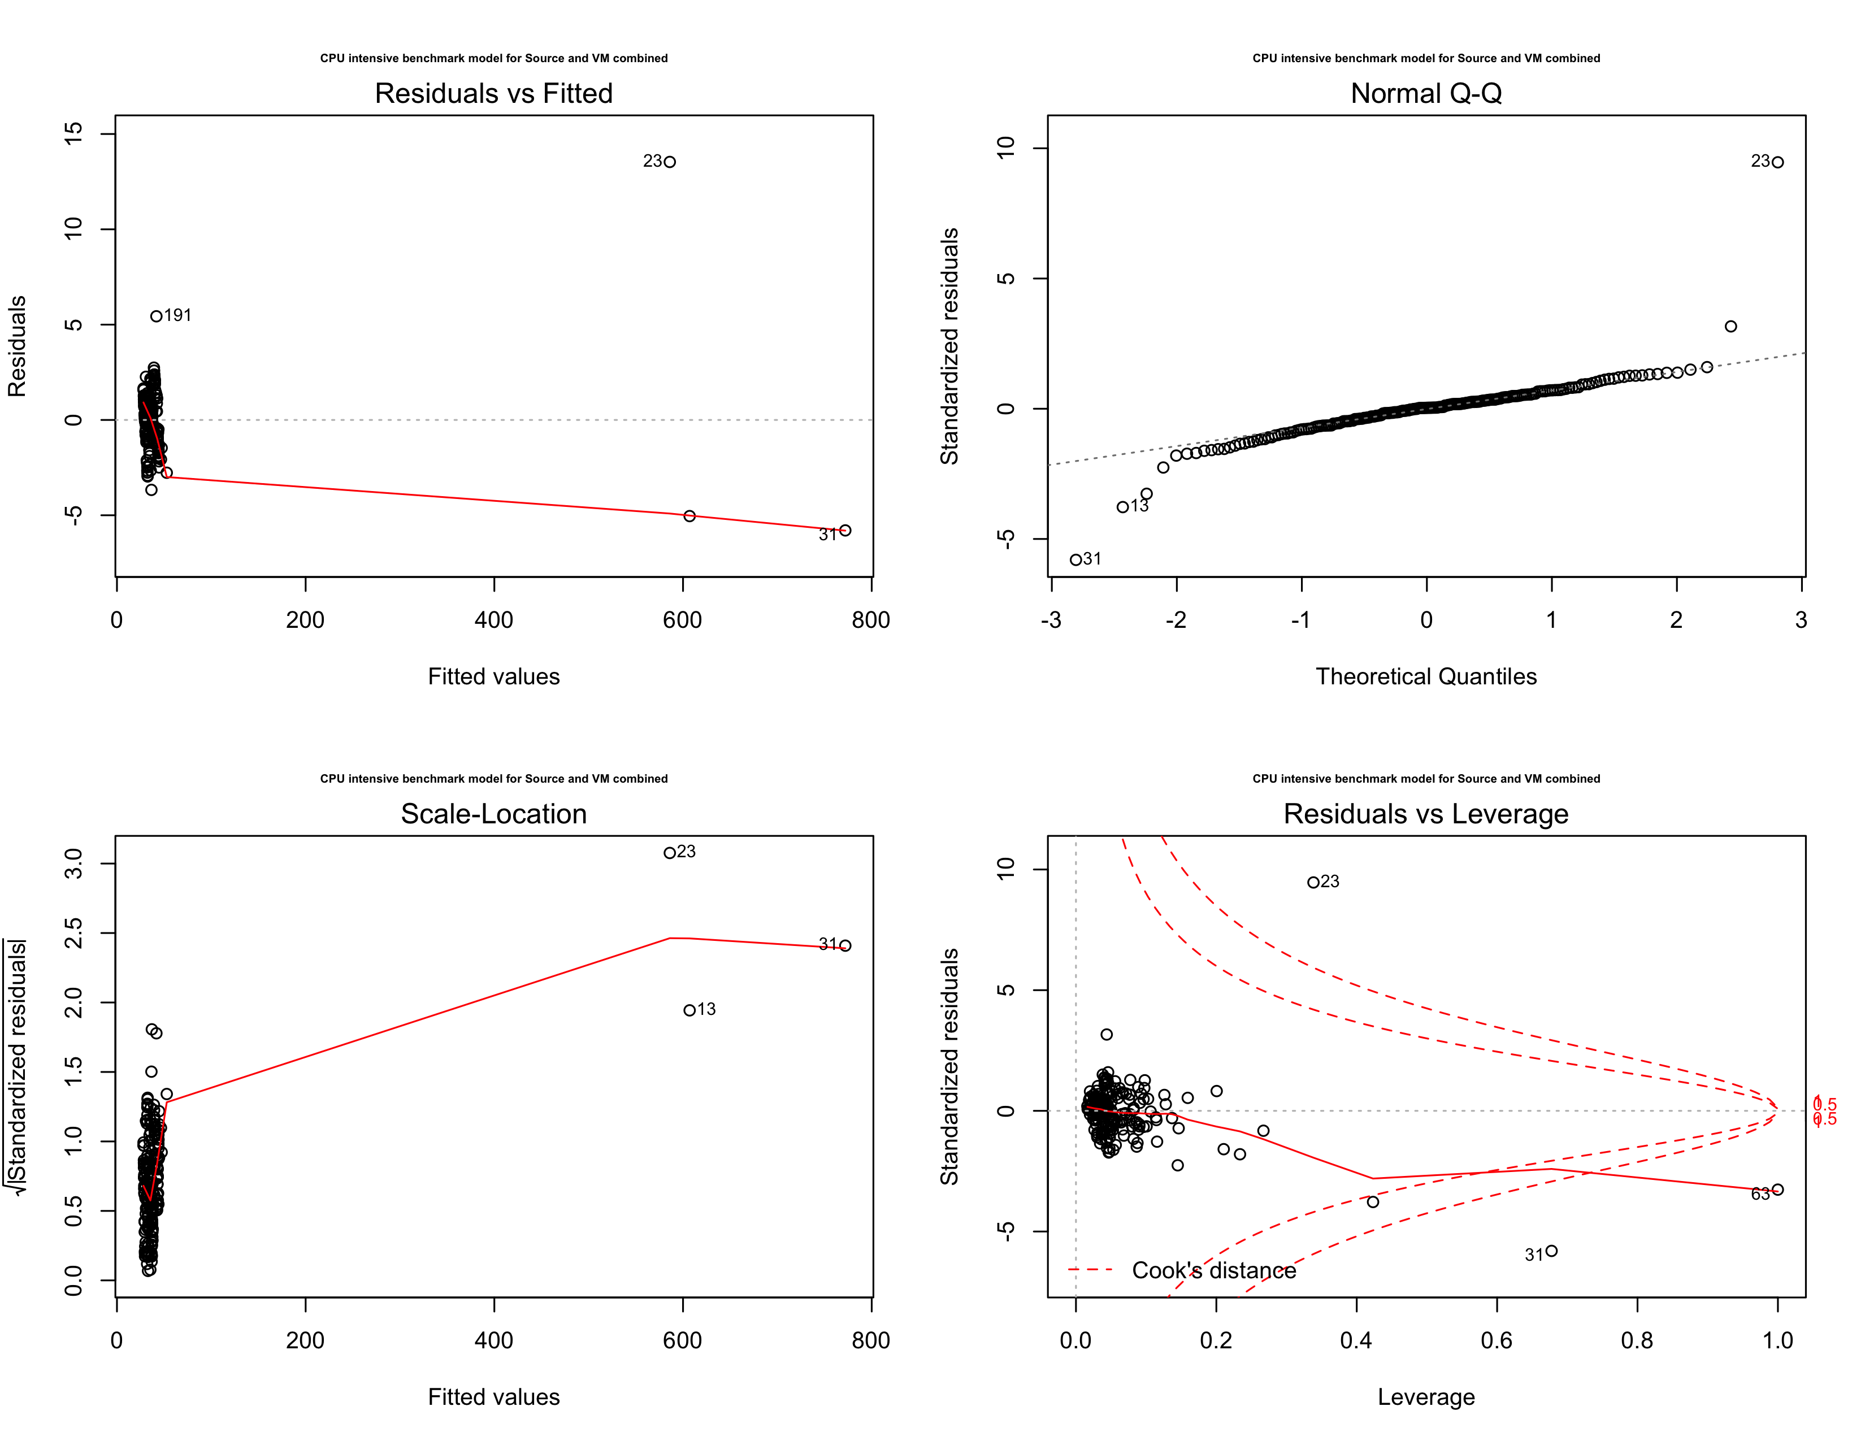
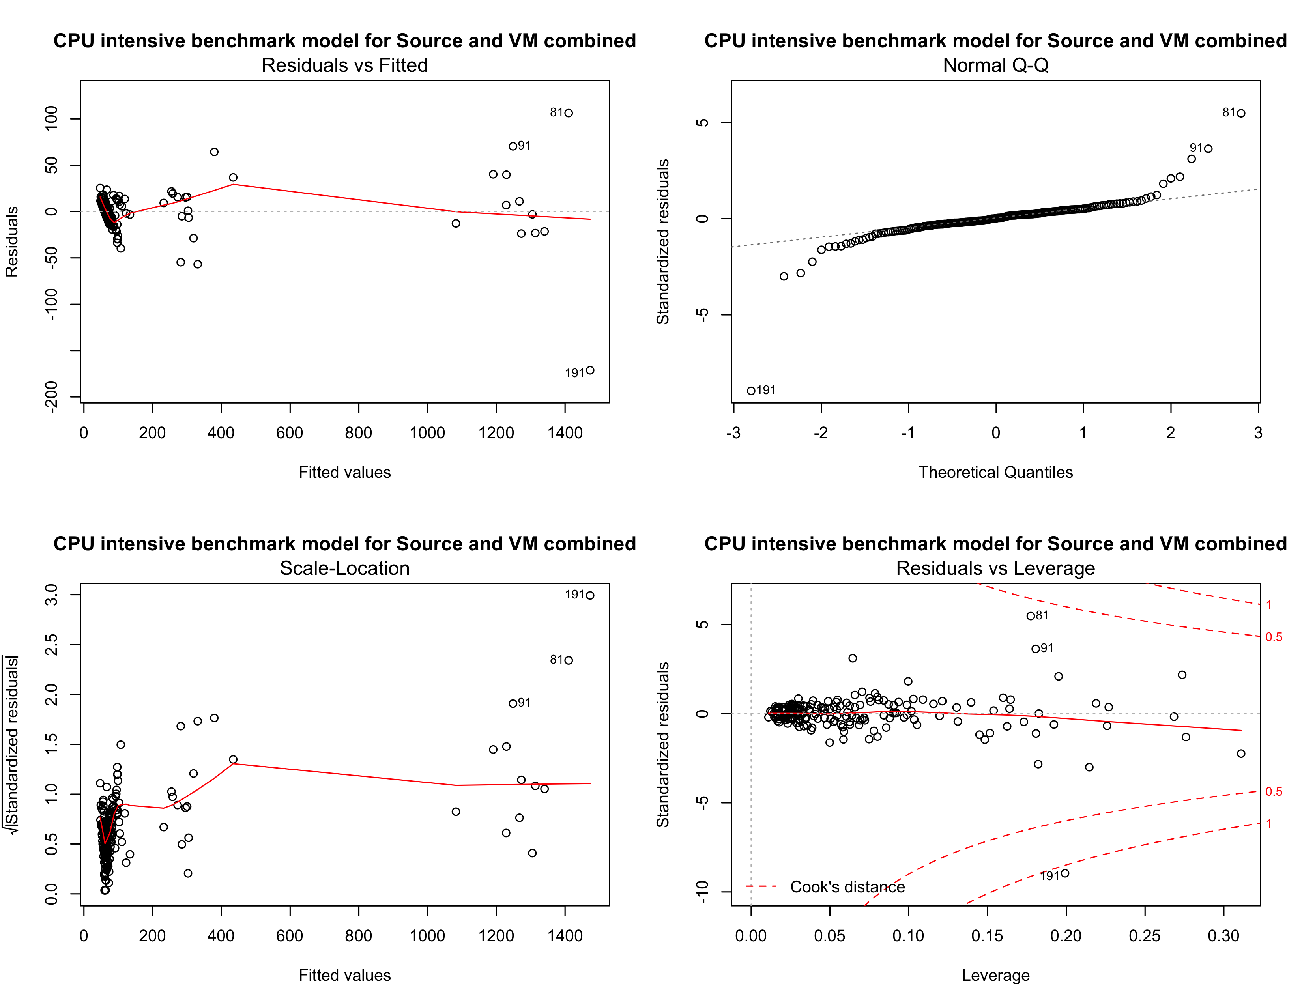

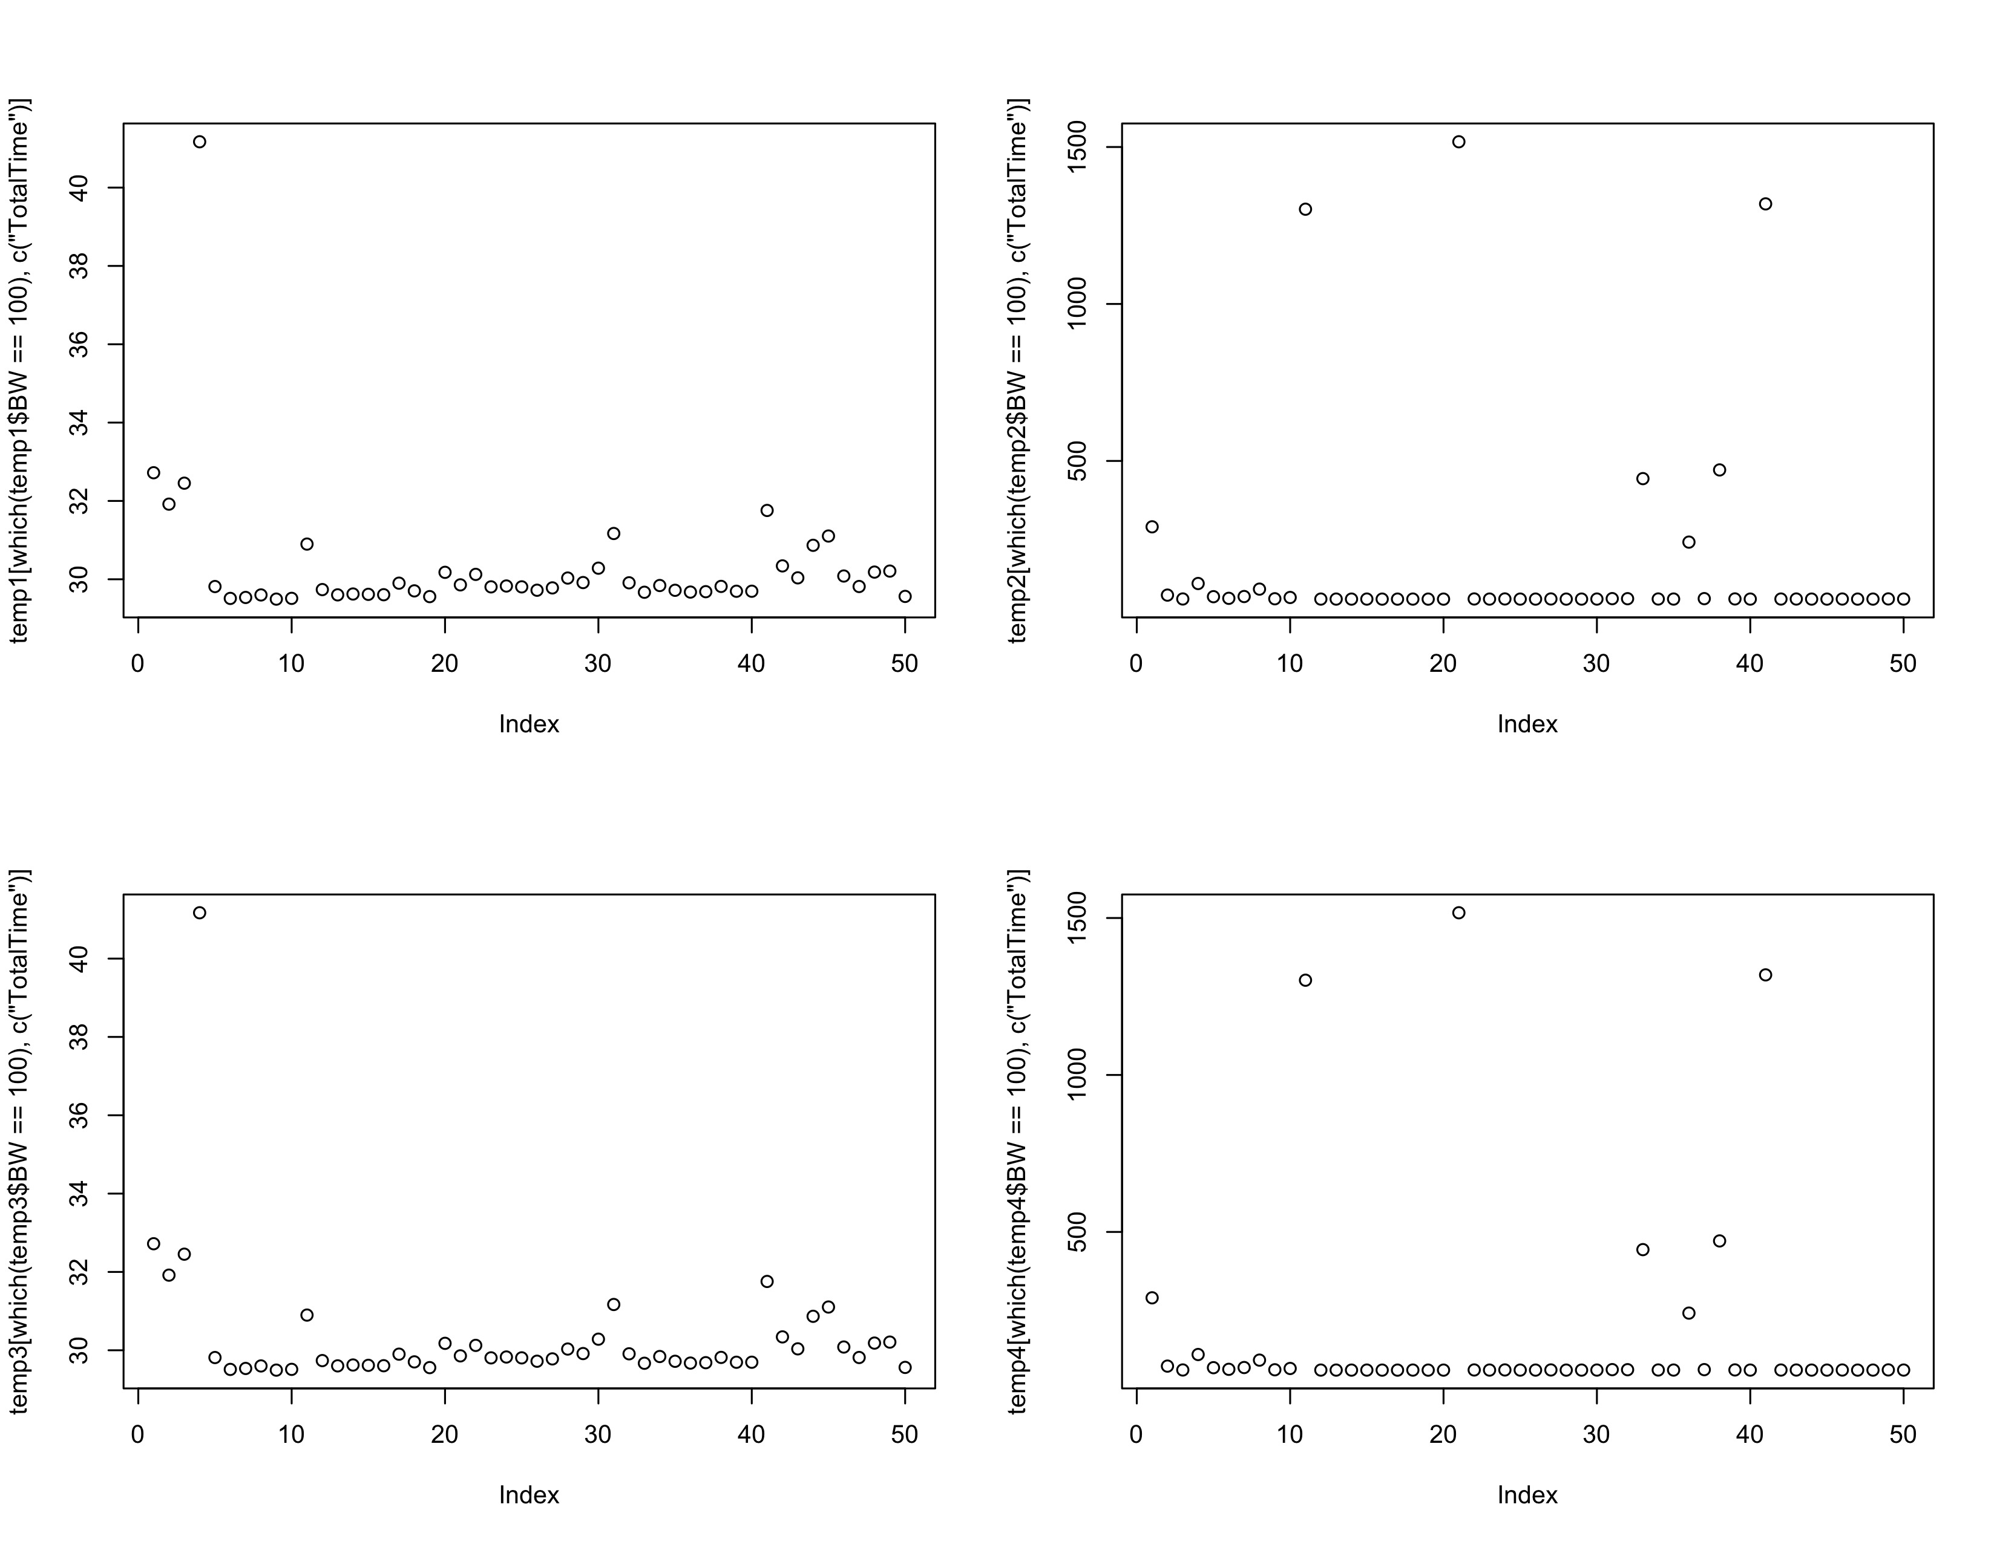
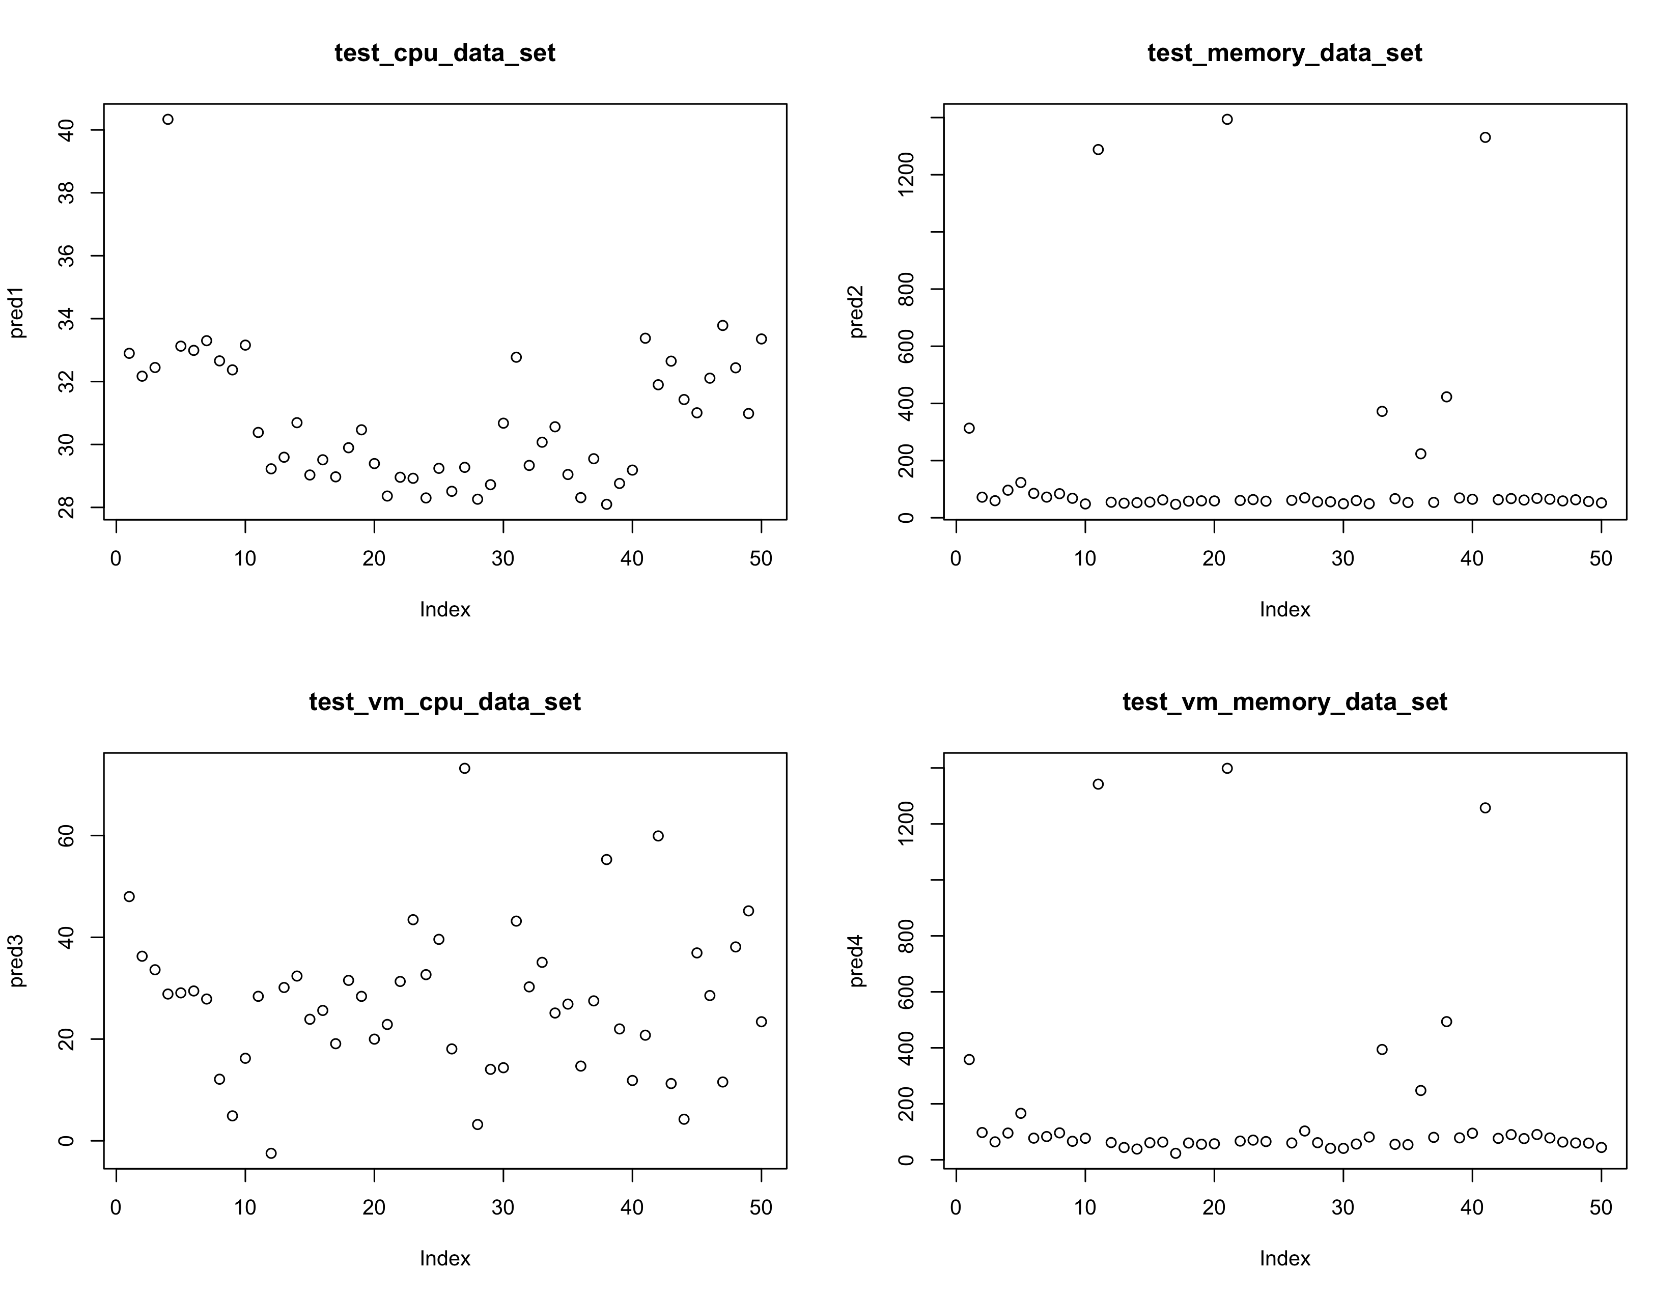

Actual Data Predicted Data



