**DEPARTMENT OF INFORMATION TECHNOLOGY**

**Course Code: DJ19ITl702 Date: 13-09-24**

**Course Name: Design Thinking Laboratory Class: Final Year**

**EXPERIMENT NO. 5**

**CO/LO:** Design a mind map of design thinking

**AIM/OBJECTIVE:** Create a Mind Map for the Online Examination System

**THEORY:**

**Design Thinking**

Design Thinking is a user-centered, iterative approach to problem-solving, focusing on creativity and innovation. It involves five key stages:

1. **Empathize**: Understand users and their needs.
2. **Define**: Clarify the core problem.
3. **Ideate**: Generate creative solutions.
4. **Prototype**: Build simple models of ideas.
5. **Test**: Gather feedback and improve.

**Mind Maps**

A **Mind Map** is a diagram that visually organizes information around a central concept or idea. It’s a flexible and intuitive way to structure thoughts, ideas, or information, helping with problem-solving, planning, and brainstorming.

**Key Elements:**

* **Central Idea**: The main concept or topic is placed at the center.
* **Branches**: Major themes or categories branch out from the central idea.
* **Sub-branches**: Further details, ideas, or concepts are connected to each branch.
* **Keywords & Images**: Use concise keywords, icons, or images to represent ideas and relationships.

**Benefits:**

* **Improves clarity** by visually mapping out relationships between ideas.
* **Enhances creativity** as it encourages free-flowing thoughts and connections.
* **Boosts memory** through the use of colors, symbols, and spatial organization.

Mind Maps are widely used in learning, project management, and brainstorming to help structure ideas and solutions.

**OBSERVATIONS/RESULT DISCUSSION:**

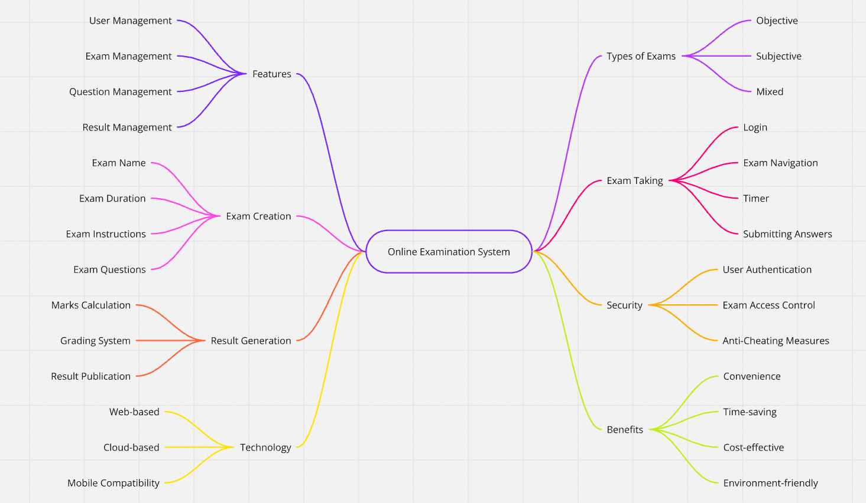

The mind map represents an "Online Examination System" divided into key areas like user management, question management, and result management. It also covers exam creation, types of exams (objective, subjective, mixed), security features such as user authentication, and benefits like time-saving and being eco-friendly. The technology aspect highlights web-based and cloud-based compatibility, presenting a clear structure for efficient system implementation.

**CONCLUSION**: Mind map understood, outlining key components and features of an Online Examination System.

**REFERENCES**: [*https://miro.com/*](https://miro.com/)