Microservice for generate pdf file using with iText

The samples are all completely independent and self-contained. You can analyse them to get an understanding of how a particular method works, or you can use the snippets as a starting point for your own project.

Requirement

1. IDE (STS, Eclipse, Intellij etc.)

2. Maven

3. JDK 1.8

Import below two depedancy

<dependency>

<groupId>com.itextpdf</groupId>

<artifactId>itext7-core</artifactId>

<version>7.1.6</version>

<type>pom</type>

</dependency>

<dependency>

<groupId>com.itextpdf</groupId>

<artifactId>itextpdf</artifactId>

<version>5.5.13.2</version>

</dependency>

How to run this project

1. Do maven clean install

2. Run project (ItextSampleApplication.java)

How to generate pdf or How to use

<http://localhost:8082/index.html>

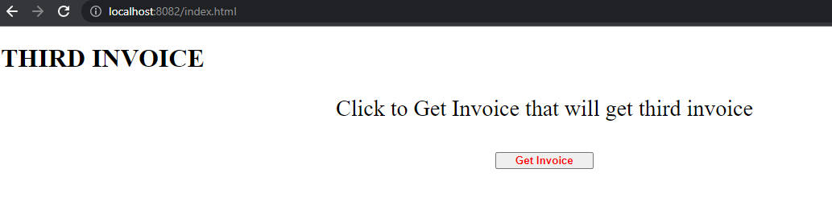

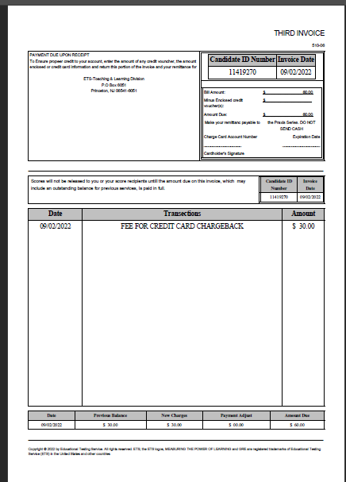

API:

@RequestMapping(value = "/getInvoice",method = RequestMethod.***GET***,produces = "application/pdf",headers="Accept=*/*")

**public** ResponseEntity<InputStreamResource> getInvoice() **throws** FileNotFoundException

Main Method

Invoice.getInvoice

You will get one html page and once you click generate button then your invoice will generate

Reference

1. <https://itextpdf.com/en>
2. <https://kb.itextpdf.com/>
3. installation-guidelines - <https://kb.itextpdf.com/home/it7kb/installation-guidelines>