Installation of Hadoop in linux machine using Docker
Apache Hadoop is a popular big data framework that is being used a lot in the software industry. As a distributed system, Hadoop runs on clusters ranging from one single node to thousands of nodes.
If you want to test out Hadoop, or don’t currently have access to a big Hadoop cluster network, you can set up a Hadoop cluster on your own computer, using Docker. Docker is a popular independent software container platform that allows you to build and ship your applications, along with all its environments, libraries and dependencies in containers. The containers are portable, so you can set up the exact same system on another machine by running some simple Docker commands. Thanks to Docker, it’s easy to build, share and run your application anywhere, without having to depend on the current operating system configuration.
For example, if you have a laptop that is running Windows but need to set up an application that only runs on Linux, thanks to Docker, you don’t need to install a new OS or set up a virtual machine. You can set up a Docker container containing all the libraries you need and delete it the moment you are done with your work.
In this tutorial, we will set up a 3-node Hadoop cluster using Docker and run the classic Hadoop Word Count program to test the system.
Start With Shortcut Today!

1. Setting up Docker
Docker installation in ubuntu
https://docs.docker.com/engine/install/ubuntu/

Execute the following set of commands given below:

1 sudo apt update

It is used to update the apt package index

2 sudo apt install apt-transport-https ca-certificates curl software-properties-common

It is used to install packages to allow apt to use a repository over HTTPS

3 install the docker io

sudo apt install docker.io-

Docker installation in windows

2. Once docker is successfull installed. we can test the installation by below command

docker --version should give you the details about the docker.

3. Let us install the hadoop in docker by Importing the Cloudera QuickStart Image from the docker Hub

sudo docker pull cloudera/quickstart:latest

4. Verify the image is installed
sudo docker images - should display the cloudera image(cloudera/quickstart).
cloudera/quickstart latest 4239cd2958c6 6 years ago 6.34GB

5. Run the hadoop docker container

sudo docker run --hostname=quickstart.cloudera --privileged=true --name hadoop -t -i -v /User/hack:/src --publish-all=true -p 8888:8888 -p 8088:8088 -p 8042:8042 cloudera/quickstart /usr/bin/docker-quickstart

Note: Extra information regarding the docker run command
https://docs.docker.com/engine/reference/commandline/run/
1. src folder from your host computer is mapped to the docker directory /Users/hack
2. incase while reruning
docker start -a container-name

docker start -a hadoop

6. Once it is run, you can check whether a new container is created using the below command
sudo docker ps

CONTAINER ID IMAGE COMMAND CREATED STATUS PORTS NAMES

b7ee8bb0f88d cloudera/quickstart "/usr/bin/docker-qui…" About a minute ago Up About a minute 0.0.0.0:8042->8042/tcp, :::8042->8042/tcp, 0.0.0.0:8088->8088/tcp, :::8088->8088/tcp, 0.0.0.0:8888->8888/tcp, :::8888->8888/tcp hadoop

https://docs.docker.com/engine/reference/commandline/ps/

8. To check the hadoop environment, execute hadoop commands

Hadoop environment
docker exec -it hadoop bin/bash

Execute hadoop commands to check version and filesystem

- hadoop fs -ls , it will list all the files in the users home directory
- hadoop version

create input directory in hdfs
create input directory for files
Users/hack:/src
9. Input files

hadoop fs -mkdir input

hadoop fs -copyFromLocal /src/tst.txt input

hadoop fs -ls input
Found 1 items
-rw-r--r-- 1 root supergroup 494 2022-04-13 10:55 input/tst.txt
[

10. write the mapreduce program
11. create the jar file

10. Upload hadoop program

11. execution of the hadoop jar
yarn jar MRWeb_211.jar WC input/ out/ -Dlog4j.configuration=log4j.properties -D mapred.map.tasks = 1

yarn jar MRH1.jar Driver input/ out/ -Dlog4j.configuration=log4j.properties -D mapred.map.tasks = 1

Note:
input - will be the directory from hdfs where inputs are taken
out - will be the directory where output is stored

out
-rw-r--r-- 1 root supergroup 0 2022-04-14 07:04 out1/_SUCCESS
-rw-r--r-- 1 root supergroup 525 2022-04-14 07:04 out1/part-r-00000

Output of your mapreduce will be available
out1/part-r-00000

9.Accessing Hue from your windows machine
To check the successful execution of the Job you can use the Hue interface with the application id. IP address is the public address of your Azure VM.
Use that ip and form the below url
http://<ipaddress>:8888/
password:cloudera
password:cloudera

Various activities to be performed in hue

Check thejob browser
Check Tasks

Check logs
2022-04-13 12:17:48,866 INFO [main] org.apache.hadoop.mapred.MapTask: Map output collector class = org.apache.hadoop.mapred.MapTask$MapOutputBuffer
2022-04-13 12:17:49,053 INFO [main] WCMapper: processing Started
2022-04-13 12:17:49,054 INFO [main] WCMapper: Tweet file processing
2022-04-13 12:17:49,054 INFO [main] org.apache.hadoop.mapred.MapTask: Starting flush of map output

Error Secnario

2022-04-13 12:17:49,067 WARN [main] org.apache.hadoop.mapred.YarnChild: Exception running child : java.util.NoSuchElementException
at java.util.StringTokenizer.nextToken(StringTokenizer.java:349)
at WCMapper.map(WCMapper.java:43)



Resource Manager
http://<ipaddress>:8088/
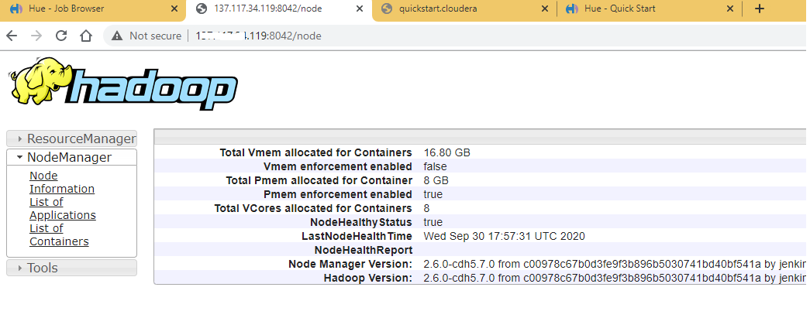

Job History Server
http://<ipaddress>:8042/
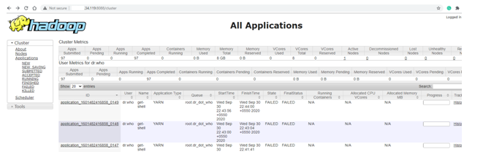

11. To check whether all the hadoop services are running, Run the jps command in your docker container
> jps
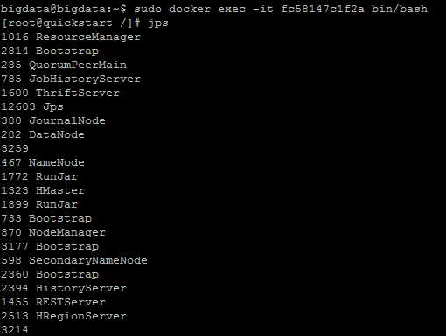

Please check whether the below services are running

1. Resource Manager
2. Namenode
3. NodeManager
4. DataNode
5. Job History Server
6. Journal Node

Appendix

1. Useful docker commands

sudo docker stop [CONTAINER ID]

It is used to stop one or more running containers.

https://docs.docker.com/engine/reference/commandline/stop/

This command you can use again to restart your container.

docker restart containerid

Input
#!/usr/bin/env bash
# create input file
mkdir -p /work/inputs && echo "apple lemon apple lemon lemon grape" > /work/inputs/input.txt
# put input file to hdfs
sudo -u hdfs hadoop fs -mkdir -p /user/hdfs/inputs
sudo -u hdfs hadoop fs -put /work/inputs/input.txt /user/hdfs/inputs

Execute

#!/usr/bin/env bash
# execute word count application
cd /work/target && sudo -u hdfs hadoop jar wc.jar WordCount /user/hdfs/inputs/input.txt /user/hdfs/outputs/output01 && cd /work
# show result
sudo -u hdfs hadoop fs -ls /user/hdfs/outputs/output01
sudo -u hdfs hadoop fs -cat /user/hdfs/outputs/output01/part-r-*

Setting up Hadoop project in eclipse.

1. Creating a java project using the below link

https://www.youtube.com/watch?v=U5yhJiFRL38

2. .Add the below list of jars from the share folder (hadoop-2.10.0\share) to your build path(one project properties you will find build path option) to resolve compilation the
dependencies

Add to build path
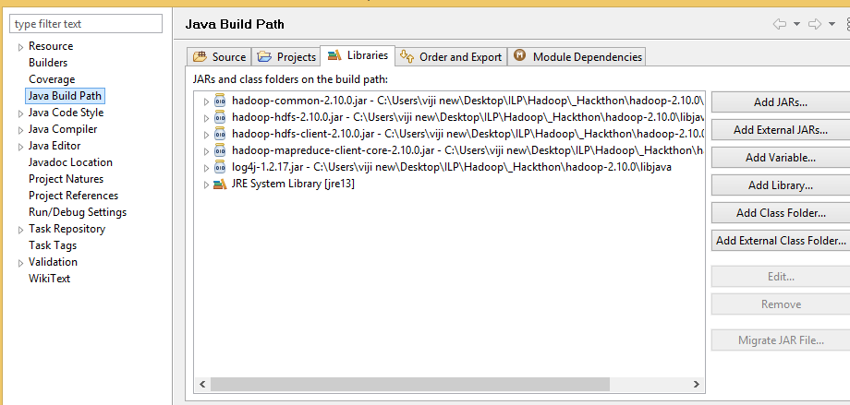

After adding the jar to the build path

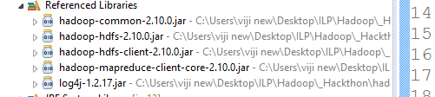

Note:
use Apache 2.10 hadoop distribution library
https://archive.apache.org/dist/hadoop/common/hadoop-2.10.0/hadoop-2.10.0.tar.gz

3. Development of MR Job

Create the driver class,mapper and reducer code using java. If there are no compilation errors, proceed with packaging.

4. create the jar using the export command.
https://www.youtube.com/watch?v=jDDYSdgNf9Q

5. Execute and deployment refer
docker_hadoop / cloudera Quickstart VM documentation

