# Hackathon Use-Case IOT + Order, Hybris Part

## Used Test data in Hybris C4C

Service Agent: Hanak, Dorottya Login: HANAKD (pw:Initial01)

Customer ID: 1000680 (Capgemini Österreich AG)

Hybris URL

<https://my304160.crm.ondemand.com>

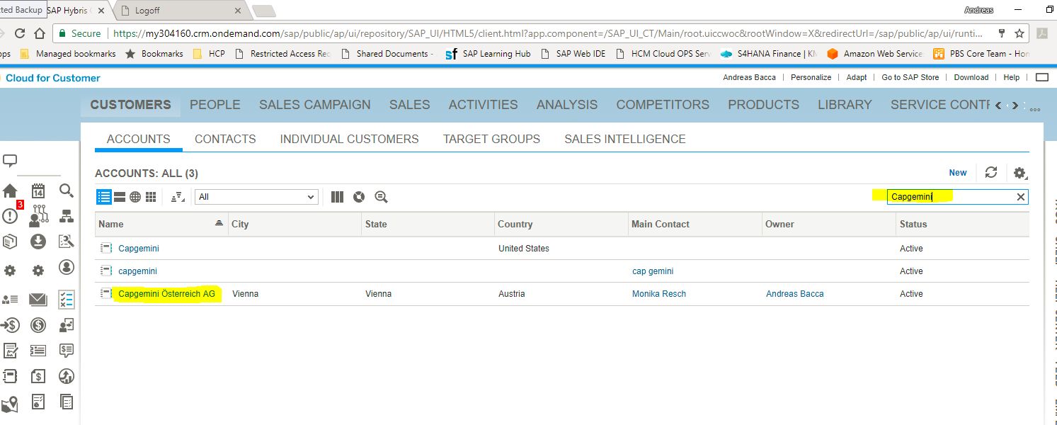

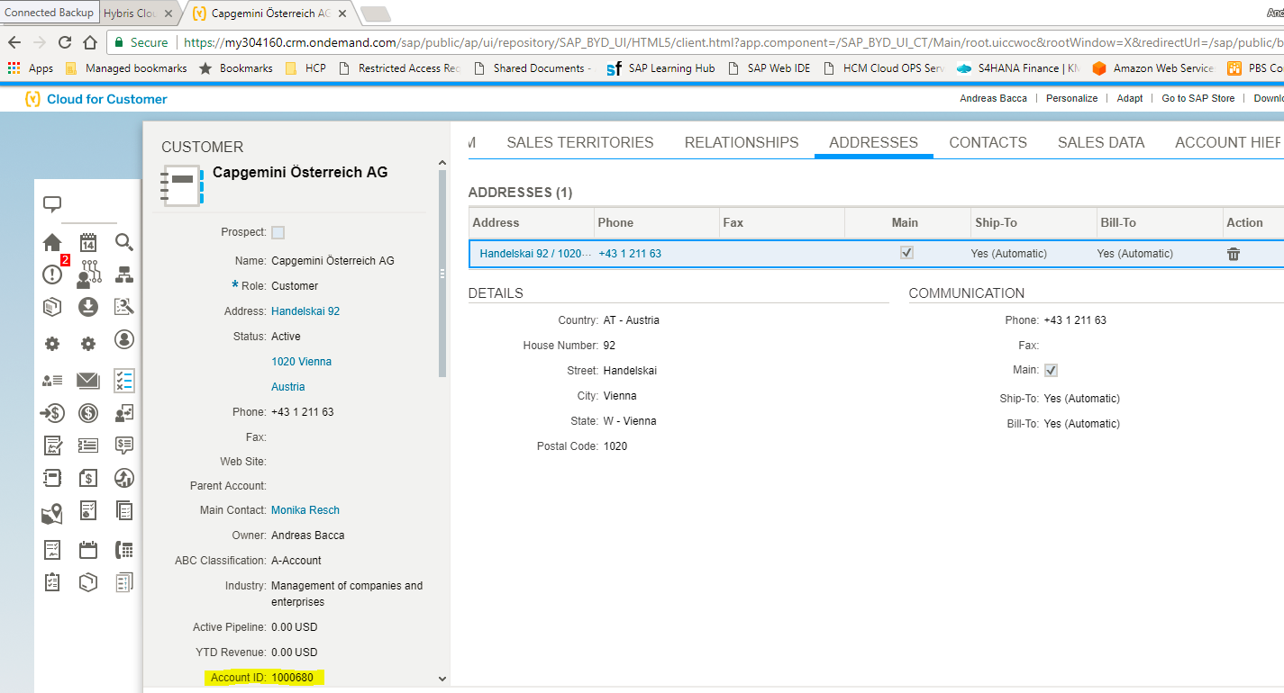

## Process

Develop an Interface between Azure and SAP Hybris

Step 1) Create a New Service Ticket in Hybris via the interface by using these parameters. The interface is triggered in Azure and based on OData protocol.

* Name
* CustomerID
* RequestedStart
* RequestedEnd
* AssignedTo

Step 2)

Check in Hybris that the Service Ticket is successfully created.

SERVICE->TICKETS

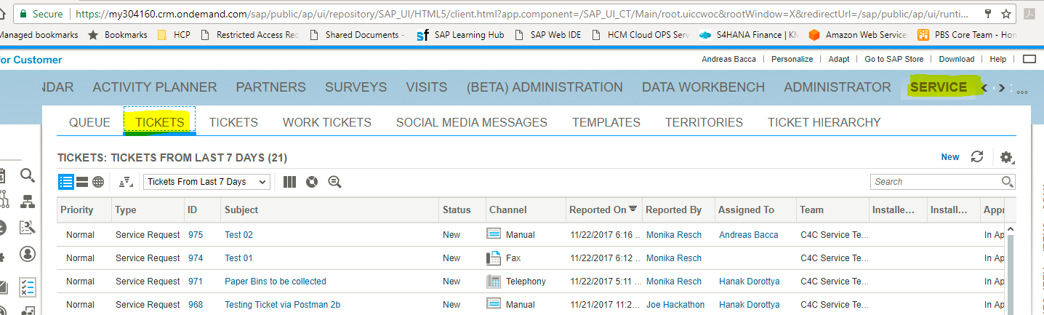

Step 3)

Check that an automatic E-Mail Notification is sent to the ‘Assigned To’

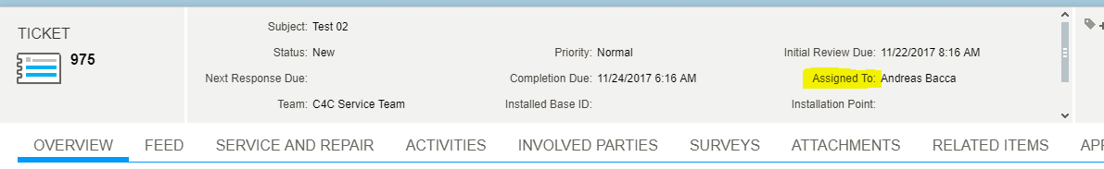

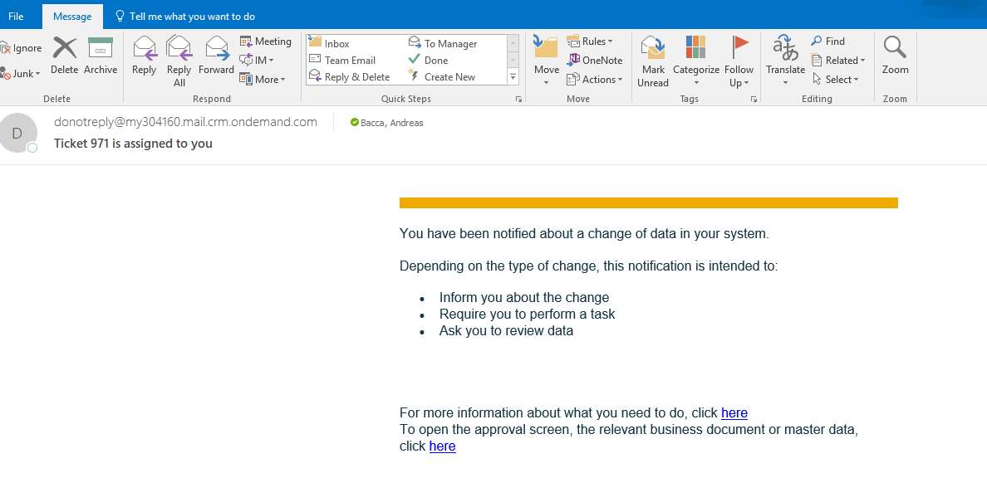

Step 4)

The Service Manager Hanak, Dorottya is communicating with the Chatbot on Azure and asking for additional information related to this ticket.

On which floor are the paper bins located? (Answer: ‘Floor 22’)

At what time should the bins be collected. (Answer ‘8.00 am in the morning’).

The interface between Azure and Hybris is sending the answers automatic to Hybris. The Service Ticket is updated.

Step 5)

Log on to Hybris and verify that the ticket is updated:

->INTERACTIONS

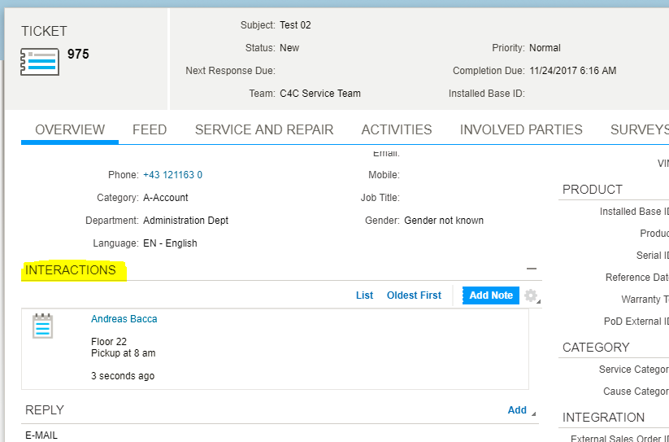

# Technical Details for the Interface

The ODATA Interface has been simulated via the App POSTMAN and successfully verified.

POSTMAN App

URL <https://my304160.crm.ondemand.com/sap/c4c/odata/>

**Task 1**

Get first a Token

GET

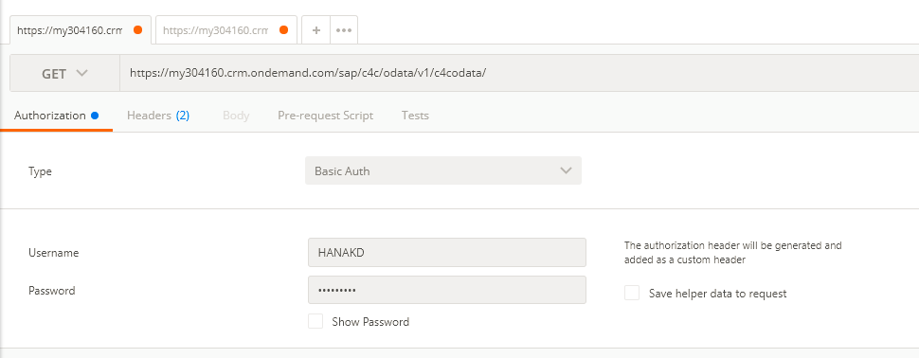

* Authorization: Basic

User: HANAKD (pw: Initial01)

* HEADERS

Enter x-csrf-token = fetch

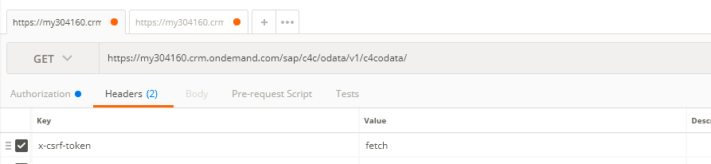

Send Request

Headers

* Authorizations : Basic

Receive Token in lower section (Headers) and copy to clipboard.

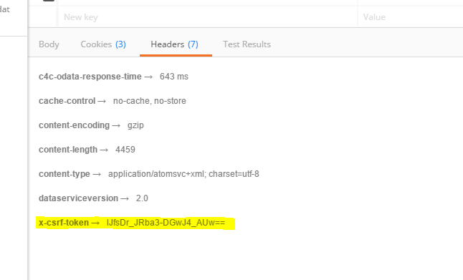

**Task 2**

Enter URL in Postman App.

<https://my304160.crm.ondemand.com/sap/c4c/odata/v1/c4codata/ServiceRequestCollection>

Type: POST

Authorization: Basic, with same credentials than in Step1)

In HEADERS enter

x-csrf-token = from step 1) above

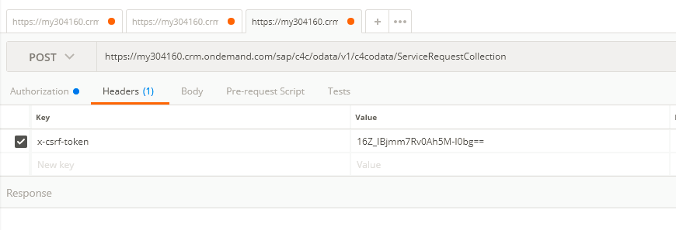

In Body (type raw, JSON) enter following parameters:

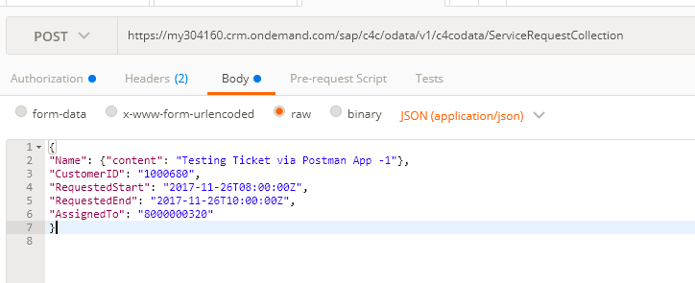

Send Request

{

"Name": {"content": "Testing Ticket via Postman App -1"},

"CustomerID": "1000680",

"RequestedStart": "2017-11-26T08:00:00Z",

"RequestedEnd": "2017-11-26T10:00:00Z",

“AssignedTo”: “8000000320”

}

If the request was successful, the Service Ticket is created.

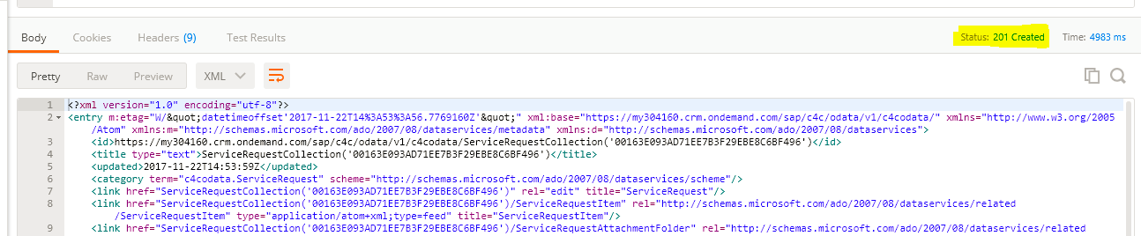

ID is visible in the XML response.

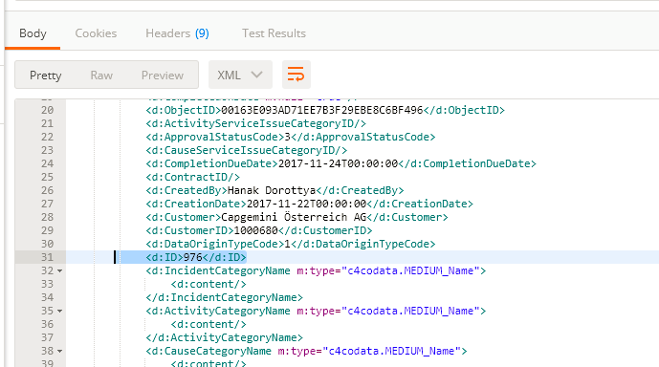

Result in Hybris

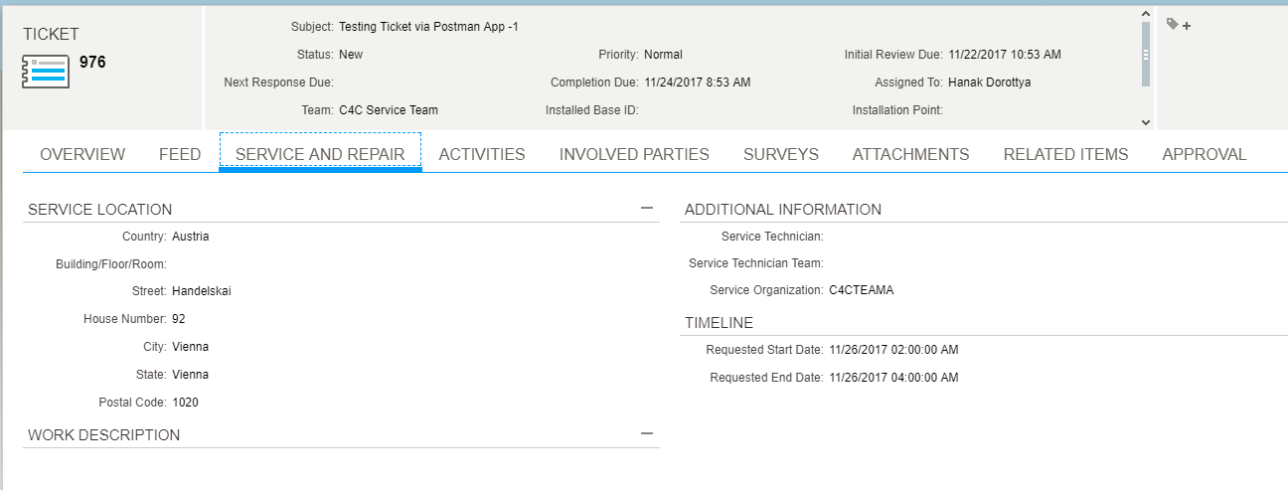

Update Note in the Service Ticket

**Task 3**

Update existing Service Ticket

Task 3.1

First send a GET request in Postman to retrieve the ObjectID of the ticket.

Example: for Ticket 976:

<https://my304160.crm.ondemand.com/sap/c4c/odata/v1/c4codata/ServiceRequestCollection?$filter=ID> eq '9768'

Result:

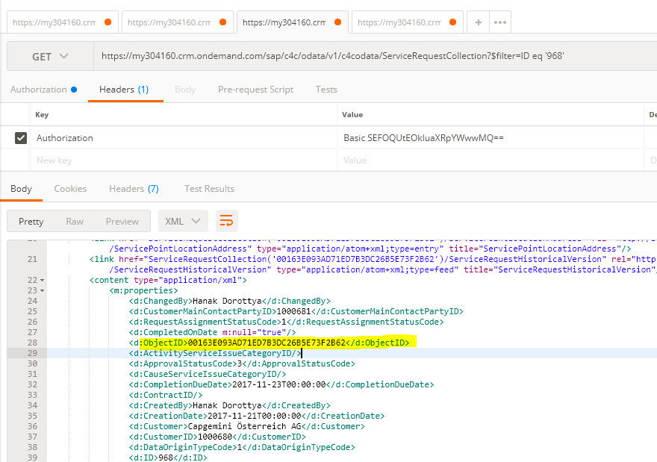

Task 3.2

Send a POST request to insert a note (00163E093AD71EE7B3D26859EC61365F is retrieved from body of the GET request)

URL

<https://my304160.crm.ondemand.com/sap/c4c/odata/v1/c4codata/ServiceRequestDescriptionCollection>

Authentication: Basic

Body:

{"TypeCode":"10008","Text":"22 Floor; Please Pickup at 8am”, "ParentObjectID":"00163E093AD71ED7B3DC26B5E73F2B62"}

Result Hybris

