# IIIT-GPS

Checkout the website by [clicking here](https://web.iiit.ac.in/~sanchit.arora/IIIT-GPS/html/index.html).

### Problem

* The students waste their vacations because they don't know from where to study things that will help them in the next semester (or near future)
* Most students have a misconception about the courses. Many think that they will enjoy the next semester because of some courses. But face reality later (like ISS or IoT).
* The students are unaware of the prerequisites of a course and its speed. "Officially" the courses like CPro assumes no knowledge of programming, but we know how fast it goes and how many students struggle with it.

### Our Solution

* Our solution to this problem is to create a platform which shows the reality of the courses.
* Instead of scattered suggestions of the seniors, more organized suggestions (and learning resources) will help a student to utilize his/her vacation.
* They will prepare themselves according to the difficulty, duration and syllabus of a course by following suggestions given by seniors.

### Current Features

* A good looking, fully responsive website to enhance user experience.
* Functionality to bookmark a course and display in "My Courses". Data is stored in local storage.
* Course cards displaying info like tags, difficulty, duration and rating.
* A dedicated course page for the Syllabus, Resources and Suggestions/Comments of other students.
* All the course pages are made dynamically on request by the user.
* The app will automatically take data from a JSON file hosted on GitHub and render it.
* A working rating system (data stored in firebase).

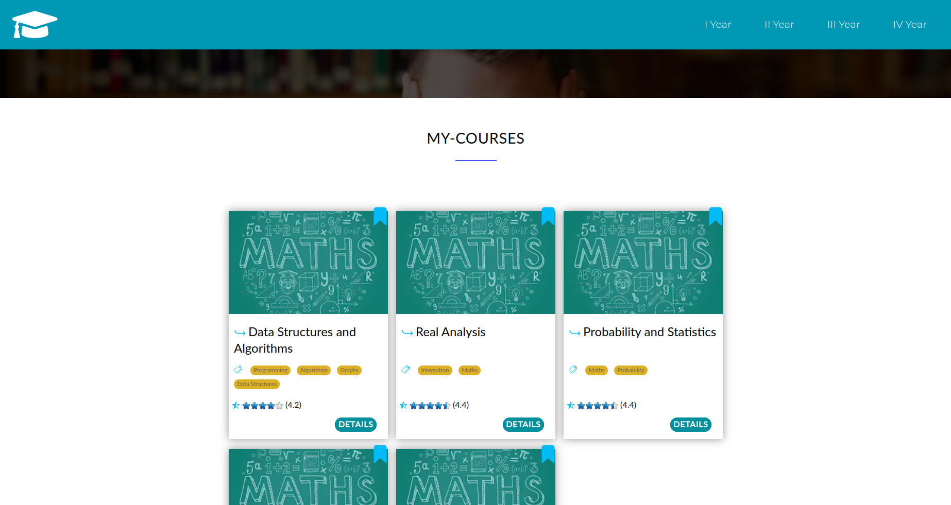

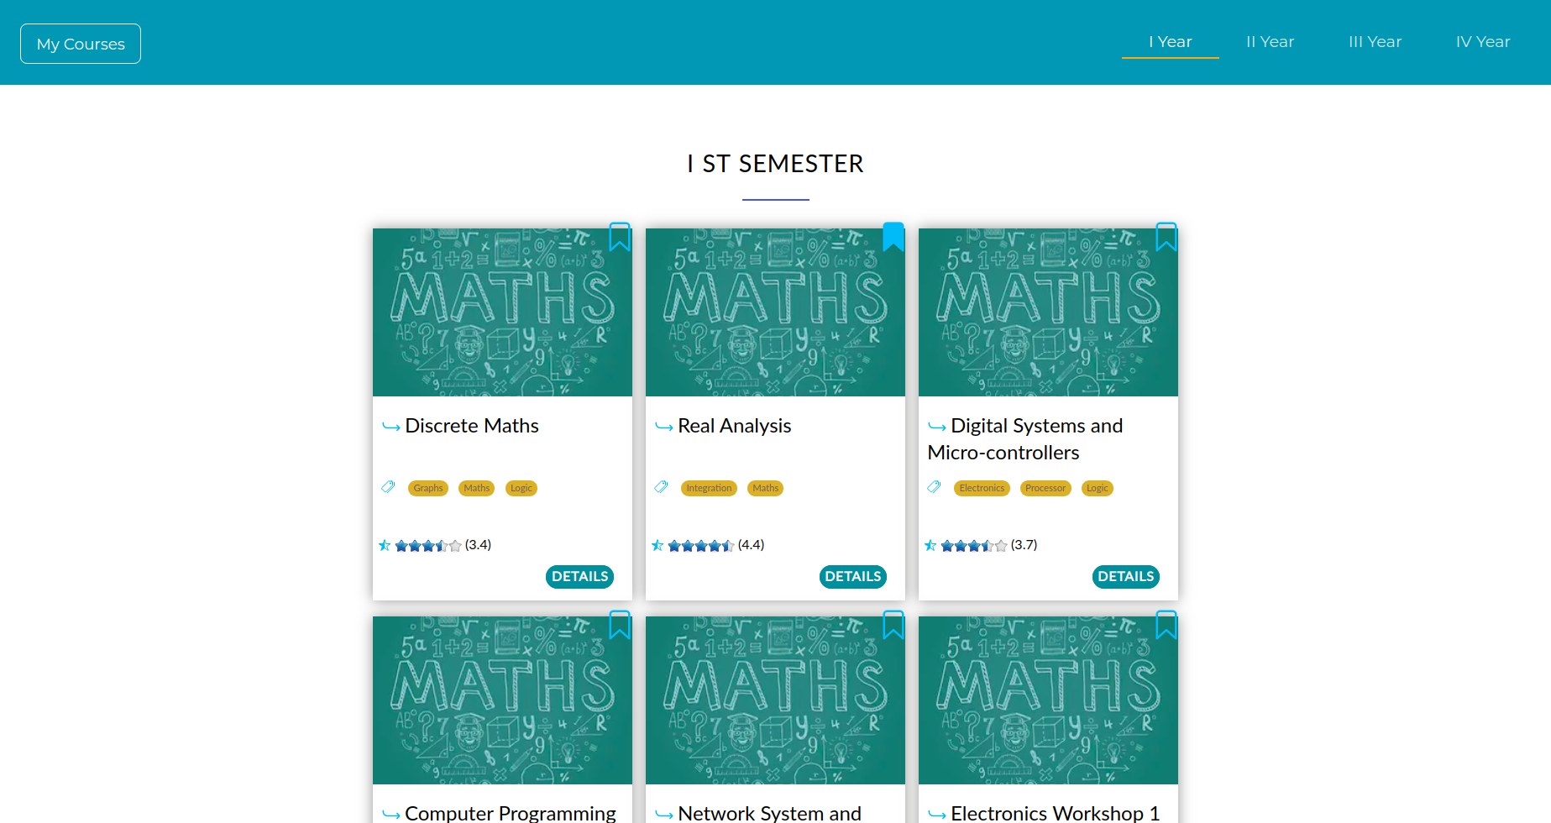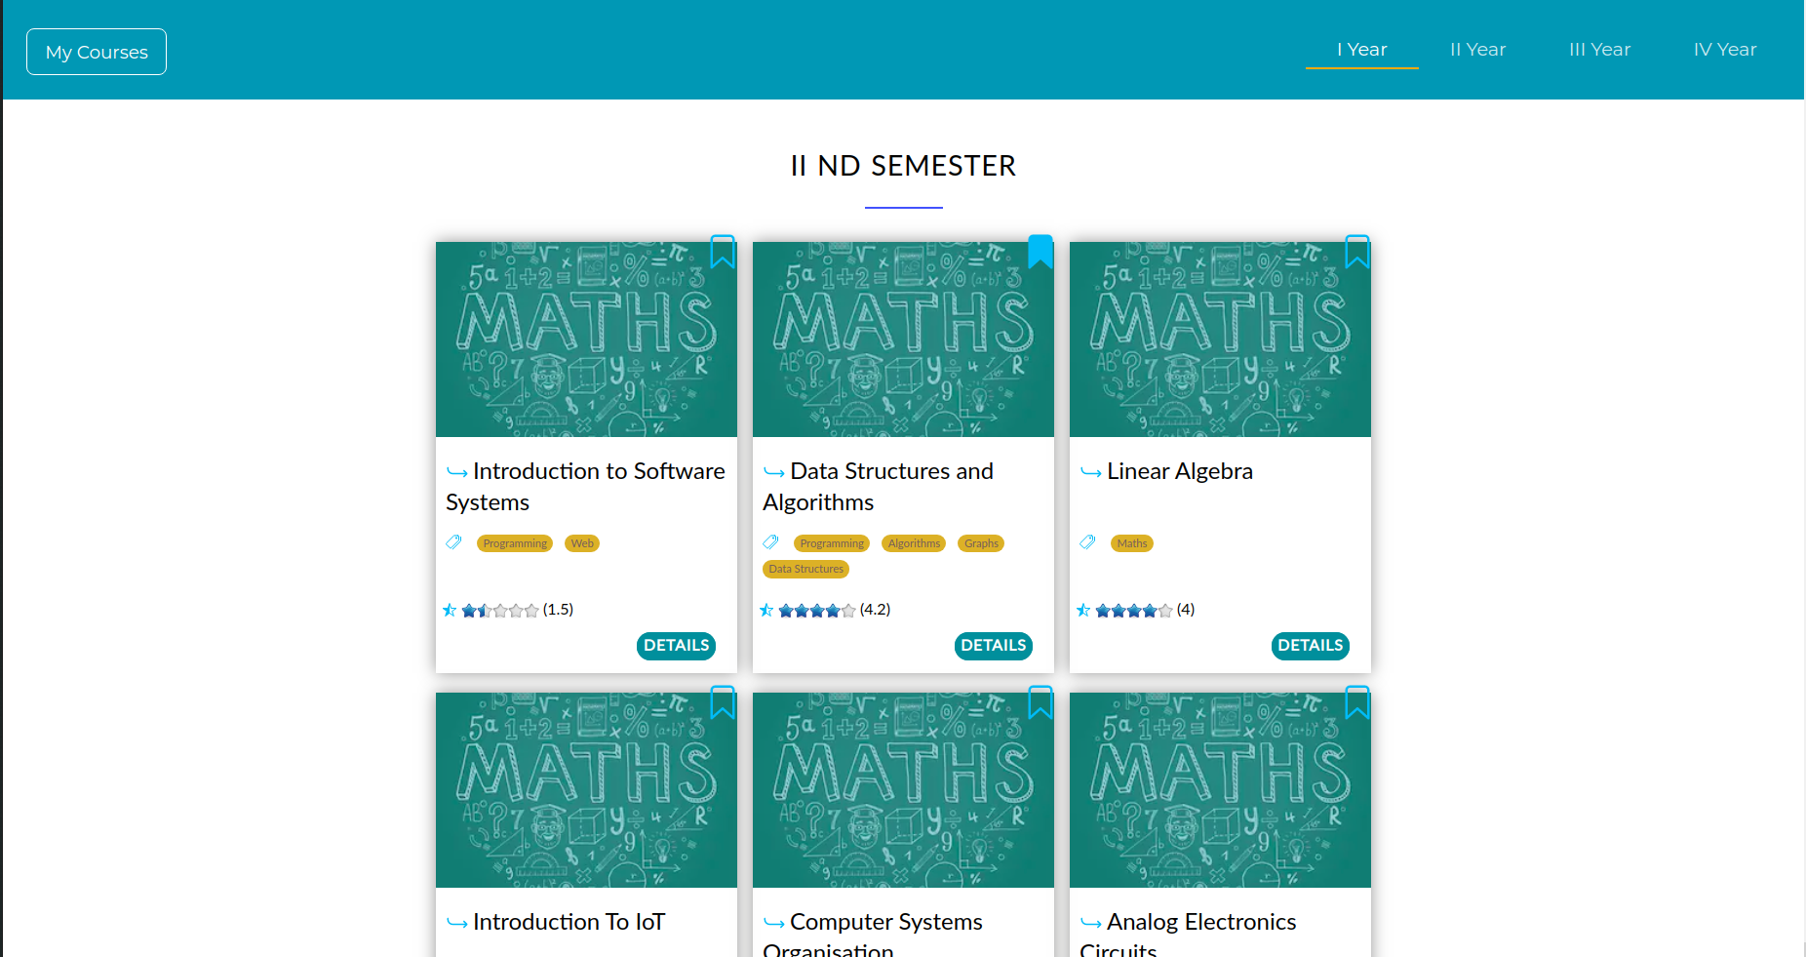

### 

### 

### Our goals for near future

* Add more courses.
* Create a database for read/write operations.
* Use a self-made commenting system.
* Add functionality to create users account and store data like bookmarked courses globally.
* Allow users to post resources which will get uploaded after review.
* Allow users to request suggestions/resources from another user.
* Implement a search bar for courses for easier access.
* Recommendation System on the basis of tags.

### Our Team

* *Gurkirat Singh*
* *Pratyush Pratap Priyadarshi*
* *Shrey Gupta*
* *Sanchit Arora*

Now students will ~~waste~~ utilize their vacations!