**Installation Cloudera QuickStartVM**

1. Download **Cloudera QuickStartVM from the below link**

<https://drive.google.com/file/d/1kgMDGeOKhDJ21EEqYOMaUzhndU71GuOL/view>

**2. Choose Linux machine 64 bit and Ram according to your machine capacity. If you have 8 GB ram**

**choose 4 GB RAM.**

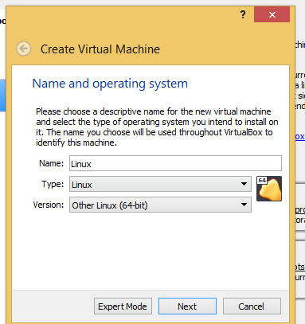**b**

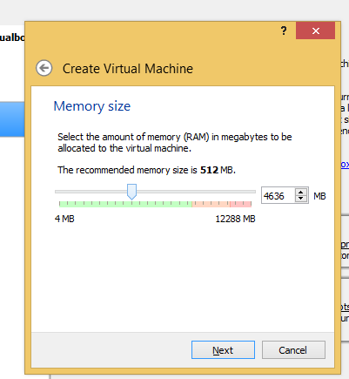

**Choose the Cloudera image you have downloaded as per below**

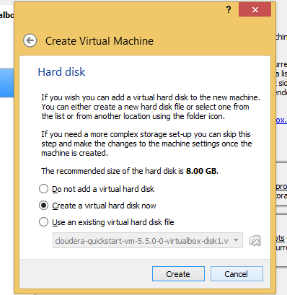

**3. Configuring the settings of Virtual Machine to transfer files from your windows machine and access internet**

**a). Add NAT adapter in your network settings for internet**

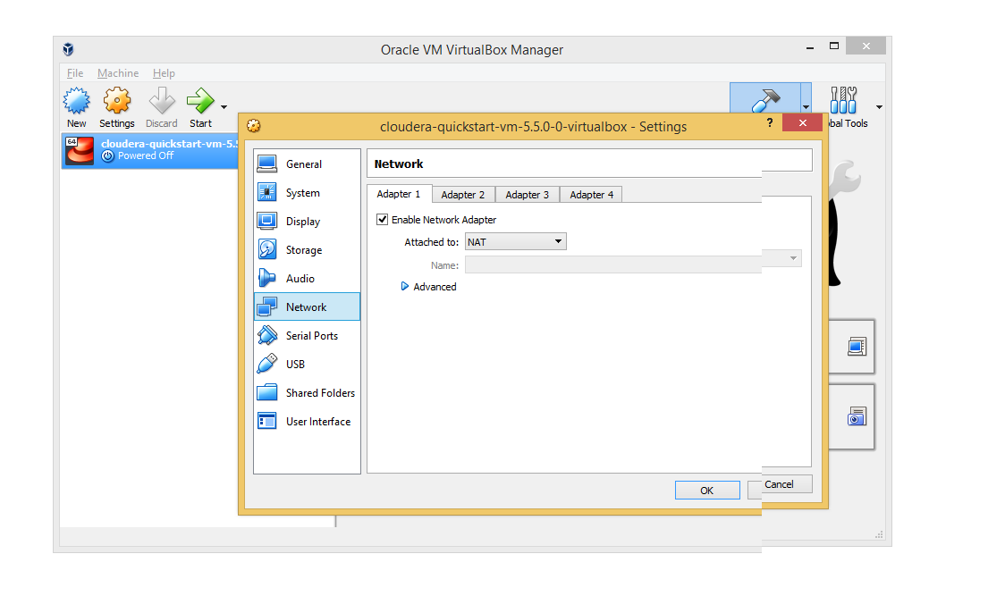

**b). Add host only adapter in your network settings to access your windows machine**

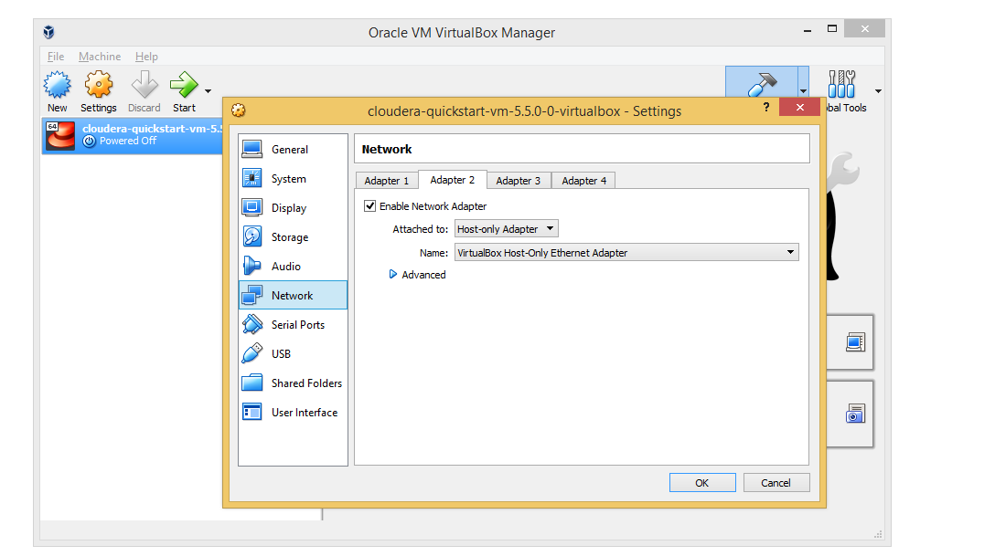

**4. Transferring the MR JAR file to Virtual Machine**

To transfer the file from your windows machine to a virtual machine follow the steps from 7 to 14

[**https://data-flair.training/blogs/transfer-data-from-windows-to-ubuntu/**](https://data-flair.training/blogs/transfer-data-from-windows-to-ubuntu/)

**5. Connecting to hadoop Cloudera vm / Any other lab instance available in the net using Putty**

*Watch the below video from timeline 0:14*

<https://www.youtube.com/watch?v=h_2txcRETHo>

Note:

Putty is helpful when you have low RAM in your windows machine using Cloudera quick start vm will become your machine slow.

**6.Accessing Hue from your windows machine.**

To check the successful execution of the Job you can use the Hue interface with the application id.

In earlier links i have explained how to find the ipaddress of your Cloudera quick start vm using ifconfig.

Use that ip and form the below url

[http://<ipaddress>:8888/](http://192.168.56.102:8888/about/)

Default user id / password: Cloudera /Cloudera

You will be able to access Hue from windows.

7. Resource Manager

[http://<ipaddress>:8088/](http://192.168.56.102:8888/about/)

8. Job history Server

[http://<ipaddress>:8888/](http://192.168.56.102:8888/about/)

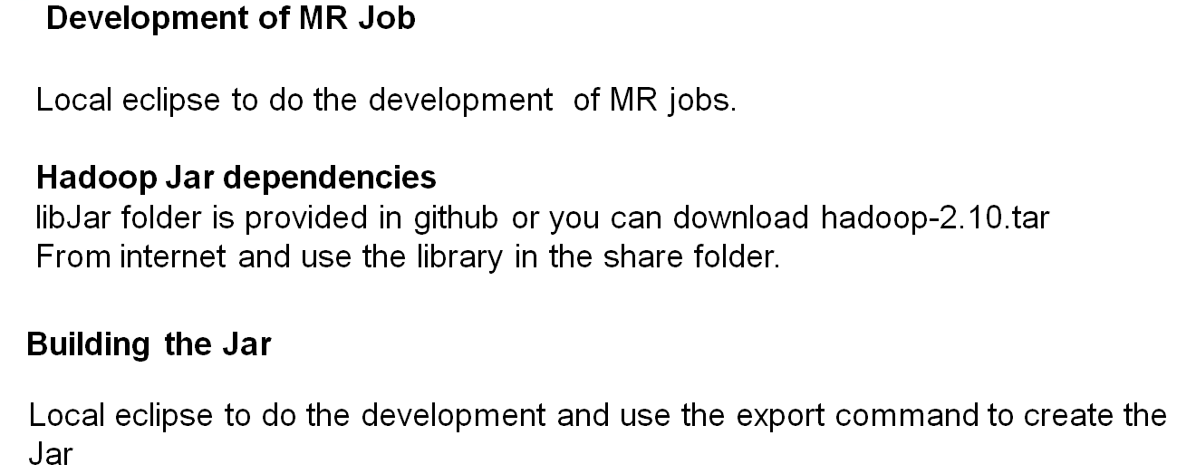

Note

Add the below list of jars from the share folder to your build path to resolve compilation

dependencies

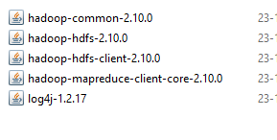

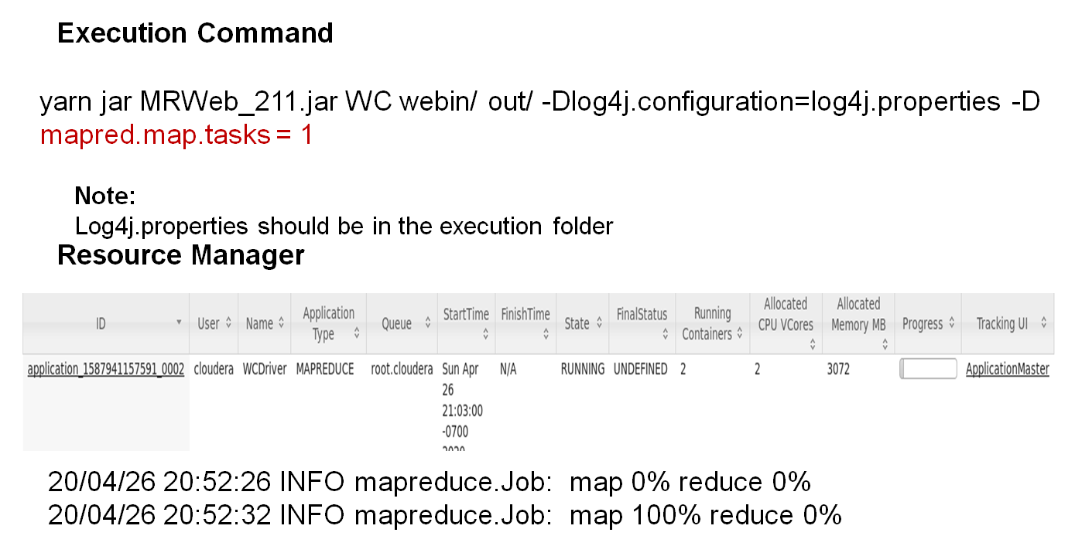

Debugging your mapreduce code

