- Put Icons Beside Each Contact Information
- Send Message Looks Like Text Please Change it to Button Style

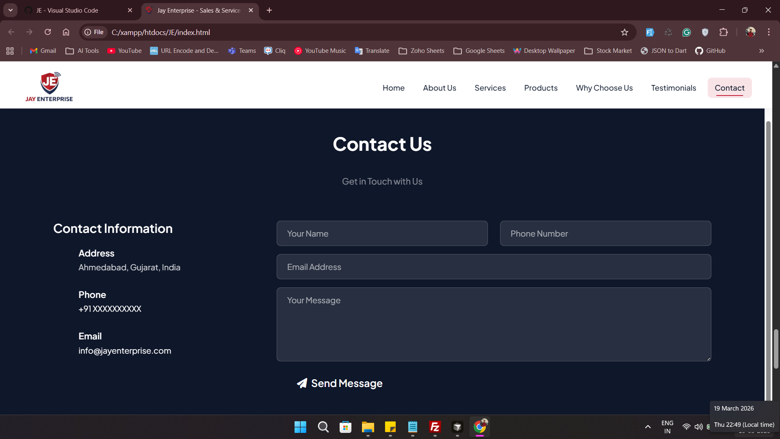

3. Put Slider in Homepage instead of Single Image + Description
4. Every Slider has Different Description as per image
5. Make Logo Size Bigger
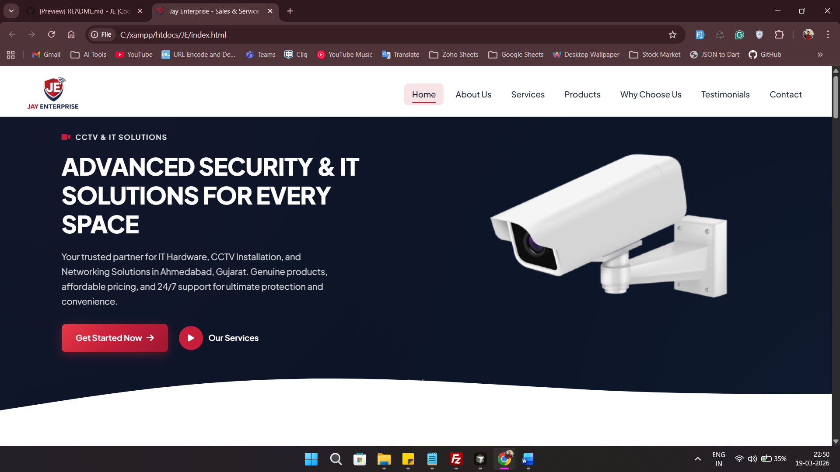
6. Our Product Page Design Change (see my website for reference)
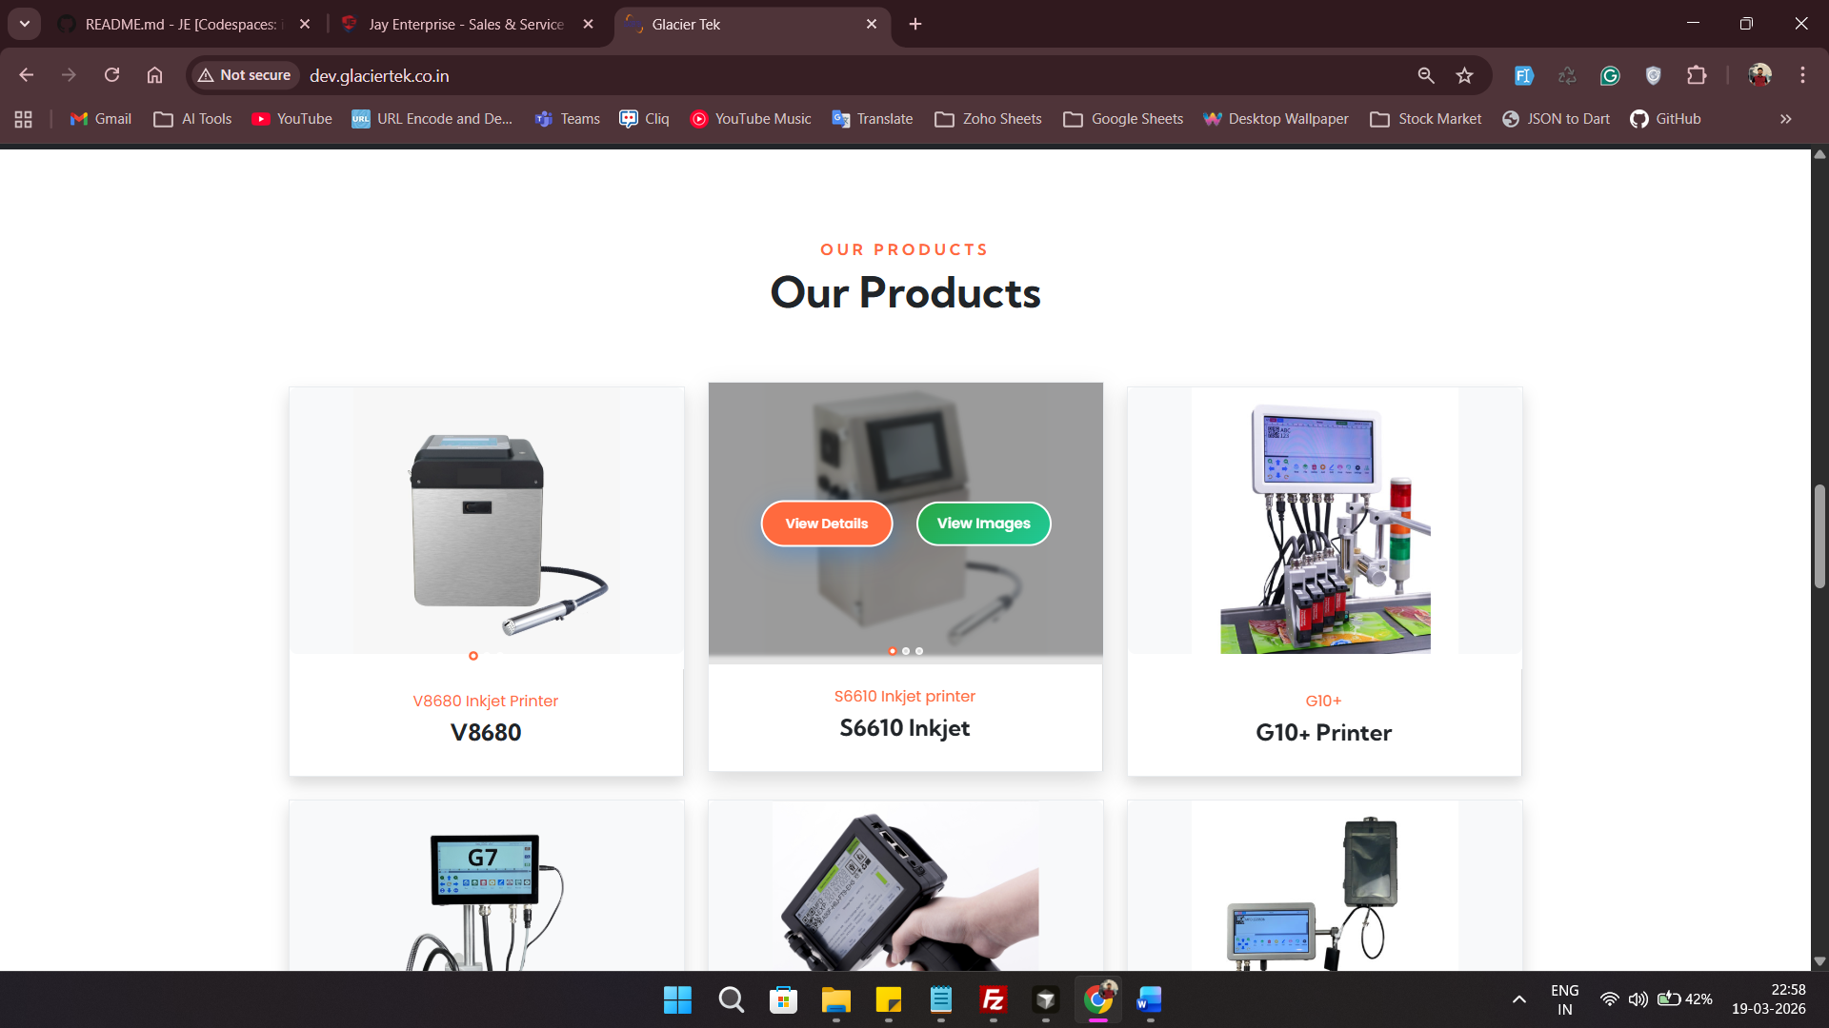

7. Make Saperate Product Page When Click on View Details Button shows as per above image (refere website : http://dev.glaciertek.co.in)

