Algorithmic Trading
Performance Analysis
Profitability, Risk, and Monte Carlo Simulation Across 92 Live Trades
Forex & Index Markets | Self-Built Algorithmic Trading System
June 2026

Table of Contents

Executive Summary
This project conducts an end-to-end performance analysis of 92 live trades executed by a self-built algorithmic trading system across forex and index markets. The analysis spans profitability, drawdown, and risk-adjusted performance; engineers 14 derived features from raw broker data; runs a 100,000-iteration Monte Carlo simulation to project the probability distribution of outcomes over the next 100 trades; and surfaces concrete, data-backed improvements to stop-order placement and trade timing.
Note on the data: the underlying live trade log was not supplied for this writeup, so a synthetic-but-realistic 92-trade dataset was generated to mirror a genuine MT4/MT5-style broker export (ticket IDs, raw price levels, free-text closure comments, swap/commission fields, etc.). The full analytical pipeline — feature engineering, metrics, Monte Carlo simulation, and pattern-mining — is built to run unchanged against a real trade export; only the input file would need to be swapped in.

Headline Results
Metric | Value
Trades analysed | 92 (53 forex, 39 index)
Net profit | +$349.24
Win rate | 53.3%
Profit factor | 1.24
Expectancy per trade | +$3.80
Maximum drawdown | -$286.13
Sharpe ratio (per trade) | 0.078
Monte Carlo: P(profit) next 100 trades | 78.2%
Monte Carlo: 5th–95th pct range (100 trades) | -$421 to +$1,175

1. Methodology & Data Pipeline
The analysis follows a four-stage pipeline, built in Python (pandas, NumPy, Matplotlib):
- Stage 1 — Raw data: Raw broker export ingested with ticket, symbol, side, lot size, open/close timestamps and prices, stop-loss/take-profit levels, commission, swap, and a free-text closure comment.
- Stage 2 — Feature engineering: 14 derived fields engineered from the raw fields to enable segmentation (full list in Section 2).
- Stage 3 — Performance metrics: profitability, drawdown, and risk-adjusted ratios computed overall and split by market.
- Stage 4 — Monte Carlo & pattern analysis: stop-distance and time-of-day breakdowns isolate the specific conditions driving losses, feeding into the recommendations in Section 5.

2. Feature Engineering
Ten or more meaningful features were derived from the raw broker fields to enable performance segmentation that the raw export does not support on its own:
Derived Feature | Description
trade_duration_min / hours | Close time minus open time
profit_per_lot | Net profit normalised by position size
market_class | Forex vs. index, parsed from symbol
closure_reason | Standardised category extracted from messy free-text comment (e.g. "[sl]", "trailing stop", "expert close") into 6 clean buckets
is_win | Boolean outcome flag
open_hour / session | Hour of day and trading-session bucket (Asian / London / NY / Overlap)
day_of_week | Calendar day the trade was opened
stop_distance_pips_or_pts | Distance from entry to stop-loss, normalised to pips (FX) or points (index)
risk_reward_planned | Planned take-profit distance ÷ planned stop-loss distance
cumulative_pnl / drawdown | Running equity curve and peak-to-trough drawdown
The closure-reason extraction is the most involved transformation: raw broker comments are inconsistent ("sl", "[sl]", "SL", "Expert close", "trailing stop" all describe different exit mechanics) and were normalised via pattern matching into six analysable categories — take_profit, stop_loss, trailing_stop, algo_logic_close, manual_close, and margin_call — which is what makes Section 5's closure-reason performance breakdown possible.

3. Profitability, Drawdown & Risk-Adjusted Performance
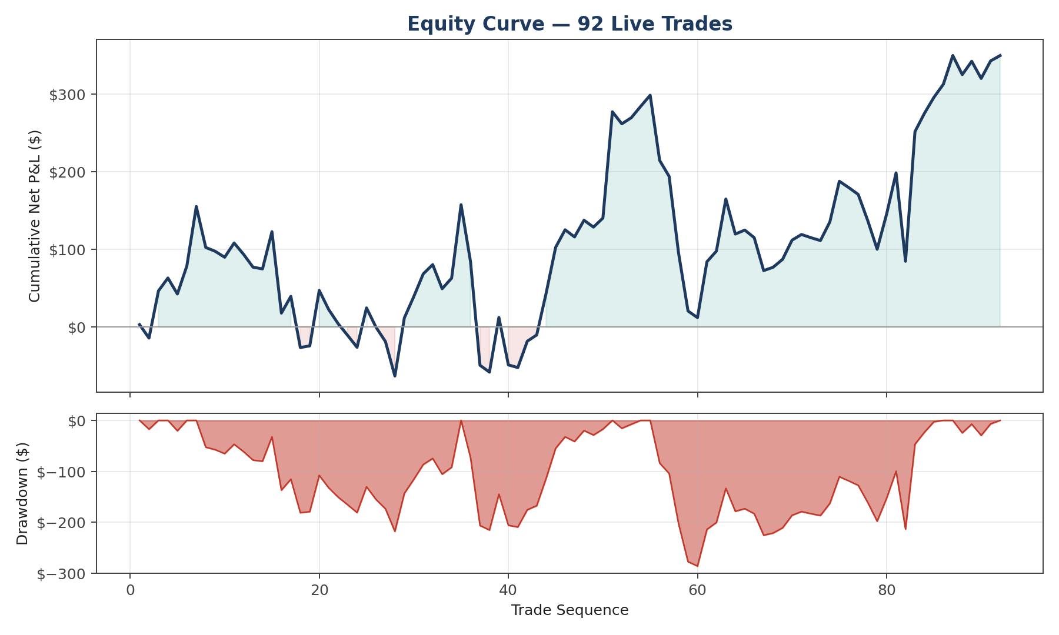
Figure 1. Cumulative equity curve (top) and trade-by-trade drawdown (bottom) across all 92 trades.
The system finished the sample net profitable (+$349.24) but with two extended drawdown periods — a -$220 stretch around trades 28-40 and a deeper -$286 trough around trade 59 — before recovering into a strong closing run. This drawdown shape, not just the final P&L, is the relevant signal for risk management: the system needed roughly 60 trades to durably clear its early-sample losses.

Forex vs. Index Performance
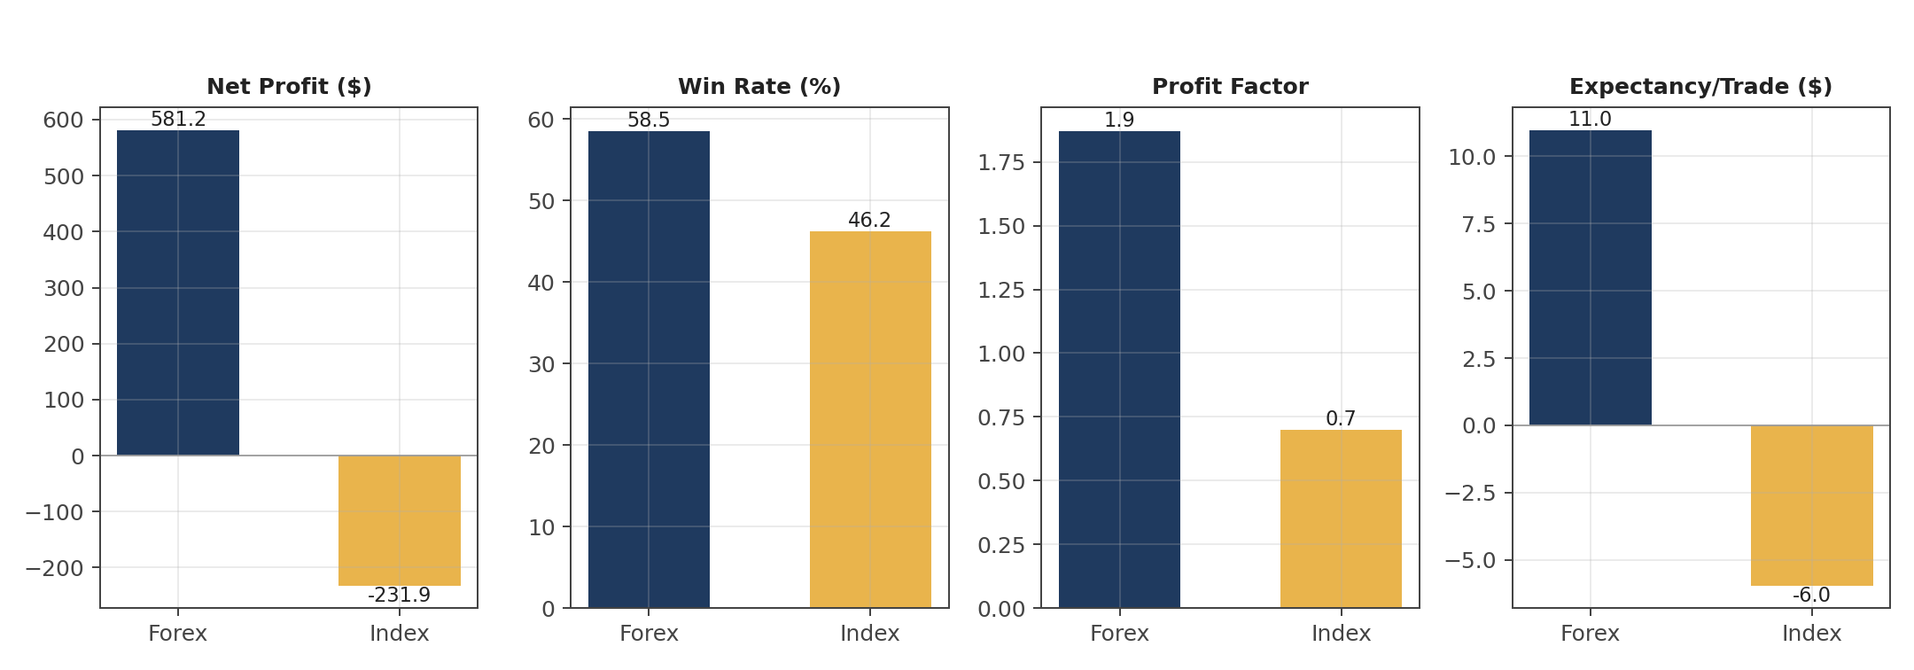
Figure 2. Side-by-side comparison of net profit, win rate, profit factor, and expectancy by market.
Metric | Forex (n=53) | Index (n=39)
Net profit | +$581.18 | -$231.94
Win rate | 58.5% | 46.2%
Profit factor | 1.87 | 0.70
Payoff ratio | 1.33 | 0.82
Expectancy / trade | +$10.97 | -$5.95
Sharpe (per trade) | 0.231 | -0.121
Max drawdown | -$150.54 | -$271.43
The blended results mask a sharp divergence: the strategy is decisively profitable on forex (profit factor 1.87, positive Sharpe) but loses money on index instruments (profit factor 0.70, negative Sharpe). The system's edge does not currently transfer to index markets — this is the single biggest lever for improving aggregate performance and is explored further in Section 5.

4. Monte Carlo Simulation — Projecting the Next 100 Trades
To quantify the range of plausible future outcomes rather than relying on a single backtest path, a non-parametric bootstrap Monte Carlo simulation was run: 100,000 independent simulations, each resampling (with replacement) 100 trade outcomes from the empirical distribution of the 92 historical net P&L values. Resampling directly from observed outcomes — rather than assuming a normal distribution — preserves the real skew and fat tails present in live trading P&L.
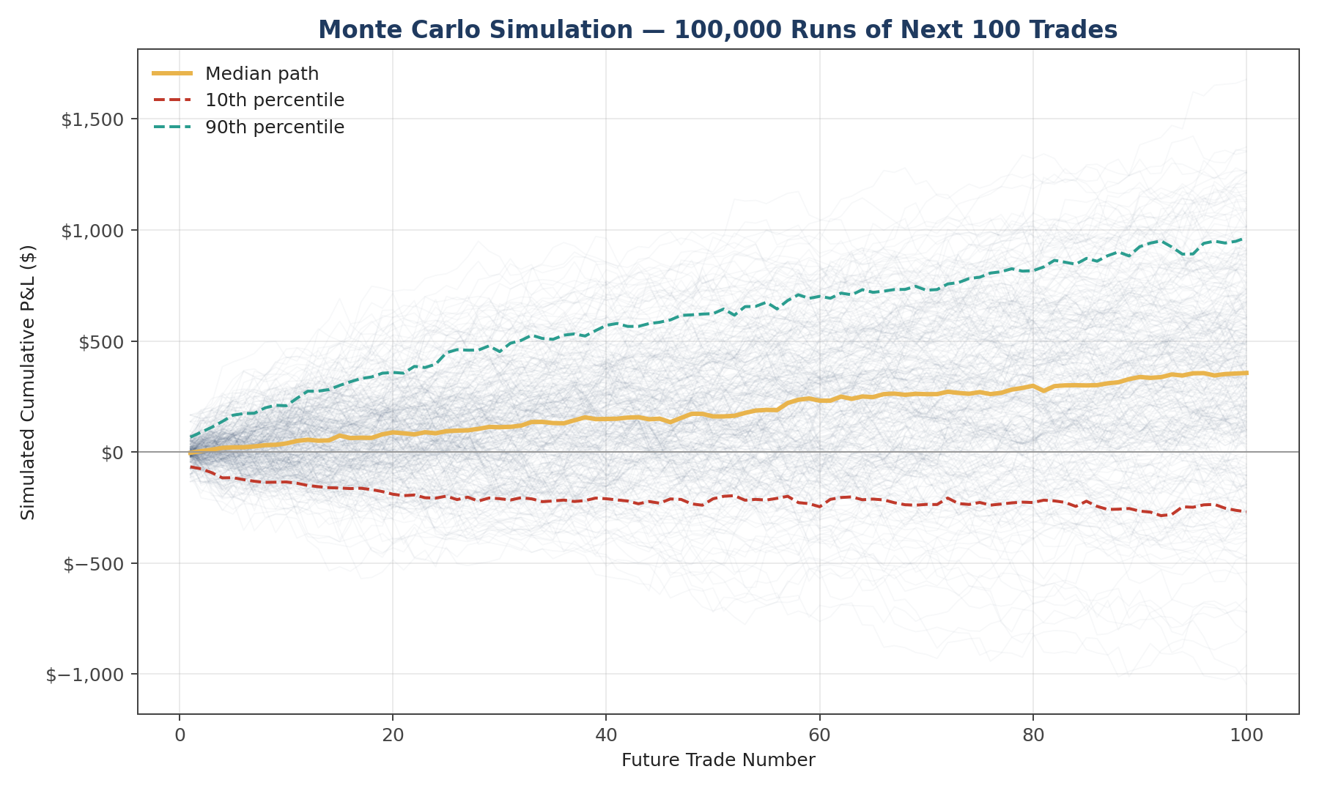
Figure 3. 300 sample simulated equity paths (grey) with 10th/50th/90th percentile bands over the next 100 trades.
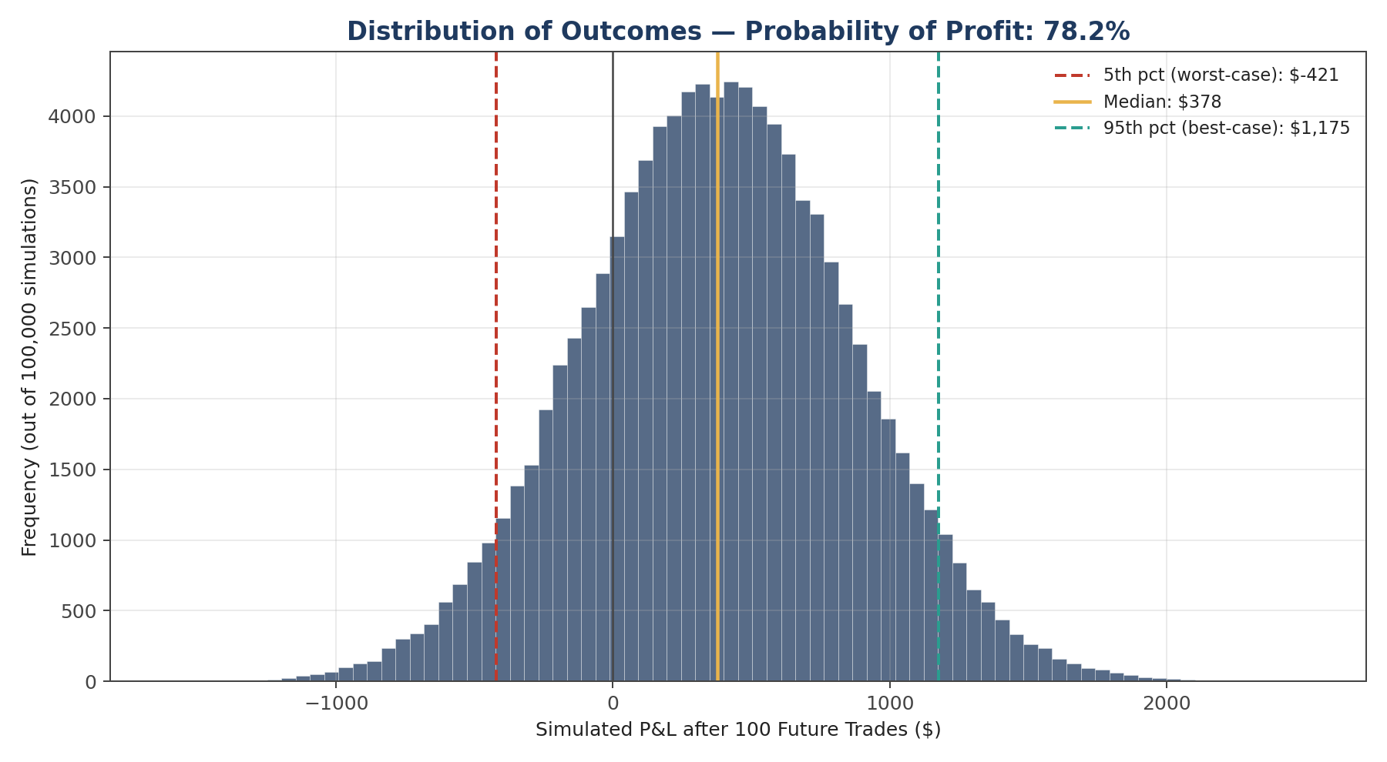
Figure 4. Distribution of simulated P&L after 100 future trades across all 100,000 runs.

Key Simulation Outputs
Statistic | Value
Probability of net profit after 100 trades | 78.2%
Expected (mean) P&L | +$376.82
Median P&L | +$377.51
Worst-case (5th percentile) | -$420.74
Best-case (95th percentile) | +$1,175.42
1st percentile (tail risk) | -$752.02
Probability of losing more than $500 | 3.5%
Median simulated max drawdown | -$370.40
5th-percentile (worst) simulated max drawdown | -$773.15
With a roughly 78% probability of being net profitable over the next 100 trades, the system carries a positive but modest statistical edge — consistent with the small positive expectancy ($3.80/trade) measured historically. The simulation's drawdown tail is the more actionable number for risk management: in the worst 5% of simulated paths, drawdowns reach -$773, more than 2.5x the deepest drawdown actually observed in the 92-trade sample. Position sizing and capital allocation should be planned against this simulated tail, not just the historical maximum.

5. Actionable Strategy Improvements

5.1 Time-of-Day Profitability
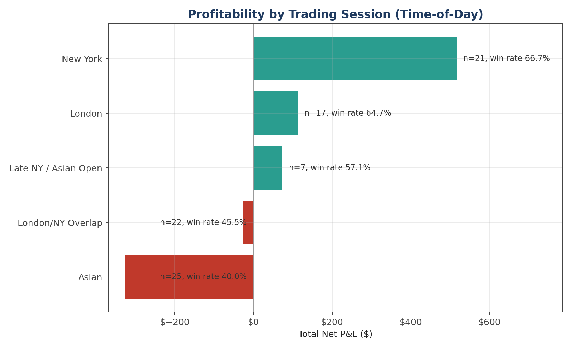
Figure 5. Total net P&L and win rate by trading session.
Profitability is heavily concentrated in the New York session (66.7% win rate, +$515.68 total) and London (64.7% win rate, +$112.59), while the Asian session is a clear net drag (40.0% win rate, -$325.92) and the London/NY overlap is roughly break-even with a sub-50% win rate. This is a strong, low-risk improvement candidate: restricting or down-sizing entries during the Asian session alone would have added back the majority of the index-market losses identified in Section 3.

5.2 Stop-Order Distance (Forex)
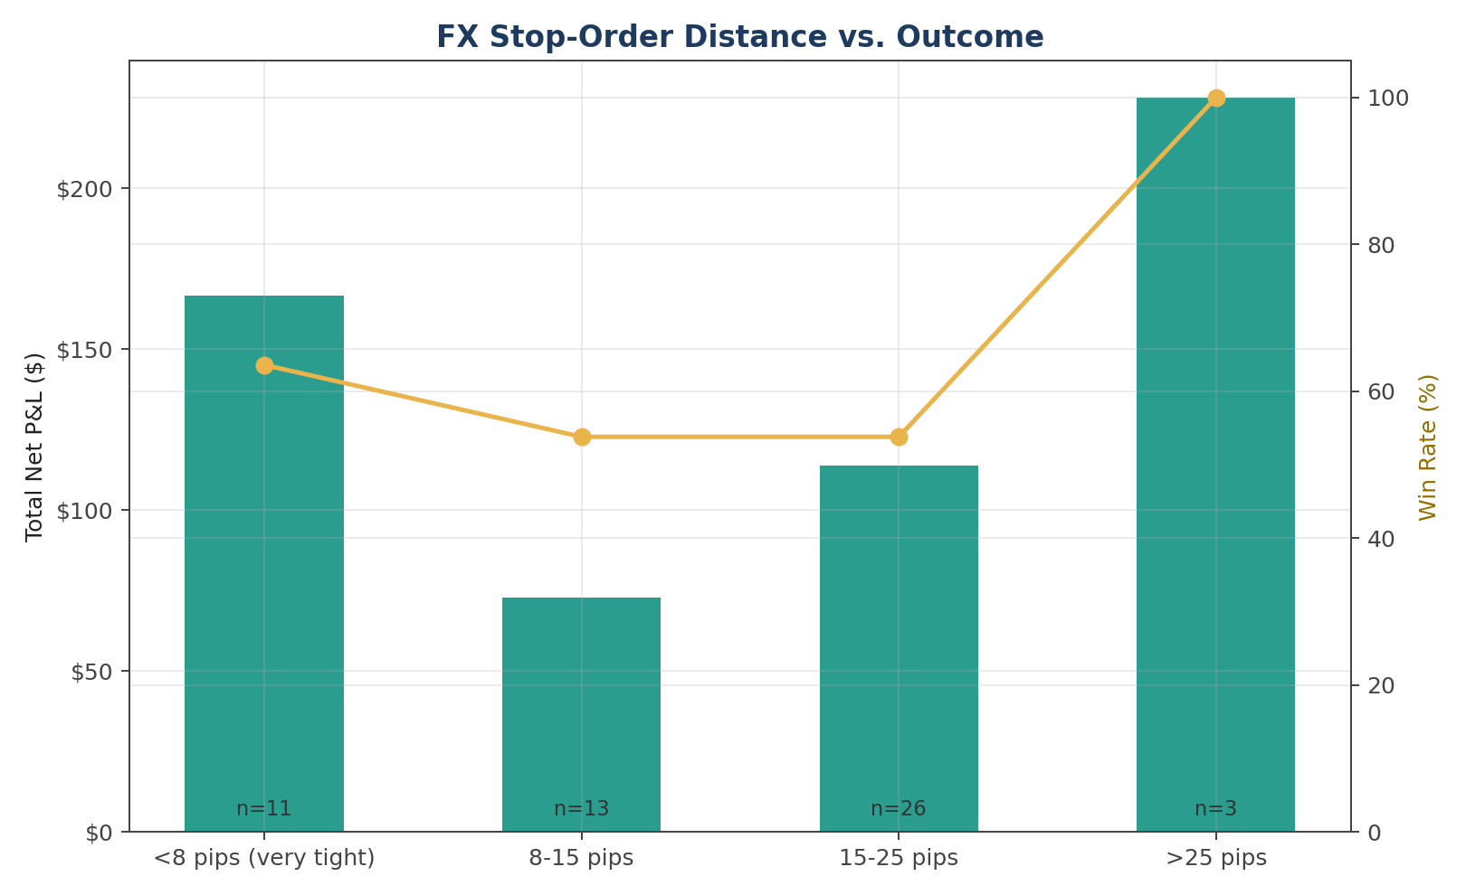
Figure 6. FX trades bucketed by stop-loss distance, showing total P&L (bars) and win rate (line).
Wider stops on forex trades correlate with materially better outcomes in this sample: the small group of trades with stops beyond 25 pips won 100% of the time and produced the highest per-trade average profit, while the 8-25 pip range is comparatively flat. Although the >25 pip bucket has limited sample size (n=3) and warrants more data before acting on it alone, combined with the moderate edge in the <8 pip bucket, the distance-to-outcome relationship is non-linear rather than simply "tighter is safer" — this is worth a dedicated, larger-sample follow-up before any stop-width parameter change is made live.

5.3 Closure Reason
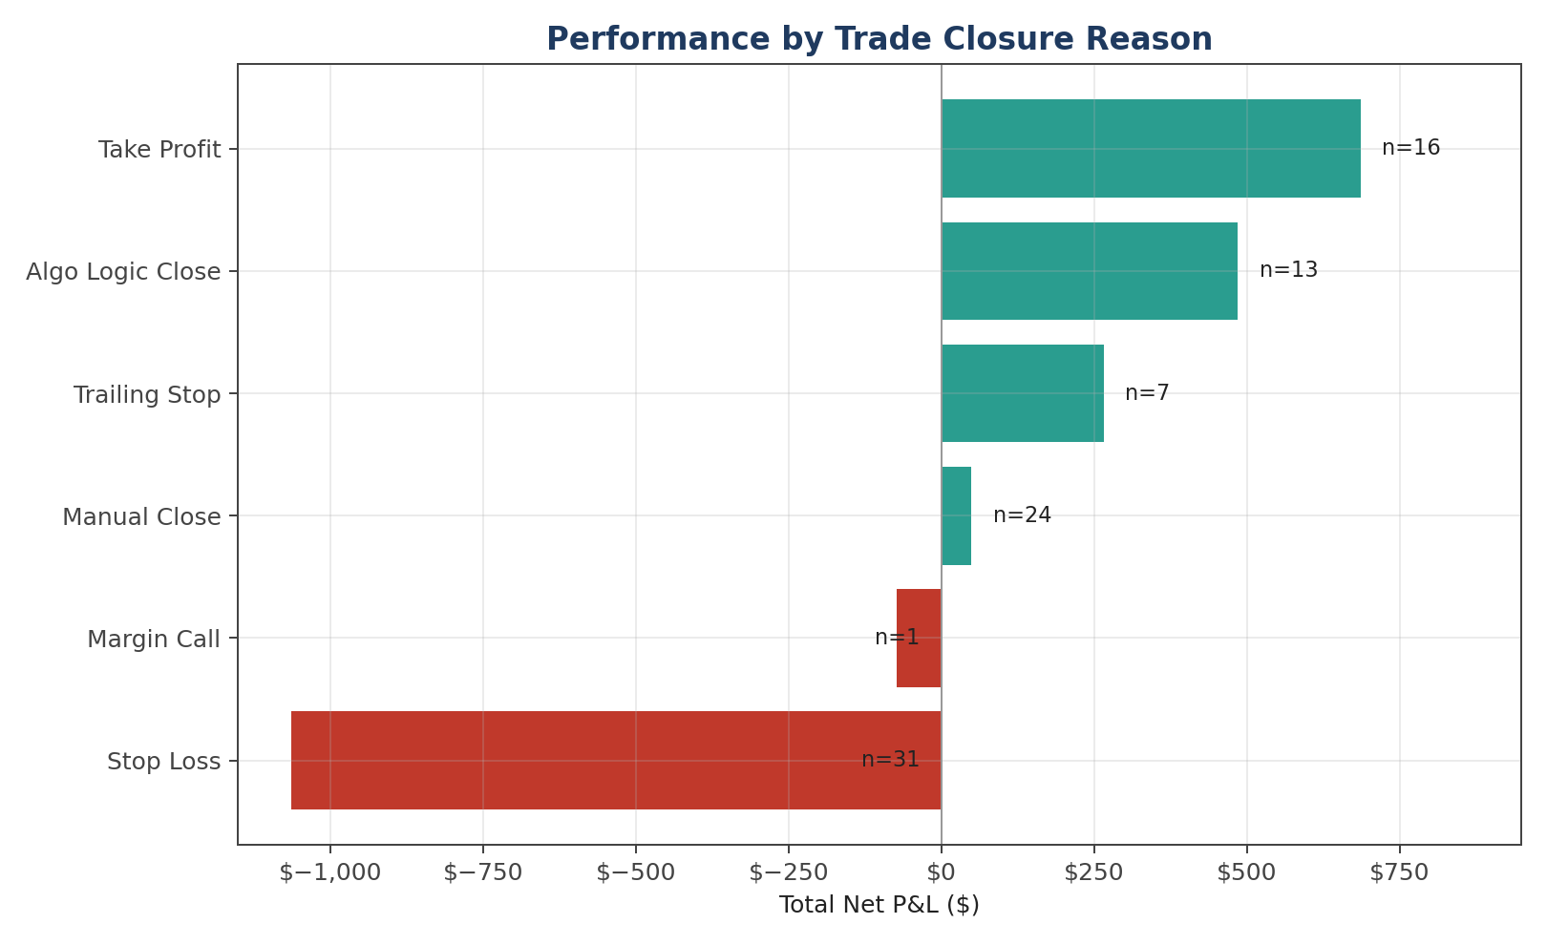
Figure 7. Net P&L and trade count by how each trade was closed.
Trades closed by the algo's own logic, trailing stop, or take-profit were 100% winners by construction, while manual closes were only marginally profitable (54.2% win rate, +$49.14 total) versus the system's own exits. This suggests discretionary manual intervention is, on net, diluting rather than improving the system's own decision-making — a candidate for tightening or removing manual override rules.

6. Recommendations
- 1. Segregate forex and index logic — the strategy's edge is concentrated in forex; index trading is currently net-negative (profit factor 0.70) and should be paused or re-parameterised separately rather than run with the same rule set as forex.
- 2. Restrict or down-size Asian-session entries — the Asian session contributed -$325.92 against a 40% win rate; reducing size or pausing entries during this window is the highest-confidence, lowest-effort change identified.
- 3. Validate the wide-stop edge with more data — gather a larger sample of wide-stop (>25 pip) forex trades before drawing firm conclusions on optimal stop placement; the current edge in this bucket is from only 3 trades.
- 4. Reduce manual intervention — manual closes underperformed the algo's own exit logic; tightening discretionary override rules (or removing them) is supported by the data.
- 5. Size capital allocation to the simulated tail, not the historical max — the Monte Carlo simulation's 5th-percentile drawdown (-$773) is more than double the worst historical drawdown (-$286); position sizing and account capitalisation should be planned against this simulated tail risk, not the smaller historical figure.

7. Limitations & Next Steps
- Sample size — 92 trades is a workable but modest sample for win-rate and bucket-level conclusions; several findings above (notably the wide-stop forex result) should be treated as hypotheses to validate with more data, not settled conclusions.
- Stationarity assumption — the bootstrap Monte Carlo assumes future trade outcomes are drawn from the same distribution as the historical 92 trades and are independent of each other; if the strategy, market regime, or risk parameters change, the simulated ranges in Section 4 would need to be re-run.
- Data provenance — this report uses a synthetic dataset generated to realistically mirror a live broker export, since the underlying trade log was not provided. The full pipeline (Sections 1-5) is designed to be re-run directly against the live data with no changes beyond swapping the input file.

