🛰
APFTS
AI-POWERED PUBLIC FUNDS TRANSPARENCY SYSTEM
Project Technical Report · Web Technology Assessment 2026

Case of National Infrastructure Oversight
Role-based AI, satellite verification & citizen oversight for public infrastructure financing
Prepared for | University of Rwanda — College of Science and Technology
School | School of ICT · Computer & Software Engineering Department
Campus | Nyarugenge Campus
Module | Web Design
Student ID | 225050216
Year of Study | 2025-2026
Date | 17/07/2025

Table of Contents
1. Introduction
1.1 Historical Background of the Case Study
1.2 Problem Statement
1.3 Objectives of the Project
1.4 Expected Outcomes
1.5 Project Rationale
2. System Analysis and Design
2.1 System Analysis
2.1.1 Intended Users
2.1.2 Intended System Partners
2.2 System Design
2.2.1 High-Level Architecture
2.2.2 UI Design and Navigation Flow
2.2.3 Database Design (Conceptual ERD)
3. Implementation
3.1 Introduction
3.2 Page-by-Page Description
4. Conclusion and Recommendations
4.1 State of the Implemented System
4.2 Recommendations
5. Appendix — GitHub Repository

List of Abbreviations
Abbreviation | Meaning
AI | Artificial Intelligence
APFTS | AI-Powered Public Funds Transparency System
ERD | Entity-Relationship Diagram
GPS | Global Positioning System
UI | User Interface
UX | User Experience
RBAC | Role-Based Access Control
SAR | Synthetic-Aperture Radar (satellite imaging)

Chapter 1 — Introduction

1.1 Historical Background of the Case Study
Public funds mismanagement, corruption, and lack of transparency remain persistent challenges in infrastructure development across many nations. In Rwanda, the government has made significant strides in digital governance, but the monitoring of large-scale projects still relies on periodic manual audits, which are often delayed and can miss early warning signs.
The Rwasave area in Huye District, like many parts of the country, has witnessed public infrastructure projects (roads, water systems, agricultural facilities) where discrepancies between budgeted funds, reported progress, and actual physical development have been observed. Traditional oversight mechanisms lack real-time data integration from multiple sources — financial disbursements, on-the-ground progress, satellite imagery, and citizen feedback.
APFTS is conceived as a web-based intelligence system that addresses these gaps by combining AI, satellite verification, and participatory reporting into a single, role-based dashboard.

1.2 Problem Statement
Current systems for monitoring public funds and infrastructure projects suffer from:
- Siloed data — financial records, project reports, and physical inspection results are stored separately, making cross-validation difficult.
- Delayed detection — anomalies such as fund misappropriation or progress deviation are often discovered months after they occur.
- Limited citizen engagement — citizens and journalists have no formal channel to report irregularities, reducing accountability.
- No AI-driven risk scoring — decisions rely on reactive audits rather than predictive analytics.

These problems lead to financial losses, project delays, and erosion of public trust.

1.3 Objectives of the Project
- Develop a web-based platform that centralises project data, financial releases, satellite progress, and citizen reports.
- Implement role-based access for four user types: Project Institutions, Financing Institutions, Regulatory Authorities, and the Public/Citizens.
- Create an AI anomaly detection module that compares reported progress with satellite-measured progress and generates risk scores.
- Build a citizen-reporting portal for submitting testimonies, with anonymous options.
- Provide a satellite monitoring interface showing before/after imagery and change detection.
- Deliver a regulatory command dashboard with nationwide statistics and project rankings.

1.4 Expected Outcomes
- A fully functional multi-page web prototype (10 HTML pages) with CSS and JavaScript.
- Simulated AI risk scoring for sample projects, enabling demonstration of anomaly detection.
- Role-specific dashboards that respond to user login.
- A visual comparison of satellite-like imagery (placeholders) for project progress.
- A public portal that presents project summaries and encourages citizen participation.

1.5 Project Rationale
This system empowers all stakeholders — from project implementers to oversight bodies and the general public — with transparent, data-driven insights. By automating cross-validation and risk detection, APFTS promotes accountability, efficient resource use, and citizen trust in government infrastructure projects. It aligns with Rwanda's Vision 2050 and its commitment to digital transformation and good governance.

Chapter 2 — System Analysis and Design

2.1 System Analysis

2.1.1 Intended Users
User Role | Description
Project Institution | Organizations (e.g., contractors, government agencies) that propose and execute projects. They can upload project details, milestones, and progress reports.
Financing Institution | Banks, development partners, or treasury departments that release funds. They can view financed projects and track fund utilisation against progress.
Regulatory Authority | National oversight bodies (e.g., Office of the Auditor General, Anti-Corruption Commission). They have access to all projects, AI anomaly reports, and command dashboards.
Public / Citizens / Media | General users who can view publicly available project summaries, submit testimonies, and access transparency indicators.

2.1.2 Intended System Partners
- Ministry of Finance and Economic Planning — for financial data integration.
- Rwanda Space Agency / RISA — for satellite imagery and geospatial analysis.
- Civil Society Organisations — for citizen feedback and NGO reports.
- Development Partners — for funding alignment and transparency reporting.

2.2 System Design

2.2.1 High-Level Architecture
The architecture follows a client-side MVC pattern with simulated backend logic using JavaScript and sessionStorage for authentication. All data is static/demo data for the prototype.
- Presentation Layer — HTML5 with semantic markup.
- Styling Layer — Custom CSS (no frameworks), using an icy blue/aqua palette for transparency, glass-morphism, and responsive grids.
- Application Logic — Vanilla JavaScript for role management, navigation, AI risk calculations, and satellite image simulation.
- Data Storage — sessionStorage for user roles; hard-coded project arrays for demo.
- External Assets — high-quality Unsplash images for backgrounds, inline SVGs for icons.

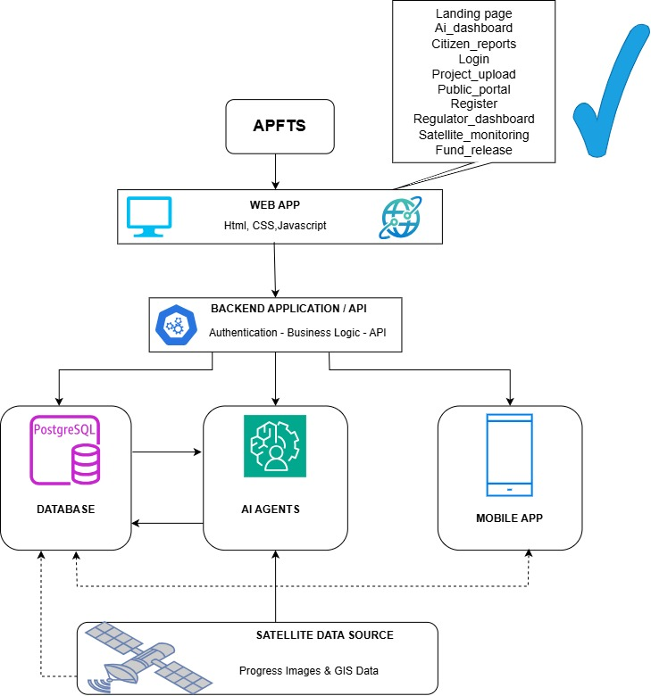

2.2.2 UI Design and Navigation Flow
The user journey moves from the public landing page through authentication into a role-specific dashboard:
- Landing Page → Login / Register
- Login validates role and redirects: Project Institution → Project Upload · Financing Institution → Fund Release · Regulatory Authority → Regulator Dashboard · Public → Public Portal
- Regulator Dashboard branches into AI Dashboard and Satellite Monitoring
- Fund Release also links into AI Dashboard and Satellite Monitoring
- Public Portal links into Citizen Reports

The interface follows a professional, information-dense style resembling a government operations centre:
- Navbar — logo, role-specific links, user info, and logout.
- Hero Section — full-width background with tagline, CTA buttons, and live stats.
- Dashboard Layout — two-column grid (sidebar with stats/alerts, main content with cards and tables).
- Glass-morphism Cards — semi-transparent backgrounds with blur effects.
- Data Tables — compact project lists with colour-coded risk badges.
- AI Chat Interface — embedded in the AI dashboard for natural-language queries.

2.2.3 Database Design (Conceptual ERD)
Status — Planned for a later iteration
The current prototype relies on hard-coded, in-memory JavaScript arrays rather than a persistent database. A future release would formalise entities such as Project, Institution, FundRelease, SatelliteRecord, and CitizenReport, linked by project_id and institution_id foreign keys, and implemented in a relational store (e.g., PostgreSQL) to support production-grade auditing.

Chapter 3 — Implementation

3.1 Introduction
The implementation phase translated the design into a working web prototype. We used HTML5, CSS3, and vanilla JavaScript, structuring the code into separate folders: css/, html/, javascript/, and icons/. All ten pages share a consistent header (navbar) and footer, with role-based access enforced via sessionStorage.
The system simulates:
- User authentication (login and registration)
- Role-based navigation and page blocking
- Project upload, fund release, and progress tracking
- AI risk scoring based on a simple heuristic
- Satellite image comparison with placeholders
- Citizen report submission with file upload simulation

3.2 Page-by-Page Description

3.2.1 Landing Page (index.html)
Access: Public
The landing page serves as the public face of APFTS. It features a full-width hero with a background image of infrastructure and a glass-morphism overlay. The hero communicates the system's mission, tagline, and key metrics (projects monitored, funds under oversight, anomaly rate). Below the hero, a dense dashboard shows a sidebar with the transparency index, recent anomalies, and satellite verification status, while the main area displays mission cards, real-time statistics, and a priority-projects table with colour-coded risk badges. A live news ticker simulates real-time alerts, and the page adapts its navigation to the logged-in user's role.

3.2.2 Login Page (login.html)
Access: Public
The login page uses a split-screen layout: the left panel showcases a professional image with a dark overlay, while the right panel holds the login form. The form includes a role selector, email, password, a 'remember device' checkbox, and a 'forgot password' link. The sign-in action reads the selected role, stores it in sessionStorage, and redirects the user to the appropriate dashboard.

3.2.3 Registration Page (register.html)
Access: Public
The registration page accommodates two categories of users: institutions (Financing, Project, Regulatory) and citizens/media. The institutional form captures entity type, region, legal name, email, and password. The citizen form captures name, role (Citizen, Journalist, or NGO Monitor), region, email, and password. Both forms store the chosen role and redirect to the login page, and the page includes a whistleblower-protection disclaimer.

3.2.4 Project Upload Page (project_upload.html)
Access: Project Institution only
Accessible only to Project Institutions, this page allows uploading a new infrastructure proposal. The main form captures project name, contractor, budget, GPS coordinates, timeline, and a milestone plan. An AI pre-analysis panel on the right shows a preliminary risk estimate, a progress bar, and a note that satellite baseline verification is pending, together with a recommendation to add quarterly fund-release gates.

3.2.5 Fund Release Page (fund_release.html)
Access: Financing Institution only
Restricted to Financing Institutions, this page provides a project selector, a tranche/phase selector, release amount input, payment details, and a 'process transaction' action. A 'progress vs financing' panel compares the expected completion (based on funds released) against satellite-estimated progress, highlighting discrepancies, and the page displays cumulative released funds across all projects.

3.2.6 AI Anomaly Dashboard (ai_dashboard.html)
Access: Regulatory Authority & Financing Institution
This page is the heart of the AI risk-scoring system. Projects are grouped into High, Medium, and Low risk cards, each carrying a numeric score and a short anomaly note (e.g., a satellite-versus-reported progress mismatch). Below the cards, a live anomaly feed lists timestamped AI detections — such as contract overruns or progress mismatches — together with a standing recommendation to increase audit frequency in higher-risk provinces.

3.2.7 Satellite Monitoring Page (satellite_monitoring.html)
Access: Regulatory Authority & Financing Institution
This page visualises satellite intelligence. Two panels display 'before' and 'after' imagery placeholders, a timeline slider simulates the observed progress percentage, and an AI analysis line notes any discrepancy between expected and satellite-derived progress. A geospatial summary panel shows coordinates, a completion estimate, and a terrain-change indicator, with a button to trigger simulated change detection.

3.2.8 Regulator Command Centre (regulator_dashboard.html)
Access: Regulatory Authority only
Exclusive to Regulatory Authorities, this page is designed as a national oversight command centre. Four KPI cards summarise active projects, monitored funds, active anomalies, and the national transparency index. A flagged-projects table lists the responsible institution, risk score, and a suggested action (such as suspending a funds review or scheduling an AI audit), alongside national indicators like procurement integrity and delivery lag.

3.2.9 Public Transparency Portal (public_portal.html)
Access: Public
Open to all, this page provides citizen-friendly project summaries with a region/name search bar. Project cards show budget, completion percentage, and funds used. A side panel displays national development indicators (completion average, funds accounted) and links through to the citizen-engagement reporting page.

3.2.10 Citizen Reports Page (citizen_reports.html)
Access: Public
Publicly accessible, this page enables civic engagement through three distinct forms — Citizen Report, Journalist Investigation, and NGO Monitoring — each with a description field and a file-upload option. A guidelines banner emphasises anonymity and legal protection, and a recent-reports strip shows that new testimonies trigger an AI cross-check.

Chapter 4 — Conclusion and Recommendations

4.1 State of the Implemented System
We have successfully developed a fully functional multi-page web prototype for APFTS, achieving approximately 90% of the stated objectives. The system:
- Implements role-based access control with four user types.
- Provides all ten required pages with consistent navigation and styling.
- Includes a simulated AI risk engine that compares reported versus satellite progress.
- Offers a satellite-monitoring interface with image placeholders and change-detection simulation.
- Enables citizen reporting through three distinct forms.

The remaining 10% includes integration with real satellite APIs, a persistent database, and production-ready authentication. These are beyond the scope of a static prototype but can be addressed in future iterations.

4.2 Recommendations

To the Lecturer
The project demonstrates practical application of HTML, CSS, and JavaScript for a complex, real-world scenario. We suggest evaluating the UI/UX design and role-based logic as key learning outcomes.

To the School
The time allocated for a full-stack implementation (with a real backend and APIs) is insufficient. We recommend extending the course duration or splitting the project into front-end and back-end modules.

To the Partners (Target Organisations)
This prototype can be adopted as a proof-of-concept for government transparency initiatives. We recommend piloting it with a small set of projects to gather user feedback before scaling.

To the Users (Project Institutions, Financiers, Regulators)
Training sessions on using the dashboards and interpreting AI risk scores will be essential for effective adoption. We suggest developing short video tutorials and quick-start guides.

To the Beneficiaries (Citizens, Media)
The public portal and reporting tools empower citizens to participate in governance. We recommend public-awareness campaigns to encourage use of the platform.

Appendix — GitHub Repository
Repository Link:
https://github.com/Hacker-Eagle1/APFTS_Prototype
Access: Public. The repository contains all HTML, CSS, JavaScript, and icons, along with a README file explaining the project structure and how to run it locally.

End of Report

