Table of Contents
Definitions, generalizations and abbreviations 2
Introduction 4
1. Description of the subject area 5
1.1. Problem analysis 5
1.2. Activity Diagram: 6
1.2. Functional requirements 9
1.3. Non-functional requirements 12
1.4 System Tech Stack 13
2. Software design 14
2.1. Deployment Diagram: 14
2.2. System architecture 16
2.3. Program architecture 19
2.4. Data architecture 22
3. Implementation and testing 24
3.1.Software architecture 24
3.2. Development 35
3.3. Implementation of the user interface 37
Conclusion 45
List of used literature 46

Definitions, generalizations and abbreviations
ERP: ERP stands for Enterprise Resource Planning. It is a type of software system used by organizations to manage day-to-day business activities such as accounting, procurement, project management, risk management, compliance, and supply chain operations.
POS: The POS system is the place where sales are made. In a retail setting, it's the system used to complete customer purchases, process payments, and record transactions.
Inventory: Inventory refers to the goods and materials a business holds for the purpose of resale or production. Inventory management ensures the right products are in the right quantity at the right time.
API: API (Application Programming Interface) is a set of rules and protocols that allow different software applications to communicate with each other. APIs define how requests and responses should be structured so systems can exchange data in a standard way.
REST API: A REST API (Representational State Transfer) is a type of API that uses HTTP methods (GET, POST, PUT, DELETE) for interacting with resources. Django REST Framework (DRF) is a powerful and flexible toolkit built on Django to create RESTful APIs.
Django REST Framework: Django, a high-level Python web framework, is used to develop API for the Inventory & Sales Management. It provides essential tools, libraries, and pre-built structures to simplify the creation of dynamic, secure, and scalable web applications.
ORM: Django's built-in Object-Relational Mapping (ORM) is used to handle database interactions for the application. The ORM maps Python objects to database tables, allowing developers to work with database records using Python code instead of raw SQL queries.

Introduction
Sales & Inventory Management System is a comprehensive and user-friendly enterprise application developed as part of a thesis project, combining the power of Django REST Framework, ReactJS, PostgreSQL to deliver a scalable and efficient solution for modern businesses. The frontend is designed with Ant Design, offering an intuitive and elegant user experience, while the backend is powered by robust RESTful APIs that ensure fast and secure data handling. This system is designed to simplify the end-to-end process of managing inventory and sales activities in small to medium-sized businesses. It enables users to manage product attributes, categorize products, and track their stock across various storage locations. Through a centralized dashboard, users can add new inventory items, update existing stock, and monitor inventory movements in real-time. A key feature of the system is its invoicing module, which allows users to generate sales invoices dynamically by adding selected products to the cart, applying discounts, calculating taxes, and tracking payment statuses. The application ensures data consistency and accuracy across all modules using asynchronous communication between services and a modular microservice structure that supports easy maintenance and scalability. This project explores not only the technical implementation of a distributed ERP system but also the practical aspects of streamlining business processes like procurement, inventory control, and sales order management through a digital platform.

1. Description of the subject area

1.1. Problem analysis
In many small and medium-sized enterprises (SMEs), managing sales and inventory remains a significant challenge due to the lack of an integrated, automated system. Businesses often rely on manual record-keeping, spreadsheets, or disconnected software applications, which leads to issues such as stock mismanagement, data inconsistency, delayed decision-making, and human error. The absence of real-time visibility into stock levels and sales data often results in lost sales opportunities, overstocking, or understocking, all of which affect profitability and operational efficiency.
Furthermore, existing ERP solutions in the market are often complex, expensive, or overly generalized, making them unsuitable or inaccessible for smaller businesses with specific, localized needs. There is a clear gap in the availability of lightweight, customizable, and cost-effective ERP systems tailored for managing inventory and sales workflows in smaller business environments.
This thesis addresses the problem by designing and developing a web-based Sales & Inventory Management System built on Django REST Framework and ReactJS. The goal is to provide a user-friendly, modular, and scalable solution that streamlines core business processes such as product tracking, inventory control, invoicing, and reporting.
This Inventory & Sales management system is mainly targeted for Lifestyle type businesses, for example, the clothing industry, fashion industry, supershop, food chain, ornaments, tech shops.
Industries are growing day by day, so they want their products to be in a managed system where they can store their information. Also, the customers want to get their item as soon as possible. They want a quick sell out service. So automation is necessary. That's where this POS system comes in handy.

1.2. Activity Diagram:
User Authentication:
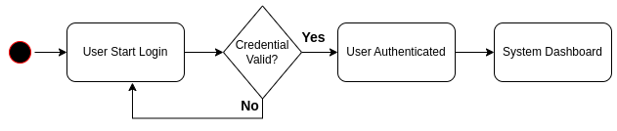
Figure 1. User authentication action diagram
Figure 1 illustrates the user authentication process.This diagram visually represents the sequence of actions and decision points that occur when a user attempts to log in to the system.
The process begins when a user initiates the login procedure.Once the login process is started, the system prompts the user to enter their credentials (typically a username and password). The process then moves to a decision point labeled "Credential Valid?", where the system checks the validity of the provided credentials. If credentials are valid, the user gets access, if not, it will give the user to correct the credentials, if still not valid, it won’t allow the access.

Inventory Module:
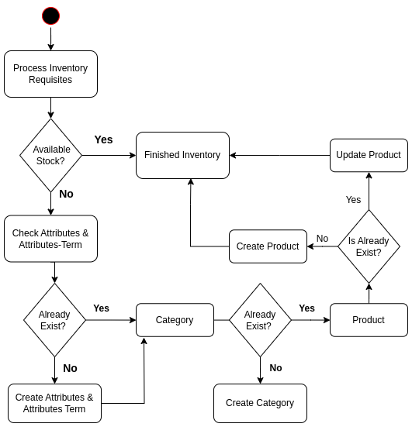
Figure 2. Inventory module diagram

The inventory module diagram (Figure 2) demonstrates the workflow for managing inventory within the Sales and Inventory Management System. The process begins with handling inventory requisites and checking for available stock. If stock is available, the inventory is marked as finished; otherwise, the system checks product attributes and terms. If the required attributes do not exist, they are created before proceeding. The workflow also includes verifying and creating categories and products as needed, ensuring that duplicate entries are avoided. When a product already exists, it is updated; otherwise, a new product is created and associated with the appropriate category. This structured approach ensures efficient inventory tracking, prevents redundancy, and maintains data integrity throughout the inventory management process.

Sales Module:

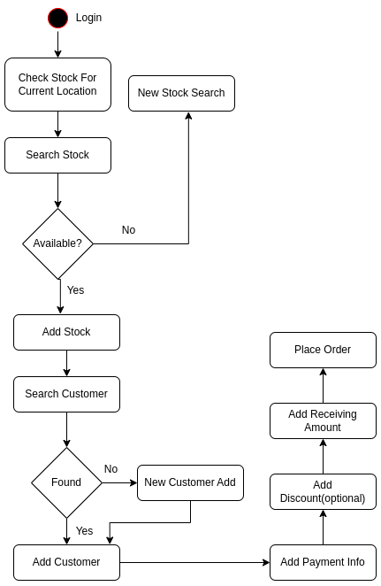
Figure 3. User authentication action diagram

The sales module action diagram (Figure 3) depicts the step-by-step workflow for processing a sales transaction in the system. The process begins with user login, followed by checking stock availability at the current location. If the desired stock is available, it is added to the transaction; if not, a new stock search is initiated. Next, the system searches for the customer-if the customer is not found, a new customer record is created. Once the customer is added, payment information is entered, with options to include discounts. The transaction concludes with the addition of the received amount and the final placement of the order. This structured flow ensures that each sales transaction is accurately processed, linking inventory, customer data, and payment details for efficient and reliable sales management.

1.2. Functional requirements
In this Inventory & Sales Management System, the main actors are Admin and Sales Person. They are the ones who manage the system, put up stocks and sell them to customers offline. Here customers may be a part of actors if the sales occur online but as the system is managed for offline businesses, the customers are out of the actor area.
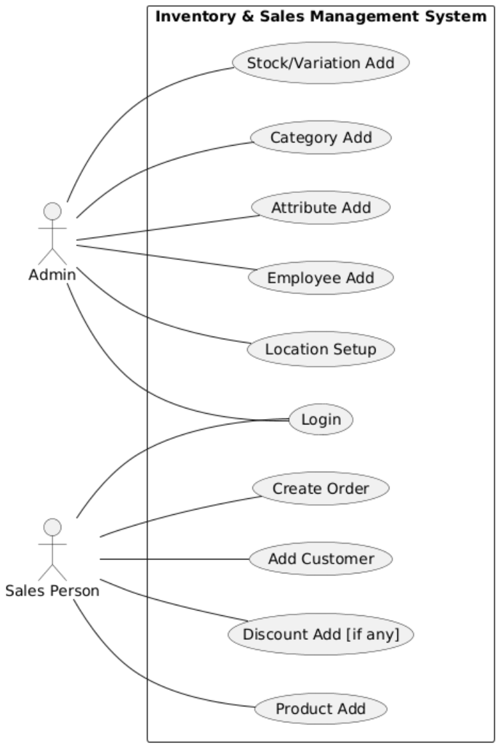
Figure 4: Use Case Diagram for Inventory & Sales Management System

Here Admin login to the system and he/she will set up the entire software with location/outlet and employee/user adding for the software. Admin will have entire access to the software where he/she can set up Attribute, Attribute Term, Category, and variation-wise Product.
Then, the sales person can login and he will have privileges of the Sales Panel. Here he will go to the POS system and there he will add products, give discounts, add customers then he will create the order. In the meantime, calculation of the invoice will be done as well.
From this description and from further discussions with customers following functional requirements were identified:
- User/Employee Creation: In the software, users can be created by adding Department, Designation and then assigning those department & designation to the new created Employee. The user will have specific privileges to the assigned system
- Attributes for Inventory: The inventory may consist of attributes/variations that should be added before. For our system, color, size, fabrics, materials etc. can be added for the system for lifestyle businesses. The attribute terms consist of the specific attribute.
- Category Of Inventory: The category makes the inventory more appropriate. The product or item will be under a category. Multiple categories can be created with a parent child system to showcase more sub categories.
- Product: This is the main part of an Inventory. When creating a new product, some items must be input: Category of the product, Purchase price, Selling Price, Location of entry, supplier etc. If the product has variation like color/size, the quantity is added for that variation. After adding a product, the barcode is auto created and can be printed as well.
- Sales Panel/POS: The sales person has the access to this panel where the product is sold to customers. Here in POS, some input is a must, like, location of sales panel, Customer information, product variation available on that location, discount(if givable) and payment info. After that the salesperson can work on an Exchange product and update any order that is placed.
- Customer Record: Customer info is added when a product is sold. For any customer related issue or checking all purchases of a customer, customer panel can be used to check them out and download excel details of them.
- Reporting Panel: In the Reporting Module, all the reports of the system can be viewed. Here we have an All Product Entry Report where all product entries with their info are added with date time. There is also a Stock Report where all available stocks can be viewed with category and location. There is also a Sales Report where all sales records, invoices and outlet/location wise records are stored. Then finally Sold Product Report where the sold record is shown with customer info, product variation sold, sold price etc.

1.3. Non-functional requirements
Performance:
- The system should handle up to 10,000 inventory records without significant performance degradation.
- Load reports within 5-10 seconds for up to 1,000 transactions.
Scalability:
The system should support the addition of new locations, product categories, and modules without major architectural changes.
Security:
- Role-based access control to restrict access to specific modules and data.
- Secure sensitive data (e.g., customer details, supplier information) using encryption.
Maintainability:
- Modular code structure to allow independent updates to specific features (e.g., inventory, sales).
- Documentation for APIs, database schemas, and user manuals.
Interoperability:
Export data in standard formats (e.g., Excel, PDF) for external reporting tools.
Data Integrity:
Prevent duplication or loss of data during stock transfers, payments, and updates.

1.4 System Tech Stack
This Web Application System is designed to work from any browser. It is an online system so it is easily accessed and updated.
- Frontend Development: ReactJS;
- Deployment: Vercel , Railway;
- Frontend UI Framework: Ant Design;
- Backend API Development: Django Rest Framework;
- Database: PostgreSQL;
- Codebase: GitHub.

2. Software design

2.1. Deployment Diagram:
Here the diagram represents deployment with microservice architecture. Client server communicates with application server. The application server sends API requests to the database. The database then sends the response to the application server which is then sent back to the client server. Initial user data is stored in the Redux store.
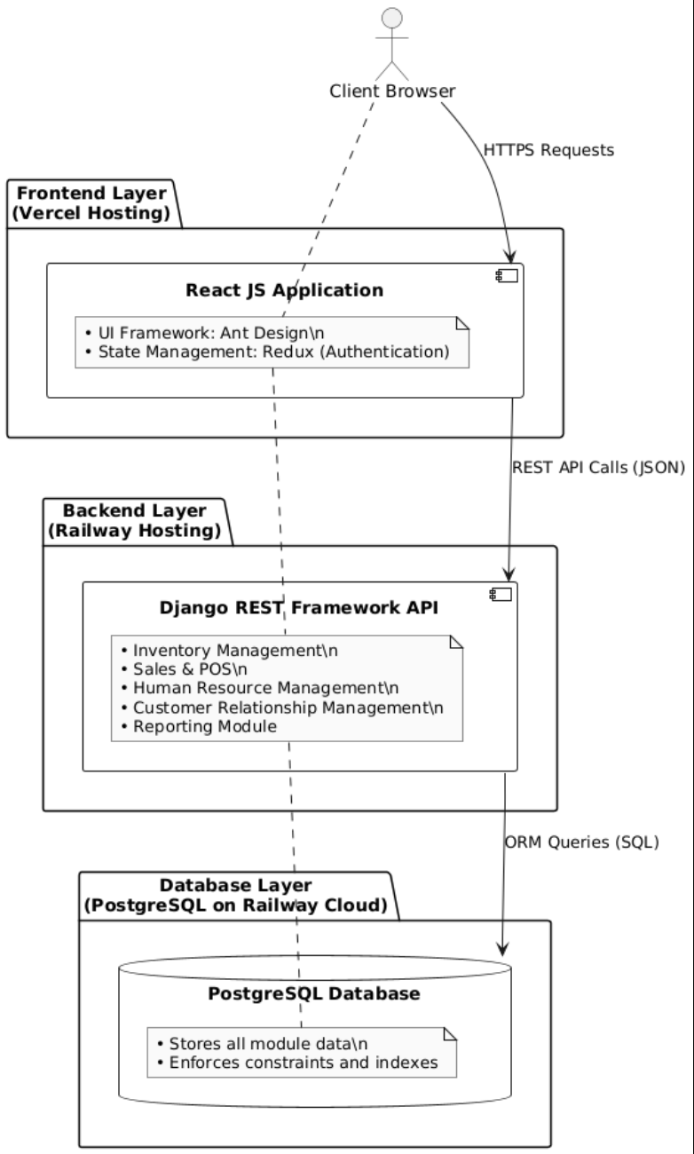
Figure 5. Deployment diagram
The deployment diagram shown in Figure 5 shows a detailed three-tier microservice setup that helps client browsers connect with the app's data layer. This design is a modern way to build systems, focusing on keeping things separate, being able to grow, and making it easier to maintain.
Architectural Layers:
Frontend Layer (Vercel Hosting):
The frontend layer is hosted on Vercel, a cloud service designed for deploying static sites and serverless functions. This layer includes:
- React JS Application: This is the main framework used on the client side.
- Ant Design: This is the UI component library that ensures a uniform look and feel across the interface.
- Redux: This is used for managing authentication states, keeping track of initial user data, and maintaining sessioninfo throughout the app.
The front end serves as the presentation layer,handling user interactions and displaying data in a cohesive interface.When users interact with the application, their browser sends HTTPS requests to this layer, which then processes these requests within the React ecosystem.

Backend Layer (Railway Hosting)
The backend layer, hosted on Railway. It includes the Django REST Framework API that acts as the core logic .It consists of different microservices like: Inventory Management for tracking products and stock, Sales & POS for handling transactions, Human Resource Management for managing employee info, Customer Relationship Management for keeping customer data, and a Reporting Module for generating analytics. These microservices work separately but can connect when necessary, showcasing the microservice architecture. This setup enables modular development, allows each service to scale independently, and offers flexibility in technology choices.

The database layer(PostgreSQL on Railway Cloud):
The database layer utilizes PostgreSQL hosted on Railway Cloud infrastructure. It stores all module data,maintaining persistent information for all microservices. It also ensures query optimization and data integrity.

Communication flow:
Users interact with the system through their browsers, sending HTTPS requests to the frontend layer hosted on Vercel. The React application processes user interactions and, when data is needed, makes REST API calls using JSON format to the appropriate microservice in the backend layer.Then request is processed by the Django REST Framework applies business logic, and uses its ORM to translate application requests into SQL queries to send it to our database.
Retrieved data flows back in same process but in reverse form database to backend via ORM responses, then from backend to frontend via JSON responses, and finally presented to the user through the React interface.
User login information is kept in the Redux store on the front end, which reduces the number of times we have to ask the backend for authentication.

2.2. System architecture
If the user is authenticated, he will be in the dashboard. The Dashboard consists of 3 panels, Customer, Product & Sales. For each module, the user can create the necessary parts, like with product modules, he/she can add attributes, attribute terms, category, variations etc. For the Sales portion, there is a POS system where billing is created.

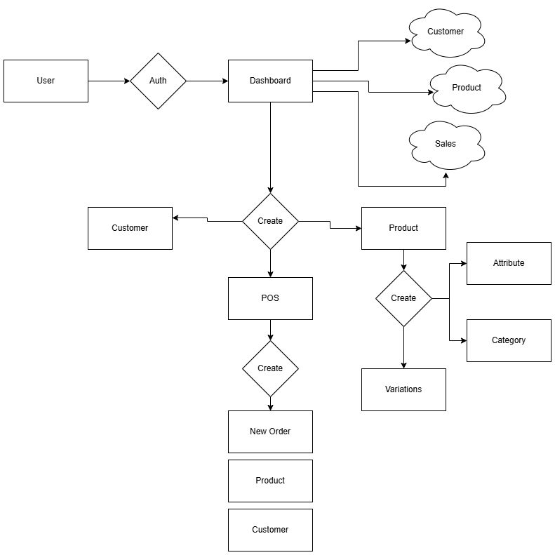
Figure 6. System architecture of the application
Component Descriptions:
1. User and Authentication
- User: Any interaction begins with the user.
- Auth: Before accessing the application, the user must be authenticated. This ensures security and restricts access to authorized individuals only.
2. Dashboard
- Once authenticated, the user is directed to the Dashboard, which serves as the main navigation hub.
- The dashboard provides access to three primary panels: Customer, Product, and Sales.
3. Module Panels
- Customer Panel:Allows users to manage customer information. Users can create, view, or update customer records.
- Product Panel:Enables management of products, including the creation of product attributes (e.g., color, size), categories (e.g., electronics, apparel), and variations .
- Sales Panel:Provides access to sales functionalities, primarily through the Point of Sale (POS) system.
4. Creation Flows
- From the dashboard, users can initiate the creation of new entities in both the Customer and Product modules.
- In the Product module, the creation process can further branch into adding Attributes, Categories, or Variations, supporting a flexible and detailed product catalog.
5. POS (Point of Sale) System
- The POS module is central to the sales process.
- Users can create new sales transactions, which involve selecting products and customers.
- The POS system then assist the creation of a New Order, associating it with the relevant products and customers.

6. Order Management
- After a sale is processed through the POS, the system records a New Order.
- Each order is linked to both the product(s) sold and the customer who made the purchase, maintaining a clear and auditable sales history.
Data Flow and Interactions:
The logical flow:
- User → Auth → Dashboard → (Customer/Product/Sales) → Create → POS → Create Order
- Each module is interconnected, allowing for seamless transitions between managing customers, products, and sales.
- The creation processes are modular, adding new features or entities can be added without disrupting the overall architecture.

This system architecture ensures a user-friendly and secure environment for managing customers, products, and sales. The modular design supports scalability and maintainability, making it suitable for businesses that want to improve their processes and adjust to changing needs.

2.3. Program architecture
Architecture Scheme:
Here is the Relation of ORM & REST API. There is the Postgresql database relation of each other in the schema.
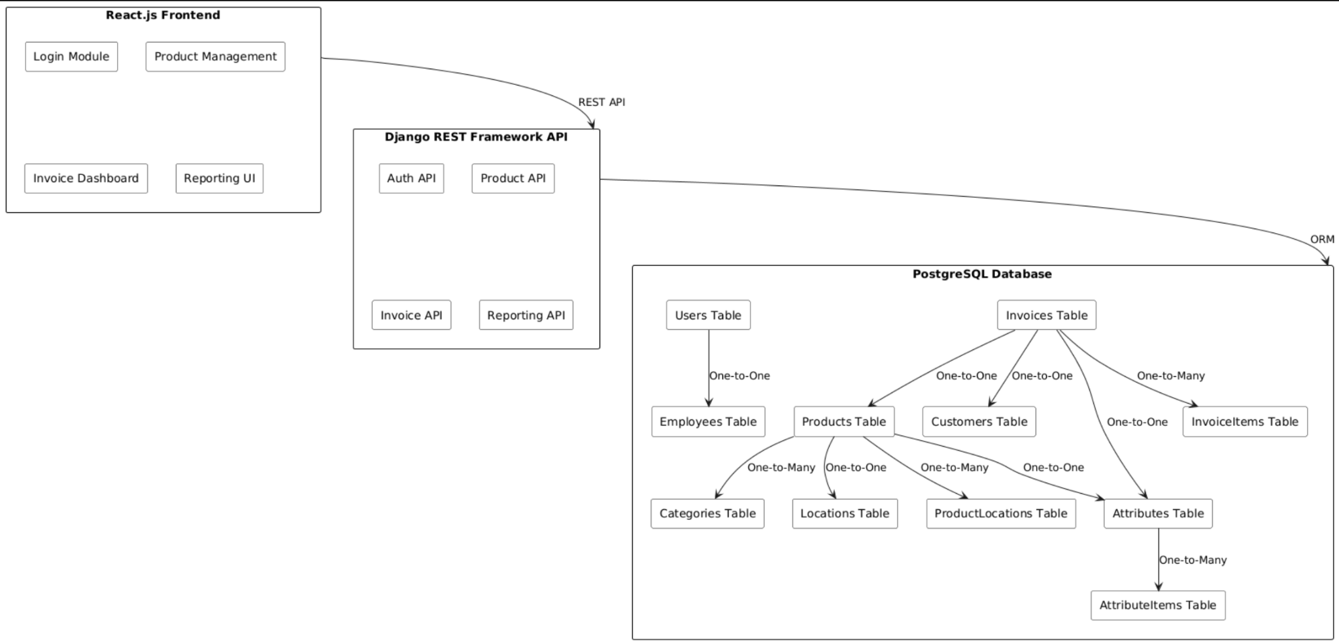
Figure 7. Program Architecture Overview
- Frontend Layer: React.js has several Modules.
  - Login Module: Handles user authentication and access.
  - Product Management: Interface for managing product data.
  - Invoice Dashboard: Shows invoice information and related actions.
  - Reporting UI: Presents logical and reporting features.
The frontend interacts with the backend exclusively via REST APIs, ensuring a clean separation between client-side logic and server-side data processing.
2. Backend Layer: Django REST Framework API
  - Auth API: Manages authentication, user sessions, and access grants..
  - Product API: Handles CRUD operations for product-related data.
  - Invoice API: Manages invoice creation, retrieval, and updates.
  - Reporting API: Provides endpoints for generating and retrieving reports.
This layer acts as an intermediary, handling client requests, executing business logic, and interacting with the database via an ORM.
3. Database Layer: PostgreSQL
The database is very organized and relational, which helps to meet complicated business needs.
4. Integration: ORM and REST API
- ORM (Object-Relational Mapper):
  - Django’s ORM makes it easier to work with the database layer, allowing developers to interact with the database using Python objects instead of raw SQL.
  - This simplifies querying, updating, and managing complex relationships between tables.
- REST API:
  - The Django REST Framework makes database resources and business logic available through RESTful endpoints..
  - The API layer receives HTTP requests from the frontend, processes them (including validation and authentication), and communicates with the ORM to perform database operations.
  - Responses are serialized into JSON and sent back to the frontend.
Data Flow Example: A user logs in via the React.js frontend.The frontend sends a POST request to the Auth API.The Auth API validates credentials, uses the ORM to fetch user data from the Users table, and returns a session token. All further interactions (e.g., fetching products, creating invoices) follow a similar pattern: the frontend calls the appropriate REST endpoint, which interacts with the ORM and database, and returns results.

Conclusion:This architecture ensures:
- Separation of concerns: Each layer handles a distinct responsibility.
- Scalability: Modular design allows for independent scaling of frontend, API, and database.
- Maintainability: ORM and REST APIs abstract complexity, making the system easier to extend and maintain.
- Security: Authentication and authorization are centralized in the backend.
This design is suitable for enterprise applications requiring robust data integrity, flexible reporting, and a responsive user interface.

2.4. Data architecture
Schema Diagram:
The schema diagram in Figure 8 presents the relational structure of the database. It illustrates how key entities-including Customer,Category,, Invoice, Attribute, and others-are organized and interconnected.Each table contains fields relevant to its domain (such as product pricing, customer contact information, invoice details and so on) and uses foreign key relationships to maintain data integrity and ensure efficient querying.

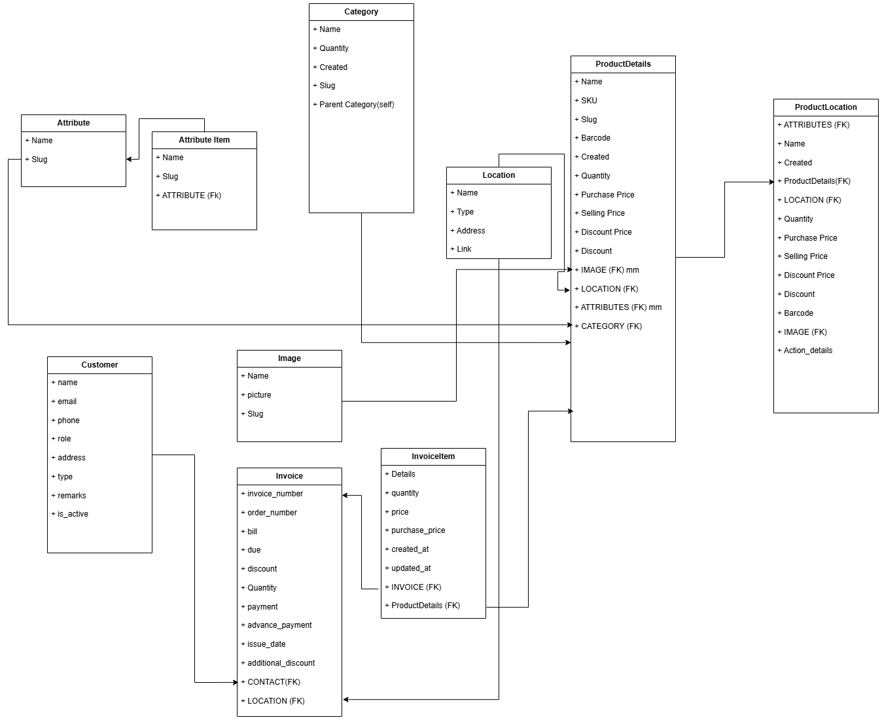
Figure 8. Schema of database tables
Relation:

- Attribute - AttributeItem: One-to-Many
- ProductDetails - AttributeItem: One-to-Many
- ProductDetails - Category: One-to-One
- ProductDetails - Location: One-to-One
- ProductDetails - ProductLocation: One-to-Many
- Invoice - InvoiceItem: One-to-Many
- InvoiceItem - ProductLocation: One-to-One
- Invoice - InvoiceItem: One-to-Many
- Invoice - Location: One-to-One
- Invoice - Customer: One-to-One

3. Implementation and testing

3.1.Software architecture
Frontend: As our frontend part progress we can see in screenshot frontend source code for a Sales & Inventory Management System, within the src components directory of a project named POS- Frontend where related functionalities are grouped into folders for maintainability and clarity.

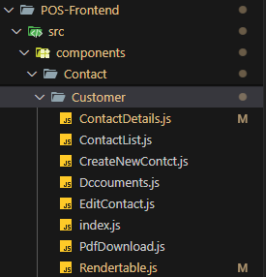
Main components :
Contact/ Customer: This folder contains customer management related components, such as:
- Viewing and editing customer contact details (ContactDetails.js, EditContact.js)
- Creating new contacts (CreateNewContct.js)
- Handling customer documents (Documents.js)
- Downloading PDFs (PdfDownload.js)
- Rendering tables of customer data (RenderTable.js)
- Centralized index file (index.js)
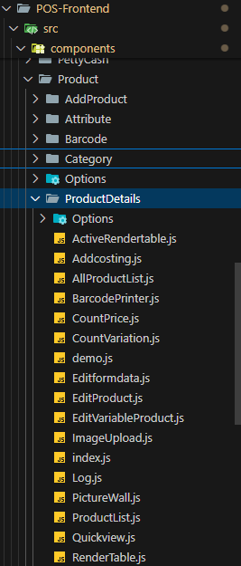

Product: This part manages product related features.
- AddProduct, Attribute, Barcode, Category, Options: Each subfolder likely contains components for adding products, managing product attributes, handling barcodes, categorizing products, and configuring product options.
- ProductDetails: Contains detailed product management components, such as:
- Listing all products (AllProductList .js)
- Editing product details (EditProduct.js, EditVariableProduct.js)
- Uploading images (ImageUpload.js)
- Managing product pricing and variations (CountPrice.js, CountVariation.js)
- Rendering product data (RenderTable.js)
- Additional utilities like product logs, quick views, and demo files

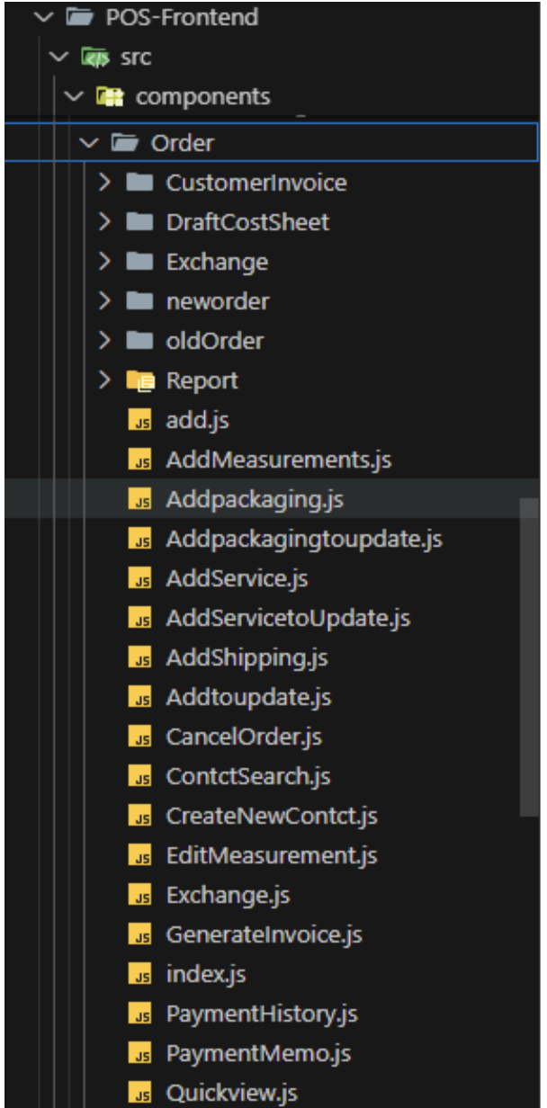
Order:This folder manages order related activity:

- Customer Invoice, Draft Cost Sheet, Exchange, new Order, old Order, Report: Components for handling invoices, cost sheets, order exchanges, and both new and old orders.
- Report: Scripts for generating and managing various order-related reports and actions, such as:
- Adding and updating packaging, services, shipping, and measurements
- Cancelling orders (CancelOrder.js)
- Creating and editing contacts and measurements
- Generating invoices (GenerateInvoice.js)
- Viewing payment history and memory
- Quick view functionality for rapid access to order data
Backend:

The backend source code for the Sales & Inventory Management System website, implemented using the Django web framework. This structure demonstrates a modular approach, where each core business domain is encapsulated within its own directory under the main project folder (POS-Backend).

Main Project Folder:
settings.py: Main library for project configuration. All middleware, environment setup, installed app are configured here.
env: environment file for database, secret key. It is kept hidden for security.
urls.py: main routing file where admin routes and app routes are declared.
asgi.py/wsgi.py: These are entry-point files used to serve your application. They are interfaces between your Django code and the web server.

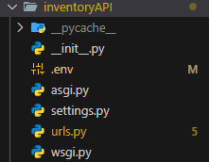

Purpose and Organization
Each domain-specific folder contains the following key files and subfolders:
__pycache__/: It is generated by Python automatically to store compiled bytecode to improve performance.
migrations/: Migration includes scripts that track and apply changes to the database schema, protecting data consistency as the system evolves.
__init__.py: Label the directory as a Python package, allowing for modular imports and code organization.
admin.py: Facilitates the registration of models within Django's integrated administrative interface, allowing website administrators to oversee data via a visual dashboard.
apps.py : Contains configuration for each functional area to help Django recognize and integrate into the overall project.
models.py : Establishes data structures for each area, such as products and orders, that are necessary for inventory and sales management.
permissions.py : (in the product): To ensure that only authorized users can perform certain actions, such as editing products user-defined access control logic is implemented.
serializers.py: It facilitates the conversion of complex data types (for example, model instances) to JSON format and back, ensuring uninterrupted communication between the server side and the website interface using the RESTful API.
signals.py : Contains event-driven logic that responds to changes in the database, for example, updates inventory data when a new order is placed.
tests.py To verify the correctness and reliability of the internal logic automated tests are provided, increasing the reliability of the website.
urls.py : Maps URL templates to view specific functions or classes, defining API endpoints through which the interface interacts with the backend.
views.py : This component performs the fundamental business logic needed to process HTTP requests and formulate responses, including creating new orders and listing available products.
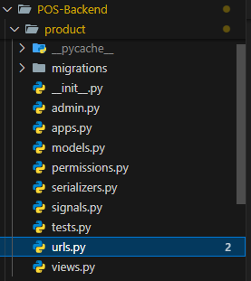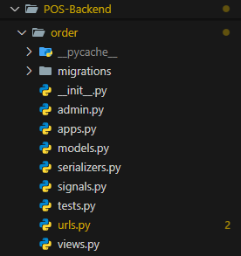

Product module:

models.py
The following models.py consist of Django ORM (Object-Relational Mapping). Here Classes are defined to represent database tables. Attribute is related to AttributeTerm with a foreign key. Category and attribute is foreign key to ProductDetails class. ProductDetails represents the main product. The Product details has price, discount quantity and others field that offers different features. In django there are serializers.py and views.py which are used for serializing data in json and representing them. The urls.py here represents the routing of each API.

class Attribute(models.Model):
"""Database model for Attribute"""
name = models.CharField(max_length=255)
slug = models.CharField(max_length=255, null=True, blank=True)
context = models.CharField(max_length=255, blank=True, null=True)
data = JSONField(null=True, blank=True)
class AttributeTerm(models.Model):
"""Database model for AttributeTerm"""
Attribute = models.ForeignKey(Attribute, on_delete=models.CASCADE)
name = models.CharField(max_length=255)
slug = models.CharField(max_length=255, null=True, blank=True)
context = models.CharField(max_length=255, blank=True, null=True)
data = JSONField(null=True, blank=True)
class Category(models.Model):
"""Database model for Category"""
Category_parent = models.ForeignKey('self',
on_delete=models.SET_NULL,
null=True,
blank=True)
name = models.CharField(max_length=255)
slug = models.CharField(max_length=255, unique=True, null=True, blank=True)
data = JSONField(null=True, blank=True)

urls.py:
router = DefaultRouter()
router.register('attribute', views.AttributeView)
router.register('term', views.AttributeTermView)
router.register('category', views.CategoryView)
# fetch product category wise
router.register('categoryProduct', views.CategoryProductView)
router.register('updatecategory', views.CategoryUpdateView)

# fetch parent product
router.register('singpleproduct', views.SingleProductView)
router.register('productwithalldetails', views.Productwithalldetails)
# fetch product details
router.register('Details', views.ProductdetailsView)
# create and update single product
router.register('DetailsUpdate', views.ProductdetailsUpdateView)
router.register('productentryledger', views.ProductLocationEntryView)
router.register('DetailsUpdateCustom', views.ProductdetailsUpdateCustomView)
router.register('product', views.ProductView) # create bulk product
# router.register('warehouse', views.warehouseView)
# router.register('treewarehouse', views.treewarehouseView)

router.register("image", views.ProductImageView)
router.register('transfer', views.TransferViewSet)
router.register('transferP', views.TransferPViewSet)
router.register('transferitem', views.TransferItemViewSet)
router.register('BarcodePrintList', views.BarcodePrintListViewSet)

Module name | Class name | Class Assignment
Product | Attribute | Model
Product | AttributeItem | Model
Product | Category | Model
Product | ProductDetails | Model
Product | ProductLocation | Model
Product | Location | Model

Table 1. Relations of modules and classes

Class name | Class description
Attribute | Product attribute
AttributeItem | Attribute variations
Category | Parent Category & Child category
ProductDetails | Main Product
ProductLocation | Variations of product
Location | Location of product
Table 2. Description of classes

Order module:

models.py:
This is the sales ORM Class where sales data is stored. The product that is added using barcode will be added here with pricing calculation. Customer field is foreign key with a customer table. Salesperson foreign key is from Employee table. Coupons are added for a discount. Payment amount, receive amount and total amount field represents sales payment info.
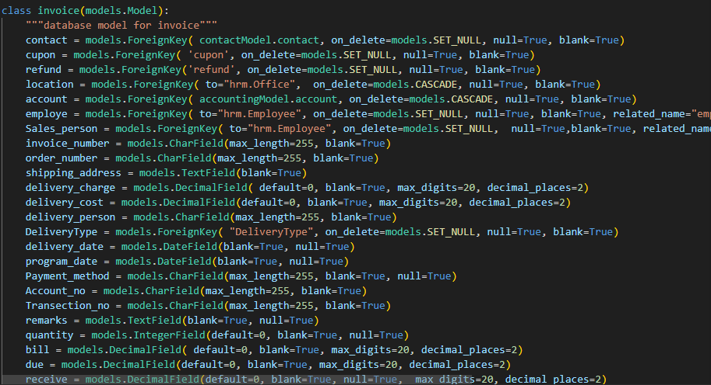
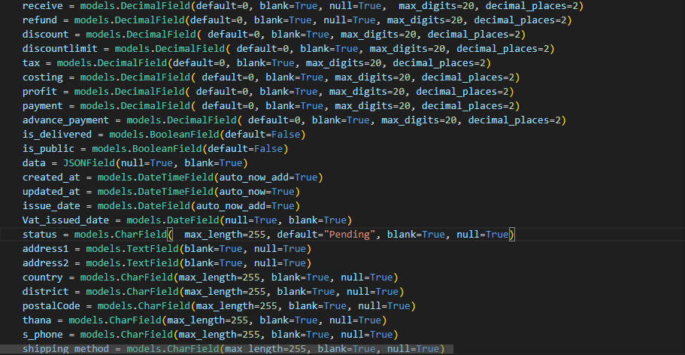

urls.py:
router = DefaultRouter()
router.register('invoices', views.InvoiceViewSet)
router.register('invoicesP', views.InvoiceViewSetP)
router.register('items', views.InvoiceItemViewSet)
router.register('items-copy', views.InvoiceItemCopyViewSet)
router.register('invoicepayments', views.InvoicePayementViewSet)
router.register('solditems', views.SoldProductsViewSet)
router.register('cupon', views.CuponViewSet)
router.register('vat', views.InvoiceVatViewSet)

Module name | Class name | Class Assignment
order | invoice | Model
order | invoiceItem | Model
Table 3. Relations of modules and classes

Class name | Class description
invoice | Invoice Creation
invoiceItem | all Items of the invoice based on variation
Table 4. Description of classes

3.2. Development
Backend API Routes:

Order Module:
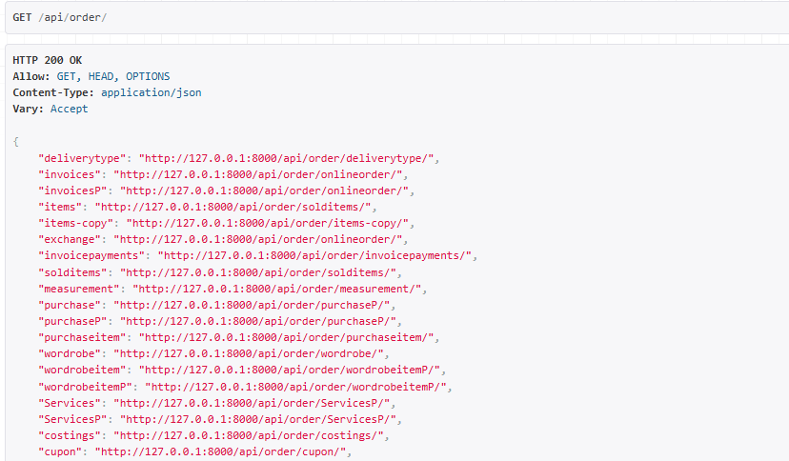
{
"invoices": "http://127.0.0.1:8000/api/order/onlineorder/",
"invoicesP": "http://127.0.0.1:8000/api/order/onlineorder/",
"items": "http://127.0.0.1:8000/api/order/solditems/",
"items-copy": "http://127.0.0.1:8000/api/order/items-copy/",
"invoicepayments": "http://127.0.0.1:8000/api/order/invoicepayments/",
"solditems": "http://127.0.0.1:8000/api/order/solditems/",
"cupon": "http://127.0.0.1:8000/api/order/cupon/",
"delivery": "http://127.0.0.1:8000/api/order/onlineorder/",
"vat": "http://127.0.0.1:8000/api/order/onlineorder/",
"onlineorder": "http://127.0.0.1:8000/api/order/onlineorder/"
}

Inventory Module:
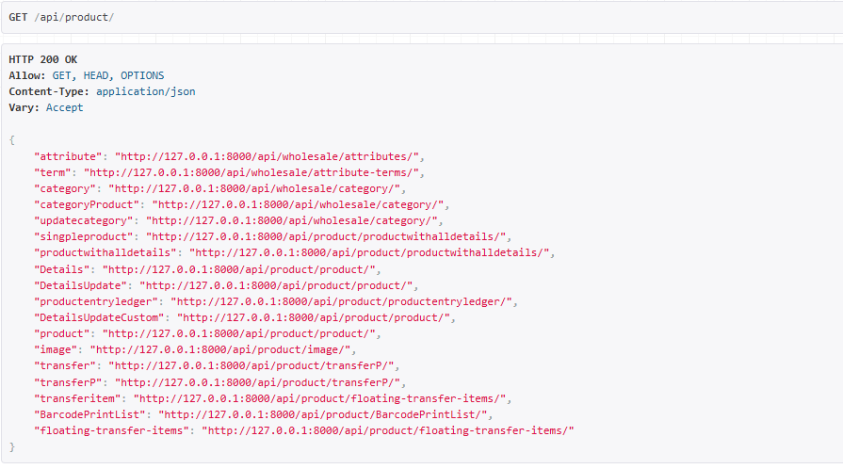
{
"attribute": "http://127.0.0.1:8000/api/product/attribute/",
"term": "http://127.0.0.1:8000/api/product/term/",
"category": "http://127.0.0.1:8000/api/product/updatecategory/",
"categoryProduct": "http://127.0.0.1:8000/api/product/updatecategory/",
"updatecategory": "http://127.0.0.1:8000/api/product/updatecategory/",
"singpleproduct": "http://127.0.0.1:8000/api/product/productwithalldetails/",
"productwithalldetails": "http://127.0.0.1:8000/api/product/productwithalldetails/",
"Details": "http://127.0.0.1:8000/api/product/product/",
"DetailsUpdate": "http://127.0.0.1:8000/api/product/product/",
"productentryledger": "http://127.0.0.1:8000/api/product/productentryledger/",
"DetailsUpdateCustom": "http://127.0.0.1:8000/api/product/product/",
"product": "http://127.0.0.1:8000/api/product/product/",
}

3.3. Implementation of the user interface
Dashboard:
This is the dashboard after login.
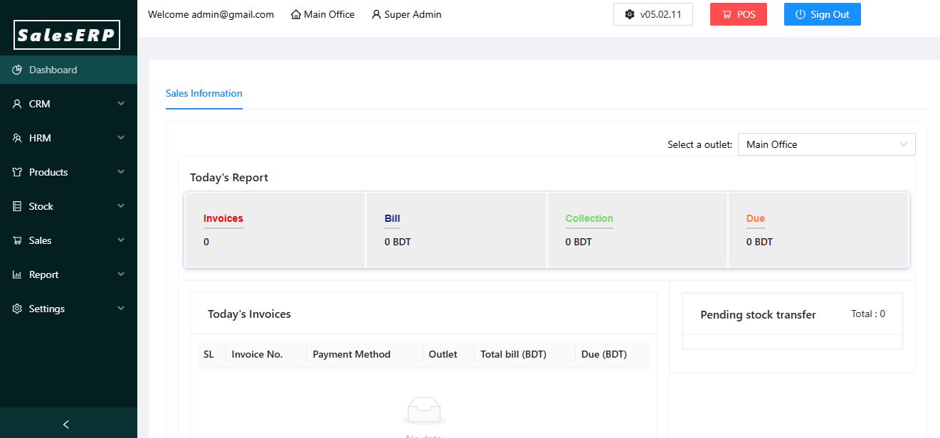

Attribute:
It is under the Product Module. Here attribute can be added and after creating attributes, their attribute terms can be added as well.

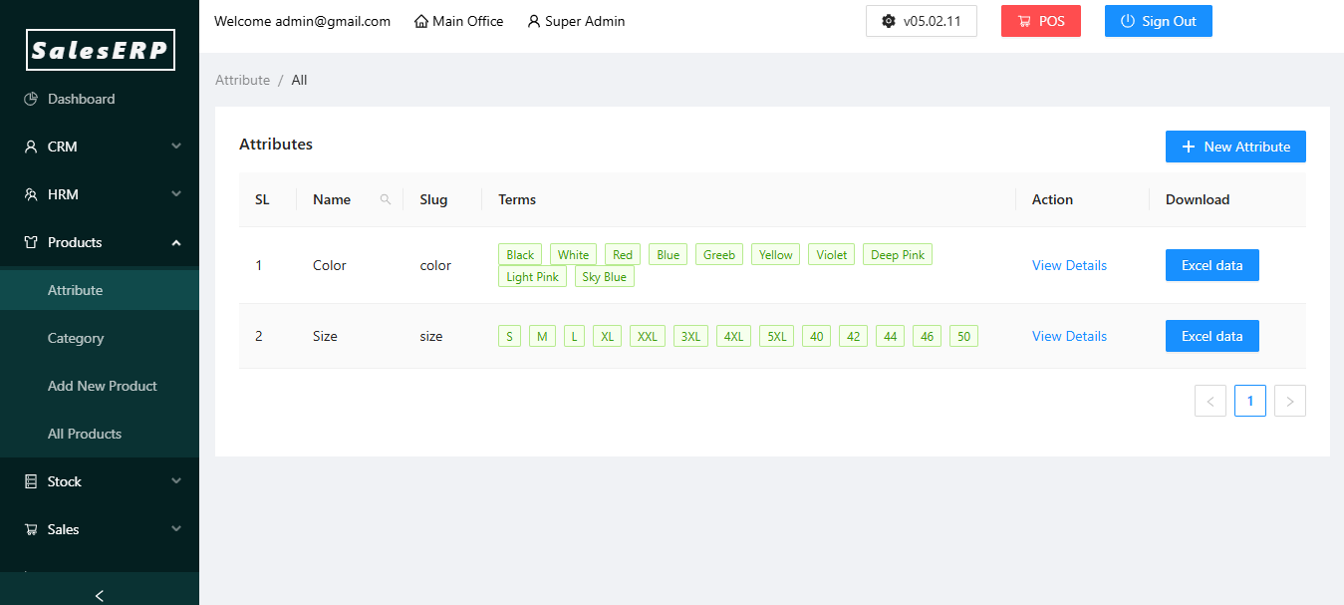
Category:
In this sub module of Product, Category can be added. Also if the category has a parent attribute, that can be added as well. that way the child category will be under the parent category attribute
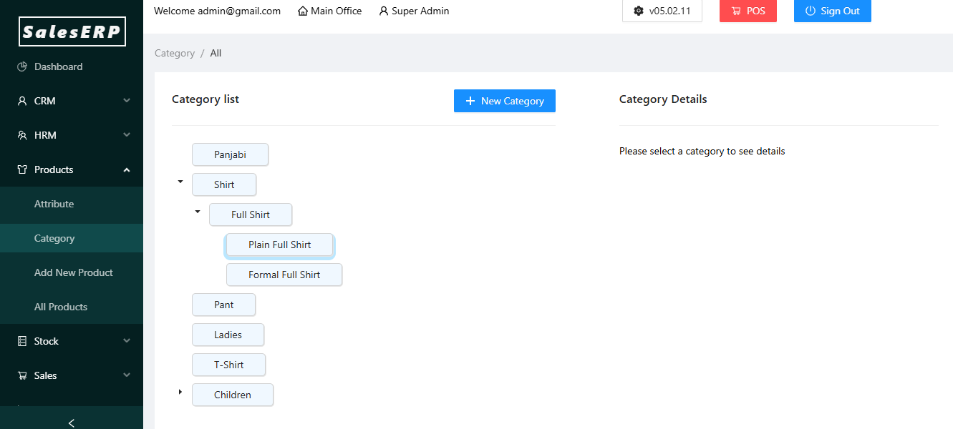

Product:
This is the main submodule for adding stock. Here, A product is added with their attribute wise variation like color/size/quantity. Also the product has its category, location for the stock, costing of it and the unique code.

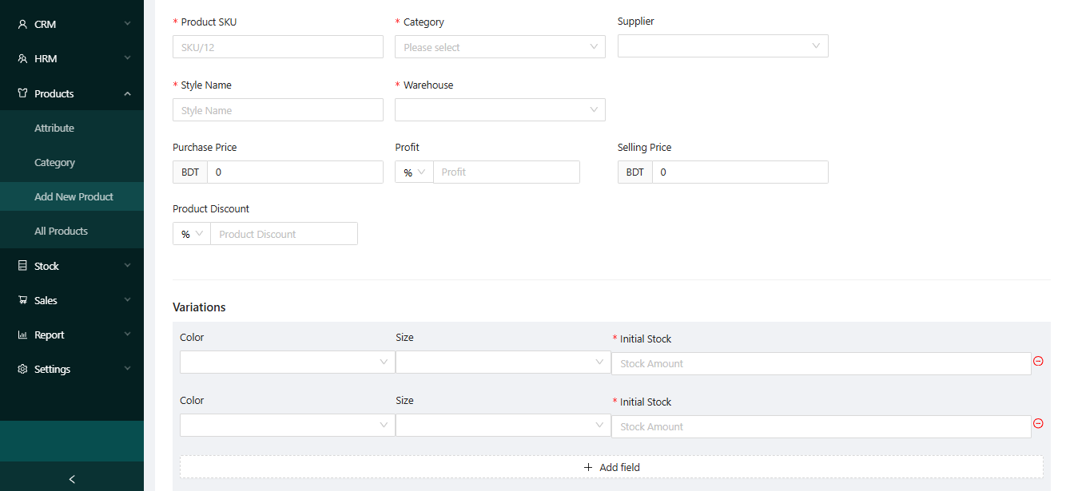

All Product:
After a product is created, it will be shown in the all product section. In this section, the product will have a barcode that is created combined with variation and product id.
Also the location product is located is also here.

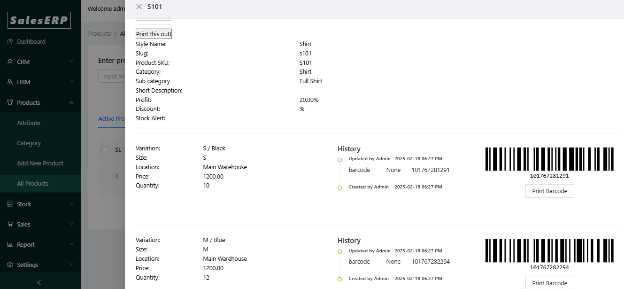

Current Stock:
This is current stock that is added in the Inventory.
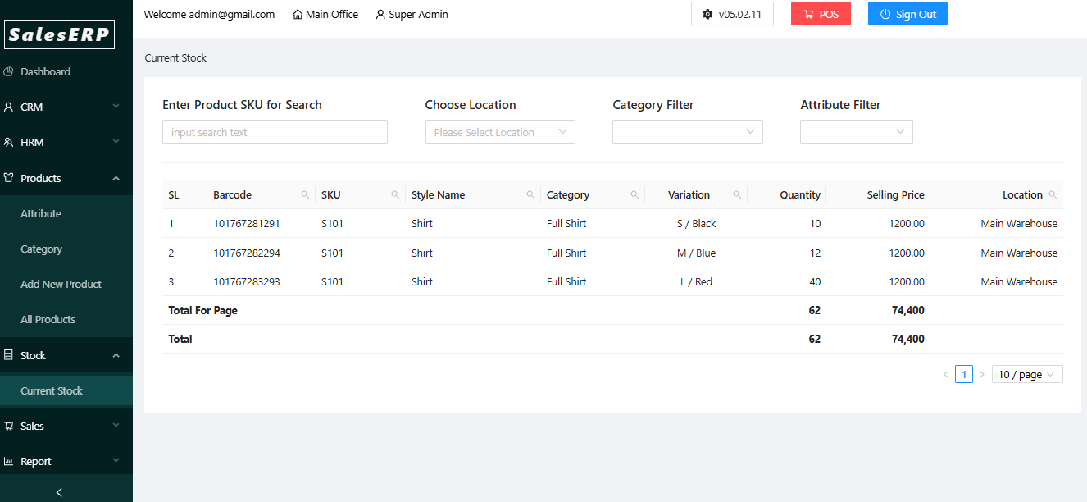

POS/Add New Order:
This is the main sales portal. Here stock can be added via the location it is situated.
Then a customer is added where the phone number is primary. Sales person can also add a discount if it applies. Clicking Confirm Order will create an order & print a invoice if it is connected with a POS machine.
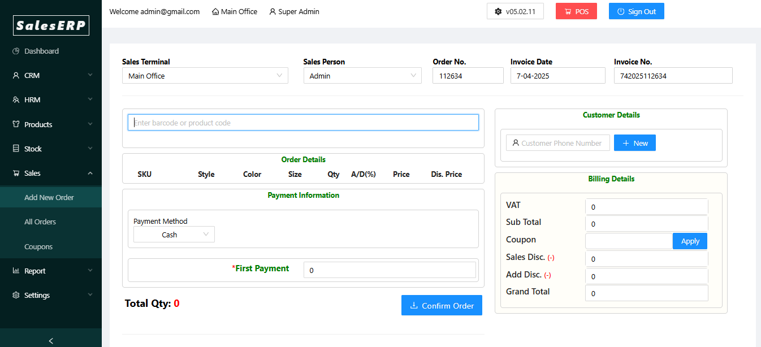

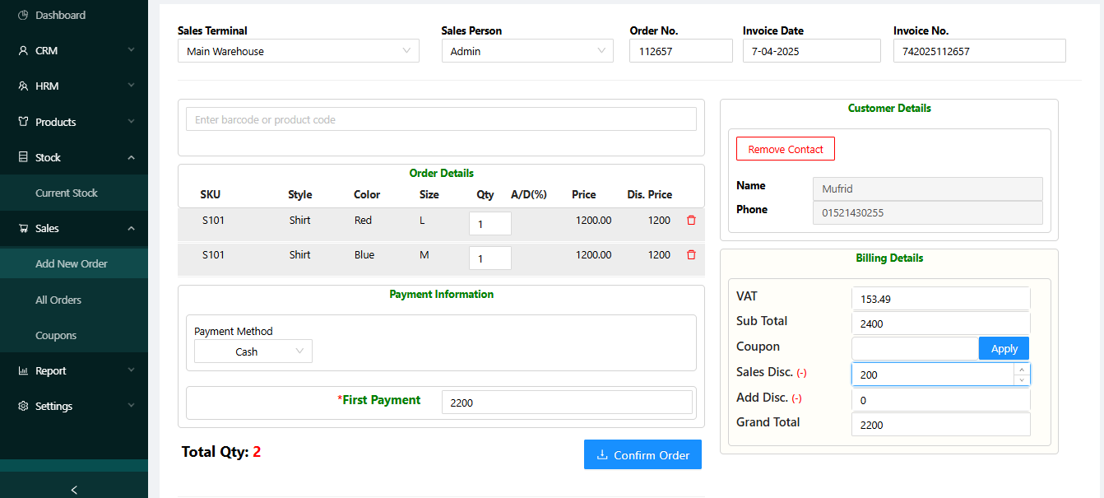

Sales Report:
User can check sales report based on Date, Outlet location filter.
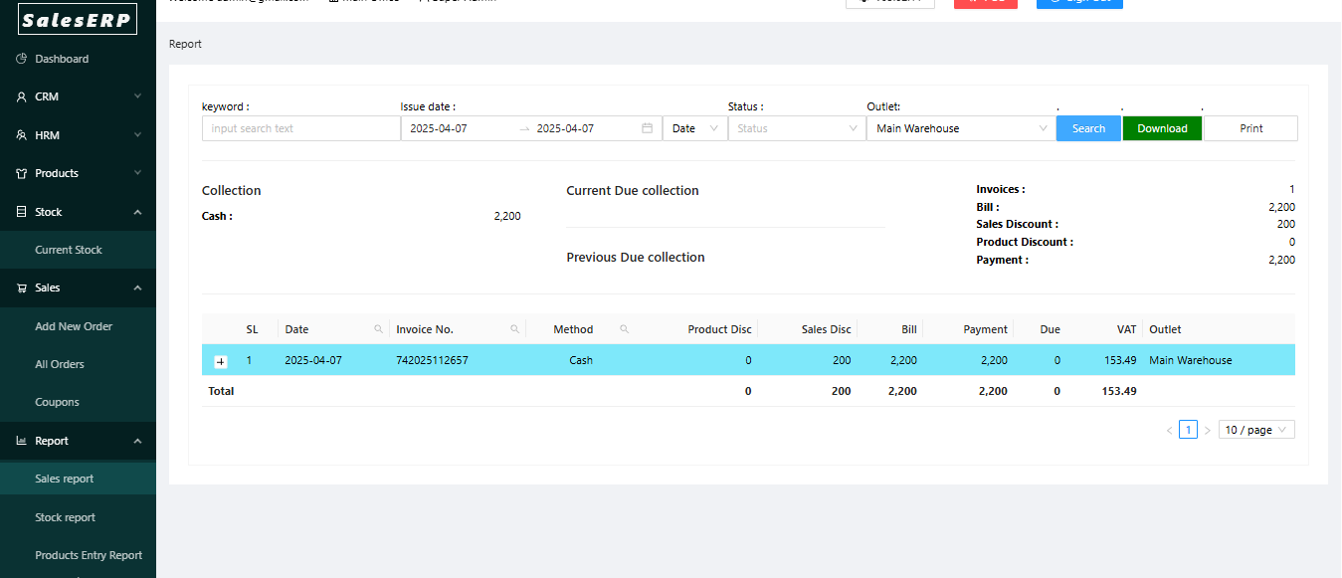

Stock Report
Current stock report of an All/single location. Excel report can be downloaded here.

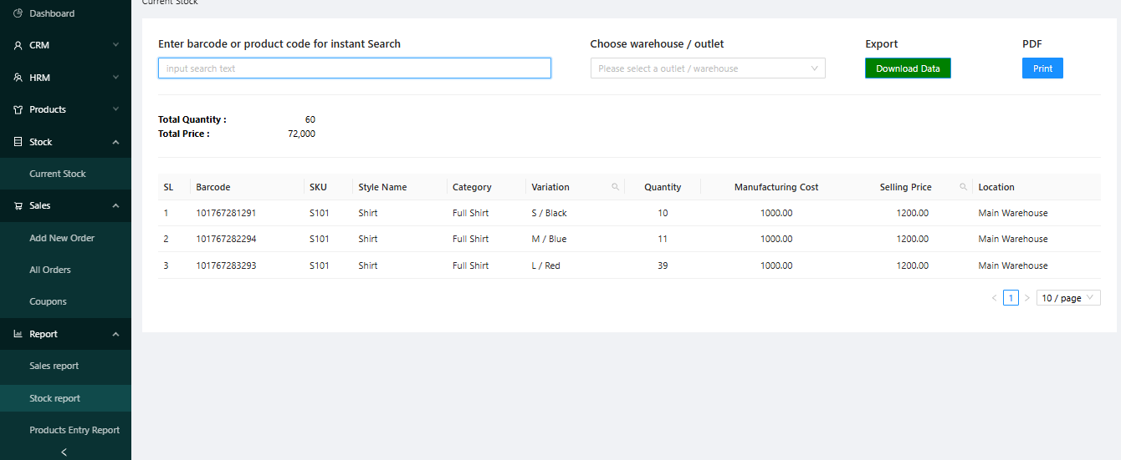

Sold Product Report:
This is the report of sold items that customers bought. It can be filtered with date wise.

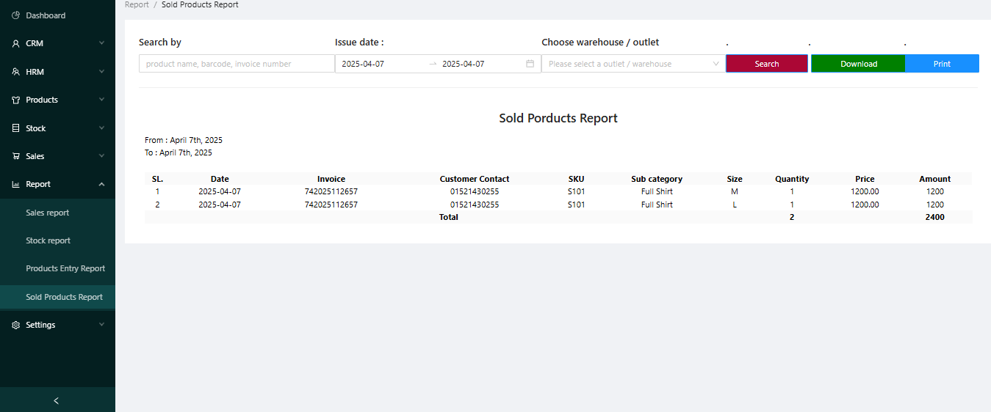

Future Scopes:

Inventory & Sales Management System is part of an ERP System. The system is dynamic. As Employee can be added here, Salary Setup, attendance, leave option, Payslip can be added for Employee. In Product module Transfer is a necessary part for transferring product from one location to another. It can be implemented as well. Also the Accounting system is an essential part of ERP System, so implementation of this is a good integration for the software.
For future technology integration we can use following:
- Prometheus: Monitoring data model, flexible query language.
- CI/CD Pipeline: Automated serving code in production via Git
- Grafana: This is used for data visualization, monitoring infrastructure and visualize time series data.

Conclusion

This Inventory & Sales Management Application combines robust API functionality & Frontend with a polished frontend to deliver a comprehensive Inventory & Sales solution. Users can create new products based on variants and sell them with the details of customers. With its scalable design and responsive interface, the application caters to diverse user needs, making it an ideal platform for modern ERP. This project demonstrates the potential of Django Rest Framework and ReactJS in creating efficient, dynamic, and user-centered web applications.

List of used literature
1. Rahmet Bee, "Sales and Inventory Management System," UTPedia, 2019.Discusses the development of a sales and inventory system aimed at replacing manual processes to improve efficiency, focusing on database design, report generation, and point of sale functionality.[Source: http://utpedia.utp.edu.my/13591/1/Rahmet%20Bee_13743.pdf]

2. Patrick Thomas Lucas, "Use of Inventory Management for Large General Item Retailers," Schreyer Honors College, The Pennsylvania State University, 2013.Applies inventory management theory to retail settings, optimizing inventory policies using ABC classification and cost models for holding and shortage costs,with [Source: https://honors.libraries.psu.edu/files/final_submissions/2045]

3.Gitlab CI Documentation - https://docs.gitlab.com/ee/ci/

4.Ant Design DocumentationOfficial documentation for Ant Design, the React UI framework used to build elegant and user-friendly interfaces, supporting responsive design and accessibility.[Source: Ant Design official site]

5.PostgreSQL DocumentationAuthoritative source on PostgreSQL features, performance tuning, indexing, and data integrity mechanisms essential for building a robust backend database for enterprise applications.[Source: PostgreSQL official site]

6.ReactJS Official DocumentationProvides comprehensive guidelines on building component-based frontend applications with React, including state management techniques and integration with REST APIs.[Source: ReactJS official site]

7.Django Rest Framework Best Practices Guide - 2025," StudyGyaan, 2024Covers key DRF development practices such as API versioning, class-based views, serialization techniques, and structuring projects for maintainability and performance.[Source: StudyGyaan Blog]

8.Escape.tech, "How to Secure Your Django Applications," 2023Provides security best practices for Django apps, including authentication, authorization, input validation, and protection against common vulnerabilities, which are crucial for backend APIs handling sensitive business data.[Source: Escape.tech Blog]

9,Getting started with Django Rest Framework by Building a Simple Product Inventory Manager" – Techie DiariesStep-by-step tutorial on creating a REST API for a product inventory manager with models, serializers, and views explained in detail.[Techie Diaries Tutorial]"

10.Inventory Management System API" – GitHub Repository by mbuthimungaiA complete inventory management system API built with Django REST Framework, featuring item, stock, transaction, category, and supplier management, containerized with Docker and using PostgreSQL.[GitHub Repo]

11."Developing an Inventory Management System with Django and Bootstrap" – mwass.hashnode.devTutorial on building an inventory system backend with Django and frontend with Bootstrap, useful for understanding integration of UI frameworks with Django.[Hashnode Article]

12"Django DRF Ecommerce Inventory with Elasticsearch and Pytest" – YouTube by Dennis IvyVideo tutorial demonstrating building an ecommerce inventory system with Django REST Framework, Elasticsearch for search, and Pytest for testing.[YouTube Video]

13.Katana MRP Blog (2024).
Inventory Management API Benefits & Process.
This industry article details how inventory management APIs enable integration with ecommerce, POS, and warehouse systems, supporting real-time inventory updates, automated order fulfillment, and demand forecasting-key features for modern Sales & Inventory web applications.[Katana MRP Blog]
14. Rest API [https://www.ibm.com/think/topics/rest-apis]

