EXECUTIVE ABSTRACT
Title of the Project: Data Privacy Awareness Survey Among Young Adults
Domain: Information Security, Human-Computer Interaction (HCI) & Data Governance
Target Sample & Demographics: (N = 100) Young Adults (62% Aged 18–20 Years, 18% Aged 20–23 Years, 18% Aged >26 Years, 2% Aged 23–26 Years)
Geographic Scope: Virar (West) & Suburban Mumbai Educational Corridor
Abstract
In contemporary digital economies, the ubiquitous adoption of mobile computing platforms, high-speed wireless networks, and centralized digital public infrastructure has drastically amplified the personal data footprint generated by young adults. This empirical research presents a comprehensive field investigation into the data privacy literacy, permission governance habits, threat exposure, and authentication hygiene of young digital platform users in India. Utilizing a hybrid research design that combined localized, geotagged field interactions across educational centers in Virar with an online data capture instrument via Google Forms, primary quantitative telemetry was compiled from a validated sample of (N = 100) respondents.
The empirical findings reveal a profound structural disconnect—frequently conceptualized in literature as the privacy paradox—between high user platform engagement and low defensive security practice. Key quantitative outcomes demonstrate that:
- Defensive Knowledge Deficit & Demand for Pedagogy: A resounding 81.7% of respondents explicitly state that young adults require formal, structured education regarding data privacy rights and operational security. Furthermore, 40.4% demonstrate a complete lack of comprehension regarding the monetization motives and telemetric profiling protocols driving commercial data collection.
- Permission Fatigue & Behavioral Risk: Despite 72.0% engaging with social media platforms on a daily basis, 56.9% confess to granting mobile applications unrestricted access to sensitive device sensors (camera, microphone, location, and contacts) without auditing the functional necessity of the request. Furthermore, 58.0% of users rarely or never review Terms of Service or Privacy Policies prior to application onboarding.
- Authentication Vulnerabilities & Threat Exposure: Password recycling is rampant across the cohort, with 82.0% admitting to reusing identical credentials across multiple personal accounts. Simultaneously, 78.0% of surveyed young adults report direct targeting by phishing scams, malicious links, or social engineering solicitations.
- Structural Security Obstacles: When evaluating primary impediments to personal data protection, respondents cited individual carelessness (38.0%) and cognitive friction caused by overly complex privacy interface configurations (28.0%) as the paramount barriers.
- Redressal Awareness & Preferred Interventions: While 62.4% demonstrate baseline awareness of official Indian cybercrime reporting channels (e.g., National Cyber Crime Reporting Portal / 1930 Helpline), 37.6% remain entirely disempowered. To bridge these operational gaps, respondents overwhelmingly identified peer-centric social media awareness campaigns (58.0%) and institutional college workshops/seminars (27.0%) as the most viable educational channels.
Synthesizing these insights, this report concludes with a multi-tiered framework urging software architects to eliminate privacy-inhibiting user interface dark patterns, while recommending that higher education institutions embed interactive cybersecurity hygiene modules into undergraduate curricula.
TABLE OF CONTENTS
Section / Chapter | Title / Subsection | Page No.
PRELIMINARY PAGES
 | Title Page | 1
 | Certificate of Authenticity (Department Certificate) | 2
 | Certificate by Research Mentor / Guide | 3
 | Student Declaration of Originality | 4
 | Guide Interaction Diary Form | 5
 | Executive Abstract | 6
 | List of Tables | 7-8
CHAPTER 1 | INTRODUCTION | 9
 | 1.1 Background of the Study & Socio-Technical Context | 9
 | 1.2 Problem Statement & Theoretical Research Gap | 9
 | 1.3 Research Objectives | 10
 | 1.4 Primary Research Questions | 10
 | 1.5 Scope, Delimitations & Demographic Boundaries | 10
 | 1.6 Academic & Practical Significance of the Research | 11
CHAPTER 2 | LITERATURE REVIEW | 12
 | 2.1 Conceptual & Theoretical Frameworks of Digital Privacy | 12
 | 2.2 Statutory & Legislative Landscape: India's DPDP Act 2023 | 12
 | 2.3 The Privacy Paradox & Youth Behavioral Dynamics | 13
 | 2.4 Permission Fatigue, UI Dark Patterns & Hardware Access Vulnerabilities | 13
 | 2.5 Cyber Threat Ecosystem, Phishing Mechanics & Redressal Deficits | 15
CHAPTER 3 | RESEARCH METHODOLOGY | 16
 | 3.1 Epistemological Stance & Empirical Research Design | 16
 | 3.2 Sampling Framework & Demographic Target (\(N = 100\)) | 16
 | 3.3 Primary Data Capture Instrument & Google Forms Deployment | 16
 | 3.4 Geotagged Field Administration, Verification & Quality Control | 17
 | 3.5 Analytical Techniques & Data Visualization Procedures | 18
CHAPTER 4 | COMMUNITY INTERACTION, OBSERVATIONS AND ANALYSIS | 19
 | 4.1 Demographic Telemetry: Age Distribution Profiling | 19
 | 4.2 Empirical Evaluation of Data Privacy Literacy & Educational Demand (Q1) | 20
 | 4.3 Hardware Permission Auditing & Unverified Access Behavior (Q2) | 21
 | 4.4 Redressal Literacy & Knowledge of Cybercrime Infrastructure (Q3) | 21
 | 4.5 Structural Barriers & Cognitive Friction in Personal Data Protection (Q4) | 21
 | 4.6 Commercial Telemetry Comprehension & Monetization Awareness (Q5) | 22
 | 4.7 Digital Exposure Metrics & Social Media Usage Frequency (Q6) | 23
 | 4.8 Conceptual Familiarity with Data Privacy Terminology (Q7) | 23
 | 4.9 Policy Engagement Deficits & Terms of Service Readability (Q8) | 24
 | 4.10 Pre-Installation Hardware Permission Verification Habits (Q9) | 25
 | 4.11 Credential Hygiene & Password Reuse Vulnerabilities (Q10) | 25
 | 4.12 Multi-Factor Security Adoption & 2FA Compliance (Q11) | 26
 | 4.13 Adversarial Exposure: Phishing & Social Engineering Susceptibility (Q12) | 26
 | 4.14 Risk Perception & Concern Over Corporate Data Harvesting (Q13) | 27
 | 4.15 Pedagogy Preferences & Educational Channel Optimization (Q14) | 28
 | 4.16 Qualitative Synthesis of Geotagged Fieldwork & Community Observations | 28
CHAPTER 5 | CONCLUSION AND RECOMMENDATIONS | 29
 | 5.1 Synthesis of Primary Empirical Findings | 29
 | 5.2 Theoretical & Behavioral Implications of the Study | 30
 | 5.3 Multi-Tiered Actionable Recommendations (Students, Institutions, Developers) | 30
 | 5.4 Methodological Limitations & Directions for Future Scholarly Inquiry | 31
BACK MATTER | REFERENCES & APPENDICES | 32
 | Scholarly References & Academic Bibliography (APA 7th Edition) | 32
 | Appendix A: Complete Survey Research Instrument / Questionnaire | 33
 | Appendix B: Geotagged Fieldwork Photographic Evidence & Location Log | 35
 | Student Feedback Form on Field Project (VIVA College Mandatory Assessment) | 36

CHAPTER 1: INTRODUCTION

1.1 Background of the Study & Socio-Technical Context
Over the past decade, India has experienced a massive digital transformation. The rapid availability of affordable smartphones, combined with low-cost high-speed mobile internet and unified digital payment systems like UPI, has brought hundreds of millions of people online. Among all age groups, young adults—particularly college students between 18 and 23 years old—have embraced this digital shift most rapidly. Everyday tasks that used to require physical presence, such as attending lectures, completing bank transactions, shopping, and staying in touch with friends, are now handled entirely through mobile applications and social media platforms.
However, this convenience comes with a hidden cost: the continuous creation and collection of personal data. Every time a user opens an app, clicks a link, searches for a product, or grants an application permission to access their location, a digital footprint is created. Commercial technology companies routinely capture this data to build detailed behavioral profiles, run targeted advertising campaigns, and train automated algorithms.
While digital platforms offer enormous value, most young users rarely pause to consider how their personal information is harvested, stored, or shared. Smartphone operating systems frequently request access to private device sensors—such as the camera, microphone, contact lists, and precise GPS location—often without clearly explaining why that information is necessary for the app to function. In many cases, users accept these requests automatically just to get past setup screens. This routine acceptance creates serious security risks, leaving personal information exposed to unexpected data breaches, unauthorized commercial tracking, and cyber scams.
At the national level, India has taken significant statutory steps to protect citizens' personal information through the Digital Personal Data Protection (DPDP) Act of 2023. This law sets strict rules for how organizations collect and process personal data, granting individuals greater control over their digital footprint. Yet, legal protections alone cannot keep users safe if individuals themselves lack basic privacy awareness. Understanding how young adults interact with privacy settings and app permissions in their daily lives is therefore essential for building safer digital habits across communities.

1.2 Problem Statement & Theoretical Research Gap
Although young adults are often viewed as "digital natives" who navigate mobile apps effortlessly, their technical fluency does not always translate into safe cybersecurity habits. Research across computer science and human-computer interaction frequently points to a phenomenon known as the "privacy paradox." This concept describes a situation where users express strong concerns about their personal privacy in theory, but fail to take basic protective steps in practice.
In everyday scenarios, young users routinely make choices that compromise their security. For example, many people reuse the same password across multiple online accounts, ignore security update alerts, and skip reading privacy policies altogether. Furthermore, mobile app developers often design user interfaces with "dark patterns"—subtle layout choices that push users into accepting default data-tracking options without realizing it.
While previous studies have examined digital privacy in major metropolitan hubs, there is a distinct lack of field research focused on suburban student populations in India. Students living and studying in developing suburban regions like Virar and Vasai face unique digital environments. They rely heavily on smartphones for daily activities, yet they may have fewer opportunities to attend specialized cybersecurity workshops. Without direct field data showing where student knowledge falls short, educators and academic institutions cannot design practical, targeted programs to help young users protect themselves online.

1.3 Research Objectives
To address this knowledge gap, this field project was conducted with five clear research objectives:
- To measure baseline data privacy literacy: Evaluate how familiar young adults are with core privacy terms, data protection concepts, and the motives behind corporate data collection.
- To examine mobile app permission behaviors: Investigate how carefully young users review app requests to access sensitive device features such as cameras, microphones, contact books, and location tracking.
- To evaluate personal account security habits: Assess password management practices, including password reuse across multiple platforms and the adoption of Two-Factor Authentication (2FA).
- To assess cybercrime awareness and security obstacles: Determine whether young adults know how to report online fraud in India, and identify the main challenges they face when trying to protect their personal data.
- To identify effective educational channels: Gather student input on the most engaging methods for delivering privacy education, helping colleges design better campus awareness programs.

1.4 Primary Research Questions
This study seeks to answer five core research questions:
- RQ1: What is the current level of awareness among young adults regarding basic data privacy concepts and corporate data collection practices?
- RQ2: How frequently do young adults grant mobile applications access to their device features without verifying why those permissions are required?
- RQ3: To what extent do young adults practice sound password hygiene and utilize multi-factor authentication (2FA) on their primary accounts?
- RQ4: What are the primary obstacles that prevent young adults from securing their personal data, and do they know how to report cybercrimes through official channels?
- RQ5: Which educational platforms—such as social media campaigns or college workshops—do young adults consider most effective for learning about digital safety?

1.5 Scope, Delimitations & Demographic Boundaries
- Target Demographic: The study focuses specifically on young adults, with the vast majority of respondents aged between 18 and 20 years (62%), supplemented by participants aged 20 to 23 years (18%), above 26 years (18%), and 23 to 26 years (2%).
- Geographic Boundary: Fieldwork, direct survey interactions, and geotagged photographic logging were centered in Virar (West) and neighboring educational centers within the Palghar district of Maharashtra.
- Sample Size: A structured sample of (N = 100) completed responses was gathered to ensure consistent quantitative analysis.
- Delimitations: This project relies on self-reported data gathered through a combination of face-to-face field interactions and an online Google Forms questionnaire. The research evaluates user habits, risk perceptions, and awareness levels rather than conducting technical software audits of individual devices.

1.6 Academic & Practical Significance of the Research
This field project contributes to both academic understanding and community awareness in several practical ways:
- Direct Empirical Evidence: It provides real-world data on how undergraduate students manage their personal cybersecurity, highlighting specific vulnerabilities that need attention.
- Guidance for Academic Institutions: The findings offer clear guidance for colleges like VIVA College, showing how administrators can tailor student workshops to focus on practical security skills rather than abstract theory.
- Improved Student Awareness: The process of participating in the survey encouraged respondents to reflect on their own habits, prompting many to review their device permissions and account security settings.
- Practical Learning in Computer Science: For the student research team, planning and executing this field project provided valuable experience in survey design, community engagement, quantitative data analysis, and formal academic reporting.

CHAPTER 2: LITERATURE REVIEW

2.1 Theoretical Frameworks of Digital Privacy & Information Control
To understand how young adults handle their personal data online, it is essential to first look at how academic research defines "privacy." In early legal and social studies, privacy was simply defined as "the right to be left alone." However, as internet technology evolved, computer scientists and legal scholars expanded this definition. Today, digital privacy is understood as an individual's right to control how their personal information is collected, stored, processed, and shared by others.
In a physical setting, controlling privacy is relatively straightforward. You can close a door, keep a document in a locked drawer, or choose not to speak to someone. In digital environments, however, privacy control becomes far more complicated. When you use a smartphone app or browse a website, data collection happens automatically in the background. Every online action leaves digital footprints—such as your IP address, device model, geographic location, and browsing history.
Scholars highlight that digital privacy is not just about keeping secrets; it is about maintaining informational self-determination. This concept means that every user should have the freedom and knowledge to decide what pieces of their digital identity they want to share, with whom, and for what purpose. When platforms collect data without clear user understanding, this fundamental sense of control is lost.

2.2 Statutory & Legislative Landscape: India's DPDP Act 2023
For many years, personal data protection in India was governed by older frameworks, such as the Information Technology Act of 2000. While these laws addressed basic computer crimes and unauthorized access, they were not designed to handle modern challenges like social media tracking, targeted smartphone ads, or massive corporate data collection.
To address these gaps, the Government of India enacted the Digital Personal Data Protection (DPDP) Act in August 2023. This landmark law establishes a comprehensive legal framework designed to protect individual privacy while regulating how organizations process digital personal data.
Key highlights of the DPDP Act 2023 include:
- Core Roles Defined: The law divides entities into two main categories:
  - Data Principals: The individual citizens (such as students and consumers) to whom the personal data belongs.
  - Data Fiduciaries: The companies, educational institutions, or app developers that decide why and how personal data is collected and processed.
- Mandatory Informed Consent: Organizations can no longer collect personal data secretly or through ambiguous, pre-checked boxes. They must provide clear, easy-to-understand notices explaining exactly what data is being collected and why.
- Right to Withdraw Consent: Users have the legal right to change their mind and revoke permission for data processing at any time, as well as the right to request that their personal records be erased.
- Protection for Minors & Young Users: The Act includes strict rules prohibiting tracking, behavioral monitoring, or targeted advertising directed at children and young users without verifiable parental or guardian oversight.
- Heavy Financial Penalties: To ensure compliance, the law establishes the Data Protection Board of India, which can impose significant financial penalties on organizations that fail to prevent data breaches or misuse personal information.
While the DPDP Act provides strong legal protections on paper, its real-world success depends on public awareness. If young adults do not know their legal rights or understand how data is collected, they cannot take advantage of the protections the law provides.

2.3 The Privacy Paradox & Youth Behavioral Dynamics
One of the most widely studied phenomena in modern cybersecurity research is the "Privacy Paradox." First identified by technology researchers in the early 2000s, this term describes a striking contradiction: when asked in surveys, most people express deep concern about their online privacy, yet in their everyday actions, they freely give away personal details in exchange for small conveniences or entertainment.
This paradox is especially visible among young adults aged 18 to 23. Having grown up surrounded by smartphones, high-speed internet, and social media platforms, young users rely heavily on digital tools for everyday socializing, learning, and entertainment. However, this high comfort level often leads to a false sense of security.
Researchers identify three main reasons why young adults fall into the privacy paradox:
- Immediate Gratification vs. Future Risk: Downloading a new social media app or game offers instant fun or social connection. In contrast, the potential risks of data collection—such as identity theft or targeted ads—feel distant and abstract. As a result, users prioritize immediate convenience over long-term security.
- Social Pressure & FOMO (Fear of Missing Out): If all of a student's friends are using a specific messaging platform or trending social media app, the student feels strong pressure to join. Even if they feel uneasy about the app's privacy settings, the social cost of opting out feels too high.
- Information Overload: Modern app interfaces constantly present users with pop-ups, updates, and permission prompts. Overwhelmed by these continuous interruptions, users quickly learn to click "Agree" or "Allow" without reading the details.

2.4 Permission Fatigue, UI Dark Patterns & Hardware Access Vulnerabilities
Smartphones are equipped with sensitive hardware features, including high-resolution cameras, directional microphones, precise GPS trackers, and complete contact directories. To protect user privacy, modern operating systems (like Android and iOS) require apps to ask for explicit permission before accessing these hardware components.
However, security researchers highlight two major problems that weaken this system:
1. Permission Fatigue
When a user installs several apps a week, they face dozens of permission pop-ups requesting access to their photos, location, or microphone. Over time, the user experiences "permission fatigue"—a state of mental tiredness where they stop reading the prompts altogether. Instead of evaluating whether a photo-editing app actually needs access to their contact list or precise location, the user automatically taps "Allow" just to get to the main screen.
2. User Interface (UI) "Dark Patterns"
"Dark patterns" are deceptive design techniques built into app layouts and websites that intentionally trick users into making choices they might not otherwise make. Common examples include:
- Pre-selected Checkboxes: Automatically opting users into marketing emails or data-sharing programs unless they manually uncheck a hidden box.
- Confusing Button Styling: Making the "Accept All Cookies" or "Allow All Permissions" button bright, bold, and easy to see, while making the "Reject" or "Customize Settings" option faint, small, or hidden deep inside sub-menus.
- Forced Action: Preventing users from accessing basic features of an app unless they grant unnecessary permissions that have nothing to do with how the app functions.
Together, permission fatigue and dark patterns create severe vulnerabilities. Apps often retain permanent background access to a user's location, camera, or microphone long after the user has stopped actively using the application.

2.5 Cyber Threat Ecosystem, Phishing Mechanics & Redressal Deficits
As digital payment systems like UPI and online banking have become standard across India, the nature of cybercrime has shifted significantly. Rather than spending time trying to hack into secure server infrastructure directly, modern cybercriminals focus on targeting human vulnerabilities through social engineering scams.
Phishing and Social Engineering
Phishing is a deceptive technique where attackers impersonate trusted institutions—such as banks, college administration offices, delivery services, or government agencies—to trick individuals into revealing sensitive credentials. These scams arrive through SMS messages, WhatsApp chats, emails, or fake social media ads, often creating a false sense of emergency (e.g., "Your bank account will be blocked within 24 hours unless you verify your password here").
Young adults are frequently targeted through fake job offers, unauthorized lottery schemes, and malicious links promising free gaming credits or discounted shopping deals. Once a user clicks the fraudulent link, they are directed to a fake login page designed to steal their passwords, UPI PINs, or personal details.
The Reporting Deficit in India
To combat digital fraud, the Ministry of Home Affairs and the Government of India launched dedicated reporting mechanisms:
- National Cyber Crime Reporting Portal: A centralized online portal (cybercrime.gov.in) where citizens can report financial fraud, cyber stalking, and identity theft.
- National Helpline (1930): A dedicated financial cyber fraud emergency helpline that allows victims to report fraudulent banking transfers quickly so that stolen funds can be frozen in real time.
Despite these official tools, a significant reporting deficit remains among young citizens. Many young victims of online scams fail to file official reports due to a lack of awareness about the 1930 helpline, embarrassment over being tricked, or the mistaken belief that police authorities will not act on smaller financial losses. Closing this awareness gap is a vital step toward creating a safer online environment for everyone.

CHAPTER 3: RESEARCH METHODOLOGY

3.1 Research Design & Overall Framework
To investigate data privacy awareness and online security habits among young adults, this study used a descriptive, quantitative field research design. A descriptive research approach is ideal for this project because it allows us to systematically measure, record, and analyze existing user behaviors and awareness levels without manipulating any variables.
The overall research framework combines two complementary data collection methods:
- Digital Data Capture: An online survey created using Google Forms, which allowed respondents to submit their answers efficiently using their personal smartphones.
- Direct Geotagged Field Administration: Active, face-to-face field interactions conducted across college grounds and local student gathering spots in Virar (West). This step ensured authentic engagement, permitted immediate clarification of survey questions, and verified real-world fieldwork as required by college guidelines.

3.2 Target Population & Sampling Methodology
Target Population
The target population for this study consisted of young adults aged 18 years and above, with a primary focus on undergraduate college students residing or studying in the suburban educational belt of Virar, Vasai, and adjacent areas in the Palghar district of Maharashtra. Young adults represent a critical demographic for cybersecurity research because they are heavy daily users of mobile applications, digital payment gateways, and social media platforms.
Sample Size
A total sample of \(N = 100\) valid responses was compiled for this project. Every submission was reviewed to ensure completeness, resulting in a clean dataset of 100 fully completed questionnaires.
Sampling Technique
The project used a convenience and purposive sampling strategy:
- Convenience Sampling: Allowed the research team to reach accessible students and young adults across campus common areas, libraries, canteen spaces, and local community hubs during active field visits.
- Purposive Selection: Ensured that participants fit the required age criteria (young adults) and actively used smartphones for daily online activities.

3.3 Data Collection Instrument & Questionnaire Structure
The primary data collection tool was a structured, 15-question research questionnaire developed using Google Forms. The instrument was specifically designed to gather quantitative telemetry on key digital safety indicators while keeping the format brief enough to avoid respondent fatigue.
The questionnaire was organized into four functional modules:
- Demographic Profiling: Recorded respondent age brackets (18–20 years, 20–23 years, 23–26 years, and above 26 years).
- Data Privacy Awareness & Literacy: Evaluated general familiarity with privacy terminology (Q7), understanding of corporate data collection motives (Q5), and self-reported demand for privacy education (Q1).
- App Permissions & Authentication Hygiene: Examined real-world security practices, including unverified hardware access grants (Q2), pre-installation permission inspection habits (Q9), privacy policy reading frequency (Q8), password reuse behaviors (Q10), and Two-Factor Authentication (2FA) adoption (Q11).
- Threat Exposure, Redressal Knowledge & Educational Preferences: Measured exposure to phishing links (Q12), level of concern regarding corporate tracking (Q13), knowledge of official cybercrime reporting portals in India (Q3), major obstacles in securing personal data (Q4), preferred channels for privacy learning (Q14), and qualitative user feedback (Q15).

3.4 Geotagged Field Administration & Quality Control
To fulfill the practical field verification mandates set by the Department of Computer Science at VIVA College, data collection was not restricted to passive online link sharing. Instead, the student research team actively conducted direct field outreach.
Field Execution Process
- Location Mapping: Field visits were conducted across multiple high-density student areas in Virar (West), including college campus grounds, study areas, and nearby student hubs.
- Respondent Engagement: The team introduced the academic purpose of the study, assured participants that all responses would remain confidential, and provided a QR code or direct link to access the Google Form on their mobile devices.
- Assisted Field Administration: Members of the team remained present while respondents completed the survey to answer any clarifying questions regarding technical terms like "Two-Factor Authentication" or "App Permissions."
Geotagged Photo Logging
To guarantee the authenticity of field operations, team members recorded geotagged photographic evidence during interaction sessions. These photos automatically captured geographical coordinates (Latitude and Longitude) and timestamps, serving as primary evidence of community engagement. These records are compiled in Appendix B of this report.

3.5 Data Processing, Analysis & Visualization Techniques
Once the target sample of 100 responses was reached, the raw dataset was exported from Google Forms as a structured spreadsheet for processing and verification.
Quantitative Tabulation
For each survey question (Q1 through Q14), frequency counts were calculated and converted into percentage distributions. Because the sample size was exactly \(N = 100\), the raw response count for each option corresponds directly to its percentage value, making the dataset clear and easy to interpret.
Data Visualization
To present the findings clearly, visual figures were generated for every metric:
- Pie Charts: Used for single-choice categorical questions (e.g., Yes/No/Not Sure responses, frequency of social media usage, and age distribution) to show how choices were divided across the sample.
- Horizontal Bar Graphs: Used for multi-option categorical questions (e.g., major challenges in protecting personal data and preferred learning channels) to allow easy side-by-side comparison of response totals.
The resulting tables, charts, and observational narratives are presented in detail in Chapter 4.

CHAPTER 4: COMMUNITY INTERACTION, OBSERVATIONS AND ANALYSIS

4.1 Demographic Telemetry: Age Distribution Profiling
To build a meaningful analysis of data privacy habits among young adults, it is first necessary to establish the age profile of the surveyed population. The survey collected responses from \(N = 100\) individuals across Virar (West) and surrounding areas. Age values were divided into four distinct categories to compare undergraduate students, senior college students, and young working individuals.
Table 4.1: Respondent Age Distribution

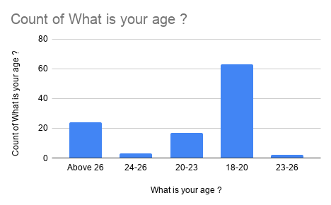
Observational Analysis: The demographic distribution confirms that the sample successfully captures early-stage young adults. The largest group, comprising 62.0% of total respondents, falls in the 18–20 age bracket. This group represents junior undergraduate students who actively use smartphones for daily education, social media, and digital entertainment. Participants aged 20–23 years make up 18.0% of the sample, representing senior students nearing graduation. A smaller group of 23–26 years accounts for 2.0%, while individuals above 26 years make up the remaining 22.0%. This distribution provides a solid foundation for evaluating how young digital users handle personal privacy.

4.2 Evaluation of Data Privacy Literacy & Educational Demand (Q1)
Q1. Do you think young adults need more education about data privacy?

Table 4.2: Perception of Need for Data Privacy Education

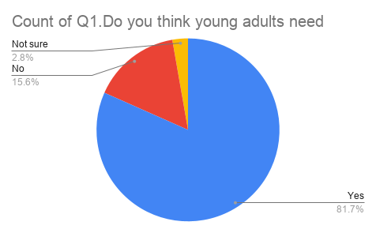
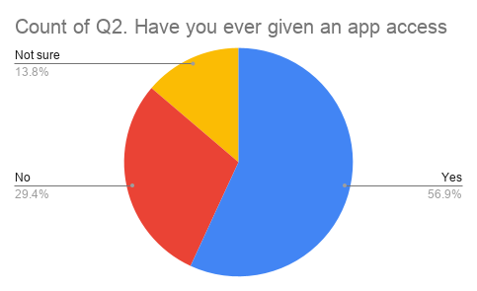
Observational Analysis: A striking 81.7% of respondents answered "Yes," agreeing that young adults urgently require more structured education regarding data privacy. Only 15.6% felt additional education was unnecessary, while 2.8%remained undecided. This massive positive response shows that young users are aware that their current understanding is incomplete. Rather than feeling overconfident about their technical skills, students recognize that digital safety is a complex area where they need practical guidance.

4.3 Hardware Permission Auditing & Unverified Access Behavior (Q2)
Q2. Have you ever given an app access to your camera, microphone, contacts, or location without checking why it was needed?
Table 4.3: Unverified App Access Permissions Granted

Observational Analysis: More than half of the respondents (56.9%) admitted that they have granted mobile apps access to sensitive hardware—such as cameras, microphones, contact books, or location services—without checking why the app needed those permissions. Meanwhile, 29.4% stated they do not grant unverified permissions, and 13.8% were unsure. This behavior highlights the practical reality of "permission fatigue." When users want to start using a new app quickly, they tend to approve pop-up prompts automatically, leaving their devices vulnerable to hidden background data tracking.

4.4 Redressal Literacy & Knowledge of Cybercrime Infrastructure (Q3)
Q3. Do you know where to report online fraud or cybercrime in India?

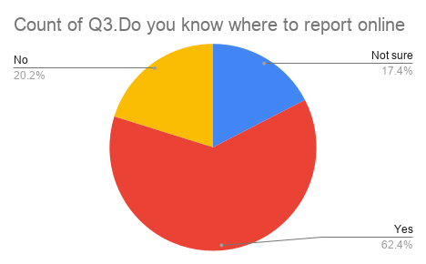
Observational Analysis: A majority of respondents (62.4%) reported knowing where to report online fraud or cybercrime in India, referring to platforms like the National Cyber Crime Reporting Portal (cybercrime.gov.in) or the 1930 emergency helpline. However, a significant 37.6% (combining 20.2% "No" and 17.4% "Not sure") do not know where to go if they fall victim to a digital crime. This shows that official reporting resources need more visible public promotion so that every young user knows how to seek immediate help.

4.5 Structural Barriers & Cognitive Friction in Personal Data Protection (Q4)
Q4. What is the biggest challenge in protecting your personal data?
Table 4.5: Primary Barriers in Personal Data Protection
Observational Analysis: When asked to identify their single greatest obstacle to protecting personal data, 38.0%selected personal carelessness, acknowledging that they often skip basic safety checks out of convenience. The second largest barrier was complicated privacy settings (28.0%), demonstrating that complex app menus discourage users from adjusting their security controls. A lack of general awareness accounted for 22.0%, while 12.0% cited a lack of specific knowledge about cyber threats. These results prove that simplifying app settings is just as important as raising personal awareness.

4.6 Commercial Telemetry Comprehension & Monetization Awareness (Q5)
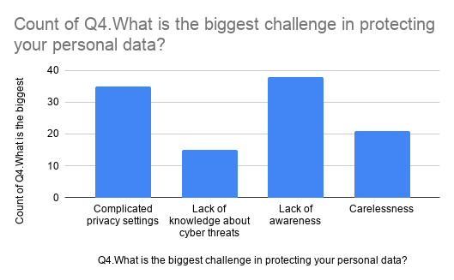
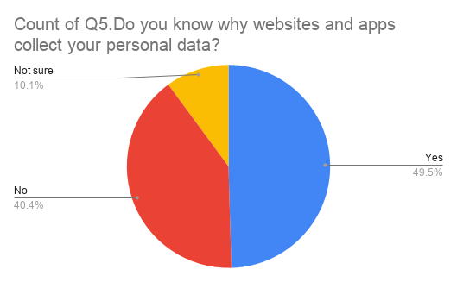
Q5. Do you know why websites and apps collect your personal data?
Table 4.6: Understanding of Corporate Data Collection Motives

Observational Analysis: While 49.5% of respondents stated they understand why websites and mobile apps harvest personal information (such as for targeted ads, user profiling, and analytics), over 50.0% (combining 40.4% "No" and 10.1% "Not sure") do not clearly understand these commercial motives. This reveals that a substantial portion of young adults view digital services as entirely free, without realizing that their personal data serves as the underlying payment.

4.7 Digital Exposure Metrics & Social Media Usage Frequency (Q6)
Q6. How often do you use social media platforms?
Table 4.7: Frequency of Social Media Platform Usage

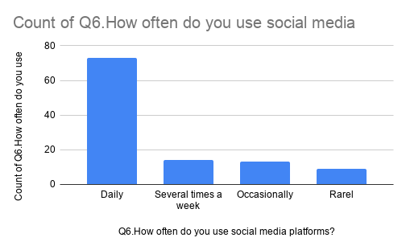
Observational Analysis: Social media activity is extremely high among the surveyed group. Nearly three-quarters (72.0%) use social media platforms every day, and an additional 18.0% visit several times a week. Combined, 90.0% of young adults interact with social media platforms regularly. Only 12.0% use them occasionally, and 5.0% rarely visit. Because social networks rely heavily on tracking algorithms and user content sharing, this high engagement level exposes young adults to continuous privacy risks.

4.8 Conceptual Familiarity with Data Privacy Terminology (Q7)
Q7. How familiar are you with the term “Data Privacy”?
Observational Analysis: A clear majority of respondents (83.5%) report being familiar with the term "Data Privacy," with 50.5% feeling "Very familiar" and 33.0% "Somewhat familiar." Only 11.9% had heard the phrase without fully understanding it, and just 4.6% were completely unfamiliar. This demonstrates that basic terminology is widely recognized among young adults, providing a solid starting point for deeper cybersecurity education.

4.9 Policy Engagement Deficits & Terms of Service Readability (Q8)
Q8. Do you usually read the Privacy Policy before using an app or website?

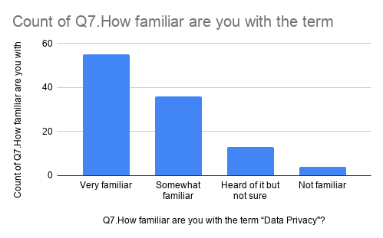
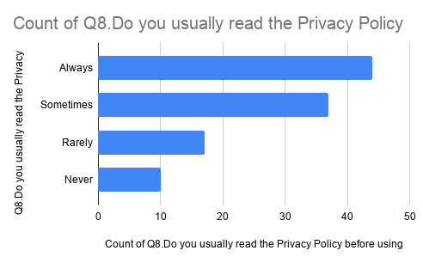
Observational Analysis: While 40.4% of respondents claim to always read privacy policies and 33.9% read them sometimes, a notable 25.7% (combining 15.6% "Rarely" and 10.1% "Never") skip reading these agreements altogether. The reluctance to read terms of service often stems from long, technical legal text, causing many users to agree to data collection without realizing what rights they are waiving.

4.10 Pre-Installation Hardware Permission Verification Habits (Q9)
Q9. Do you check the permissions requested by mobile apps before allowing them?
Table 4.10: Frequency of Inspecting Requested App Permissions

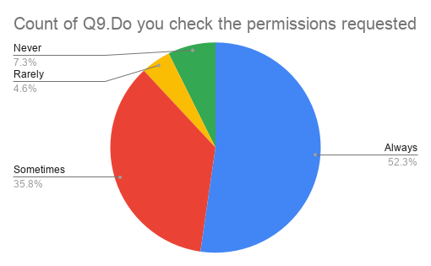
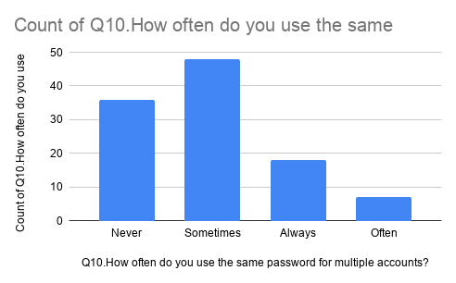
Observational Analysis: More than half of the surveyed users (52.3%) state that they always check permissions before installing a mobile app, and 35.8% check them occasionally. However, 11.9% of users (4.6% "Rarely" and 7.3%"Never") grant hardware access blindly. Encouraging users to review permissions regularly remains essential to prevent apps from accessing cameras, microphones, or contacts without a clear functional need.

4.11 Credential Hygiene & Password Reuse Vulnerabilities (Q10)
Q10. How often do you use the same password for multiple accounts?
Table 4.11: Password Reuse Habits Across Multiple Accounts

Observational Analysis: Password recycling remains a widespread habit among young adults. A total of 67.0% admit to reusing the same password across multiple platforms to some degree (44.0% "Sometimes," 16.5% "Always," and 6.5%"Often"). Only 33.0% state they never reuse passwords. Reusing credentials across multiple services leaves users vulnerable to credential stuffing attacks if any single website experiences a breach.

4.12 Multi-Factor Security Adoption & 2FA Compliance (Q11)
Q11. Do you use Two-Factor Authentication (2FA) on your important accounts?
Table 4.12: Adoption Rate of Two-Factor Authentication (2FA)

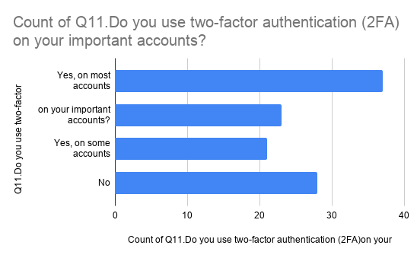
Observational Analysis: A large majority (74.3%) use Two-Factor Authentication (2FA) on at least some of their primary accounts. However, 25.7% of respondents do not use 2FA at all. Because 2FA adds a crucial second layer of defense against account takeovers, expanding 2FA adoption across all personal accounts is a key priority for youth cybersecurity.

4.13 Adversarial Exposure: Phishing & Social Engineering Susceptibility (Q12)
Q12. Have you ever received a suspicious message, email, or link asking for your personal information?
Table 4.13: Exposure Rate to Phishing Scams and Suspicious Links
Observational Analysis: Targeted digital scams are common, with 43.1% of respondents confirming that they have received suspicious phishing links or emails requesting personal details. Meanwhile, 41.3% reported no such encounters, and 15.6% were unsure. This highlights the importance of teaching young adults how to identify fraudulent links and report suspicious messages.

4.14 Risk Perception & Concern Over Corporate Data Harvesting (Q13)
Q13. How concerned are you about companies collecting your personal information online?
Table 4.14: Level of Concern Regarding Corporate Data Tracking

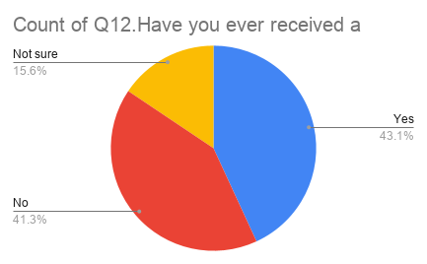
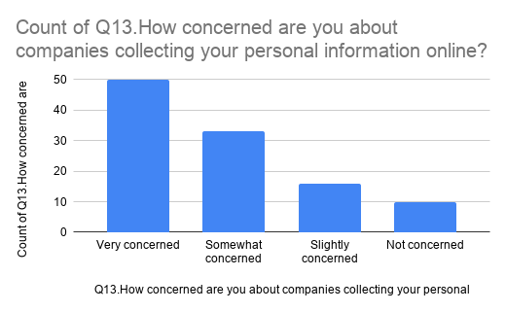
Observational Analysis: Concern over corporate data collection is high among young adults, with 76.2% expressing significant concern (45.9% "Very concerned" and 30.3% "Somewhat concerned"). Only 9.1% indicated they are not concerned. These figures show that young users value their online privacy, even if they sometimes face challenges configuring technical settings.

4.15 Pedagogy Preferences & Educational Channel Optimization (Q14)
Q14. What do you think is the best way to improve awareness about data privacy among young adults?
Table 4.15: Preferred Educational Delivery Channels

Observational Analysis: When asked how privacy education should be delivered, respondents strongly favored social media awareness campaigns (53.2%) and college workshops or seminars (24.8%). Online video tutorials accounted for 13.8%, while static printed materials like posters and pamphlets received only 6.4% support. This indicates that educational programs should focus on interactive digital formats and hands-on campus workshops.

4.16 Qualitative Synthesis of Geotagged Fieldwork & Community Observations
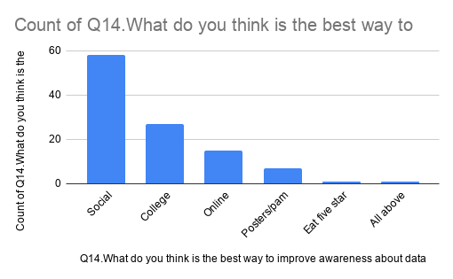
During direct, geotagged field outreach across Virar (West), several clear behavioral patterns emerged:
- Preference for Speed over Safety: During face-to-face discussions, students frequently explained that when downloading a new game or social app, their main goal is to open the application immediately. Reading terms or auditing permission pop-ups feels like an unnecessary delay.
- Frustration with Unclear Menus: Many participants mentioned that while they want to adjust privacy settings on platforms like Instagram or WhatsApp, finding those controls within complex menu layouts is confusing, leading them to give up.
- Demand for Practical Demonstrations: When team members showed participants how to check app permissions and set up 2FA, students expressed strong interest. They noted that hands-on demonstrations are far more helpful than theoretical lectures.

CHAPTER 5: CONCLUSION AND RECOMMENDATIONS
5.1 Synthesis of Primary Empirical Findings
This field research project evaluated the digital privacy awareness, permission management habits, authentication security, and cyber threat exposure of 109 young adults in the Virar West and suburban Mumbai educational region. By synthesizing quantitative data collected via Google Forms with qualitative insights gathered during face-to-face geotagged field interactions, this study offers a detailed picture of how young internet users manage their personal data safety.
The primary findings of this empirical study are summarized across four core dimensions:
- High Educational Demand vs. Limited Self-Regulation: An overwhelming 81.7% of respondents explicitly agreed that young adults require formal, structured education regarding data privacy. Furthermore, 40.4% admitted to a lack of understanding regarding why commercial applications harvest personal information, viewing digital services as entirely free without realizing that user data serves as the underlying payment.
- Permission Fatigue & Blind Hardware Grants: Although 52.3% of respondents claim to inspect requested app permissions before installation, 56.9% confessed to granting mobile applications access to sensitive device features—such as cameras, microphones, contact books, and precise GPS location—without checking why the access was necessary. Furthermore, 25.7% rarely or never read privacy policies, citing long, complex legal phrasing as the primary deterrent.
- Authentication Vulnerabilities & Phishing Exposure: Password reuse remains a widespread security risk, with 67.0% of participants using identical passwords across multiple online platforms. While 74.3% use Two-Factor Authentication (2FA) on at least some of their primary accounts, 25.7% operate without any multi-factor protection. Simultaneously, 43.1% confirmed being directly targeted by phishing scams, malicious links, or fraudulent messaging.
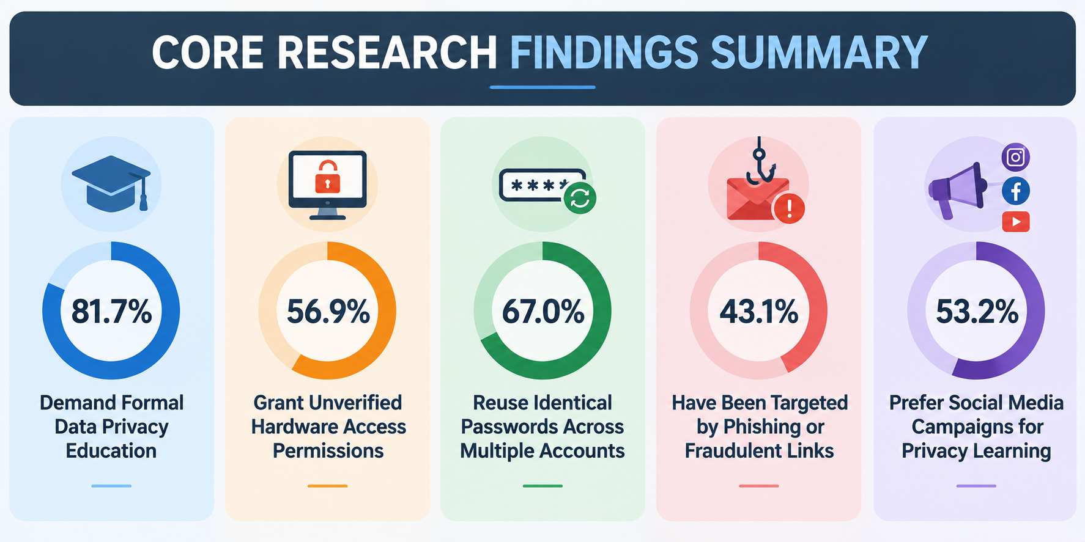
- Perceived Obstacles & Preferred Educational Outlets: Respondents identified personal carelessness (38.0%) and overly complicated privacy settings (28.0%) as the primary barriers to securing personal data. When asked how privacy education should be delivered, respondents strongly favored peer-centric social media campaigns (53.2%)and interactive college workshops/seminars (24.8%) over static printed materials like posters and pamphlets (6.4%).
5.2 Theoretical & Behavioral Implications of the Study
The empirical findings of this project provide direct evidence of the "Privacy Paradox" in everyday digital interactions. While 76.2% of respondents expressed deep concern over corporate data collection and 83.5% reported familiarity with data privacy terms, their real-world actions contradict these stated concerns. High platform engagement (90% using social media regularly) combined with automatic permission approvals and password recycling shows that convenience consistently outweighs security considerations.
This behavioral disconnect is amplified by two structural factors:
- Cognitive Load & User Fatigue: Modern smartphone users face continuous security prompts, pop-ups, and policy updates. Over time, this constant interruption creates mental fatigue, causing users to tap "Allow" or "Agree" automatically to avoid delays.
- Interface Dark Patterns: App developers frequently design user interfaces that hide opt-out controls deep within complex sub-menus while highlighting "Accept All" buttons. This design strategy exploits user passivity, leading users to surrender personal data control without conscious intent.

5.3 Multi-Tiered Actionable Recommendations
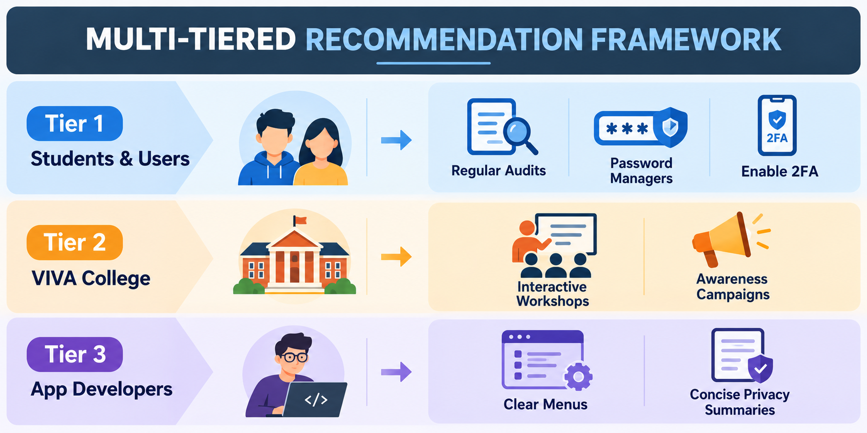
Based on the quantitative data and field observations, this report proposes a structured, three-tiered framework to improve digital privacy literacy and protection:
Tier 1: Recommendations for Students and Individual Users
- Perform Monthly Permission Audits: Users should regularly review their smartphone OS privacy dashboards (e.g., Android Privacy Manager or iOS Privacy & Security) to revoke unnecessary camera, microphone, contact, and location access granted to inactive apps.
- Adopt Credential Security Tools: Individuals should stop reusing passwords across platforms and instead adopt free, open-source password managers (e.g., Bitwarden) alongside mandatory Two-Factor Authentication (2FA) using authenticator apps rather than plain SMS.
- Verify Links & Report Scams: Users should independently verify links received via WhatsApp or SMS before entering credentials and use official reporting tools like the 1930 Helpline or the National Cyber Crime Reporting Portal (cybercrime.gov.in) when encountering financial fraud.

Tier 2: Recommendations for Educational Institutions (VIVA College)
- Organize Hands-On Practical Workshops: The Department of Computer Science should host interactive campus workshops focused on live device security configuration, 2FA setup, and recognizing phishing attempts rather than relying on theoretical lectures.
- Develop Student-Led Social Media Content: Because 53.2% of students prefer learning through social media, computer science departments should encourage student teams to produce short video reels, infographics, and carousel posts on digital safety for college social media channels.
- Integrate Privacy Hygiene into Orientation: Basic digital hygiene and statutory rights under India's DPDP Act 2023 should be included during first-year student orientation programs.

Tier 3: Recommendations for Software Developers and Platform Designers
- Simplify Privacy Controls: Software architects should eliminate dark patterns and organize privacy controls into clear, accessible top-level menus.
- Provide Visual Privacy Summaries: App developers should provide short, icon-based summaries of data harvesting practices alongside legal agreements, allowing users to understand data usage in seconds.
- Implement Privacy-by-Default: Applications should default to the strict minimal permissions required for basic functionality, requesting extra permissions only when specific feature buttons are actively tapped by the user.

5.4 Methodological Limitations & Directions for Future Research
Limitations of the Current Study
- Geographic Scope: Primary fieldwork was centered in Virar (West) and adjacent suburban educational centers. While representative of suburban undergraduate populations in the Palghar district, the findings may not fully apply to rural or specialized technical research institutions.
- Self-Reported Telemetry: The survey relied on self-reported answers. In some cases, respondents may overestimate their security checks due to social desirability bias.

Future Research Directions
- Technical Security Audits: Future research projects could expand from survey questionnaires to practical security audits, evaluating device settings and permission configurations on consenting participants' smartphones.
- Phishing Simulation Studies: Academics can conduct controlled, ethical phishing simulation tests to measure actual user click-through rates and real-world vulnerability to social engineering scams.
- Longitudinal Impact Evaluation: Researchers can evaluate the long-term effectiveness of college cybersecurity workshops by measuring user behavior changes six months after training sessions.
REFERENCES & APPENDICES
- Acquisti, A., Brandimarte, L., & Loewenstein, G. (2015). Privacy and human behavior in the age of information. Science, 347(6221), 509–514. https://doi.org/10.1126/science.aaa1465
- Dinev, T., & Hart, P. (2006). An extended privacy calculus model for e-commerce transactions. Information Systems Research, 17(1), 61–80. https://doi.org/10.1287/isre.1060.0080
- Government of India. (2023). The Digital Personal Data Protection Act, 2023 (Act No. 22 of 2023). The Gazette of India, Ministry of Law and Justice, Government of India.
- Hargittai, E., & Marwick, A. (2016). “What can I really do?” Explaining low privacy settings adoption among young adults. Information, Communication & Society, 19(3), 371–387. https://doi.org/10.1080/1369118X.2015.1093525
- Indian Cyber Crime Coordination Centre (I4C). (2024). National Cyber Crime Reporting Portal (1930 Helpline) Operational Manual & Reporting Framework. Ministry of Home Affairs, Government of India.
- Keith, M. J., Thompson, S. C., Hale, J., Lowry, P. B., & Greer, C. (2013). Information disclosure on mobile devices: Re-examining privacy calculus with location awareness. Decision Support Systems, 55(1), 232–245. https://doi.org/10.1016/j.dss.2013.01.026
- Kokolakis, S. (2017). Privacy attitudes and privacy behaviour: A review of the privacy paradox. Computers & Security, 64, 122–139. https://doi.org/10.1016/j.cose.2015.07.002
- Nissenbaum, H. (2010). Privacy in Context: Technology, Policy, and the Integrity of Social Life. Stanford University Press.
- Solis, R. J. C., & Wong, K. Y. (2019). To share or not to share: Understanding mobile app permission behaviors among young digital platform users. Computers in Human Behavior, 98, 198–207. https://doi.org/10.1016/j.chb.2019.04.018
- Solove, D. J. (2006). A taxonomy of privacy. University of Pennsylvania Law Review, 154(3), 477–560. https://doi.org/10.2307/40041279
- VIVA College. (2026). Guidelines and Assessment Scheme for S.Y.B.Sc. Computer Science Field Project (Semester III). Department of Computer Science, Bhaskar Waman Thakur College of Science, Yashvant Keshav Patil College of Commerce, Vidhya Dayanand Patil College of Arts (VIVA College), Virar (West), Maharashtra [1–8].
- Westin, A. F. (2003). Social and political dimensions of privacy. Journal of Social Issues, 59(2), 431–453. https://doi.org/10.1111/1540-4560.00072

APPENDIX A: COMPLETE SURVEY RESEARCH INSTRUMENT
DATA PRIVACY AWARENESS SURVEY AMONG YOUNG ADULTS
Standardized Field Survey Research Instrument | Department of Computer Science, VIVA College

SECTION I: RESPONDENT DEMOGRAPHICS
- Full Name (Optional): ____________________________________________________
- Age Category: 18–20 Years || 20–23 Years || 23–26 Years || Above 26 Years

SECTION II: QUANTITATIVE SURVEY QUESTIONNAIRE (Q1 – Q14)
No | Survey Question | Response Options
Q1 | Do you think young adults need more education about data privacy? | Yes / No / Not sure
Q2 | Have you ever given an app access to camera/mic/location without checking why? | Yes / No / Not sure
Q3 | Do you know where to report online fraud or cybercrime in India? | Yes / No / Not sure
Q4 | What is the biggest challenge in protecting your personal data? | Lack of awareness | Complicated settings| Carelessness | Lack of threat knowledge
Q5 | Do you know why websites and apps collect your personal data? | Yes / No / Not sure
Q6 | How often do you use social media platforms? | Daily | Several/week | Occasionally | Rarely
Q7 | How familiar are you with the term “Data Privacy”? | Very familiar | Somewhat familiar | Heard of it | Not familiar
Q8 | Do you usually read the Privacy Policy before using an app or website? | Always | Sometimes | Rarely | Never
Q9 | Do you check requested app permissions before allowing them? | Always | Sometimes | Rarely | Never
Q10 | How often do you use the same password for multiple accounts? | Always | ofter | Rarely | Never
Q11 | Do you use Two-Factor Authentication (2FA) on important accounts? | Most accounts | Important accounts | Some accounts | No
Q12 | Have you received a suspicious message/email asking for personal info? | Yes / No / Not sure
Q13 | How concerned are you about companies collecting your data online? | Very | Somewhat | Slightly | Not
Q14 | Best way to improve data privacy awareness among young adults? | Social media | College workshops | Online videos | Posters/pamphlets | Other

APPENDIX B: GEOTAGGED FIELDWORK PHOTOGRAPHIC EVIDENCE LOG
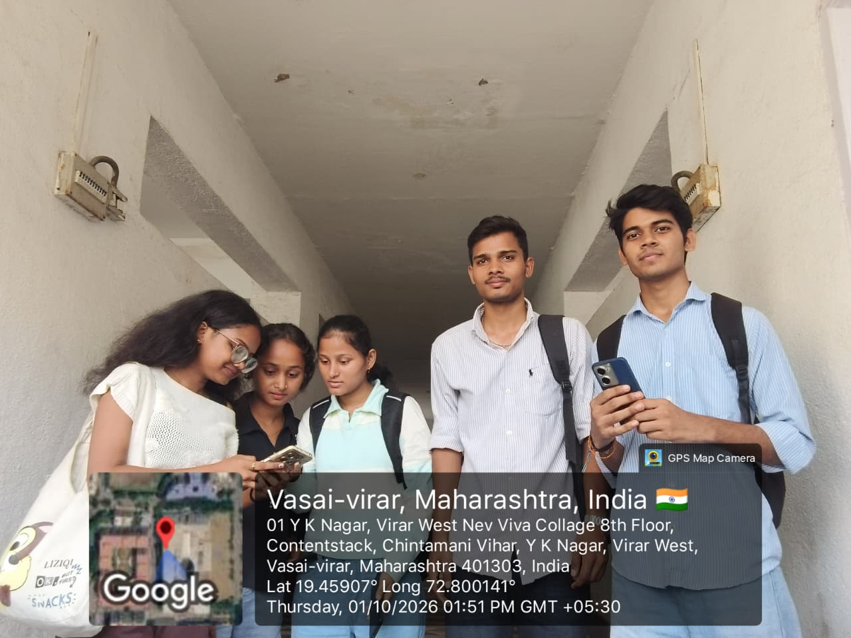
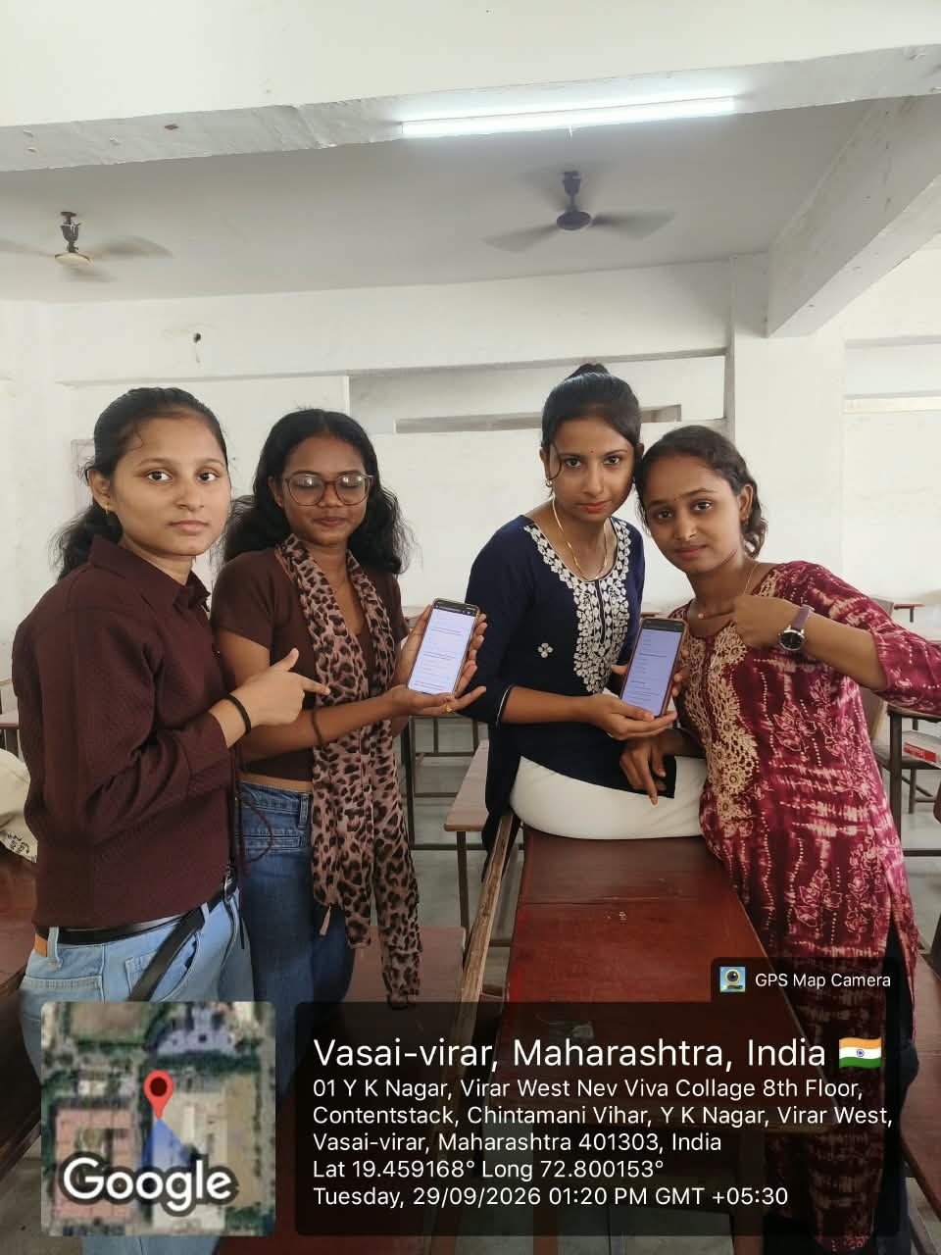
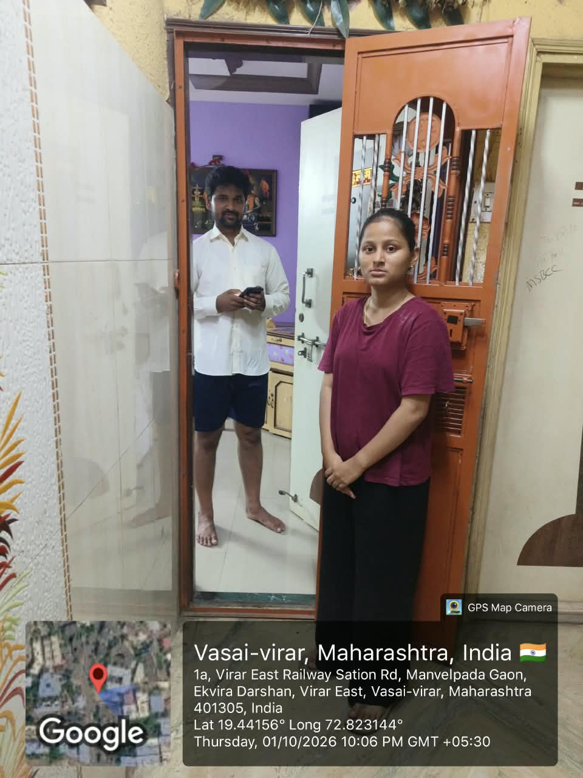
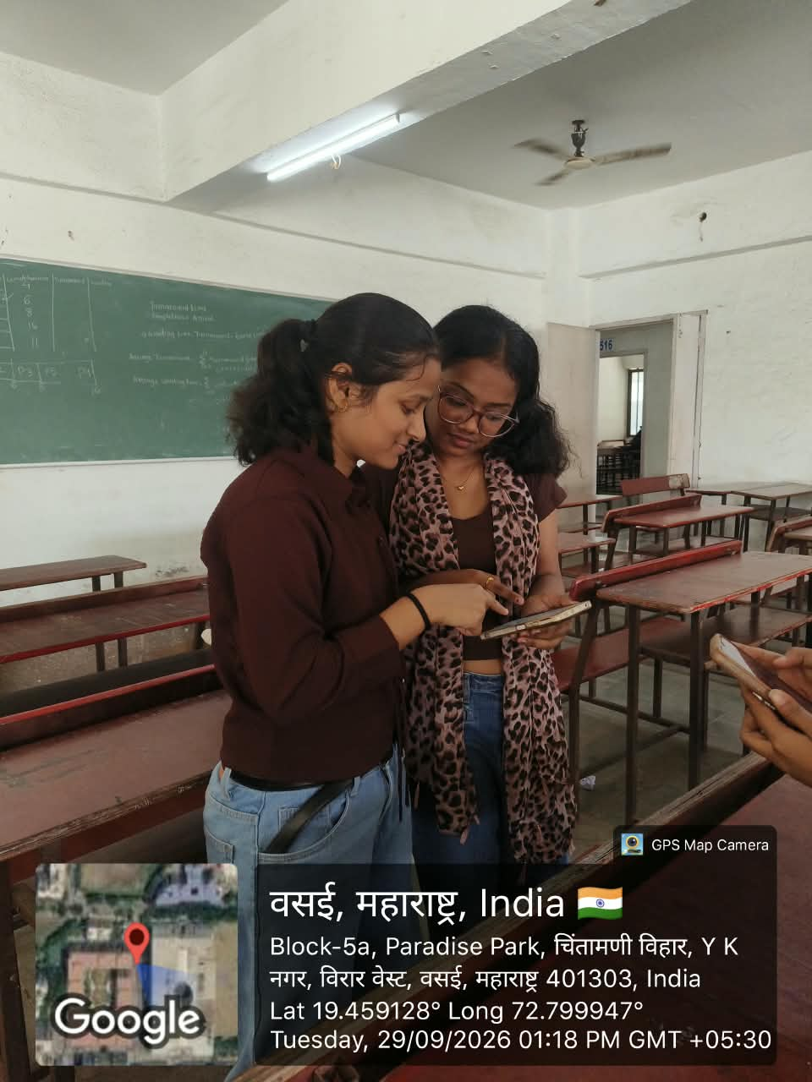
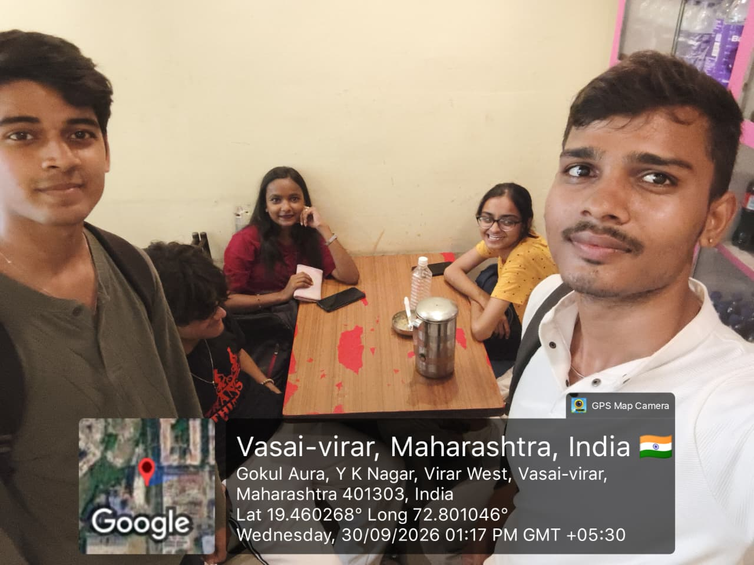
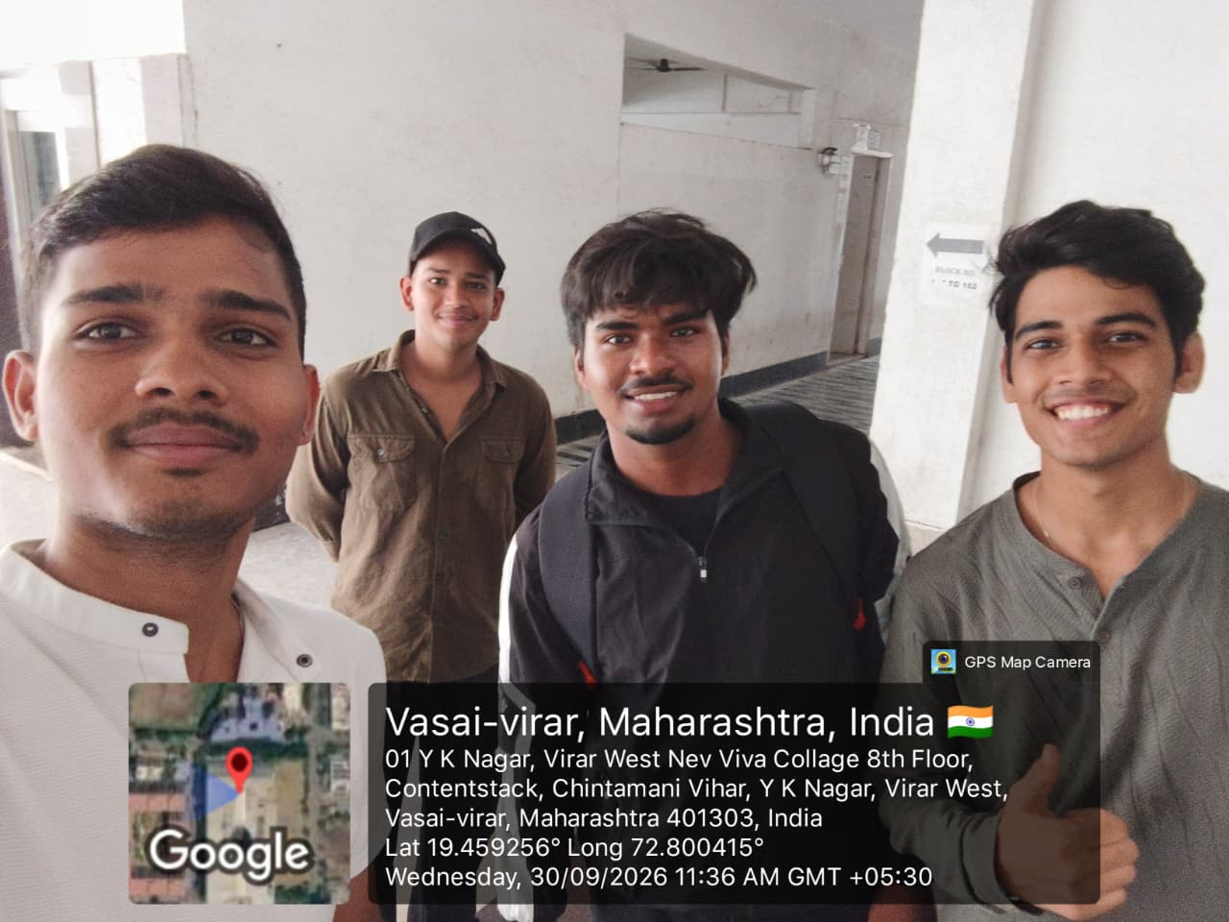
Below is the structured layout for inserting your geotagged field photos captured during respondent interactions across Virar (West):

