Experiment No - 1

Aim- To implement Inter-Process Communication between client and server using Python socket programming.

Theory: Inter-Process Communication (IPC) is a mechanism that allows processes to exchange information. In distributed systems, processes may run on different machines connected through a network. Communication between these processes is achieved using networking protocols such as TCP/IP.Socket programming is a method used for communication between two systems over a network. A socket acts as an endpoint of communication. The server waits for connection requests, while the client initiates the communication.
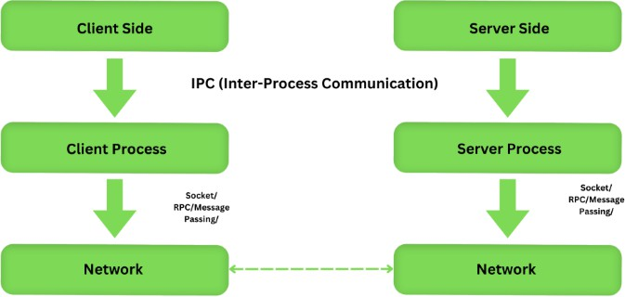
Python provides a socket library that allows easy implementation of network communication.
Fig 1: Inter process Communication Process

Sockets Mechanism
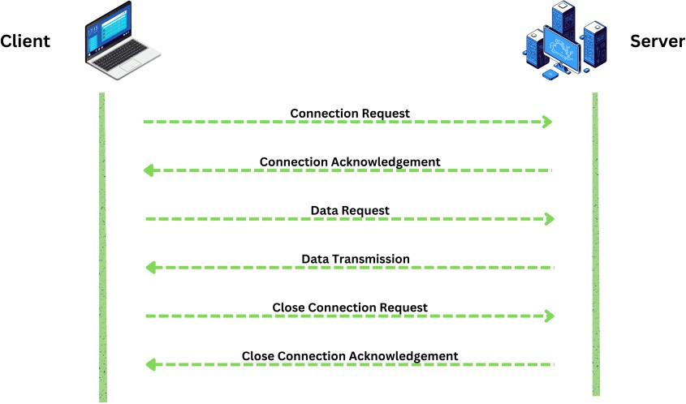
The Sockets are the End Points of Communication between two machines. They provide a way for processes to communicate with each other, either on the same on machine or over the Internet also possible. The Sockets enable the communication connection between Server and the client to transfer data in a bidirectional way.
Fig 2: Client Server Communication using Sockets

Algorithm:

- Import the socket module.
- Create a server socket.
- Bind the socket to host and port.
- Start listening for client connections.
- Accept connection requests from clients.
- Receive message from client.
- Display the message.
- Close the connection.

Program:
Client-
import socket

# Create socket object
client_socket = socket.socket(socket.AF_INET, socket.SOCK_STREAM)

# Server details
host = '127.0.0.1'
port = 12345

# Connect to server
client_socket.connect((host, port))
print("Connected to server!")

while True:
# Send message to server
message = input("Client: ")
client_socket.send(message.encode())

if message.lower() == 'exit':
print("Connection closed.")
break

# Receive response from server
data = client_socket.recv(1024).decode()
print(f"Server: {data}")

if data.lower() == 'exit':
print("Server ended the connection.")
break

# Close socket
client_socket.close()

Server-
import socket
# Create a socket object
server_socket = socket.socket(socket.AF_INET, socket.SOCK_STREAM)
# Define host and port
host = '127.0.0.1' # Localhost
port = 12345
# Bind the socket
server_socket.bind((host, port))
# Listen for connections
server_socket.listen(5)
print("Server is waiting for connection...")
# Accept connection
conn, addr = server_socket.accept()
print(f"Connected to client: {addr}")
while True:
# Receive data from client
data = conn.recv(1024).decode()
if not data:
break
print(f"Client: {data}")
# Exit condition
if data.lower() == 'exit':
print("Connection closed by client.")
break
# Send response to client
message = input("Server: ")
conn.send(message.encode())
if message.lower() == 'exit':
print("Connection closed by server.")
break
# Close connection
conn.close()
server_socket.close()

Result:

Experiment No - 2

Aim: To implement Remote Procedure / RMI Call between client and server.

Theory: Remote Procedure Call (RPC) is a protocol that allows a program to execute a procedure on another machine without knowing network details. Python provides an XMLRPC library that allows functions to be called remotely over HTTP.RPC simplifies distributed programming by making remote calls appear like local function calls.
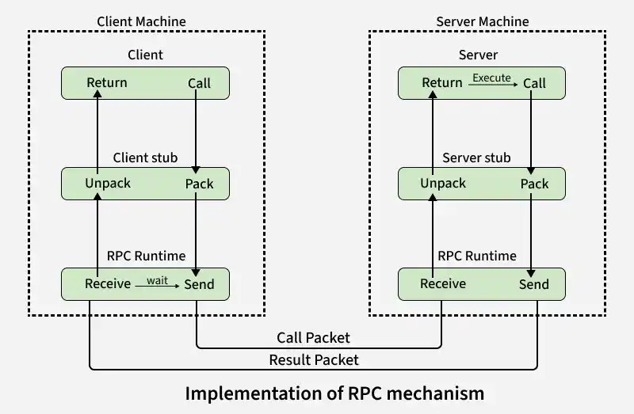

How RPC Works (Step by Step)
- Client Calls Stub: The client calls a local procedure (stub) as if it were normal.

- Marshalling: The stub packs (marshals) all input parameters into a message.
- Send to Server: The message is sent across the network to the server.
- Server Stub: The server stub unpacks the message and calls the actual server procedure.
- Execution & Return: The server runs the procedure and returns the result to the stub.
- Back to Client: The server stub sends the result back, and the client stub unpacks it.
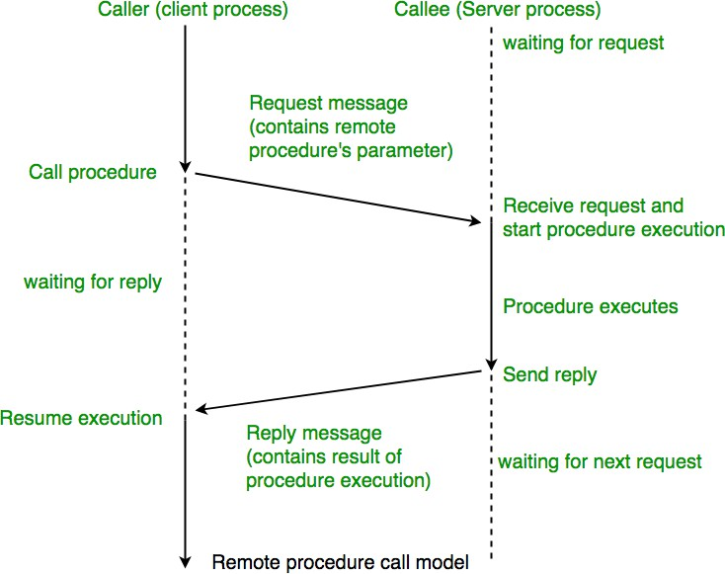

Algorithm
- Create an RPC server.
- Define a function to perform computation.
- Register the function with the server.
- Start the server.
- Client connects to server.
- Client invokes remote function.
- The server processes requests and returns results.

Program:

Server-
import socket
import json
# Define functions that can be called remotely
def add(a, b):
return a + b
def subtract(a, b):
return a - b
def multiply(a, b):
return a * b
def divide(a, b):
if b == 0:
return "Error: Division by zero"
return a / b

# Function mapping
functions = {
"add": add,
"subtract": subtract,
"multiply": multiply,
"divide": divide
}
# Create socket
server = socket.socket(socket.AF_INET, socket.SOCK_STREAM)
server.bind(('127.0.0.1', 5000))
server.listen(5)
print("RPC Server is running...")
while True:
conn, addr = server.accept()
print(f"Connected to {addr}")
data = conn.recv(1024).decode()
request = json.loads(data)
func_name = request["function"]
args = request["args"]

print(f"Client requested: {func_name}{tuple(args)}")
# Execute function
if func_name in functions:
try:
result = functions[func_name](*args)
except Exception as e:
result = str(e)
else:
result = "Error: Function not found"
# Send response
response = json.dumps({"result": result})
conn.send(response.encode())

conn.close()

Client-
import socket
import json
def call_remote_function(function_name, args):
client = socket.socket(socket.AF_INET, socket.SOCK_STREAM)
client.connect(('127.0.0.1', 5000))

# Create request
request = {
"function": function_name,
"args": args
}
client.send(json.dumps(request).encode())
# Receive response
response = client.recv(1024).decode()
result = json.loads(response)
client.close()
return result["result"]
# User interaction
while True:
print("\nAvailable functions: add, subtract, multiply, divide")
func = input("Enter function name (or 'exit'): ")
if func.lower() == 'exit':
break
a = float(input("Enter first number: "))
b = float(input("Enter second number: "))
result = call_remote_function(func, [a, b])
print("Result from server:", result)

Result:

Remote Method Invocation in Java
Remote Method Invocation (RMI) is an API that allows an object to invoke a method on an object that exists in another address space, which could be on the same machine or on a remote machine. Through RMI, an object running in a JVM present on a computer (Client-side) can invoke methods on an object present in another JVM (Server-side). RMI creates a public remote server object that enables client and server-side communications through simple method calls on the server object.
Stub Object: The stub object on the client machine builds an information block and sends this information to the server.
The block consists of
An identifier of the remote object to be used
Method name which is to be invoked
Parameters to the remote JVM

Skeleton Object: The skeleton object passes the request from the stub object to the remote object. It performs the following tasks
It calls the desired method on the real object present on the server.
It forwards the parameters received from the stub object to the method.

Working of RMI
The communication between client and server is handled by using two intermediate objects: Stub object (on client side) and Skeleton object (on server-side) as also can be depicted from below media as follows:

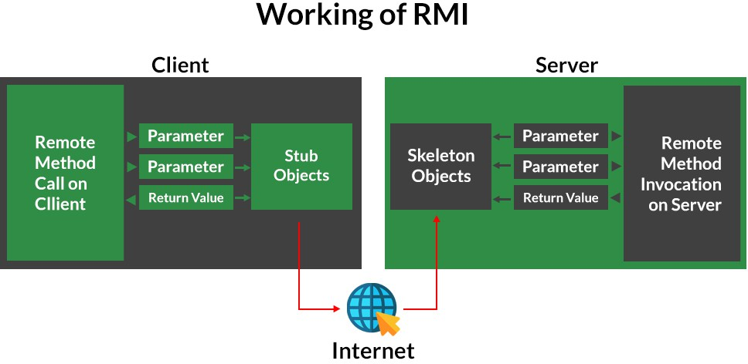

These are the steps to be followed sequentially to implement Interface as defined below as follows:
- Defining a remote interface
- Implementing the remote interface
- Creating Stub and Skeleton objects from the implementation class using rmic (RMI compiler)
- Start the rmi registry
- Create and execute the server application program
- Create and execute the client application program.

Program:
import java.rmi.*;
import java.rmi.registry.*;
import java.rmi.server.*;

/* =======================
Remote Interface (RPC)
======================= */
interface HelloService extends Remote {
String sayHello(String name) throws RemoteException;
}

/* =======================
Remote Implementation
======================= */
class HelloServiceImpl extends UnicastRemoteObject
implements HelloService {

protected HelloServiceImpl() throws RemoteException {
super();
}

@Override
public String sayHello(String name) throws RemoteException {
return "Hello " + name + ", this message is from RMI Server!";
}
}
/* =======================
Main Class (Server + Client)
====================== */
public class RMIRPC {

// -------- SERVER --------
static void startServer() {
try {
LocateRegistry.createRegistry(1099);
HelloService service = new HelloServiceImpl();
Naming.rebind("rmi://localhost/HelloService", service);
System.out.println("✅ RMI Server started...");
} catch (Exception e) {
e.printStackTrace();
}
}
// -------- CLIENT --------
static void startClient() {
try {
HelloService service =
(HelloService) Naming.lookup("rmi://localhost/HelloService");

String response = service.sayHello("Student");
System.out.println("📩 Server Response: " + response);
} catch (Exception e) {
e.printStackTrace();
}
}

// -------- MAIN --------
public static void main(String[] args) {
if (args.length == 0) {
System.out.println("Usage:");
System.out.println(" java RMIRPC server");
System.out.println(" java RMIRPC client");
return;
}

if (args[0].equalsIgnoreCase("server")) {
startServer();
} else if (args[0].equalsIgnoreCase("client")) {
startClient();
}
}
}

Result:

Experiment No -3

Aim: To implement group communication using multicast.

Theory: Group communication allows one sender to transmit messages to multiple receivers simultaneously. Multicast networking enables efficient communication with multiple nodes without sending individual messages.
Types of Group Communication in a Distributed System

Below are the three types of group communication in distributed systems:
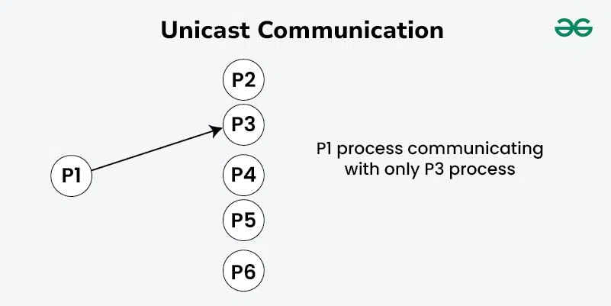
- Unicast Communication
Fig: Unicast Communication
- Unicast communication is the point-to-point transmission of data between two nodes in a network. In the context of distributed systems:

- Unicast is when a sender sends a message to a specific recipient, using their unique network address.
- Each message targets one recipient, creating a direct connection between the sender and the receiver.
- You commonly see unicast in client-server setups, where a client makes requests and receives responses, as well as in direct connections between peers.
- This method makes good use of network resources, is easy to implement, and keeps latency low because messages go straight to the right person.
- Unicast isn’t efficient for sending messages to many recipients at once, as it requires separate messages for each one, leading to more work.

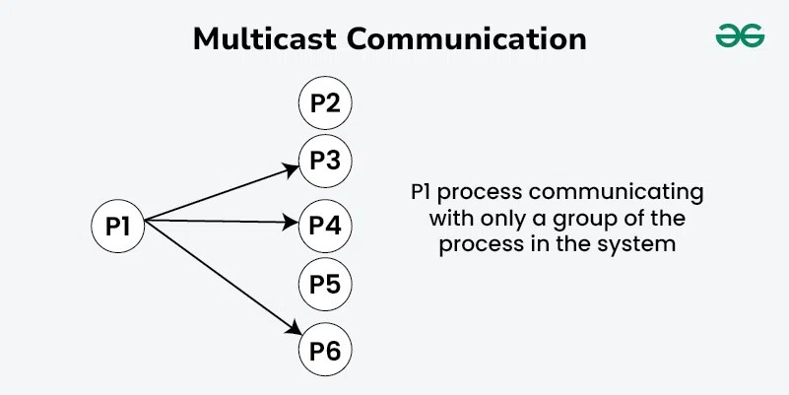
- Multicast Communication
Fig: Multicast Communication
Multicast communication involves sending a single message from one sender to multiple receivers simultaneously within a network. It is particularly useful in distributed systems where broadcasting information to a group of nodes is necessary:
- Multicast lets a sender share a message with a specific group of people who want it.
- This way, the sender can reach many people at once, which is more efficient than sending separate messages.

- This approach is often used to send updates to subscribers or in collaborative applications where real-time sharing of changes is needed.
- By sending data just once to a group, multicast saves bandwidth, simplifies communication, and can easily handle a larger number of recipients.
- Managing group membership is necessary to ensure reliable message delivery, and multicast can run into issues if there are network problems that affect everyone in the group.

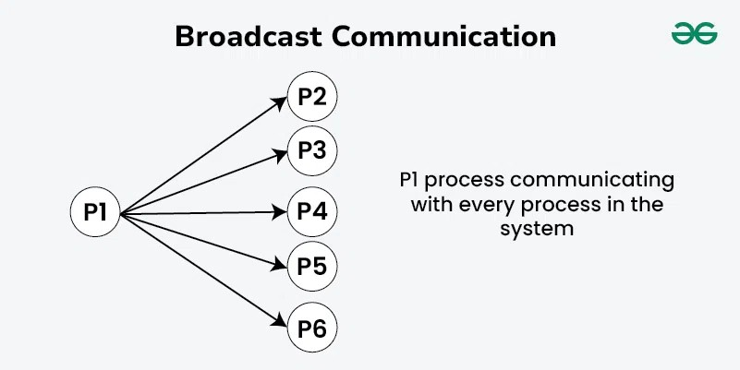
- Broadcast Communication
- Fig: Broadcast Communication

Broadcast communication involves sending a message from one sender to all nodes in the network, ensuring that every node receives the message:

- Broadcast is when a sender sends a message to every node in the network without targeting specific recipients.
- Messages are delivered to all nodes at once using a special address designed for this purpose.
- It’s often used for network management tasks, like sending status updates, or for emergency alerts that need to reach everyone quickly.

- Broadcast ensures that every node receives the message without needing to specify who the recipients are, making it efficient for sharing information widely.
- It can cause network congestion in larger networks and raises security concerns since anyone on the network can access the broadcast message, which might lead to unauthorized access.

Algorithm:
- Create a sender program.
- Define multicast IP address and port.
- Send a message to the multicast group.
- Create a receiver program.
- Join a multicast group.
- Receive and display messages.

Program:

Sender-
import socket
import time
MCAST_GRP = '224.1.1.1'
MCAST_PORT = 5007
# Create UDP socket
sock = socket.socket(socket.AF_INET, socket.SOCK_DGRAM, socket.IPPROTO_UDP)

# Set TTL (time-to-live)
sock.setsockopt(socket.IPPROTO_IP, socket.IP_MULTICAST_TTL, 2)

print("Multicast Sender Started...")

while True:
message = input("Enter message to send (or 'exit'): ")

if message.lower() == 'exit':
break

sock.sendto(message.encode(), (MCAST_GRP, MCAST_PORT))

Receiver-
import socket
import struct
# Multicast group details
MCAST_GRP = '224.1.1.1'
MCAST_PORT = 5007
# Create socket
sock = socket.socket(socket.AF_INET, socket.SOCK_DGRAM, socket.IPPROTO_UDP)
# Allow multiple clients to use same port
sock.setsockopt(socket.SOL_SOCKET, socket.SO_REUSEADDR, 1)
# Bind to the server address
sock.bind(('', MCAST_PORT))
# Join multicast group
mreq = struct.pack("4sl", socket.inet_aton(MCAST_GRP), socket.INADDR_ANY)
sock.setsockopt(socket.IPPROTO_IP, socket.IP_ADD_MEMBERSHIP, mreq)

print("Receiver joined multicast group...")
while True:
data, addr = sock.recvfrom(1024)
print(f"Message from {addr}: {data.decode()}")

Result:

Experiment 4

Clock Synchronization (Cristian’s Algorithm Simulation)
Aim: To simulate clock synchronization in distributed systems.

Theory: In distributed systems, each node has its own clock which may differ from others. Clock synchronization ensures all systems maintain consistent time. Cristian’s algorithm synchronizes a client clock with a time server.

Cristian's Algorithm is a clock synchronization algorithm used to synchronize time with a time server by client processes. This algorithm works well with low-latency networks where Round Trip Time is short as compared to accuracy while redundancy-prone distributed systems/applications do not go hand in hand with this algorithm. Here Round Trip Time refers to the time duration between the start of a Request and the end of the corresponding Response.
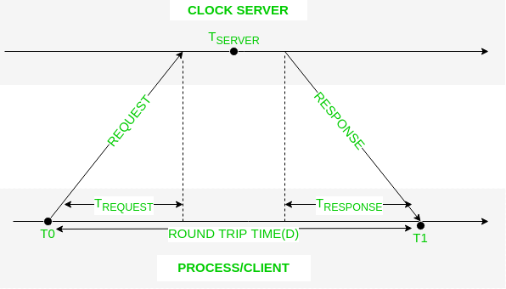
Below is an illustration imitating the working of Cristian's algorithm:

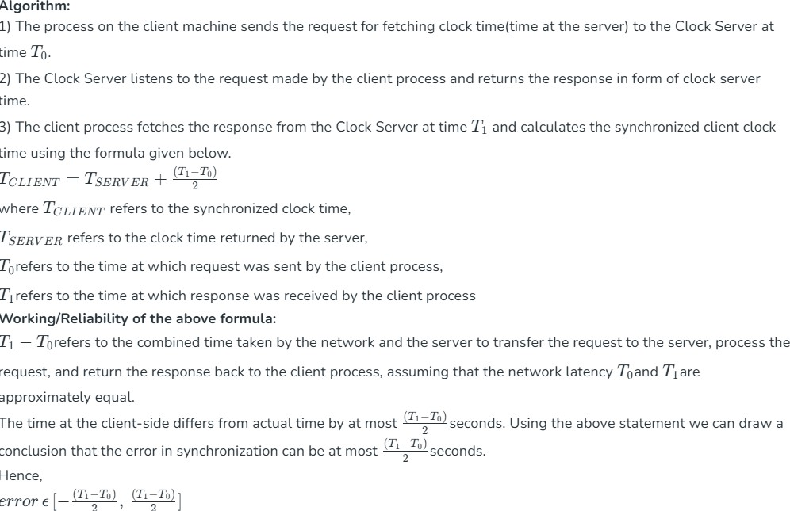Program:

Server-
import socket
import time
HOST = '127.0.0.1'
PORT = 5000
server_socket = socket.socket(socket.AF_INET, socket.SOCK_STREAM)
server_socket.bind((HOST, PORT))
server_socket.listen(5)
print("Time Server is running...")
while True:
conn, addr = server_socket.accept()
print(f"Connected by {addr}")
# Receive request
data = conn.recv(1024)

if not data:
break
# Get server time
server_time = time.time()
# Send server time
conn.send(str(server_time).encode())
conn.close()

Client-
import socket
import time

HOST = '127.0.0.1'
PORT = 5000

client_socket = socket.socket(socket.AF_INET, socket.SOCK_STREAM)

# Record request time (T0)
T0 = time.time()

client_socket.connect((HOST, PORT))
client_socket.send(b"Request Time")

# Receive server time (Ts)
data = client_socket.recv(1024)
T1 = time.time()

Ts = float(data.decode())

client_socket.close()

# Calculate Round Trip Time (RTT)
RTT = T1 - T0

# Cristian’s Algorithm adjustment
client_time = Ts + (RTT / 2)

print("\n--- Clock Synchronization ---")
print(f"Client Request Time (T0): {T0}")
print(f"Server Time (Ts): {Ts}")
print(f"Client Receive Time (T1): {T1}")
print(f"Round Trip Time (RTT): {RTT}")
print(f"Synchronized Client Time: {client_time}")
print(f"Local System Time: {time.time()}")

Result:

Experiment 5

Aim: To simulate leader election using Bully Algorithm.

Theory: Election algorithms are used to choose a coordinator among distributed processes when the existing coordinator fails. In the Bully algorithm, the process with the highest ID becomes the new coordinator.
In distributed systems, leader election algorithms are used to select a coordinator among multiple processes when the current coordinator fails. The Ring Algorithm is a distributed election algorithm where processes are arranged in a logical ring structure.
In this algorithm, each process has a unique ID and knows the ID of its neighbor in the ring. When a process detects that the coordinator has failed, it initiates an election message containing its own ID and passes it to the next process in the ring.
Each process that receives the election message compares its own ID with the ID in the message. If its ID is higher, it replaces the ID in the message with its own and forwards it to the next process. This process continues until the message returns to the initiator.
The process with the highest ID becomes the new coordinator and announces itself to all other processes in the ring.

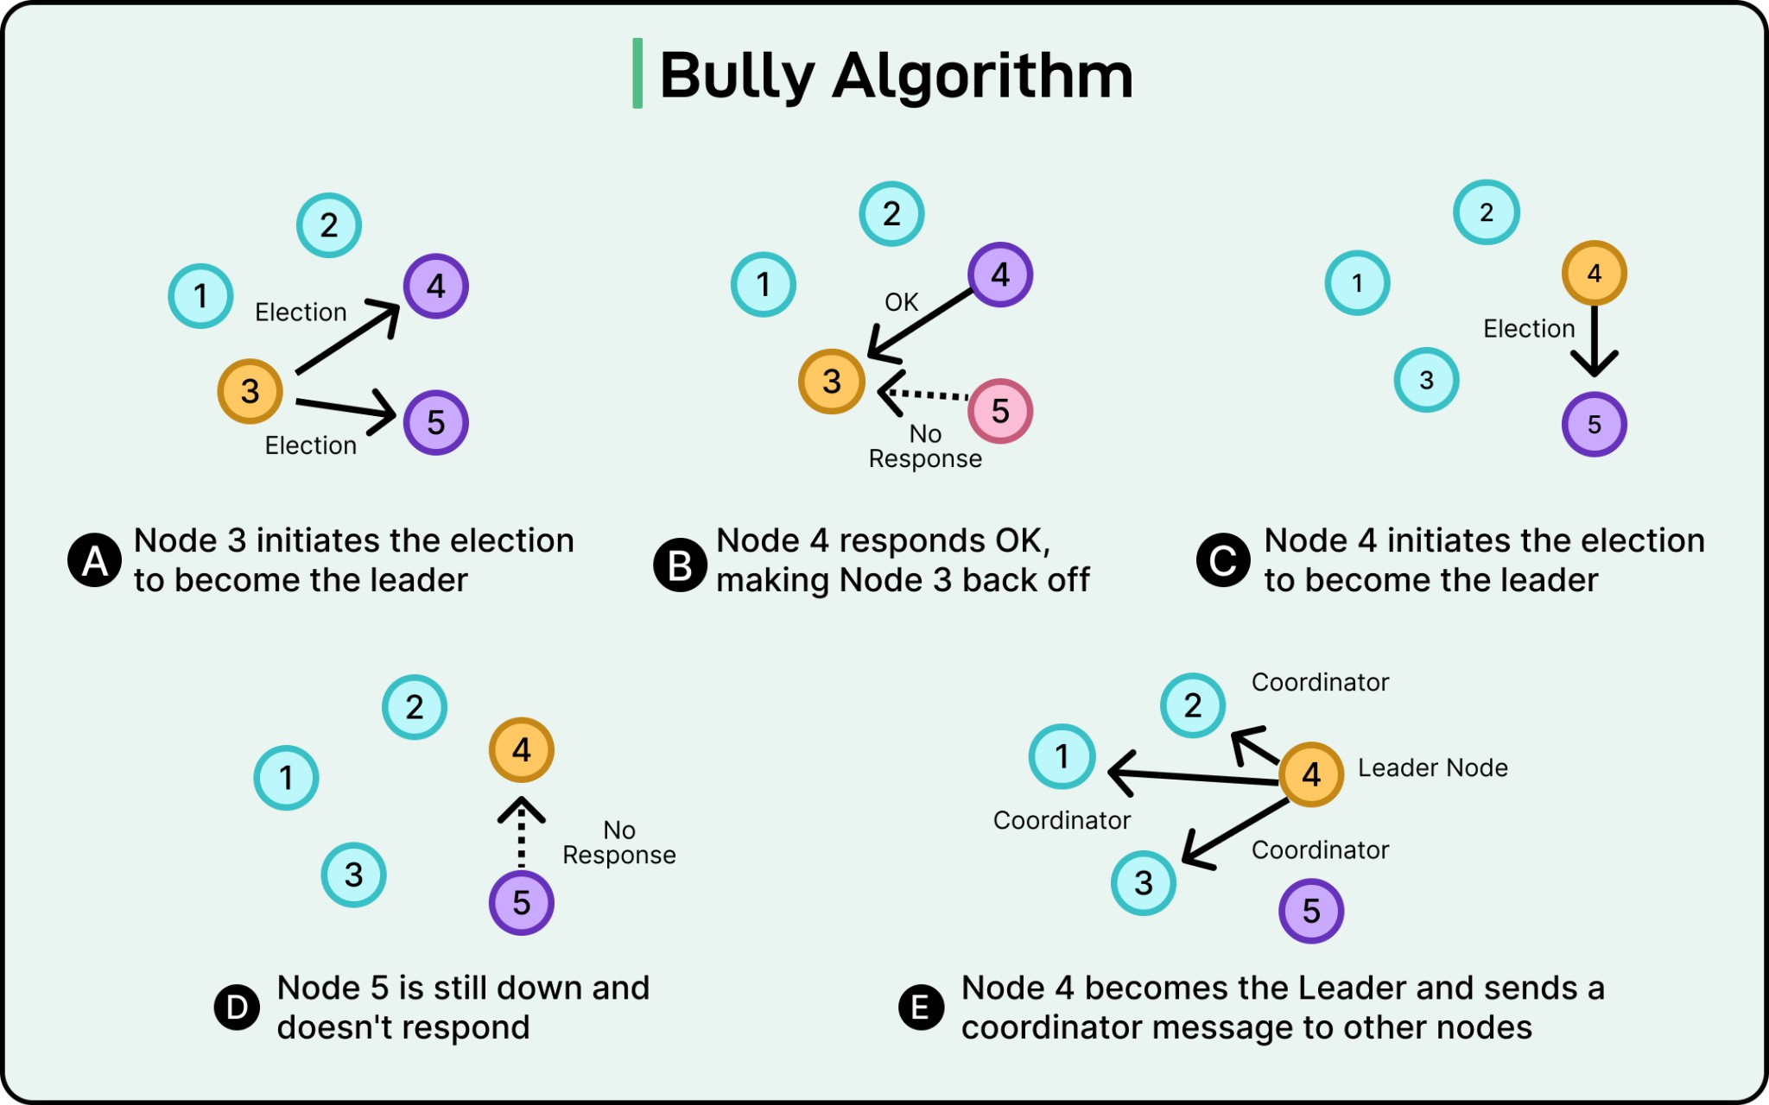

Algorithm:
- Define a list of processes with unique IDs.
- Arrange the processes logically in a ring structure.
- Select a process to initiate the election.
- Pass the election message to the next process in the ring.
- Each process compares its ID with the received ID.
- The highest ID is selected as the coordinator.
- Display the elected coordinator.

Program:

import time
class Process:
def __init__(self, pid):
self.pid = pid
self.alive = True
class BullyAlgorithm:
def __init__(self, num_processes):
self.processes = [Process(i) for i in range(1, num_processes + 1)]
self.coordinator = max(self.processes, key=lambda p: p.pid)
def display_processes(self):
print("\nProcess Status:")
for p in self.processes:
status = "Alive" if p.alive else "Down"
print(f"Process {p.pid}: {status}")
print(f"Current Coordinator: P{self.coordinator.pid}")
def crash_process(self, pid):
for p in self.processes:
if p.pid == pid:
p.alive = False
print(f"\n Process {pid} crashed!")

if self.coordinator.pid == pid:
print("Coordinator crashed! Starting election...")
self.start_election(self.get_highest_alive())
return
def get_highest_alive(self):
alive = [p for p in self.processes if p.alive]
return max(alive, key=lambda p: p.pid)
def start_election(self, initiator):
print(f"\n Process {initiator.pid} starts election")
higher_processes = [
p for p in self.processes if p.pid > initiator.pid and p.alive
]
if not higher_processes:
self.coordinator = initiator
print(f"\n Process {initiator.pid} becomes the NEW COORDINATOR")
return
for p in higher_processes:
print(f"Process {initiator.pid} → ELECTION → Process {p.pid}")
time.sleep(1)
# Higher process responds and takes over
next_initiator = max(higher_processes, key=lambda p: p.pid)
print(f"\nProcess {next_initiator.pid} responds OK")
self.start_election(next_initiator)
def recover_process(self, pid):
for p in self.processes:
if p.pid == pid:
p.alive = True
print(f"\n Process {pid} recovered!")
print("Recovered process starts election...")
self.start_election(p)
return
# ---- Simulation ----
if __name__ == "__main__":
system = BullyAlgorithm(5)
system.display_processes()
# Crash current leader
system.crash_process(5)
time.sleep(2)
system.display_processes()
# Recover highest process
system.recover_process(5)
time.sleep(2)
system.display_processes()

Result:

Experiment 6

Aim: To implement mutual exclusion in distributed systems.

Theory: Mutual exclusion ensures that only one process can access a shared resource at a time to prevent conflicts.
Mutual exclusion is a concurrency control property which is introduced to prevent race conditions. It is the requirement that a process can’t enter its critical section while another concurrent process is currently present or executing in its critical section i.e only one process is allowed to execute the critical section at any given instance of time.

Mutual exclusion in single computer system Vs. distributed system: In single computer system, memory and other resources are shared between different processes. The status of shared resources and the status of users is easily available in the shared memory so with the help of shared variable (For example: Semaphores) mutual exclusion problem can be easily solved. In Distributed systems, we neither have shared memory nor a common physical clock and therefore we can’t solve mutual exclusion problem using shared variables. To eliminate the mutual exclusion problem in distributed system approach based on message passing is used. A site in distributed system do not have complete information of state of the system due to lack of shared memory and a common physical clock.

Requirements of Mutual exclusion Algorithm:
- No Deadlock: Two or more sites should not endlessly wait for any message that will never arrive.
- No Starvation: Every site who wants to execute critical section should get an opportunity to execute it in finite time. Any site should not wait indefinitely to execute critical section while other site are repeatedly executing critical section
- Fairness: Each site should get a fair chance to execute critical section. Any request to execute critical section must be executed in the order they are made i.e Critical section execution requests should be executed in the order of their arrival in the system.
- Fault Tolerance: In case of failure, it should be able to recognize it by itself in order to continue functioning without any disruption.

Some points are need to be taken in consideration to understand mutual exclusion fully:
- It is an issue/problem which frequently arises when concurrent access to shared resources by several sites is involved. For example, directory management where updates and reads to a directory must be done atomically to ensure correctness.
- It is a fundamental issue in the design of distributed systems.
- Mutual exclusion for a single computer is not applicable for the shared resources since it involves resource distribution, transmission delays, and lack of global information.

Solution to distributed mutual exclusion: As we know shared variables or a local kernel can’t be used to implement mutual exclusion in distributed systems. Message passing is a way to implement mutual exclusion. Below are the three approaches based on message passing to implement mutual exclusion in distributed systems:
- Token Based Algorithm:
- A unique token is shared among all the sites.
- If a site possesses the unique token, it is allowed to enter its critical section
- This approach uses sequence number to order requests for the critical section.
- Each request for critical section contains a sequence number. This sequence number is used to distinguish old and current requests.
- This approach ensures Mutual exclusion as the token is unique

Example : Suzuki–Kasami Algorithm

- Non-token based approach:
- A site communicates with other sites in order to determine which sites should execute critical section next. This requires exchange of two or more successive round of messages among sites.
- This approach use timestamps instead of sequence number to order requests for the critical section.
- When ever a site make request for critical section, it gets a timestamp. Timestamp is also used to resolve any conflict between critical section requests.
- All algorithm which follows non-token-based approach maintains a logical clock. Logical clocks get updated according to Lamport's scheme
Example : Ricart–Agrawala Algorithm

- Quorum based approach:
- Instead of requesting permission to execute the critical section from all other sites, each site requests only a subset of sites which is called a quorum.
- Any two subsets of sites or Quorum contain a common site.
- This common site is responsible to ensure mutual exclusion

Example : Maekawa’s Algorithm

Program:

import threading
import time
class Process:
def __init__(self, pid, total):
self.pid = pid
self.clock = 0
self.requesting = False
self.timestamp = 0
self.replies = 0
self.total = total
self.deferred = []
def request_cs(self, processes):
self.clock += 1
self.timestamp = self.clock
self.requesting = True
self.replies = 0
print(f"\nProcess {self.pid} requesting CS")
for p in processes:
if p.pid != self.pid:
p.receive_request(self, self.timestamp)

while self.replies < self.total - 1:
time.sleep(0.1)
self.enter_cs()
def receive_request(self, sender, ts):
self.clock = max(self.clock, ts) + 1
if (not self.requesting or
(ts, sender.pid) < (self.timestamp, self.pid)):
sender.receive_reply()
print(f"{self.pid} → REPLY → {sender.pid}")
else:
self.deferred.append(sender)
def receive_reply(self):
self.replies += 1
def enter_cs(self):
print(f"🟢 {self.pid} ENTER CS")
time.sleep(1)
print(f"🔵 {self.pid} EXIT CS")
self.requesting = False
for p in self.deferred:
p.receive_reply()
print(f"{self.pid} (deferred) → REPLY → {p.pid}")
self.deferred.clear()
if __name__ == "__main__":
n = 3
processes = [Process(i, n) for i in range(n)]
threads = []
for p in processes:
t = threading.Thread(target=p.request_cs, args=(processes,))
threads.append(t)
for t in threads:
t.start()
time.sleep(0.5)
for t in threads:
t.join()

Result:

Experiment 7

Aim: To detect deadlock using a wait-for graph.

Theory: Deadlock occurs when processes wait indefinitely for resources held by other processes. A wait-for graph helps identify circular dependencies.
Deadlocks are a fundamental problem in distributed systems. A process may request resources in any order and a process can request resources while holding others. A Deadlock is a situation where a set of processes are blocked as each process in a Distributed system is holding some resources and that acquired resources are needed by some other processes.

Example: If there are three processes p1,p2 and p1 are acquiring r1 resource and that r1 is needed by p2 which is acquiring another resource r2 and that is needed by p1. Here cycle occurs. It is called a deadlock.

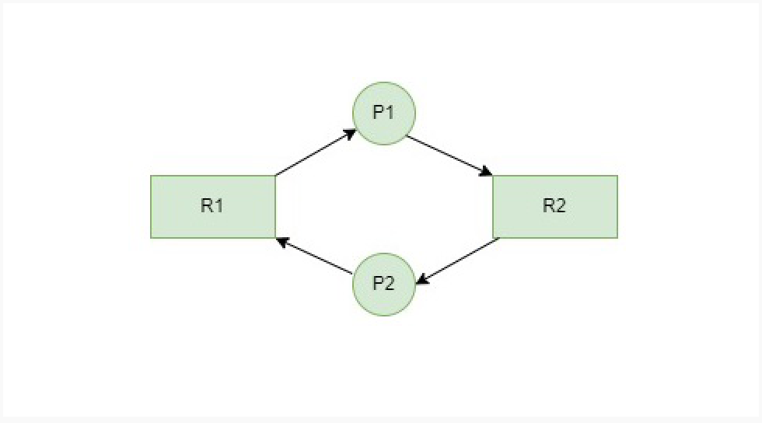
Here in the above graph, we found a cycle from P1 to P2 and again to P1. So we can say that the system is in a deadlock state. The Problem of deadlocks has been generally studied in distributed systems under the following models:
- The system has only reusable resources.
- Processes are allowed only exclusive access to resources.

- There is only one copy of each resource.

Deadlock Detection
The deadlock Detection Algorithm is of two types:
- Wait-for-Graph Algorithm (Single Instance)
- Banker's Algorithm (Multiple Instance)

Wait-for-Graph Algorithm

It is a variant of the Resource Allocation graph. In this algorithm, we only have processes as vertices in the graph. If the Wait-for-Graph contains a cycle then we can say the system is in a Deadlock state. We need to remove resources while converting from Resource Allocation Graph to Wait-for-Graph.

- Resource Allocation Graph: Contains Processes and Resources.
- Wait-for-Graph: Contains only Processes after removing the Resources while conversion from Resource Allocation Graph.

Algorithm:
Below are the steps to follow:
- Step 1: Take the first process (Pi) from the resource allocation graph and check the path in which it is acquiring resource (Ri), and start a
- wait-for-graph with that particular process.
- Step 2: Make a path for the Wait-for-Graph in which there will be no Resource included from the current process (Pi) to next process (Pj), from that next process (Pj) find a resource (Rj) that will be acquired by next Process (Pk) which is released from Process (Pj).
- Step 3: Repeat Step 2 for all the processes.
- Step 4: After completion of all processes, if we find a closed-loop cycle then the system is in a deadlock state, and deadlock is detected.

Example 1:

Consider a Resource Allocation Graph with 4 Processes P1, P2, P3, P4, and 4 Resources R1, R2, R3, R4. Find if there is a deadlock in the Graph using the Wait for Graph-based deadlock detection algorithm.

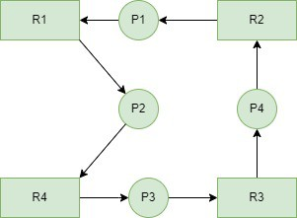 Step 1
First take Process P1 which is waiting for Resource R1, resource R1 is acquired by Process P2, Start a Wait-for-Graph for the above Resource Allocation Graph.

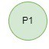

Step 2
Now we can observe that there is a path from P1 to P2 as P1 is waiting for R1 which is been acquired by P2. Now the Graph would be after removing resource R1 looks like.

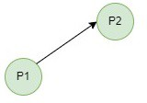

Step 3
From P2 we can observe a path from P2 to P3 as P2 is waiting for R4 which is acquired by P3. So make a path from P2 to P3 after removing resource R4 looks like.

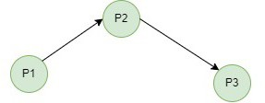

Step 4
From P3 we find a path to P4 as it is waiting for P3 which is acquired by P4. After removing R3 the graph looks like this.

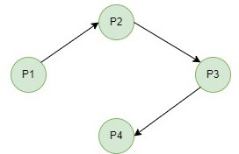

Step 5
Here we can find Process P4 is waiting for R2 which is acquired by P1. So finally, the Wait-for-Graph is as follows:

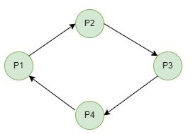

Step 6

Note: Finally In this Graph, we found a cycle as the Process P4 again came back to the Process P1 which is the starting point (i.e., it's a closed-loop). So, According to the Algorithm if we found a closed loop, then the system is in a deadlock state. So here we can say the system is in a deadlock state.

Example 2:

Now consider another Resource Allocation Graph with 4 Processes P1, P2, P3, P4, and 3 Resources R1, R2, R3. Find if there is a deadlock in the Graph using the Wait for Graph-based deadlock detection algorithm.

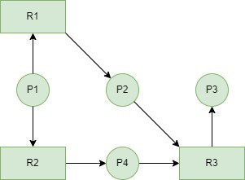 Step 1
First take Process P1 which is waiting for Resource R1, resource R1 is acquired by Process P2, Start a Wait-for-Graph for the above Resource Allocation Graph.



Step 2
Now we can observe that there is a path from P1 to P2 and also from P1 to P4 as P1 is waiting for R1 which is been acquired by P2 and P1 is also waiting for R2 which is acquired by P4. Now the Graph would be after removing resources R1 and R2 looks like.

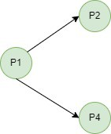 Step 3

From P2 we can observe a path from P2 to P3 as P2 is waiting for R3 which is acquired by P3. So make a path from P2 to P3 after removing resource R3 looks like.
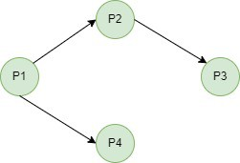
Step 4
Here we can find Process P4 is waiting for R3 which is acquired by P3. So finally the Wait-for-Graph looks like after removing Resource R3 looks like.

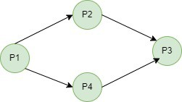 Step 5
In this Graph, we don't find a cycle as no process came back to the starting point (i.e., there is no closed loop). So, According to the Algorithm if we found a closed loop, then the system is in a deadlock state. But here we didn't find any closed loop so the system is not in a deadlock state. The system is in a safe state.

Note: In Example 2, even though it looks like a loop but there is no process that has reached the first process, or starting point again. So there is no closed loop.

Issues in Wait-for-Graph based Deadlock Detection Algorithm
For every resource we call WFG Detection Algorithm, the computation time would be very high for the CPU if there are many resources. The solution for this is, rather than calling this algorithm for every resource request that cannot be granted immediately. Just invoke the algorithm after a definite interval.

- Scalability: Graph maintenance becomes costly in large systems with many processes and resources.
- Overhead: Continuous updating of edges (waits-for relations) increases runtime overhead.
- False Deadlock Detection: Temporary waits may be mistaken for deadlocks if the graph is checked too frequently.
- Delayed Detection: If checked infrequently, real deadlocks may persist for long before detection.
- Complexity: Cycle detection in dynamic graphs requires extra computation.
- Distributed Systems Issue: Constructing a global wait-for-graph is difficult due to partial knowledge and message delays.

Program:

class WaitForGraph:
def __init__(self, processes):
self.graph = {p: [] for p in processes}
def add_edge(self, p1, p2):
# p1 is waiting for p2
self.graph[p1].append(p2)
def detect_deadlock(self):
visited = set()
rec_stack = set()
def dfs(node):
visited.add(node)
rec_stack.add(node)

for neighbor in self.graph[node]:
if neighbor not in visited:
if dfs(neighbor):
return True
elif neighbor in rec_stack:
return True
rec_stack.remove(node)
return False
for process in self.graph:
if process not in visited:
if dfs(process):
return True
return False
# ---- Simulation ----
if __name__ == "__main__":
processes = ["P1", "P2", "P3", "P4"]

wfg = WaitForGraph(processes)

# Add dependencies (Wait relationships)
wfg.add_edge("P1", "P2")
wfg.add_edge("P2", "P3")
wfg.add_edge("P3", "P1") # This creates a cycle (deadlock)
wfg.add_edge("P4", "P2")

print("\nWait-For Graph:")
for p in wfg.graph:
print(f"{p} → {wfg.graph[p]}")

if wfg.detect_deadlock():
print("\n🔴 Deadlock Detected!")
else:
print("\n🟢 No Deadlock.")

Result:

Experiment 8

Aim: To simulate load balancing in distributed systems.

Theory:
Load balancing distributes workloads across multiple processors to improve system performance and avoid overloading.

A load balancer is a device that acts as a reverse proxy and distributes network or application traffic across a number of servers. Load adjusting is the approach to conveying load units (i.e., occupations/assignments) across the organization which is associated with the distributed system. Load adjusting should be possible by the load balancer. The load balancer is a framework that can deal with the load and is utilized to disperse the assignments to the servers. The load balancers allocates the primary undertaking to the main server and the second assignment to the second server.
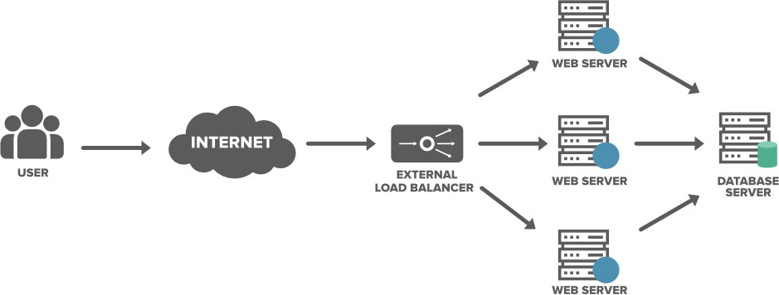

Purpose of Load Balancing in Distributed Systems:

- Security: A load balancer provide safety to your site with practically no progressions to your application.

- Protect applications from emerging threats: The Web Application Firewall (WAF) in the load balancer shields your site.
- Authenticate User Access: The load balancer can demand a username and secret key prior to conceding admittance to your site to safeguard against unapproved access.
- Protect against DDoS attacks: The load balancer can distinguish and drop conveyed refusal of administration (DDoS) traffic before it gets to your site.
- Performance: Load balancers can decrease the load on your web servers and advance traffic for a superior client experience.
- SSL Offload: Protecting traffic with SSL (Secure Sockets Layer) on the load balancer eliminates the upward from web servers bringing about additional assets being accessible for your web application.
- Traffic Compression: A load balancer can pack site traffic giving your clients a vastly improved encounter with your site.

Load Balancing Approaches:

- Round Robin
- Least Connections
- Least Time
- Hash
- IP Hash

Classes of Load Adjusting Calculations:

Following are a portion of the various classes of the load adjusting calculations.
- Static: In this model assuming any hub/node is found with a heavy load, an assignment can be taken arbitrarily and move the undertaking to some other arbitrary system.
- Dynamic: It involves the present status data for load adjusting. These are better calculations than static calculations.
- Deterministic: These calculations utilize processor and cycle attributes to apportion cycles to the hubs.
- Centralized: The framework states data is gathered by a single hub.

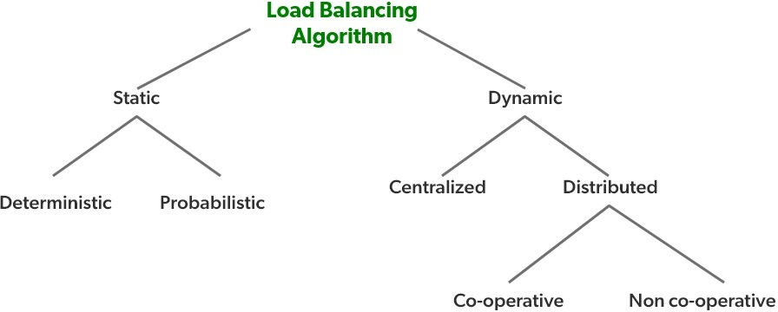
Advantages of Load Balancing:

Load balancers minimize server response time and maximize throughput.
Load balancer ensures high availability and reliability by sending requests only to online servers
Load balancers do continuous health checks to monitor the server’s capability of handling the request.

Migration:

Another important policy to be used by a distributed operating system that supports process migration is to decide about the total number of times a process should be allowed to migrate.

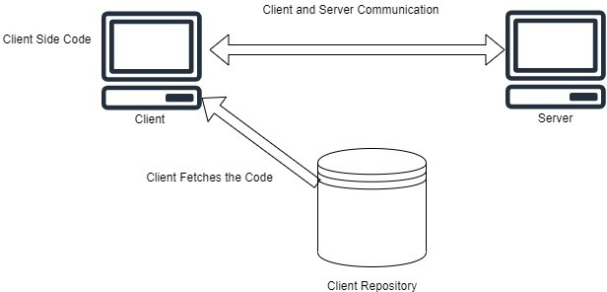

Migration Models:

- Code section
- Resource section
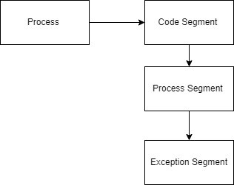
- Execution section

Code section: It contains the real code.
Resource fragment: It contains a reference to outer resources required by the interaction.

Execution section: It stores the ongoing execution condition of interaction, comprising private information, the stack, and the program counter.
Powerless movement: In the powerless relocation just the code section will be moved.
Solid relocation: In this movement, both the code fragment and the execution portion will be moved. The relocation additionally can be started by the source.

Program:

import random
import time
class Server:
def __init__(self, sid):
self.sid = sid
self.load = 0

def assign_task(self, task):
self.load += 1
print(f"Task {task} → Server {self.sid} (Load: {self.load})")
time.sleep(0.3)

def finish_task(self):
if self.load > 0:
self.load -= 1

class LoadBalancer:
def __init__(self, num_servers):
self.servers = [Server(i) for i in range(num_servers)]
self.index = 0 # for round robin

# Round Robin
def round_robin(self, task):
server = self.servers[self.index]
server.assign_task(task)
self.index = (self.index + 1) % len(self.servers)

# Least Loaded
def least_loaded(self, task):
server = min(self.servers, key=lambda s: s.load)
server.assign_task(task)

# Random
def random_assign(self, task):
server = random.choice(self.servers)
server.assign_task(task)

def show_load(self):
print("\nCurrent Server Loads:")
for s in self.servers:
print(f"Server {s.sid}: {s.load}")
# ---- Simulation ----
if __name__ == "__main__":
lb = LoadBalancer(3)

tasks = list(range(1, 11))
print("\n--- Round Robin ---")
for t in tasks:
lb.round_robin(t)
lb.show_load()
time.sleep(1)
print("\n--- Least Loaded ---")
for t in tasks:
lb.least_loaded(t)
lb.show_load()
time.sleep(1)
print("\n--- Random Assignment ---")
for t in tasks:
lb.random_assign(t)
lb.show_load()

Result:

Experiment 9

Aim: To simulate distributed shared memory.

Theory: Distributed Shared Memory (DSM) allows multiple systems to access shared data as if they share the same memory.
Distributed shared memory can be achieved via both software and hardware. Hardware examples include cache coherence circuits and network interface controllers. In contrast, software DSM systems implemented at the library or language level are not transparent and developers usually have to program them differently.

What is Distributed Shared Memory?
It is a mechanism that manages memory across multiple nodes and makes inter-process communications transparent to end-users. The applications will think that they are running on shared memory. DSM is a mechanism of allowing user processes to access shared data without using inter-process communications. In DSM every node has its own memory and provides memory read and write services and it provides consistency protocols. The distributed shared memory (DSM) implements the shared memory model in distributed systems but it doesn't have physical shared memory. All the nodes share the virtual address space provided by the shared memory model. The Data moves between the main memories of different nodes.

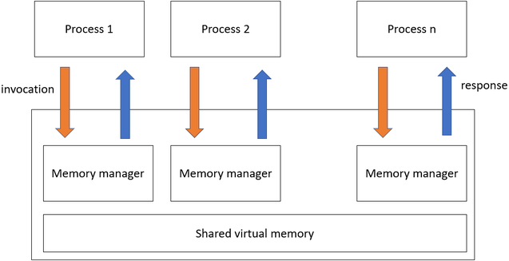
Types of Distributed Shared Memory
- On-Chip Memory
- The data is present in the CPU portion of the chip.
- Memory is directly connected to address lines.
- On-Chip Memory DSM is expensive and complex.

- Bus-Based Multiprocessors
- A set of parallel wires called a bus acts as a connection between CPU and memory.
- Accessing of same memory simultaneously by multiple CPUs is prevented by using some algorithms.
- Cache memory is used to reduce network traffic.

- Ring-Based Multiprocessors
- There is no global centralized memory present in Ring-based DSM.
- All nodes are connected via a token passing ring.
- In ring-bases DSM a single address line is divided into the shared area.

Advantages of Distributed Shared Memory

- Simpler Abstraction: Programmer need not concern about data movement, as the address space is the same it is easier to implement than RPC.
- Easier Portability: The access protocols used in DSM allow for a natural transition from sequential to distributed systems. DSM programs are portable as they use a common programming interface.
- Locality of Data: Data moved in large blocks i.e. data near to the current memory location that is being fetched, may be needed future so it will be also fetched.
- On-Demand Data Movement: It provided by DSM will eliminate the data exchange phase.
- Larger Memory Space: It provides large virtual memory space, the total memory size is the sum of the memory size of all the nodes, paging activities are reduced.
- Better Performance: DSM improve performance and efficiency by speeding up access to data.
- Flexible Communication Environment: They can join and leave DSM system without affecting the others as there is no need for sender and receiver to existing,
- Process Migration Simplified: They all share the address space so one process can easily be moved to a different machine.

Disadvantages of Distributed Shared Memory
- Accessibility: The data access is slow in DSM as compare to non-distributed.
- Consistency: When programming is done in DSM systems, programmers need to maintain consistency.
- Message Passing: DSM use asynchronous message passing and is not efficient as per other message passing implementation.
- Data Redundancy: DSM allows simultaneous access to data, consistency and data redundancy is common disadvantage.
- Lower Performance: CPU gets slowed down, even cache memory does not aid the situation.

Program:

import threading
import time

class DSM:
def __init__(self, num_nodes):
self.memory = {"x": 0} # shared variable
self.nodes = [Node(i, self) for i in range(num_nodes)]

def broadcast_update(self, key, value, source_id):
print(f"\n Broadcasting update: {key} = {value} from Node {source_id}")
for node in self.nodes:
if node.node_id != source_id:
node.update_local_copy(key, value)

class Node:
def __init__(self, node_id, dsm):
self.node_id = node_id
self.dsm = dsm
self.local_memory = dict(dsm.memory)

def read(self, key):
value = self.local_memory.get(key, None)
print(f"Node {self.node_id} READ {key} = {value}")
return value

def write(self, key, value):
print(f"\n Node {self.node_id} WRITE {key} = {value}")
self.local_memory[key] = value

# Update global memory
self.dsm.memory[key] = value

# Broadcast change to other nodes
self.dsm.broadcast_update(key, value, self.node_id)

def update_local_copy(self, key, value):
print(f"Node {self.node_id} updating {key} = {value}")
self.local_memory[key] = value

# ---- Simulation ----
def node_work(node):
time.sleep(node.node_id)

node.read("x")
new_value = node.node_id * 10
node.write("x", new_value)
time.sleep(1)
node.read("x")

if __name__ == "__main__":
dsm = DSM(3)

threads = []
for node in dsm.nodes:
t = threading.Thread(target=node_work, args=(node,))
threads.append(t)

for t in threads:
t.start()

for t in threads:
t.join()

Result:

Experiment 10

Aim: Study of Distributed File System (AFS/CODA)

Theory: A distributed file system (DFS) is a networked architecture that allows multiple users and applications to access and manage files across various machines as if they were on a local storage device. Instead of storing data on a single server, a DFS spreads files across multiple locations, enhancing redundancy and reliability.
- This setup not only improves performance by enabling parallel access but also simplifies data sharing and collaboration among users.
- By abstracting the complexities of the underlying hardware, a distributed file system provides a seamless experience for file operations, making it easier to manage large volumes of data in a scalable manner.

Components of DFS
- Location Transparency: Location Transparency achieves through the namespace component.
- Redundancy: Redundancy is done through a file replication component.

In the case of failure and heavy load, these components together improve data availability by allowing the sharing of data in different locations to be logically grouped under one folder, which is known as the "DFS root". It is not necessary to use both the two components of DFS together, it is possible to use the namespace component without using the file replication component and it is perfectly possible to use the file replication component without using the namespace component between servers.

Distributed File System Replication
Early iterations of DFS made use of Microsoft's File Replication Service (FRS), which allowed for straightforward file replication between servers. The most recent iterations of the whole file are distributed to all servers by FRS, which recognises new or updated files. "DFS Replication" was developed by Windows Server 2003 R2 (DFSR). By only copying the portions of files that have changed and minimising network traffic with data compression, it helps to improve FRS. Also,

it provides users with flexible configuration options to manage network traffic on a configurable schedule.
Features of DFS
- Transparency
- Structure transparency: There is no need for the client to know about the number or locations of file servers and the storage devices. Multiple file servers should be provided for performance, adaptability, and dependability.
- Access transparency: Both local and remote files should be accessible in the same manner. The file system should be automatically located on the accessed file and send it to the client’s side.
- Naming transparency: There should not be any hint in the name of the file to the location of the file. Once a name is given to the file, it should not be changed during transferring from one node to another.
- Replication transparency: If a file is copied on multiple nodes, both the copies of the file and their locations should be hidden from one node to another.
- User mobility: It will automatically bring the user's home directory to the node where the user logs in.
- Performance: Performance is based on the average amount of time needed to convince the client requests. This time covers the CPU time + time taken to access secondary storage + network access time. It is advisable that the performance of the Distributed File System be similar to that of a centralized file system.
- Simplicity and ease of use: The user interface of a file system should be simple and the number of commands in the file should be small.
- High availability: A Distributed File System should be able to continue in case of any partial failures like a link failure, a node failure, or a storage drive crash. A high authentic and adaptable distributed file system should have different and independent file servers for controlling different and independent storage devices.
- Scalability: Since growing the network by adding new machines or joining two networks together is routine, the distributed system will inevitably grow over time. As a result, a good distributed file system should be built to scale quickly as the number of nodes and users in the system grows. Service should not be substantially disrupted as the number of nodes and users grows.
- Data integrity: Multiple users frequently share a file system. The integrity of data saved in a shared file must be guaranteed by the file system. That is, concurrent access requests from many users who are competing for access to the same file must be correctly synchronized using a concurrency control method. Atomic transactions are a high-level concurrency management mechanism for data integrity that is frequently offered to users by a file system.
- Security: A distributed file system should be secure so that its users may trust that their data will be kept private. To safeguard the information contained in the file system from unwanted & unauthorized access, security mechanisms must be implemented.

History of DFS
The server component of the Distributed File System was initially introduced as an add-on feature. It was added to Windows NT 4.0 Server and was known as "DFS
4.1". Then later on it was included as a standard component for all editions of Windows 2000 Server. Client-side support has been included in Windows NT 4.0 and also in later on version of Windows. Linux kernels 2.6.14 and versions after it come with an SMB client VFS known as "cifs" which supports DFS. Mac OS X 10.7 (lion) and onwards supports Mac OS X DFS.

Working of DFS
There are two ways in which DFS can be implemented:

- Standalone DFS namespace allows only for those DFS roots that exist on the local computer and are not using Active Directory. A Standalone DFS can only be acquired on those computers on which it is created. It does not provide any fault liberation and cannot be linked to any other DFS. Standalone DFS roots are rarely come across because of their limited advantage.
- Domain-based DFS namespace stores the configuration of DFS in Active Directory, creating the DFS namespace root accessible at \\<domainname>\<dfsroot> or \\<FQDN>\<dfsroot>

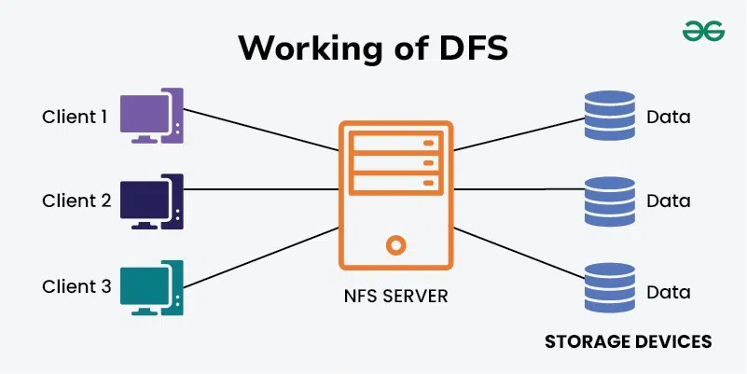
Fig: Distributed File System (DFS)
Applications of DFS:
- NFS: NFS stands for Network File System. It is a client-server architecture that allows a computer user to view, store, and update files remotely. The protocol of NFS is one of the several distributed file system standards for Network-Attached Storage (NAS).
- CIFS stands for Common Internet File System. CIFS is an accent of SMB. That is, CIFS is an application of SIMB protocol, designed by Microsoft.
- SMB stands for Server Message Block. It is a protocol for sharing a file and was invented by IBM. The SMB protocol was created to allow computers to perform read and write operations on files to a remote host over a Local Area Network (LAN). The directories present in the remote host can be accessed via SMB and are called as "shares".
- Hadoop is a group of open-source software services. It gives a software framework for distributed storage and operating of big data using the MapReduce programming model. The core of Hadoop contains a storage part, known as Hadoop Distributed File System (HDFS), and an operating part which is a MapReduce programming model.
- NetWare is an abandon computer network operating system developed by Novell, Inc. It primarily used combined multitasking to run different services on a personal computer, using the IPX network protocol.

Andrew File System (AFS)
Andrew File System (AFS) is a distributed network file system developed at Carnegie Mellon University. It is designed to support a large number of clients and provide efficient file sharing across distributed environments.

Features of AFS
- Client-side caching improves performance.
- Location transparency, users access files without knowing their physical location.
- Scalability, supports thousands of clients.
- Security using authentication mechanisms.
- Volume-based file management.

Working of AFS
- Clients request files from the server.
- Files are cached on the client machine.
- Updates are synchronized with the server.
- Multiple clients can access files efficiently.

CODA File System
CODA is an advanced distributed file system derived from AFS. It was also developed at Carnegie Mellon University and focuses on high availability and fault tolerance.

Features of CODA
- Disconnected operation, clients can work even when the network is unavailable.
- Server replication for high availability.
- Fault tolerance in case of server failures.
- Automatic conflict resolution.

Working of CODA
- Files are replicated on multiple servers.

- Clients access cached copies of files.
- If the network fails, the client can continue working locally.
- Once the connection is restored, changes are synchronized with servers.

Feature | AFS | CODA
Developed at | Carnegie Mellon University | Carnegie Mellon University
Caching | Client-side caching | Advanced caching
Fault Tolerance | Limited | High
Disconnected Operation | Not supported | Supported
Replication | Limited | Multiple server replication

